Exhibit 10.3129087

Table of Contents

UNITED STATES

SECURITIES AND EXCHANGE COMMISSION

WASHINGTON, D.C. 20549

FORM 10-K

(Mark One)

- ANNUAL REPORT PURSUANT TO SECTION 13 OR 15(d) OF THE SECURITIES EXCHANGE ACT OF 1934 For the fiscal year ended January 1, 2023
or

- TRANSITION REPORT PURSUANT TO SECTION 13 OR 15(d) OF THE SECURITIES EXCHANGE ACT OF 1934 For the transition period from ___________________ to ___________________
Commission File Number: 001-41059

Lulu’s Fashion Lounge Holdings, Inc.

(Exact Name of Registrant as Specified in its Charter)

Delaware | 20-8442468
(State or other jurisdiction of | (I.R.S. Employer
incorporation or organization) | Identification No.)
195 Humboldt Avenue
Chico, California | 95928
(Address of principal executive offices) | (Zip Code)

(530) 343-3545

(Registrant’s telephone number, including area code)

Securities registered pursuant to Section 12(b) of the Act:

Title of each class |  | Trading Symbol(s) |  | Name of each exchange on which registered
Common stock, $0.001 par value per share |  | LVLU |  | Nasdaq Global Market
 | Securities registered pursuant to Section 12(g) of the Act:
 |  | None.

Indicate by check mark if the registrant is a well-known seasoned issuer, as defined in Rule 405 of the Securities Act. YES ☐ NO ☒ Indicate by check mark if the registrant is not required to file reports pursuant to Section 13 or Section 15(d) of the Act. YES ☐ NO ☒
Indicate by check mark whether the registrant: (1) has filed all reports required to be filed by Section 13 or 15(d) of the Securities Exchange Act of 1934 during the preceding 12 months (or for such shorter period that the registrant was required to file such reports), and (2) has been subject to such filing requirements for the past 90 days. YES ☒ NO ☐
Indicate by check mark whether the registrant has submitted electronically every Interactive Data File required to be submitted pursuant to Rule 405 of Regulation S-T (§232.405 of this chapter) during the preceding 12 months (or for such shorter period that the registrant was required to submit such files). YES ☒ NO ☐

Indicate by check mark whether the registrant is a large accelerated filer, an accelerated filer, a non-accelerated filer, a smaller reporting company, or an emerging growth company. See the definitions of “large accelerated filer,” “accelerated filer,” “smaller reporting company,” and “emerging growth company” in Rule 12b-2 of the Exchange Act.

Large accelerated filer | ☐ | Accelerated filer | ☒
Non-accelerated filer | ☐ | Smaller reporting company | ☒
 |  | Emerging growth company | ☒

If an emerging growth company, indicate by check mark if the registrant has elected not to use the extended transition period for complying with any new or revised financial accounting standards provided pursuant to Section 13(a) of the Exchange Act. ☐

Indicate by check mark whether the registrant has filed a report on and attestation to its management’s assessment of the effectiveness of its internal control over financial reporting under Section 404(b) of the Sarbanes-Oxley Act (15-U.S.C. 7262(b)) by the registered public accounting firm that prepared or issued its audit report. ☐

If securities are registered pursuant to Section 12(b) of the Act, indicate by check mark whether the financial statements of the registrant included in the filing reflect the correction of an error to previously issued financial statements. ☐

Indicate by check mark whether any of those error corrections are restatements that required a recovery analysis of incentive-based compensation received by any of the registrant’s executive officers during the relevant recovery period pursuant to §240.10D-1(b). ☐
Indicate by check mark whether the registrant is a shell company (as defined in Rule 12b-2 of the Act). YES ☐ NO ☒

At July 3, 2022, the last business day of the registrant’s most recently completed second fiscal quarter, the aggregate market value of the common stock of the registrant held by non-affiliates was approximately $96.9 million based on the closing price of the common stock on such date.
The number of shares of registrant’s common stock outstanding as of March 10, 2023, was 39,289,341.

DOCUMENTS INCORPORATED BY REFERENCE

Portions of the registrant’s definitive Proxy Statement, relating to its 2023 Annual Meeting of Stockholders to be filed with the Securities and Exchange Commission are incorporated by reference into Part III of this Annual Report on Form 10-K.

Table of Contents
 |  |  |  |  |  |  |  |  |  |  |  |  |  |  |  |  |  |  |  | TABLE OF CONTENTS
Part I |  |  |  |  |  |  |  |  |  |  |  |  |  |  |  |  |  |  |  |  |  |  |  |  |  |  |  |  | Page
 | Item |  | 1. |  |  |  |  | Business |  |  |  |  |  |  |  |  |  |  |  |  |  |  |  |  |  |  |  |  | 7
 | Item |  | 1A. |  |  |  |  | Risk Factors |  |  |  |  |  |  |  |  |  |  |  |  |  |  |  |  |  |  |  |  | 16
 | Item |  | 1B. |  |  |  |  | Unresolved Staff Comments |  |  |  |  |  |  |  |  |  |  |  |  |  |  |  |  |  |  |  |  | 50
 | Item |  | 2. |  |  |  |  | Properties |  |  |  |  |  |  |  |  |  |  |  |  |  |  |  |  |  |  |  |  | 50
 | Item |  | 3. |  |  |  |  | Legal Proceedings |  |  |  |  |  |  |  |  |  |  |  |  |  |  |  |  |  |  |  |  | 50
 | Item |  | 4. |  |  |  |  | Mine Safety Disclosures |  |  |  |  |  |  |  |  |  |  |  |  |  |  |  |  |  |  |  |  | 51
PART II
 | Item |  | 5. |  |  |  |  | Market for Registrant’s Common Equity, Related Stockholder Matters, and Issuer Purchases of Equity Securities |  |  |  |  |  |  |  |  |  |  |  |  |  |  |  |  |  |  |  |  | 52
 | Item |  | 6. |  |  |  |  | Reserved |  |  |  |  |  |  |  |  |  |  |  |  |  |  |  |  |  |  |  |  | 55
 | Item |  | 7. |  |  |  |  | Management’s Discussion and Analysis of Financial Condition and Results of Operations |  |  |  |  |  |  |  |  |  |  |  |  |  |  |  |  |  |  |  |  | 55
 | Item |  | 7A. |  |  |  |  | Quantitative and Qualitative Disclosure About Market Risk |  |  |  |  |  |  |  |  |  |  |  |  |  |  |  |  |  |  |  |  | 67
 | Item |  | 8. |  |  |  |  | Financial Statements and Supplementary Data |  |  |  |  |  |  |  |  |  |  |  |  |  |  |  |  |  |  |  |  | 69
 | Item |  | 9. |  |  |  |  | Changes in and Disagreements with Accountants on Accounting and Financial Disclosure |  |  |  |  |  |  |  |  |  |  |  |  |  |  |  |  |  |  |  |  | 103
 | Item |  | 9A. |  |  |  |  | Controls and Procedures |  |  |  |  |  |  |  |  |  |  |  |  |  |  |  |  |  |  |  |  | 103
 | Item |  | 9B. |  |  |  |  | Other Information |  |  |  |  |  |  |  |  |  |  |  |  |  |  |  |  |  |  |  |  | 103
 | Item |  | 9C. |  |  |  |  | Disclosure Regarding Foreign Jurisdictions That Prevent Inspections |  |  |  |  |  |  |  |  |  |  |  |  |  |  |  |  |  |  |  |  | 104
PART III
 | Item |  | 10. |  |  |  |  | Directors, Executive Officers, and Corporate Governance |  |  |  |  |  |  |  |  |  |  |  |  |  |  |  |  |  |  |  |  | 105
 | Item |  | 11. |  |  |  |  | Executive Compensation |  |  |  |  |  |  |  |  |  |  |  |  |  |  |  |  |  |  |  |  | 105
 | Item |  | 12. |  |  |  |  | Security Ownership of Certain Beneficial Owners and Management and Related Stockholder Matters |  |  |  |  |  |  |  |  |  |  |  |  |  |  |  |  |  |  |  |  | 105
 | Item |  | 13. |  |  |  |  | Certain Relationships and Related Transactions, and Director Independence |  |  |  |  |  |  |  |  |  |  |  |  |  |  |  |  |  |  |  |  | 105
 | Item |  | 14. |  |  |  |  | Principal Accountant Fees and Services |  |  |  |  |  |  |  |  |  |  |  |  |  |  |  |  |  |  |  |  | 105
PART IV
 | Item |  | 15. |  |  |  |  | Exhibit and Financial Statement Schedules |  |  |  |  |  |  |  |  |  |  |  |  |  |  |  |  |  |  |  |  | 106
 | Item |  | 16. |  |  |  |  | Form 10-K Summary |  |  |  |  |  |  |  |  |  |  |  |  |  |  |  |  |  |  |  |  | 110
 |  |  |  |  |  |  |  | Signatures |  |  |  |  |  |  |  |  |  |  |  |  |  |  |  |  |  |  |  |  | 111

2

Table of Contents

FORWARD-LOOKING STATEMENTS

This Annual Report on Form 10-K contains forward-looking statements. We intend such forward-looking statements to be covered by the safe harbor provisions for forward-looking statements contained in Section 27A of the Securities Act of 1933, as amended (the “Securities Act”), and Section 21E of the Securities Exchange Act of 1934, as amended (the “Exchange Act”). All statements other than statements of historical facts contained in this Annual Report on Form 10-K may be forward-looking statements. In some cases, you can identify forward-looking statements by terms such as “may,” “will,” “should,” “expects,” “plans,” “anticipates,” “could,” “intends,” “targets,” “projects,” “contemplates,” “believes,” “estimates,” “forecasts,” “predicts,” “potential” or “continue” or the negative of these terms or other similar expressions. Forward-looking statements contained in this Annual Report on Form 10-K include, but are not limited to statements regarding our future results of operations and financial position, industry and business trends, stock compensation, business strategy, plans, market growth and our objectives for future operations.

The forward-looking statements in this Annual Report on Form 10-K are only predictions. We have based these forward-looking statements largely on our current expectations and projections about future events and financial trends that we believe may affect our business, financial condition and results of operations. Forward-looking statements involve known and unknown risks, uncertainties and other important factors that may cause our actual results, performance or achievements to be materially different from any future results, performance or achievements expressed or implied by the forward-looking statements, including, but not limited to, the important factors discussed in Part I, “Item 1A. Risk Factors” in this Annual Report on Form 10-K. The forward-looking statements in this Annual Report on Form 10-K are based upon information available to us as of the date of this Annual Report on Form 10-K, and while we believe such information forms a reasonable basis for such statements, such information may be limited or incomplete, and our statements should not be read to indicate that we have conducted an exhaustive inquiry into, or review of, all potentially available relevant information. These statements are inherently uncertain and investors are cautioned not to unduly rely upon these statements.

You should read this Annual Report on Form 10-K and the documents that we reference in this Annual Report on Form 10-K and have filed as exhibits to this Annual Report on Form 10-K with the understanding that our actual future results, levels of activity, performance and achievements may be materially different from what we expect. We qualify all of our forward-looking statements by these cautionary statements. These forward-looking statements speak only as of the date of this Annual Report on Form 10-K. Except as required by applicable law, we do not plan to publicly update or revise any forward-looking statements contained in this Annual Report on Form 10-K, whether as a result of any new information, future events or otherwise.

3

Table of Contents

BASIS OF PRESENTATION

On August 28, 2017, we executed a reorganization of our corporate structure. Our original parent company was called Lulu’s Holdings, LLC. This entity was converted to Lulu’s Holdings, L.P. (the “LP”). We formed two new subsidiaries, Lulu’s Fashion Lounge Holdings, Inc. and Lulu’s Fashion Lounge Parent, LLC, to sit between the LP and our operating company. Our operating company, previously known as Lulu’s Fashion Lounge, Inc., was converted from a California corporation to a Delaware limited liability company, Lulu’s Fashion Lounge, LLC, an indirect wholly-owned subsidiary of Lulu’s Fashion Lounge Holdings, Inc. In connection with our initial public offering, the LP was liquidated. Unless otherwise indicated or the context otherwise requires, references in this Annual Report on Form 10-K to the terms “Lulus,” “we,” “us,” “our,” or the “Company” refer to Lulu’s Fashion Lounge Holdings, Inc. and its consolidated subsidiaries.

Our fiscal year is a “52-53 week” year ending on the Sunday closest in proximity to December 31, such that each quarterly period will be 13 weeks in length, except during a 53 week year when the fourth quarter will be 14 weeks. References herein to “fiscal 2022” and/or “2022” relate to the year ending January 1, 2023, “fiscal 2021” and/or “2021” relate to the year ended January 2, 2022 and “fiscal 2020” and/or “2020” relate to the year ended January 3, 2021. The years ended January 1, 2023 and January 2, 2022 were 52-week years. The year ended January 3, 2021 was a 53-week year.

Throughout this Annual Report on Form 10-K, we provide a number of key performance indicators used by management and typically used by our competitors in our industry. These and other key performance indicators are discussed in more detail in the section titled “Management’s Discussion and Analysis of Financial Condition and Results of Operations—Key Operating and Financial Metrics.” In this Annual Report on Form 10-K, we also reference Adjusted EBITDA, which is a non-GAAP (accounting principles generally accepted in the United States of America) financial measure. See “Management’s Discussion and Analysis of Financial Condition and Results of Operations—Non-GAAP Financial Measures” for a discussion of Adjusted EBITDA, as well as a reconciliation of net income (loss) to Adjusted EBITDA. Net income (loss) is the most directly comparable financial measure to Adjusted EBITDA required by, or presented in accordance, with GAAP.

4

Table of Contents

SUMMARY RISK FACTORS

Our business is subject to numerous risks and uncertainties, including those described in Part I, “Item 1A. Risk Factors” in this Annual Report on Form 10-K. You should carefully consider these risks and uncertainties when investing in our common stock. The principal risks and uncertainties affecting our business include the following:

- If we are not able to successfully maintain our desired merchandise assortment or manage our inventory effectively, we may be unable to attract a sufficient number of customers or sell sufficient quantities of our merchandise;

- Our success depends on our ability to anticipate, identify, measure, and respond quickly to new and rapidly changing fashion trends, customer preferences and demands, and other factors;

- We rely on consumer discretionary spending and may be adversely affected by economic downturns and other macroeconomic conditions or trends;

- The COVID-19 pandemic has had and may in the future have an adverse effect on our labor workforce availability, supply chain, business, financial condition, and results of operations in ways that remain unpredictable;

- We may be unable to maintain a high level of engagement with our customers and increase their spending with us, which could harm our business, financial condition, and results of operations;

- Our business depends on our ability to maintain a strong community around the Lulus brand with engaged customers and influencers.

- We rely on third parties to drive traffic to our platform;

- Use of social media, influencers, affiliate marketing, email, SMS, podcast advertisements, promotional partnerships and direct mail may adversely impact our brand and reputation or subject us to fines or other penalties;

- We operate in the highly competitive retail apparel industry;

- We may not accurately forecast income and appropriately plan our expenses;

- Our business is affected by seasonality, which could result in fluctuations in our results of operations;

- We may not be able to successfully implement our growth strategy;

- As we pursue our international growth strategy, we will become subject to international business uncertainties;

- Our ability to obtain merchandise on a timely basis at competitive prices could suffer as a result of any deterioration or change in our supplier relationships or events that adversely affect our suppliers or their ability to obtain financing for their operations;

- Merchandise returns could harm our business;

- System security risk issues, including any real or perceived failure to protect confidential or personal information against security breaches and disruption of our internal operations or information technology systems, could have a material adverse effect on our business, financial condition, and results of operations;

- We rely significantly on technology and systems to support our supply chain, payments, financial reporting and other key aspects of our business;

5

Table of Contents

- Our business relies heavily on email and other messaging services, and any restrictions on the sending of emails or messages or an inability to timely deliver such communications could materially adversely affect our business, financial condition and results of operations;

- Our business, including our costs and supply chain, is subject to risks associated with sourcing, manufacturing, and warehousing;

- We have three distribution facilities and several administrative offices and disruptions to the operations at these locations could have a material adverse effect on our business, financial condition, cash flows, and results of operations;

- We rely on third-party suppliers, manufacturers, distributors, and other suppliers, and they may not continue to produce products or provide services that are consistent with our standards or applicable regulatory requirements;

- Many of our third-party suppliers and manufacturers are based in China, which exposes us to risks inherent in doing business there;

- We rely upon independent third-party transportation providers for substantially all of our merchandise;

- We may be unable to protect our trademarks or other intellectual property rights;

- Unfavorable changes or failure by us to comply with evolving internet and e-commerce regulations could substantially harm our business and results of operations;

- If our suppliers fail to comply with applicable laws, including a failure to use acceptable labor practices, or if our suppliers suffer disruptions in their businesses, we could suffer adverse business consequences;

- U.S. import levels may increase and could harm our business;

- Changes in laws, including employment laws and laws related to our merchandise, could make conducting our business more expensive or otherwise cause us to change the way we do business;

- A failure to comply with current laws, rules and regulations or changes to such laws, rules and regulations and other legal uncertainties may adversely affect our business, financial performance, results of operations or business growth;

- We may require additional capital to support business growth and this capital might not be available or may be available only by diluting existing stockholders;

- We expect that our stock price will fluctuate significantly;

- Changes in accounting standards and subjective assumptions, estimates and judgments by management related to complex accounting matters could significantly affect our financial results or financial condition;

- There are claims made against us from time to time that can result in litigation that could distract management from our business activities and result in significant liability or damage to our brand; and

- We depend on our senior management personnel.

6

Table of Contents

PART I

Item 1. Business.

Our Business

Lulus is a customer-driven, digitally-native fashion brand primarily serving a large, diverse community of Millennial and Gen Z women, who typically meet us in their 20s and stay with us through their 30s and beyond. We focus relentlessly on giving our customers what they want. We do this by using data coupled with human insight to deliver a curated and continuously evolving broad assortment of on-trend, affordable luxury fashion for many of life’s moments. Our customer obsession sets the tone for everything we do, from our personalized online shopping experience to our exceptional customer service.

We are focused on building authentic personal relationships with our customers and offering them coveted products they cannot purchase elsewhere. We incorporate the pulse of the consumer by engaging with her where she is: across the web, on social media and across our platform, through reviews, feedback and one-on-one interactions with our Style Advisors, Fit Experts and Bridal Concierge. Customers express their love for our brand on social media and by word-of-mouth (both in-person and online).

A key differentiator of our business model from traditional fashion retail is our use of data to optimize almost all elements of our business. Nowhere is this more pronounced than in our product creation and curation cycle. Traditional merchandising approaches are risk and capital intensive, characterized by extended in-house design cycles, seasonal assortment decisions, deep buys, limited customer feedback, and high markdowns. Unlike traditional retailers, we leverage a “test, learn, and reorder” strategy to bring hundreds of new products to market every week; we test them in small batches, learn about customer demand and then quickly reorder winning products in higher volume to optimize profitability. This strategy allows us to rapidly convert new products into profitable sales on a consistent and repeatable basis while minimizing fashion and trend risk.

Why We Win

Customer-Driven Fashion Brand: Lulus is one of the first digitally-native fashion brands in the United States primarily serving Millennial and Gen Z women. We take pride in our ability to offer more luxurious fabrics and incorporate elevated stylistic details into our products relative to what is offered by other comparably-priced brands. Our obsessive focus on customer experience creates deep personal connections, which in turn rewards us with customer loyalty and word-of-mouth sharing of the brand.

Customer-Centric Experience: We are passionate about building a brand synonymous with exceptional customer service. We have effectively brought the boutique experience online, developing one-on-one relationships with our customers in order to learn and then address their individual needs. Our customers value Lulus for our personalized fit and styling assistance, which remains a top reason for customer contact when additional advice is required beyond that of our popular automated fit analyst tool. Further, we are able to offer standardized sizing across the Lulus assortment, simplifying the shopping experience and giving our customer confidence that she is selecting the best fit.

Leveraging Data to Best Serve our Customer: We have built a massive dataset which gives us strong insight into our customers. Millions of customers have interacted with us, leaving detailed reviews, interacting with our on-demand Style Advisors, Fit Experts, and Bridal Concierge, and completing checkout surveys. Across Facebook, Instagram, Pinterest, Snapchat, TikTok, Twitter and YouTube, our over 8.1 million followers engage with us through their comments, feedback, photographs, and support of our brand with their digital followers. In aggregate, this dataset gives us a deep understanding of our customers’ preferences.

Marketing and Engagement Strategy: We engage with our customer where she is, in authentic and personalized ways: through our website, mobile app, email, SMS, and on social media. This strategy helps drive brand awareness while fostering deep connections with our customers. Our authentic partnerships with brand ambassadors span the full spectrum of followership and engagement levels, from nano- and micro-influencers, to college ambassadors and celebrities, all of whom wear and genuinely love our brand.

Data-Driven Product Creation Strategy: Our innovative product creation strategy leverages the power of data and our “test, learn, and reorder” approach to bring new styles online almost every weekday. We are highly focused on optimization of inventory levels to meet customer demand and minimize markdowns. This efficient, data-driven process, coupled with human insight, allows us to respond to fashion trends with speed and precision while significantly reducing risk in our business.

7

Table of Contents

Marketing

Our marketing strategy leverages our strong visual brand presence to build awareness and drive engagement with our large, diverse community of loyal customers. We integrate the power of data across multiple channels to offer a singular brand voice that speaks to Millennial and Gen Z women. We meet the Lulus customer wherever she is, enabling her discovery of the brand and providing her numerous opportunities to interact with others in the Lulus community. Through this engagement with our customers, we strive to build personal connections that are authentic and durable. We attract and engage customers through a combination of owned, earned and paid media.

Upon attracting a new or existing customer to our website or mobile experience, we seek to maximize conversion through a variety of strategies:

- Brand Strength and Exclusivity: As a digitally-native fashion brand, we benefit from the ability to focus our resources, as well as our customers’ attention, primarily on the Lulus brand, without the distraction or complexity of managing and marketing a large multi-brand portfolio. As a result, we focus on offering the best possible assortment of Lulus products for our customers.

- Product Reviews: One of the most important aspects of our digital shopping experience is our extensive database of proprietary customer product reviews, which we first enabled in 2012 and now amounts to over one million reviews. Our website has the functionality to allow customers to upload their own product photos along with their reviews, which bring the products to life on a diverse array of body types.

- Boutique Styling Experience: We strive to offer exceptional customer service before, during, and after each purchase. We accomplish this by continuously improving the boutique experience on our platform through features such as our product recommendation engine and targeted messaging and with our in-house team of customer service associates who maintain deep expertise of our brand, products, and systems.

- Personalized and Optimized Shopping Experience: We customize and personalize our interactions with each Lulus customer by monitoring information such as how she arrives on our site, her on-site behavior, and what she buys. Our customer insights, predictive capabilities, product recommendations, and custom-built website work seamlessly together to offer each customer a personalized experience across web, mobile, our mobile app, email, and SMS.

These strategies work in unison to help drive order conversion. Whether she is browsing social media or providing feedback on a recent purchase, we engage with our customer across a multitude of touchpoints throughout the discovery and purchase journey.

8

Table of Contents

Our Growth Strategies

Due to the mass market appeal of our brand, we believe there is a significant opportunity to bring new customers into the Lulus community through increased brand awareness. We intend to grow awareness of the Lulus brand and attract new customers through the following strategies:

- Further investment in performance digital marketing strategies;

- Exploration and expansion of new marketing channels;

- Continued expansion of our brand ambassador program at all engagement tiers, including celebrity, micro- and nano-influencers, and college ambassadors to introduce Lulus to new audiences;

- Expansion of marketing programs that leverage word-of-mouth referral;

- Further development and testing of physical retail opportunities to expand on brand awareness, such as in-store partnerships with third-party retailers and small-format pop-ups and showrooms; and

- Continued development of brand partnerships, with a clear focus on brands with strong customer affinity and crossover potential. This includes collaborations with apparel brands and influencers, as well as adjacent category opportunities such as beauty, home, and lifestyle.

Enhance and Retain Existing Customer Relationships

We have a large and growing Lulus community and 3.2 million Active Customers as of January 1, 2023. We continue to leverage data-driven customer insights to develop strong customer relationships and become a one-stop shop for Gen Z and Millennial women. For example, we have had success leveraging data-driven insights across categories to offer personalized suggestions and reminders at targeted points in time, and we are focused on expanding these capabilities to provide enhanced real-time recommendations and post-purchase engagement. Additionally, we continually develop and evaluate new tools and programs designed to improve the key customer metrics that drive our business, such as frequency of purchase and Average Order Value (“AOV”) through the following strategies:

- Optimization of our website and mobile experience through continued A/B and multivariate testing;

- Improvement of customer segmentation and personalization features;

- Leveraging our expanded multi-region distribution facilities to offer faster order delivery and developing new shipping options;

- Development of our loyalty program, including through the launch of our revamped loyalty program in February 2022, to engender even deeper brand engagement, drive repeat purchase behavior and increase wallet share;

- Enhancement of our customer service through the expansion of our Style Advisors, Fit Experts, and Bridal Concierge dedicated to creating a truly personalized digital boutique experience;

- Continued development of our affordable luxury brand positioning and content; and

- Incorporating new technology that enhances our customers’ experience.

We have learned that enhancing our existing customers’ experience drives increased word-of-mouth (in-person and online) recommendations, which in turn helps grow brand awareness.

9

Table of Contents

Pursue Category Expansion

We believe there is tremendous potential to continue to drive growth in our underpenetrated categories. We have a significant opportunity to grow our share of total apparel budget with expansion into these underdeveloped areas. For example, our success in apparel beyond our core dress categories demonstrates our ability to successfully launch and grow share in new categories. Our deep and personal engagement with our customers through product reviews, exit surveys and social media feedback helps us understand the product categories they are most interested in shopping and will continue to inform the breadth and depth of the categories we offer.

Due to our customer data-driven product creation strategy, we have the ability to test new categories with minimal upfront investment and risk. New categories are opened with a controlled assortment of branded and partner products through which we learn to understand customer demand via our reorder algorithms. Our ability to leverage our existing categories to introduce and grow new ones has resulted in customer repeat orders with strong product diversification.

Pursue International Expansion

While we expect the majority of our near-term growth to continue to come from the United States, we believe that serving international customers represents a long-term growth opportunity. To date, we have shipped our merchandise to over 100 countries, while spending minimal dollars on marketing outside of the United States, demonstrating our global appeal and broader market opportunity. Our long-term strategy is to increase our focus on our platform and distribution process for international customers, allowing for a more optimized shopping experience, including more flexibility across languages and currencies. We believe that providing a localized shopping experience will significantly enhance our ability to serve customers in international markets.

Suppliers

We collaborate with a network of more than 300 suppliers, who serve as our design and manufacturing partners. These suppliers often give us priority access and exclusivity to designs, given the strong relationships we have built over the last two decades. We do not have any long-term commitments requiring us to purchase minimum volumes from any supplier. We take great effort to ensure that all suppliers share our commitment to quality and ethics, including through adherence to our Vendor and Supplier Code of Conduct.

Technology

The www.lulus.com website, mobile app, merchandising, customer, order, and warehouse management systems are proprietary, purpose-built solutions with the goal of delivering the best possible customer experience and operational efficiency. From payment card industry compliant checkout to the software running on handheld barcode scanners in order fulfillment, these key software processes are developed, maintained, and enhanced by our in-house engineering and data teams to meet and exceed our customers’ expectations in a scalable way. Data-driven insights are core to what we do at Lulus. Technology drives and supports our business in several foundational areas, like our merchandising test, learn and reorder model, our cost-efficient marketing, and high operational efficiency.

Our proprietary reorder system is informed and powered by our data warehouse with predictive data modeling and business intelligence. Sales analyses across hundreds of product attributes and assortment architecture and trend analyses inform our buyers’ selection of new styles. Customer demand and return signal data, product profitability, seasonality, and product demand prediction are taken into consideration to advise our reorder buyers which products to reorder, when those reorders should arrive, and in what quantities.

We combine purpose-built technology systems with customer focused engineering and data teams, to provide us with deep customer behavior insights. Integrating information from many available sources, from customer actions and feedback on the platforms to predictive analysis, continuously enhances our understanding of customer preference. This understanding allows us to activate personalization across our platform and in our various marketing channels.

We also use our technology to optimize our operational efficiency as e-commerce fulfillment and reverse logistics are critical to profitability. We have implemented, and will continue to implement, robotics and other automation to support various processes and increase efficiency within our distribution facilities. Our business model is characterized by high SKU velocity, low to no SKU affinity, quick order-to-to-ship requirements, short return-to-refund timelines, and fast inventory turnover. We have built our own proprietary, integrated e-commerce backend system to minimize cost and maximize customer satisfaction.

10

Table of Contents

We have built our software development and deployment cycles such that software changes can be deployed daily after being verified by fully automated testing, as well as by human functional testing. We work with reputable cloud services providers across multiple data centers, with fully redundant infrastructure within each data center, as well as with full failover capability between data centers, which allows us to serve our customers at virtually any time. Our infrastructure is flexible and scalable to provide our customers with the best possible shopping experience.

Security and Data Protection

We are committed to the security of our customers’ data and personal information. We aggregate and analyze data in order to optimize the customer experience internally, and do not monetize the information we collect by selling it to third parties for money for their own external purposes. We utilize both on-premise and cloud-based technologies and undertake technical and other administrative measures to ensure the protection of our systems and customer data. We use various in-house and third-party tools to support our security policies and procedures including user access controls, server monitoring, (web) firewalls, security content policies, and data encryption. We also use external certified security partners to test for vulnerabilities in our software and infrastructure, and assist in our security practices, which are designed to comply with the Payment Card Industry Data Security Standard. Finally, we have implemented processes and procedures to allow customers to review and remove their non-transactional account data and to opt out of the sharing or selling of their personal information.

Competition

The women’s apparel, footwear, and accessories industry is large, fragmented, highly competitive and rapidly evolving. The industry consists of various brands and retailers that employ several different operating models at varying price points, and consumers have the option to shop both offline and online. Our competition includes traditional brands and retailers who market to consumers via offline and online channels. Our competition also includes e-commerce retailers that generally operate as online department stores for third-party and/or private label brands. Further, we may face new competitors and increased competition from existing competitors as we increase our brand awareness, expand our categories, and pursue international expansion.

Competition in our industry is based on, among other things, quality, concept, price, breadth, and style of merchandise, as well as customer service, brand image, brand quality, strength of brand relationships, and ability to anticipate, identify, and respond to new and changing fashion trends. Because we are an early mover in our category, we believe we have a significant head start on becoming the go-to brand for Millennial and Gen Z consumers. As one of the first digitally-native brands, Lulus is well-positioned to capitalize on our deep digital footprint, social media infrastructure, loyal and active customer community, and product creation model. As a vertically integrated business, we retain full control of critical aspects of our business including brand, product, marketing, distribution, and customer service. Our long operating history means that we have collected a valuable dataset over the last decade while refining an efficient, scalable business model.

Seasonality

We experience moderate seasonal fluctuations in aggregate sales volume during the year. Seasonality in our business does not follow that of traditional retailers, such as a typical concentration of revenue in the holiday quarter. Historically, our net revenue is highest in our second and third fiscal quarters compared to the rest of the year due to higher demand for special event dresses and spring and summer fashion. The seasonality of our business has resulted in variability in our total net revenue quarter-to-quarter. We believe that this seasonality has affected and will continue to affect our results of operations. We recognized 25%, 30%, 24% and 21% of our annual net revenue during the first, second, third and fourth quarters of 2022, respectively.

Trademarks and Intellectual Property

Our trademarks, including LULUS® and ®, are registered with the United States Patent and Trademark Office. We also own the registrations for LULU’S®, LOVELULUS®, and COVETED CURATED COLLECTED®. We own the domain name www.lulus.com. We believe the Lulus® trademark has significant value in the marketing of our merchandise. We have registrations in Canada, the European Union (the “EU”), the United Kingdom, Australia, Mexico, China, and several other countries, as well as additional pending international applications. We vigorously protect our intellectual property rights.

11

Table of Contents

Regulation and Legislation

We are subject to labor and employment laws, laws governing advertising and promotions, privacy laws, safety regulations, customer protection regulations and other laws that regulate retailers and govern the promotion and sale of merchandise and warehouse facilities. We monitor changes in these laws and believe that we are in material compliance with applicable laws.

We are also subject to a number of domestic and foreign laws and regulations that affect companies conducting business on the internet, many of which are still evolving and could be interpreted in ways that could harm our business. These laws and regulations include federal and state consumer protection laws and regulations, which address, among other things, the privacy and security of consumer information, sending of commercial email, and unfair and deceptive trade practices.

Under applicable federal and state laws and regulations addressing privacy and data security, we must provide notice to consumers of our policies with respect to the collection and use of personal information, our sharing of personal information with third parties, and notice of any changes to our data handling practices. In some instances, we may be obligated to give customers the right to prevent sharing or selling of their personal information with third parties. Under applicable federal and state laws, we also are required to adhere to a number of requirements when sending commercial email to consumers, including identifying advertising and promotional emails as such, ensuring that subject lines are not deceptive, giving consumers an opportunity to opt-out of further communications and clearly disclosing our name and physical address in each commercial email. Regulation of privacy and data security matters is an evolving area, with new laws and regulations enacted frequently. For example, California enacted the California Consumer Privacy Act (“CCPA”) which has been significantly amended and expanded by the California Privacy Rights Act (“CPRA”) and which, among other things, requires certain disclosures to California consumers, and affords such consumers new abilities to opt out of certain sales and sharing of personal information, including with regard to targeted advertising activities. Additionally, Colorado, Connecticut, Virginia, and Utah have all enacted data privacy legislation and other states are following suit. In addition, under applicable federal and state unfair competition laws, including the California Consumer Legal Remedies Act and Federal Trade Commission (“FTC”) regulations, we must, and our network of influencers may be required to, accurately identify product offerings, not make misleading claims on our websites or in advertising, and use qualifying disclosures where and when appropriate. The growth and demand for e-commerce could result in more stringent domestic and foreign consumer protection laws that impose additional compliance burdens on companies that transact substantial business on the internet.

Our international business is subject to additional laws and regulations, including environmental laws and restrictions on imports from, exports to, and services provided to persons located in certain countries and territories, as well as foreign laws and regulations addressing topics such as advertising and marketing practices, customs duties and taxes, privacy, data protection, information security and consumer rights, any of which might apply by virtue of our sales in foreign countries and territories or our contacts with consumers in such foreign countries and territories. For example, the United States and China and the United States and Mexico, where certain of our products are manufactured, have recently engaged in an escalating trade war, which has led to each side threatening tariffs that could adversely affect our business and results of operations or cause us to relocate manufacturing to other countries and territories, which could disrupt our operations. In addition, the General Data Protection Regulation (“GDPR”), the UK General Data Protection Regulation (“UK GDPR”), the UK Data Protection Act 2018, and the Swiss Data Protection Act (“FADP”) impose stringent requirements regarding the collection, handling, use and transfer of personal data of individuals located in the European Economic Area (“EEA”) and provide for substantial penalties for noncompliance. These regulations impact the use of cookies, tracking technologies and other e-marketing efforts, and there has been significant recent European court and regulatory decisions in this area, including through privacy activists. More generally, many foreign jurisdictions have laws, regulations, or other requirements relating to privacy, data protection, and consumer protection, and countries and territories are adopting new legislation or other obligations with increasing frequency. Many of these laws may require disclosure to and consent from consumers for the use of data for various purposes, including marketing, which may reduce our ability to market our products. In addition, in December 2022, a provisional political agreement was reached between the European Parliament and the Council of the EU regarding deforestation-free supply chains. The resulting proposed regulation, once it is formally adopted, is expected to require that certain commodities including cattle, cocoa, coffee, oil palm, soya, wood, and rubber, and certain products derived therefrom, that are placed on the EU market, or exported from the EU market, no longer contribute to deforestation or forest degradation. This proposed EU regulation, of which draft text has been approved by the Permanent Representatives’ Committee (Interinstitutional File No. 2021/0366 (COD)), is expected at this time to contain requirements including due diligence and traceability obligations necessitating the linking of certain commodities and certain derived products to their place of production. We do not know of any existing environmental law, regulation nor condition that reasonably would be expected to have a material adverse effect on our business, capital expenditures, or operating results. However, future changes to environmental laws or regulations may impact our operations and could result in increased costs.

12

Table of Contents

In many jurisdictions, there is great uncertainty whether or how existing laws governing issues such as property ownership, sales and other taxes, libel and personal privacy apply to the internet and e-commerce. New legislation or regulation, the application of laws and regulations from jurisdictions whose laws do not currently apply to our business or the application of existing laws and regulations to the internet and e-commerce could result in significant additional obligations on our business or may necessitate changes to our business practices. These obligations or required changes could have an adverse effect on our cash flows and results of operations. Further, any actual or alleged failure to comply with any of these laws or regulations by us, our suppliers or our network of influencers could hurt our reputation, brand and business, force us to incur significant expenses in defending against proceedings or investigations, distract our management, increase our costs of doing business, result in a loss of customers and suppliers and may result in the imposition of monetary penalties. See “Risk Factors—Risks Related to Our Business and Industry— A failure to comply with current laws, rules and regulations, or changes to such laws, may adversely affect our business, financial performance, results of operations, or business growth.”

Environmental, Social, and Governance (ESG)

At Lulus, we believe in being responsible business stewards and strive to understand the impact that our business has on our employees, customers, and the planet. We will look for opportunities to play a constructive role in addressing the environmental, social, and governance (“ESG”) challenges of the fashion industry while working towards creating long-term value for our Company and our stakeholders.

Governance. Lulus’ ESG efforts are overseen by our Board of Directors through our Nominating and Corporate Governance Committee. Our Executive Chairman and General Counsel work with internal stakeholders, including a cross-functional ESG Steering Committee, as well as with outside specialists, to set and implement the Company’s ESG strategy. Our ESG strategy and initiatives are discussed regularly at the Board level.

Approach. In 2022, we engaged a third-party ESG consultant to conduct a materiality assessment. Working with internal and external stakeholders, this process helped us to identify the priority material topics that our stakeholders care about. As part of our developing strategy, we plan to formalize a framework for our efforts and reporting around these topics and look forward to sharing our continued progress on ESG matters. We also engaged a third-party greenhouse gas (“GHG”) consulting firm to assess our 2021 Scope 1 and 2 GHG emissions and will be working with the same firm to assess our 2022 Scope 1 and 2 GHG emissions. This will enable us to set a baseline for our GHG Scope 1 and 2 emissions and create a plan for improvement. Laying the groundwork for a greater oversight of our suppliers and supporting the health and wellbeing of all the people who make our products, we formalized our Vendor and Supplier Code of Conduct which sets forth our expectations for working conditions in all factories producing Lulus products. We make available our Vendor and Supplier Code of Conduct free of charge through our investor relations website, which is located at https://investors.lulus.com. We also held a Vendor Summit on social aspects of the supply chain and began providing training to our vendors on responsible sourcing and production practices. We have engaged an outside supply chain risk management and audit company to evaluate our supply chain risks and develop an oversight and auditing program, which we will be starting in 2023.

Recent Developments

Leadership Changes

On November 11, 2022, our Board of Directors approved a leadership succession plan (“Succession Plan”) that took effect on March 6, 2023 (the "Effective Date"). Specifically, Crystal Landsem, former Co-President and Chief Financial Officer, became Chief Executive Officer as of the Effective Date. David McCreight, former Chief Executive Officer, became Executive Chairman as of the Effective Date and succeeded Evan Karp as Chairman of the Board of Directors. Mr. Karp will continue his service as a director on the Board of Directors. Mark Vos, former Co-President and Chief Information Officer, received a title change to President and Chief Information Officer and reports to the Executive Chairman as of the Effective Date. On March 5, 2023, Lulus entered into a new employment agreement with Ms. Landsem, reflecting her new role as Chief Executive Officer, which became effective on the Effective Date. On November 11, 2022, Lulus entered into a new employment agreement with Mr. McCreight, reflecting his new role as Executive Chairman, which became effective on the Effective Date. On March 5, 2023, Lulus entered into an amendment to the employment agreement with Mr. Vos reflecting the updates described above which became effective on the Effective Date.

13

Table of Contents

On March 6, 2023, the Board of Directors appointed Tiffany R. Smith as the new Chief Financial Officer, as of the Effective Date. On March 8, 2023, Lulus entered into an employment agreement with Ms. Smith, reflecting her role as Chief Financial Officer, which became effective on the Effective Date.

Human Capital Resources

Employees and Demographics. Our employees, also known as the “LuCrew” are integral to the success of the Company, and we strive to prioritize our employees’ development, growth, and wellbeing. As of January 1, 2023, we had 805 full-time and part-time employees. We use contingent labor in varying levels throughout the year to augment our workforce. None of our employees are represented by a labor union, and we have had no labor-related work stoppages. We believe that we have good relationships with our employees.

As of January 1, 2023:
Gender |  |  | Board of Directors |  | Leadership (1) |  |  | All Employees
Female |  |  | 44.4 | % |  | 50.0 | % | 65.6 | %
Male |  | 55.6 % |  |  |  | 50.0 % |  | 33.7 %
Non-Binary |  | - % |  |  |  | - % |  | 0.7 %
Age
Gen Z & Millennial (2) |  | 22.2 % |  |  |  | 60.7 % |  | 79.4 %
All Other |  | 77.8 % |  |  |  | 39.3 % |  | 20.6 %
Race / Ethnicity
Native American or Alaska Native |  | - % |  |  |  | - % |  | 0.5 %
Asian |  | 33.3 % |  |  |  | 10.7 % |  | 6.7 %
Black or African American |  | - % |  |  |  | - % |  | 5.8 %
Hispanic or Latinx |  | - % |  |  |  | 14.3 % |  | 41.0 %
Native Hawaiian or Pacific Islander |  | - % |  |  |  | - % |  | 0.4 %
Two or More Races or Ethnicities (3) |  | 11.1 % |  |  |  | 7.1 % |  | 4.2 %
White |  | 55.6 % |  |  |  | 67.9 % |  | 41.4 %

- Leadership includes all employees at the director level or higher.

- Gen Z & Millennials includes individuals forty-one years of age or younger.

- Individuals who identify as two or more races are included in “Two or More Races or Ethnicities” and excluded from other categories.

Company Culture and Values. We are proud of our strong culture, which is embodied by our diverse workforce. Our culture is defined by our core values: “All Voices, All In, Always Evolving.”

- “All Voices” means every voice, at every level, is valued and encouraged. We are a team made up of individuals, and diversity and self-expression are welcome. We treat each other with respect. We listen actively and are open and honest with each other.

- “All In” means we are “all in” on ensuring the best possible customer experience, from placing the order to opening the package upon delivery, and every interaction along the way. We pitch in to support our team members and get the job done.

- “Always Evolving” means we are digital natives, changing and evolving along with our customers and technology. We are never satisfied with the status quo. We constantly seek to improve ourselves, our product, and our Company. We take pride in the growth of our teams, promoting top performers and infusing our Company with new and fresh ideas from outside hires. We strive to embody these core values in our connections with our customers as well as our employees.

We strive to embody these core values in our connections with our customers as well as our employees. Our core values form an integral part of our employee experience and expectations. Employees are introduced to these core values during orientation, and they

14

Table of Contents

are a component of employees’ performance evaluation. We also honor “Core Values Champions” in our monthly company newsletter and in our “All Voices” meetings, which are open to the entire Company.

Diversity and Inclusion. In support of diversity and inclusion, we are committed to a program of Belonging, Dignity, Justice and Joy (BDJJ) and strive to incorporate these concepts into all that we do. This program, backed by strong leadership support, has the goal of fostering an environment where everyone feels honored and respected when they are being their authentic self. We also recognize that representation is important, but not enough—we transcend a commitment to diversity with a commitment to anti-racism. During 2022, Lulus continued to develop our BDJJ program with ongoing BDJJ learning sessions offered to all employees; BDJJ task forces; a BDJJ focus in our monthly newsletter; and a renewed dedication to our Affinity Groups. These Affinity Groups create opportunities for employees to share their diverse perspectives and connect with each other on a deeper level and are intended to foster a culture that is open, inclusive and respectful. They have also contributed to greater understanding Companywide of different perspectives, with celebrations and learning experiences open to the entire Company, such as a Black History Month Lunch & Learn, AAPI Employee Panel Discussion and Lunch, Hispanic Heritage Month Panel Discussion, LGBTQIA+ Pride Month Celebrations (including a popular costume contest), and an Intergenerational Poverty Group Food Drive. The Affinity Groups also helped Lulus identify nonprofits to support, including The Trevor Project, The Asian American Foundation, The Loveland Foundation, Puerto Rico Rise Up, and the Hispanic Access Foundation. We recognize Juneteenth as a Company holiday and offered a special Juneteenth learning session to understand the significance of the celebration. Lulus is also dedicated to increasing opportunities for women and girls, particularly in fields such as technology where they are underrepresented. In August 2022 we partnered with Girls Who Code to support their summer technology program for girls in high school. This work with Girls Who Code, a program aimed at closing the gender gap in technology and in which over half of the participants come from historically underrepresented or marginalized groups, is only a recent addition to Lulus’ long history of supporting organizations that empower women and girls.

Leadership and Development. Central to our “Always Evolving” core value is a dedication to developing our LuCrew members by providing them with skills and development opportunities. We have a dedicated Manager of Culture and Learning, and new in 2022, a Talent Engagement and Development Specialist, both of whom are dedicated to employee learning and development, including our BDJJ program. Our Leadership Advisory Committee contributes to the prioritization and planning of new internal development strategies and training opportunities for the LuCrew. In 2022 we formalized LuCrew Leadership Competencies and developed more than ten leadership development courses to build proficiency in those Leadership Competencies. We also offer a targeted leadership fundamentals training series for our new and emerging leaders. Further, we work to celebrate our leaders, with annual leadership awards (both peer and executive nominated).

Compensation and Benefits. Our compensation and benefits are designed to enable us to attract, motivate, and retain qualified and dedicated talent. We regularly evaluate wages and salary bands to be competitive with the market. We also offer competitive employee benefits including life and health insurance (medical, dental, and vision), paid time off, paid sick leave, and 401(k) plan with Company match. In 2022 we implemented an Employee Stock Purchase Program, and in 2023 we implemented paid parental leave and doubled the paid time off offered to entry level employees. We recognize employee birthdays and milestone anniversaries both in our newsletter and with individual gifts. Almost all of our corporate and customer service employees have the option of working remotely or on a hybrid basis, and our offices are pet-friendly.

Health and Safety. The health and safety of our employees is core to our Lulus values. Each of our Distribution Centers has a safety team and safety captains dedicated to maintaining a safe workplace. Throughout the COVID-19 pandemic we have taken proactive and precautionary steps to protect the health and safety of our employees, including protocols regarding social distancing and face coverings, symptom screenings, and enhanced cleanings. We also encouraged our employees to obtain COVID-19 vaccinations once they became available. In addition, during 2022, we continued to offer paid COVID-19 leave for absences related to COVID-19. We provide several channels for employees to make suggestions or report concerns related to health and safety. In support of our employees’ mental health, we have an Employee Assistance Program that provides all employees up to three visits per year with a licensed professional counselor. We also highlighted mental health resources for Mental Health Awareness month and provided trainings on emotional intelligence.

15

Table of Contents

Available Information

Our investor relations website is investors.lulus.com. In addition to the information about us contained in this Annual Report on Form 10-K, information about us can be found on our website. Our website and information included in or linked to our website are not part of this Annual Report on Form 10-K. Our annual reports on Form 10-K, quarterly reports on Form 10-Q, current reports on Form 8-K and amendments to those reports filed or furnished pursuant to Section 13(a) or 15(d) of the Securities Exchange Act of 1934, as amended, are available free of charge through our website as soon as reasonably practicable after they are electronically filed with or furnished to the SEC. Additionally the SEC maintains an internet site that contains reports, proxy and information statements and other information. The address of the SEC’s website is www.sec.gov.

Item 1A. Risk Factors.

Our operations and financial results are subject to various risks and uncertainties including these described below. You should carefully consider the risks and uncertainties described below, together with the other information contained in this Annual Report on Form 10-K, including our consolidated financial statements and related notes. The risks and uncertainties described below are not the only ones we face. Additional risks and uncertainties not presently known to us, or that we currently deem immaterial, may also become important factors that adversely affect our business. If any of the following risks or others not specified below materialize, our business, financial condition, results of operations and liquidity could be materially and adversely affected. In that case, the market price of our common stock could decline, and you may lose all or part of your investment. See “Forward-Looking Statements.”

Risks Related to Our Business

Our business depends on our ability to maintain a strong community around the Lulus brand with engaged customers and influencers. We may not be able to maintain and enhance our existing brand community if we receive customer complaints, negative publicity or otherwise fail to live up to consumers’ expectations, which could materially adversely affect our business, financial condition, and results of operations.

We believe that maintaining our brand image, particularly with our core target customers, is important to maintaining and expanding our customer base and sales. Maintaining and enhancing our brand image may require us to make additional investments in areas such as merchandising, marketing, online operations, online displays and other promotions, and employee training. These investments may be substantial and may not ultimately be successful. If we are unable to maintain or enhance our brand image, brand awareness, and reputation, our business, financial condition, and results of operations may be materially and adversely affected.

Our ability to identify new styles and maintain and enhance our existing brand is critical to retaining and expanding our base of customers. A significant portion of our customers’ experience depends on third parties outside of our control, including suppliers and logistics providers such as UPS and the U.S. Postal Service. If these third parties do not meet our or our customers’ expectations or if they increase their rates, our business may suffer irreparable damage or our costs may increase. In addition, maintaining and enhancing relationships with third-party brands may require us to make substantial investments, and these investments may not be successful. Also, if we fail to promote and maintain our brand, or if we incur excessive expenses in this effort, our business, financial condition, and results of operations may be materially adversely affected. We anticipate that, as our market becomes increasingly competitive, maintaining, and enhancing our brand may become increasingly difficult and expensive.

Customer complaints or negative publicity about our website or mobile app, products, merchandise quality, product delivery times, customer data handling and security practices or customer support, especially on social media, blogs, and in reviews, could rapidly and severely diminish consumer use of our website or mobile app and customer and supplier confidence in us, and result in harm to our brand. We believe that much of the growth in our customer base to date has originated from word-of-mouth, including social media and our influencer-driven marketing strategy. If we are not able to develop and maintain positive relationships with our network of influencers or our online customer community, our ability to promote and maintain or enhance awareness of Lulus and leverage social media platforms to drive visits to www.lulus.com or our mobile app may be adversely affected.

16

Table of Contents

The COVID-19 pandemic has had and may in the future have an adverse effect on our labor workforce availability, supply chain, business, financial condition, and results of operations in ways that remain unpredictable.

While there continues to be uncertainty related to the COVID-19 pandemic, we believe the significant impact of the pandemic on the demand for our product, related to social distancing mandates, lockdowns, cancelled social events and travel, has largely subsided. However, we are still susceptible to broader COVID-19 risks globally, especially in relation to our supply chain. We continue to take actions to anticipate changes in the business environment and supply chain pressures, including placing orders earlier than pre-pandemic times, leveraging our “test, learn and reorder” approach to test small order quantities and then graduate successful styles to our re-order algorithms and diversifying our supply chain network to mitigate rising costs and service delays. We have modified our business practices in response to the COVID-19 pandemic and plan to continue to take proactive measures.

The COVID-19 outbreak has the potential to cause a disruption in our supply chain and may adversely impact economic conditions in North America, Europe, China, and elsewhere. These and other disruptions, as well as poor economic conditions generally, may lead to a decline in our sales and operating results. In addition, the continuation of the COVID-19 pandemic may adversely affect the economies and financial markets of many countries and could result in a sustained reduction in the demand for our products, delayed or cancelled orders by customers, or unanticipated inventory accumulation or shortages. A decline in the sales and operating results of our products could in turn materially and adversely affect our ability to pursue our growth strategy. Each of these results would reduce our future sales and profit margins, which in turn could materially and adversely affect our business, financial condition, and results of operations.

We are unable to accurately predict the ultimate impact on our operations that the COVID-19 pandemic will continue to have on our operations going forward due to uncertainties that will be dictated by the length of time that such disruptions continue, which will, in turn, depend on among other factors, the currently unknowable duration, trajectory, and severity of the COVID-19 pandemic, including with respect to variants, the impact of governmental regulations that might be imposed in response to the COVID-19 pandemic, the distribution, uptake, efficiency and efficacy of vaccination programs and other treatments, and overall changes in consumer behavior.

Economic conditions resulting from the continuation or future outbreaks of the COVID-19 pandemic, which may have an adverse impact on discretionary consumer spending, could also impact our business. A reduction in consumer spending or disposable income could affect us more significantly than companies in other industries and companies with a more diversified product offering due in part to the fact that the discretionary retail items and specialty retail products we sell are discretionary purchases for consumers. In the past, governments have taken unprecedented actions in an attempt to address and rectify these extreme market and economic conditions by providing liquidity and stability to financial markets. If these actions are not successful, the return of adverse economic conditions could have a negative effect on our business, financial condition, and results of operations.

Our efforts to acquire or retain customers may not be successful, which could prevent us from maintaining or increasing our sales.

Our success depends on our ability to acquire customers in a cost-effective manner. In order to expand our customer base, we must appeal to and acquire customers who have historically used other means of commerce in shopping for apparel and may prefer alternatives to our offerings, such as traditional brick-and-mortar retailers and the websites and mobile apps of our competitors. We have made significant investments related to customer acquisition and expect to continue to spend significant amounts to acquire additional customers. For example, we engage in social media marketing campaigns and maintain relationships with thousands of social media and celebrity influencers. Such campaigns can be expensive and may not result in cost-effective acquisition of customers. We cannot assure that the benefit of acquiring new customers will exceed the cost. If we fail to deliver a quality shopping experience, or if consumers do not perceive the products we offer to be of high value and quality, we may not be able to acquire new customers. If we are unable to acquire or retain customers who purchase products in numbers sufficient to grow our business, we may not be able to generate the scale necessary to drive beneficial network effects with our suppliers, our net revenue may decrease, and our business, financial condition, and results of operations may be materially adversely affected.

We also seek to engage with our customers and build awareness of our brands through sponsoring unique events and experiences, such as in-person influencer events or pop-ups, which are experiences we create for our customers and influencers. We anticipate that our marketing initiatives may become increasingly expensive as competition increases and generating a meaningful return on those initiatives may be difficult. If our marketing efforts are not successful in promoting awareness of our brands and products, driving customer engagement or attracting new customers, or if we are not able to effectively manage our marketing expenses, our business, financial condition, and results of operations will be adversely affected.

17

Table of Contents

We obtain a significant amount of traffic via social networking platforms or other online channels used by our current and prospective customers. As e-commerce and social networking platforms continue to rapidly evolve, we must continue to maintain and establish relationships with these channels and may be unable to develop or maintain these relationships on acceptable terms. We also acquire and retain customers through paid search/product listing ads, paid social, retargeting, affiliate marketing, and personalized email and direct mail marketing. If we are unable to cost-effectively drive traffic to our website or mobile app, our ability to acquire new customers and our financial condition would suffer.

We may be unable to maintain a high level of engagement with our customers and increase their spending with us, which could harm our business, financial condition, cash flows, or results of operations.

A high proportion of our net revenue comes from repeat purchases by existing customers, especially those existing customers who are highly engaged and purchase a significant amount of merchandise from us. If existing customers no longer find our merchandise appealing, they may make fewer purchases and may stop shopping with us. Even if our existing customers find our merchandise appealing, if customer buying preferences change, they may decide to purchase less merchandise over time. Additionally, if customers who purchase a significant amount of merchandise from us were to make fewer purchases or stop shopping with us, then our sales may decline. A decrease in the number of our customers or a decrease in their spending on the merchandise we offer could negatively impact our business, financial condition, cash flows, and results of operations. Further, we believe that our future success will depend in part on our ability to increase sales to our existing customers over time and, if we are unable to do so, our business may suffer.

Our success depends on our ability to anticipate, identify, measure, and respond quickly to new and rapidly changing fashion trends, customer preferences and demands and other factors.

Our core market of apparel, footwear, and accessories for women is subject to new and rapidly changing fashion trends, constantly evolving consumer preferences and demands, and a modest brand loyalty. Accordingly, our success is dependent on our ability to anticipate, identify, measure and respond to the latest fashion trends and customer demands, and to translate such trends and demands into appropriate, desirable product offerings in a timely manner. A select team of our employees is primarily responsible for performing this analysis and making initial product decisions, and they rely on feedback on fashion trends from a variety of sources, which may not accurately predict evolving fashion trends. Our failure to anticipate, identify or react swiftly and appropriately to new and changing styles, trends or desired customer preferences or to accurately anticipate and forecast demand for certain product offerings is likely to lead to lower demand for our merchandise, which could cause, among other things, sales declines, excess inventories, a greater number of markdowns and lower margins. Further, if we are not able to anticipate, identify and respond to changing fashion trends and customer preferences, we may lose customers and market share to our competitors who are able to better anticipate, identify and respond to such trends and preferences. In addition, because our success depends on our brand image, our business could be materially adversely affected if new product offerings are not accepted by our customers. We cannot assure investors that our new product offerings will be met with the same level of acceptance as our past product offerings or that we will be able to adequately respond to fashion trends or the preferences of our customers in a timely manner or at all. If we do not accurately anticipate, identify, forecast, or analyze fashion trends and sales levels, it could have a material adverse effect on our business, financial condition, cash flows, and results of operations.

We rely on third parties to drive traffic to our platform, which could negatively affect our business, financial condition, cash flows, and results of operations.

Our success depends on our ability to attract customers cost effectively. With respect to our marketing channels, we rely heavily on relationships with providers of online services, search engines, social media, directories, and other websites and e-commerce businesses to provide content, advertising banners, and other links that direct customers to our websites. We rely on these relationships to provide significant traffic to our website. In particular, we rely on digital platforms, such as Google and Facebook, as important marketing channels. Digital channels change their algorithms periodically, and our rankings in organic searches and visibility in social media feeds may be adversely affected by those changes, as has occurred from time to time, requiring us to increase our spending on paid marketing to offset the loss in traffic. Search engine companies may also determine that we are not in compliance with their guidelines and consequently penalize us in their algorithms as a result. Even with an increase in marketing spend to offset any loss in search engine optimization traffic as a result of algorithm changes, the recovery period in organic traffic may span multiple quarters or years. If digital platforms change or penalize us with their algorithms, terms of service, display and featuring of search results, or if competition increases for advertisements, we may be unable to cost-effectively attract customers.

18

Table of Contents

Our relationships with digital platforms are not covered by long-term contractual agreements and do not require any specific performance commitments. In addition, many of the platforms and agencies with whom we have advertising arrangements provide advertising services to other companies, including retailers with whom we compete. As competition for online advertising has increased, the cost for some of these services has also increased. A significant increase in the cost of the marketing providers upon which we rely could adversely impact our ability to attract customers cost effectively and harm our business, financial condition, results of operations, and prospects.

Lastly, in response to changes in advertising and consumer privacy requirements, our advertising partners may change the types of information we can use for targeted advertising, and this could affect our ability to advertise effectively and efficiently.

Certain of our key operating metrics are subject to inherent challenges in measurement and real or perceived inaccuracies in such metrics may harm our reputation and negatively affect our business.

We track certain key operating metrics using internal data analytics tools, which have certain limitations. In addition, we rely on data received from third parties, including third-party platforms, to track certain performance indicators. Data from both such sources may include information relating to fraudulent accounts and interactions with our sites or the social media accounts of our influencers (including as a result of the use of bots or other automated or manual mechanisms to generate false impressions that are delivered through our sites or their accounts). We have only limited abilities to verify data from our sites or third parties and perpetrators of fraudulent impressions may change their tactics and may become more sophisticated, which would make it still more difficult to detect such activity.

Our methodologies for tracking metrics may also change over time, which could result in changes to the metrics we report. If we undercount or overcount performance due to the internal data analytics tools we use or issues with the data received from third parties, or if our internal data analytics tools contain algorithmic or other technical errors, the data we report may not be accurate or comparable with prior periods.

In addition, limitations, changes or errors with respect to how we measure data may affect our understanding of certain details of our business, which could affect our longer-term strategies. If our performance metrics are not accurate representations of the reach or monetization of our brand, if we discover material inaccuracies in our metrics or the data on which such metrics are based, or if we can no longer calculate any of our key performance metrics with a sufficient degree of accuracy and cannot find an adequate replacement for the metric, our business, financial condition and operating results could be adversely affected.

Use of social media, influencers, affiliate marketing, email, SMS, podcast advertisements, promotional partnerships and direct mail may adversely impact our brand and reputation or subject us to fines or other penalties.

We use social media including Facebook, Instagram, Pinterest, Snapchat, TikTok, Twitter and YouTube, as well as affiliate marketing, email, SMS, podcast advertisements, promotional partnerships and direct mail as part of our multi-channel approach to marketing, and we encourage our customers to use social media while shopping. We utilize various marketing-related contests and giveaways that are subject to applicable laws. We also maintain relationships with thousands of social media influencers, who serve as our brand ambassadors, and engage in sponsorship initiatives. Laws and regulations governing the use of these platforms and other digital marketing channels are rapidly evolving. It may become more difficult for us or our partners to comply with such laws, and future data privacy laws and regulations or industry standards may restrict or limit our ability to use some or all of the marketing strategies on which we currently rely. The failure by us, our employees or third parties acting at our direction to abide by applicable laws and regulations in the use of these platforms could adversely impact our reputation or subject us to fines or other penalties. In addition, our employees or third parties acting at our direction, including our large network of social media brand ambassadors, may knowingly or inadvertently make use of social media in ways that could lead to the loss or infringement of intellectual property, as well as the public disclosure of proprietary, confidential or sensitive personal information of our business, employees, customers, or others. Any such inappropriate use of social media tools could also cause business interruptions and reputational damage.

Customers value readily available information concerning retailers and their goods and services and often act on such information without further investigation and without regard to its accuracy. Information concerning us, whether accurate or not, may be posted on social media platforms at any time and may have a disproportionately adverse impact on our brand, reputation, or business. The harm may be immediate without affording us an opportunity for redress or correction and could have a material adverse effect on our business, financial condition, and results of operations.

19

Table of Contents

In addition, an increase in the use of social media for product promotion and marketing may cause an increase in the burden on us to monitor compliance of such materials, and increase the risk that such materials could contain problematic product or marketing claims in violation of applicable regulations. For example, in some cases, the FTC has sought enforcement action where an endorsement has failed to clearly and conspicuously disclose a financial relationship between an influencer and an advertiser.

Negative commentary regarding us, our products, or influencers and other third parties who are affiliated with us may also be posted on social media platforms and may have an adverse impact to our reputation or business. Influencers with whom we maintain relationships could engage in behavior or use their platforms to communicate directly with our customers in a manner that reflects poorly on our brand and may be attributed to us or otherwise adversely affect us. It is not possible to prevent such behavior, and the precautions we take to detect this activity may not be effective in all cases. Our target customers often value readily available information and often act on such information without further investigation and without regard to its accuracy. The harm may be immediate, without affording us an opportunity for redress or correction.

We have not historically used traditional advertising channels, and if we become unable to continue to connect with our target customer base, it could have a material adverse effect on our business, financial condition, and results of operations.

We utilize organic, content, affiliate marketing, email, SMS, direct mail, paid search, and social media marketing, along with newer channels such as podcast advertisements and promotional partnerships, to capture the interest of our customers and drive them to our platform. We historically have not used traditional advertising channels, such as newspapers, magazines, and television, which are used by some of our competitors. In the future, we expect to increase our use of social media, such as Facebook, Instagram, Pinterest, Snapchat, TikTok, Twitter and YouTube for marketing purposes. If our marketing efforts are not successful, there may be no immediately available or cost-effective alternative marketing channel for us to use to build or maintain brand awareness. As we execute our growth strategy, our ability to successfully integrate into our target customers’ communities or to expand into new markets will be dependent on our ability to connect with our target customers through marketing channels. Failure to successfully connect with our target customers in new and existing markets could have a material adverse effect on our business, financial condition, and results of operations.

Further, the social media platforms we rely on for marketing purposes are dependent on third party mobile operating systems that we do not control, such as iOS and Android, and any changes in such systems must be adapted to. These changes could adversely affect our ability to connect with our target customers, and our customer growth could be harmed and our business, financial condition and operating results may be materially and adversely affected.

We may not accurately forecast income and appropriately plan our expenses.

We base our current and future expense levels on our operating forecasts and estimates of future income. Income and results of operations are difficult to forecast because they generally depend on the volume and timing of the orders we receive, which are uncertain. Additionally, our business is affected by general economic and business conditions around the world. A softening in income, whether caused by changes in customer preferences or a weakening in global economies, may result in decreased net revenue levels, and we may be unable to adjust our spending in a timely manner to compensate for any unexpected shortfall in income. This inability could cause our (loss)/income after tax in a given quarter to be (higher)/lower than expected. We also will make certain assumptions when forecasting the amount of expense we expect related to our future share based payments, which includes the expected volatility of our share price, the expected life of share awards granted and the expected rate of share awards forfeitures. These assumptions are partly based on historical results. If actual results differ from our estimates, our net income in a given quarter may be lower than expected or our net loss in a given quarter may be higher than expected.

Our business depends on the transportation of a large number of products. Our ability to accurately forecast and plan expenses could be adversely impacted by limitations on fuel supplies or increases in fuel prices that result in higher costs of transportation and distribution of our products. Although we are able to update our forecasts and estimates based on current data and modify the pricing of our products accordingly, there is often a lag before such modified pricing is reflected in our operating results, and there is a limit to how much of any fuel price or other distribution cost increases we can pass onto our customers. Any such limits may adversely affect our results of operations.

20

Table of Contents

If we fail to provide high-quality customer support, it could have a material adverse effect on our business, financial condition, and results of operations.

Our ongoing customer support is important to the successful marketing and sale of our merchandise. Providing this support requires that our customer support personnel have fashion, retail, technical, and other knowledge and expertise, making it difficult for us to hire qualified personnel and scale our support operations. The demand on our customer support organization will increase as we expand our business and pursue new customers, and such increased support could require us to devote significant development services and support personnel, which could strain our team and infrastructure and reduce our profit margins. If we do not help our customers quickly resolve issues and provide effective ongoing customer support, our ability to sell additional merchandise to existing and future customers could suffer and our reputation would be harmed. If we are unable to hire and retain customer support personnel capable of consistently providing customer support at a high level, as demonstrated by their enthusiasm for our culture, understanding of our customers, and knowledge of the merchandise that we offer, our ability to expand our business may be impaired.

Our business is affected by seasonality, which could result in fluctuations in our results of operations.

We experience moderate fluctuations in aggregate sales volume during the year. Historically, our net revenue has been highest in our second and third fiscal quarters. The seasonality of our business has resulted in variability in our total net revenue quarter-to-quarter. In addition, our customers may change their order patterns and buying habits, including frequency of purchase and/or number of items per order. As a result, we may not be able to accurately predict our quarterly sales. Accordingly, our results of operations are likely to fluctuate significantly from period to period. This seasonality, along with other factors that are beyond our control, including general economic conditions, changes in consumer preferences, weather conditions, including the effects of climate change, the availability of import quotas, transportation disruptions and foreign currency exchange rate fluctuations, could adversely affect our business and cause our results of operations to fluctuate.

We are subject to payment-related risks that could increase our operating costs, expose us to fraud or theft, subject us to potential liability and potentially disrupt our business.

We accept payments online via credit and debit cards, Klarna, Afterpay, PayPal, Lulus gift cards, and Lulus online credit, which subject us to certain regulations and risk of fraud, and we may in the future offer new payment options to customers that would be subject to additional regulations and risks. We pay interchange and other fees in connection with credit card payments, which may increase over time and adversely affect our results of operations. While we use third parties to process credit and debit card payments, we are subject to payment card association operating rules and certification requirements, including the Payment Card Industry Data Security Standard and rules governing electronic funds transfers. If we fail to comply with applicable rules and regulations or experience a security breach involving payment card information, we may be subject to fines, assessments and/or higher transaction fees and may lose our ability to accept online payments or other payment card transactions. If any of these events were to occur, our business, financial condition, and results of operations could be adversely affected.

Our cash could be adversely affected if the financial institutions in which we hold our cash fail.

The Company maintains domestic cash deposits in Federal Deposit Insurance Corporation (“FDIC”) insured banks. The domestic bank deposit balances may exceed the FDIC insurance limits. These balances could be impacted if one or more of the financial institutions in which we deposit monies fails or is subject to other adverse conditions in the financial or credit markets.

We may incur significant losses from customer and or credit card fraud.

We have in the past incurred and may in the future incur losses from various types of fraud, including stolen credit card numbers, claims that a customer did not authorize a purchase, merchant fraud, and customers who have closed bank accounts or have insufficient funds in open bank accounts to satisfy payments, and any such losses may be significant. In addition to the direct costs of such losses, if the fraud is related to credit card transactions and becomes excessive, it could potentially result in us paying higher fees or losing the right to accept credit cards for payment. In addition, under current credit card practices, we are liable for fraudulent credit card transactions because we do not obtain a cardholder’s signature. Our failure to adequately prevent fraudulent transactions could damage our reputation, result in litigation or regulatory action and lead to expenses that could substantially impact our results of operations.

21

Table of Contents

Risks Related to Our Growth

The estimates of market opportunity and forecasts of market growth included in this Annual Report on Form 10-K may prove to be inaccurate, and even if the markets in which we compete achieve the forecasted growth, our business may not grow at similar rates, or at all.

Market opportunity estimates and growth forecasts included in this Annual Report on Form 10-K are subject to significant uncertainty and are based on assumptions and estimates which may not prove to be accurate. The estimates and forecasts included in this Annual Report on Form 10-K relating to size and expected growth of our target market may prove to be inaccurate. Even if the markets in which we compete meet the size estimates and growth forecasts included in this Annual Report on Form 10-K, our business may not grow at similar rates, or at all. Our growth is subject to many factors, including our success in implementing our business strategy, which is subject to many risks and uncertainties.

Our past results may not be indicative of future results.

Although our net revenue and profitability have historically grown rapidly prior to and immediately following the impact of the COVID-19 pandemic in the United States in 2020, this should not be considered as indicative of our future performance. We operate in a rapidly evolving industry that may not develop in a manner favorable to our business. You should consider our business and prospects in light of the risks and challenges we may encounter.

Our future success will depend in large part upon our ability to, among other things:

- cost-effectively acquire new customers and engage with and retain existing customers;

- overcome the impacts of the ongoing COVID-19 pandemic;

- adequately and effectively staff our distribution facilities;

- manage our inventory effectively;

- anticipate and respond to macroeconomic changes;

- increase our market share;

- increase consumer awareness of our brand and maintain our reputation;

- successfully expand our offering and geographic reach;

- offer an assortment of merchandise that is attractive to our customers;

- compete effectively;

- avoid interruptions in our business from information technology downtime, cybersecurity breaches, or labor stoppages;

- effectively manage our growth;

- hire, integrate, and retain talented people at all levels of our organization;

- maintain the quality of our technology infrastructure;

- expand internationally;

- develop new features to enhance the customer experience on our sites; and

22

Table of Contents

- add new suppliers and deepen our relationships with existing suppliers.

If we fail to address the risks and challenges that we face, including those associated with the challenges listed above as well as those described elsewhere in this “Risk Factors” section, our business and our operating results will be adversely affected.

We may not be able to successfully implement our growth strategy.

Our future growth, profitability and cash flows depend upon our ability to successfully implement our business strategy, which, in turn, is dependent upon a number of factors, including our ability to:

- grow our brand awareness and attract new customers;

- enhance and retain our existing customer relationships;

- pursue category expansion; and

- pursue international expansion.

We cannot assure that we can successfully achieve any or all of the above initiatives in the manner or time period that we expect. Further, achieving these objectives will require investments which may result in short-term costs without generating any net revenue and, therefore, may be dilutive to our earnings. We cannot provide any assurance that we will realize, in full or in part, the anticipated benefits we expect our strategy will achieve. The failure to realize those benefits could have a material adverse effect on our business, financial condition, and results of operations.

Our current growth plans may place a strain on our existing resources and could cause us to encounter challenges we have not faced before.

As we expand, our operations will become more complex. We have grown rapidly, with our net revenue increasing from $133 million in 2016 to $370 million in 2019, followed by a decrease in net revenue growth from $370 million in 2019 to $249 million in 2020 due primarily to the impact of the COVID-19 pandemic. Our net revenue growth rebounded from $249 million in 2020 to $376 million in 2021 as our customer returned to a more normal social and event calendar following the COVID-19 pandemic and lockdowns in 2020. Our net revenue growth continued through the first half of 2022 and slowed in the second half of 2022 as macroeconomic pressures emerged resulting in net revenue growth from $376 million in 2021 to $440 million in 2022. We expect our future growth to bring new challenges. Among other difficulties that we may encounter, this growth may place a strain on our existing infrastructure, including our distribution facilities, information technology systems, financial controls, merchandising, and operations personnel. We may also place increased demands on our suppliers, to the extent we increase the size of our merchandise orders. The increased demands that our growth plans may place on our infrastructure may cause us to operate our business less efficiently or effectively, which could cause a deterioration in the performance of our business. New order delivery times could lengthen as a result of the strains that growth may place on our existing resources, and our growth may make it otherwise difficult for us to respond quickly to changing trends, customer preferences and other factors. This could impair our ability to continue to offer on-trend merchandise which could result in excess inventory, greater markdowns, loss of market share and decreased sales which, in turn, could have a material adverse effect on our business, financial condition, and results of operations.

In addition, our growth may place increased demands on our existing operational, managerial, administrative, and other resources. Specifically, our inventory management systems and personnel processes may need to be further upgraded to keep pace with our growth strategy. We cannot anticipate all of the demands that our expanding operations will impose on our business, and our failure to appropriately address these demands could have an adverse effect on business, financial condition, and results of operations.

We may not be able to manage our growth effectively, and such rapid growth may adversely affect our corporate culture.

We have rapidly and significantly expanded our operations and anticipate expanding further as we pursue our growth strategies. Such expansion increases the complexity of our business and places a significant strain on our management, operations, technical systems, financial resources, and internal control over financial reporting functions. Our current and planned personnel, systems, procedures, and controls may not be adequate to support and effectively manage our future operations.

23

Table of Contents

Our collaborative culture is important to us, and we believe it has been a major contributor to our success. We may have difficulties maintaining our culture or adapting it sufficiently to meet the needs of our future and evolving operations as we continue to grow, including as we expand internationally. In addition, our ability to maintain our culture as a public company, with the attendant changes in policies, practices, corporate governance, and management requirements may be challenging. Failure to maintain our culture could have a material adverse effect on our business, financial condition, and results of operations.

As we pursue our international growth strategy, we will become subject to international business uncertainties.

We intend to increase sales of our products to customers located outside the United States. Further, we may establish additional relationships in other countries to grow our operations. The substantial up-front investment required, the lack of consumer awareness of our products in jurisdictions outside of the United States, differences in consumer preferences and trends between the United States and other jurisdictions, the risk of inadequate intellectual property protections and differences in packaging, labeling and related laws, rules and regulations are all substantial matters that need to be evaluated prior to doing business in new territories. We cannot assure that our international efforts will be successful. International sales and increased international operations may be subject to risks such as:

- difficulties in staffing and managing foreign operations;

- burdens of complying with a wide variety of laws and regulations, including more stringent regulations relating to data privacy and security, particularly in the EU;

- adverse tax effects and foreign exchange controls making it difficult to repatriate earnings and cash;

- political, economic instability, terrorism and wars, such as the current situation with Ukraine and Russia and increased tensions between Taiwan and China;

- global macroeconomic conditions, including inflation, labor shortages, supply chain shortages, or other economic, political or legal uncertainties or adverse developments;

- natural disasters;

- trade restrictions;

- differing employment practices and laws and labor disruptions;

- differing consumer protection and product laws;

- the imposition of government controls;

- an inability to use or to obtain adequate intellectual property protection for our key brands and products;

- tariffs and customs duties and the classifications of our goods by applicable governmental bodies;

- a legal system subject to undue influence or corruption;

- a business culture in which illegal sales practices may be prevalent;

- logistics and sourcing;

- military conflicts; and

- acts of terrorism.

The occurrence of any of these risks could negatively affect our international business and consequently our overall business, financial condition, and results of operations.

24

Table of Contents

Risks Related to Our Industry

The global apparel industry is subject to intense pricing pressure.

The apparel industry is characterized by low barriers to entry for both suppliers and marketers, global sourcing through suppliers located throughout the world, trade liberalization, continuing movement of product sourcing to lower cost countries, regular promotional activity and the ongoing emergence of new competitors with widely varying strategies and resources. These factors have contributed, and may continue to contribute in the future, to intense pricing pressure and uncertainty throughout the supply chain. Pricing pressure has been exacerbated by the availability of raw materials in recent years. Additionally, inflation and supply chain constraints caused by business challenges resulting from, among other things, the COVID-19 pandemic could increase pricing pressure on our business. This pressure could have adverse effects on our business and financial condition, including:

- reduced gross margins across our product lines and distribution channels;

- increased supplier demands for allowances, incentives, and other forms of economic support; and

- increased pressure on us to reduce our product costs and operating expenses.

We operate in the highly competitive retail apparel industry, and the size and resources of some of our competitors may allow them to compete more effectively than we can, which could adversely impact our growth and market share, and have a material adverse effect on our business, financial condition, and results of operations.

We operate in the highly competitive retail apparel industry. We compete on the basis of a combination of factors, including our quality, concept, price, breadth, and style of merchandise, as well as our online experience and level of customer service, our brand image, and our ability to anticipate, identify and respond to new and changing fashion trends and customer demands. While we believe that we compete primarily with apparel retailers and internet businesses that specialize in women’s apparel, footwear, and accessories, we also face competition from national and regional department stores, specialty retailers, fast-fashion retailers, value retailers, and mass merchants. In addition, our expansion into markets served by our competitors and entry of new competitors or expansion of existing competitors into our markets could have a material adverse effect on our business, financial condition, and results of operations.

We also compete with a wide variety of large and small retailers for customers, suppliers, influencers and personnel. The competitive landscape we face, particularly among apparel retailers, is subject to rapid change as new competitors emerge and existing competitors change their offerings. We cannot assure investors that we will be able to continue to compete successfully and navigate the shifts in the competitive landscape in our markets.

Additionally, the COVID-19 pandemic has accelerated the need for traditional brick-and-mortar retailers to invest significant resources in their e-commerce operations, including traditional retailers that either did not have e-commerce operations prior to the COVID-19 pandemic or only had a nascent platform. As a result of these significant investments, the e-commerce market for apparel has become extremely competitive, and we now face competition from a broad range of national and international firms. Although the COVID-19 pandemic has negatively affected demand for apparel and fashion as retail categories, this increased competition has resulted in greater and continued downward price pressure, which could have a material adverse effect on our business, financial condition, and results of operations.

Many of our existing and potential competitors are, and many of our potential competitors may be, larger and have greater name recognition and access to greater financial, marketing and other resources than us. Therefore, these competitors may be able to adapt to changes in trends and customer desires more quickly, devote greater resources to the marketing and sale of their products, generate greater brand recognition or adopt more aggressive pricing policies than we can. Many of our competitors also utilize advertising and marketing media which we have not historically used, including advertising via newspapers, magazines, and television, which may provide them with greater brand recognition than we have. As a result, we may lose market share, which could reduce our sales and have a material adverse effect on our business, financial condition, and results of operations.

Our competitors may also sell certain products or substantially similar products through outlet centers or discount stores, increasing the competitive pressure for those products. We cannot assure investors that we will continue to be able to compete successfully against existing or future competitors. Our expansion into markets served by our competitors and entry of new competitors or expansion of

25

Table of Contents

existing competitors into our markets could have a material adverse effect on us. Competitive forces and pressures may intensify as our presence in the retail marketplace grows.

We do not possess exclusive rights to many of the elements that comprise our online experience and merchandise offerings. Some apparel retailers offer a personalized shopping experience that in certain ways is similar to the one we strive to provide to our customers. Our competitors may seek to emulate facets of our business strategy, including “test, learn, and reorder,” speed-to-market and online experience, which could result in a reduction of any competitive advantage or special appeal that we might possess. In addition, some of our merchandise offerings are sold to us on a non-exclusive basis. As a result, our current and future competitors, especially those with greater financial, marketing, or other resources, may be able to duplicate or improve upon some or all of the elements of our online experience or merchandise offerings that we believe are important in differentiating our website and our customers’ shopping experience. If our competitors were to duplicate or improve upon some or all of the elements of our online experience or product offerings, our competitive position could suffer, which could have a material adverse effect on our business, financial condition, and results of operations.

We rely on consumer discretionary spending and may be adversely affected by economic downturns and other macroeconomic conditions or trends.

Our business and results of operations are subject to global economic conditions and their impact on consumer discretionary spending. Customer purchases of discretionary retail items and specialty retail products, which include our apparel, footwear, and accessories, may be adversely affected by economic conditions such as employment levels, salary and wage levels, the availability of customer credit, inflation, high interest rates, high tax rates, high fuel prices, and customer confidence with respect to current and future economic conditions. Customer purchases may decline during recessionary periods or at other times when unemployment is higher, fuel prices are higher or disposable income is lower. During 2022, we experienced reductions in net revenue during periods when fuel prices were at their highest levels. These risks may be exacerbated for retailers like us that focus significantly on selling discretionary fashion merchandise to customers who seek value. Customer willingness to make discretionary purchases may decline, may stall or may be slow to increase due to national and regional economic conditions.

Our sales may be particularly susceptible to economic and other conditions in certain regions or states. Considerable uncertainty and volatility remains in the national and global economy, and any further or future slowdowns or disruptions in the economy could adversely affect online shopping traffic and customer discretionary spending and could have a material adverse effect on our business, financial condition, and results of operations. In addition, we may not be able to maintain our recent rate of growth in net revenue if there is a decline in customer spending.

Risks Related to Our Merchandise and Inventory

If we are not able to successfully maintain our desired merchandise assortment or manage our inventory effectively, we may be unable to attract a sufficient number of customers or sell sufficient quantities of our merchandise, which could result in excess inventories, markdowns, and foregone sales.

We offer our customers a broad merchandise assortment with new styles introduced virtually every day in small batches. This enables us to learn about customer demand using our proprietary reorder algorithm, which allows us to reorder winning products in higher volume. We cannot assure investors that we will be able to continue to stock a broad assortment of merchandise at our current frequency. If we are unable to offer a broad merchandise assortment or manage our inventory effectively, customers may choose to visit our website less frequently, our brand could be impaired, we could lose sales, and our ability to compete successfully and our market share may decline. Further, any failure to manage our merchandise assortment could lead to excess inventories which could lead to markdowns. We have experienced logistics issues that have adversely affected our ability to manage our inventory in the past and may experience such issues in the future. If we are unable to successfully maintain our desired merchandise assortment, it could have a material adverse effect on our business, financial condition, and results of operations.

Our ability to obtain merchandise on a timely basis at competitive prices could suffer as a result of any deterioration or change in our supplier relationships or events that adversely affect our suppliers or their ability to obtain financing for their operations.

We have many important supplier relationships. We do not own or operate any manufacturing facilities. Instead, we purchase nearly all of our merchandise from third-party suppliers. During 2022, our top 11 suppliers accounted for approximately 50% of our purchases,

26

Table of Contents

with no single supplier accounting for more than 9.1% of our purchases. During 2021, our top 12 suppliers accounted for approximately 50% of our purchases, with no single supplier accounting for more than 9.7% of our purchases. Our business and financial performance depend in large part on our ability to evaluate merchandise quickly for style and then modify if needed or to improve the quality, look, and fit of the item. We must also be able to quickly source merchandise and place orders in order to successfully execute our strategy of rapidly responding to evolving fashion trends. Merchandise may not be available to meet our fashion needs on a timely basis, at competitive prices, or at all. Due to the nature of our product strategy, we do not have long-term commitments with any of our suppliers, and we generally operate without any contractual assurances of continued supply, pricing, or access to new products. Our standard terms and conditions do not commit us or our suppliers to any particular quantities, which are established on a purchase order basis.

Our supplier relationships, and therefore our business, could be materially adversely affected if our suppliers:

- raise the prices they charge us;

- change pricing terms to require us to pay upfront or upon delivery;

- reduce our access to styles, brands, and merchandise by entering into broad exclusivity arrangements with our competitors or otherwise in the marketplace;

- sell similar merchandise to our competitors with similar or better pricing, many of whom already purchase merchandise in significantly greater volume and, in some cases, at lower prices than we do;

- lengthen their lead times;

- decrease the quality of their merchandise;

- initiate or expand sales of apparel, footwear, and accessories to retail customers directly through their own stores, catalogs, or on the internet and compete with us directly; or

- otherwise choose to discontinue selling merchandise to us.

The success of our business is driven in part by the price-value proposition we offer our customers. If the costs of the raw materials, for example cotton, synthetics, and trim, or other inputs, such as energy costs or prevailing wages, used in producing our merchandise increase, our suppliers may look to pass these cost increases along to us. The price and availability of such raw materials may fluctuate significantly, depending on many factors which are outside of our control, including commodity prices, crop yields, and weather patterns. In addition, the costs of other inputs are also outside of our control. If our suppliers attempt to pass any cost increases on to us and we refuse to pay the increases, we could lose those suppliers, resulting in the risk that we could not fill our purchase orders in a timely manner or at all. If we pay the increases, we could either attempt to raise retail prices for our merchandise, which could adversely affect our sales and our brand image, or choose not to raise prices, which could adversely affect the profitability of our merchandise sales. As a result, any increase in the cost of raw materials or other inputs could have a material adverse effect on our business, financial condition, and results of operations.

We historically have established good working relationships with many suppliers, some of which have more limited resources, production capacities and operating histories than others. Market and economic events that adversely impact our suppliers could impair our ability to obtain merchandise in sufficient quantities. Such events include difficulties or problems associated with our suppliers’ business, finances, ability to import or ship merchandise as a result of strikes, labor disruptions or other events, costs, production, insurance, and reputation. We cannot assure investors that we will be able to acquire desired merchandise in sufficient quantities on acceptable terms or at all in the future, especially if we need significantly greater amounts of inventory in connection with the growth of our business, or that we will be able to get such merchandise delivered to our distribution facilities on a timely basis. We may need to develop new relationships, as our current suppliers may be unable to supply us with needed quantities and we may not be able to find similar merchandise on the same terms. If we are unable to acquire suitable merchandise in sufficient quantities, at acceptable prices with adequate delivery times due to the loss of or a deterioration or change in our relationship with one or more of our key suppliers or if events harmful to our suppliers occur, it could have a material adverse effect on our business, financial condition, and results of operations.

27

Table of Contents

If new trade restrictions are imposed or existing trade restrictions become more burdensome, our ability to source imported merchandise efficiently and cost effectively could be materially adversely affected.

A majority of our inventory is produced by foreign manufacturers, including those based in China, which is either directly imported by domestic importers or imported by us from foreign suppliers. Our dependence on foreign supply sources are subject to risks associated with global sourcing and manufacturing which could result in disruptions to our operations.

Suppliers, to the extent they obtain merchandise from outside of the United States, are subject to trade restrictions, including tariffs, safeguards, or quotas, changes to which could increase the cost or reduce the supply of merchandise available to us. Under the World Trade Organization Agreement, effective January 1, 2005, the United States and other World Trade Organization member countries removed quotas on goods from World Trade Organization members, which in certain instances we believe affords our suppliers greater flexibility in importing textile and apparel products from World Trade Organization countries from which they source our merchandise. However, as the removal of quotas resulted in an import surge from China, the United States imposed safeguard quotas on a number of categories of goods and apparel from China and may impose additional quotas in the future. These and other trade restrictions could have a significant impact on our suppliers’ sourcing patterns in the future. The extent of this impact, if any, and the possible effect on our purchasing patterns and costs, cannot be determined at this time. We cannot predict whether any of the countries in which our suppliers’ merchandise is currently manufactured or may be manufactured in the future will be subject to additional trade restrictions imposed by the United States or foreign governments, nor can we predict the likelihood, type or effect of any restrictions. Trade restrictions, including increased tariffs or quotas, embargoes, safeguards, and customs restrictions against items we offer, as well as U.S. or foreign labor strikes, work stoppages or boycotts, could increase the cost or reduce the supply of merchandise to our suppliers, and we would expect the costs to be passed along in increased prices to us, which we may be unable to pass on to our customers, which could have a material adverse effect on our business, financial condition, and results of operations.

Merchandise returns could harm our business.

We allow our customers to return merchandise, subject to our return policy. If merchandise return economics become more costly, our business, financial condition, and results of operations could be harmed. Further, we modify our policies relating to returns from time to time, which may result in customer dissatisfaction or an increase in the number of merchandise returns. Supplier non-compliance can also result in increased returns. From time to time our products are damaged in transit, which can increase return rates and harm our brand. Competitive pressures could cause us to alter our return policies or our shipping policies, which could result in an increase in damaged products and an increase in merchandise returns.

Risks Related to Our Technology Infrastructure

System security risk issues, including any real or perceived failure to protect confidential or personal information against security breaches and disruption of our internal operations or information technology systems, could have a material adverse effect on our business, financial condition, and results of operations.

External parties, such as experienced computer programmers and hackers, or even internal users (including both employees and non-employees with authorized access), may be able to penetrate or create systems disruptions or cause shutdowns of our networks, systems and applications or those of third-party companies with which we have contracted to provide services. We collect and use personal information about our employees, customers and others, and sometimes rely upon third-party service providers to maintain or process data on our behalf and to provide security for the information in their possession. Any real or perceived compromise of such information could deter customers from using our platform, subject us to governmental investigations and/or enforcement actions, fines and penalties, litigation, claims and other liabilities, and harm our reputation, which could have a material adverse effect on our business, financial condition and results of operations. Moreover, we could incur significant expenses or disruptions of our operations in connection with system failures or other factors beyond our control. Such failures or breaches in our information systems could also result in the disclosure, misappropriation or misuse of or unauthorized access to our confidential, proprietary, or personal information, disruption of our operations or damage to our networks and systems. An increasing number of websites, including several large internet companies, have recently disclosed breaches of their security, some of which have involved increasingly sophisticated and highly targeted attacks on portions of their sites. For example, online businesses have been targeted with attacks aimed at compromising the security of payment card information submitted by customers for online purchases, including by injecting malicious code or scripts on website pages or by gaining unauthorized access to payment systems. As an online retailer, we may be targeted with similar attempts.

28

Table of Contents

Although we take steps to protect our networks, systems, applications and data, we or our service providers may be unable to anticipate, defend against, or timely identify and respond to such activity, including hacking, malware, viruses, social engineering (such as phishing or other scams), extortion, account takeover attacks, denial or degradation of service attacks, supply chain attacks, computer and network vulnerabilities or the negligence and malfeasance of individuals with authorized access to our data. For example, an unauthorized actor interfered with one of our payment processing systems during a five-day period in August 2016, and intermittently may have been able to intercept approximately 12,500 payment card numbers used for purchases by customers entering a new payment card on our website during that period. We remediated the incident and notified affected customers and state regulators of the incident in accordance with our response plan. In addition to remediating the issue, we have subsequently implemented various additional security measures to prevent and mitigate the attack vectors used to gain access to the www.lulus.com file system. When we notified potentially affected customers, we provided them with information on how to help detect and prevent abuse of their personal and credit card information. The incident did not appear to have any negative impact on customers’ purchasing confidence. In addition, sophisticated hardware and operating system software and applications that we buy or license from third parties may contain defects in design or manufacture, including “bugs” and other problems that could unexpectedly interfere with the security and operation of the systems. The costs to us to eliminate or alleviate security problems, viruses and bugs, or any problems associated with the outsourced services provided to us, could be significant, and efforts to address these problems could result in interruptions, delays or cessation of service that may impede our sales, distribution, or other critical functions and have a material adverse effect on our business, financial condition and results of operations.

In addition, many governments have enacted laws or regulations that require companies to notify individuals about certain types of security incidents or breaches, and any such disclosures may lead to negative publicity and may deter customers from shopping on our platform. It is also possible that security breaches affecting our competitors or others in our industry could also result in negative publicity that indirectly harms our reputation. Increasing public, industry, and governmental focus on privacy and data security may continue to lead to additional guidance or legislative and regulatory action, and the increased emphasis on privacy may lead customers to request that we take additional measures to enhance security or restrict the manner in which we collect and use customer information to gather insights into customer behavior and craft our marketing programs. As a result, we may have to modify our business systems and practices with the goal of further improving data security, which could result in reduced net revenue, increased expenditures and operating complexity. Any compromise of our security or security breach could result in a violation of applicable privacy and other laws, significant legal and financial exposure or damage to our reputation, which could have a material adverse effect on our business, financial condition, and results of operations.

Our existing general liability and cybersecurity insurance may not cover any, or cover only a portion of any, potential claims or expenses related to security breaches that affect us or may not be adequate to indemnify us for all or any portion of liabilities that may be imposed. In addition, we cannot assure investors that the limitations on liability in our contracts would be enforceable or adequate or would otherwise protect us from any such liabilities with respect to any particular claim. Any imposition of liability that is not covered by insurance or is in excess of insurance coverage would increase our operating expenses and reduce our net income, if any, or increase our net loss.

We continually update, augment and add technology systems, which could potentially disrupt our operations and have a material adverse effect on our business, financial condition, and results of operations.

Over the years, we have found a balance between developing proprietary applications that are optimized for and tailored to our business and customers’ needs on the one hand, and best-in-class third-party solutions on the other hand. We periodically evaluate whether our proprietary application solutions can be replaced by either more advanced or more cost effectively scaled third-party solutions. While currently our order and warehouse management systems are developed in-house, when suitable third-party solutions become available, we might replace our internal systems depending on the growth and the demands of the business.

For example, in 2017 we implemented a data warehouse solution that in near real-time integrates data from our proprietary software applications and third-party software applications to unlock the various data silos and allow for holistic business intelligence analysis and reporting. The actionable insights we have been able to gather from these analytics have allowed us to detect and act on trends sooner, identify improvement opportunities and implement predictive analysis models to gain efficiencies.

Additionally, from time to time, our systems require modifications and updates, including by adding new hardware, software, and applications; maintaining, updating, or replacing legacy programs; and integrating new service providers, and adding enhanced or new functionality. Although we are actively selecting systems and vendors and implementing procedures to enable us to maintain the integrity

29

Table of Contents

of our systems when we modify them, there are inherent risks associated with modifying or replacing systems, and with new or changed relationships, including accurately capturing and maintaining data, realizing the expected benefit of the change and managing the potential disruption of the operation of the systems as the changes are implemented. The failure of our information systems and the third-party systems we rely on to perform as designed, or our failure to implement and operate them effectively, could disrupt our business or subject us to liability and thereby harm our profitability.

The risks associated with the above systems changes, as well as any failure of such systems to operate effectively, could disrupt and adversely impact the promptness and accuracy of our merchandise distribution, transaction processing, financial accounting and reporting, and our internal controls over financial reporting, the efficiency of our operations and our ability to properly forecast earnings and cash requirements. We could be required to make significant additional expenditures to remediate any such failures or problems in the future.

We may not be able to successfully implement these new systems or, if implemented, we may still face unexpected disruptions or cost overruns in the future, any of which could have a material adverse effect on our business, financial condition, and results of operations.

We rely significantly on technology and systems to support our supply chain, payments, financial reporting and other key aspects of our business. Any failure, inadequacy, interruption or security failure of those systems could have a material adverse effect on our business, reputation and brand, financial condition, and results of operations.

The satisfactory performance, reliability and availability of our sites, transaction-processing systems and technology infrastructure are critical to our reputation and our ability to acquire and retain customers, as well as maintain adequate customer service levels. Our ability to effectively manage our business depends significantly on our information systems and platforms provided by third parties, which we use primarily to manage items, purchase orders, stock ledgers and allocation and supply chain planning. To manage the growth of our operations and personnel, we will need to continue to improve and expand our operational and financial systems, transaction processing and internal controls and business processes; in doing so, we could encounter transitional issues and incur substantial additional expenses. If we are unable to maintain our current relationships with these service providers, there is no assurance that we will be able to locate replacements on a timely basis or on acceptable terms. The failure of our information systems to operate effectively, problems with transitioning to upgraded or replacement systems or expanding them, or a breach in security of these systems, could materially adversely affect the promptness and accuracy of our merchandise distribution, transaction processing, financial accounting and reporting, the efficiency of our operations and our ability to properly forecast earnings and cash requirements. We could be required to make significant additional expenditures to remediate any such failure, problem or breach. Any such events could have a material adverse effect on our business, financial condition, and results of operations.

Further, we house many of our systems offsite at third-party data centers. Our data centers may be subject to cyber-attacks or other technology-related incidents, and also break-ins, sabotage and intentional acts of vandalism that could cause disruptions in our ability to serve our customers and protect data. Some of our systems are not fully redundant, and our disaster recovery planning cannot account for all eventualities. The occurrence of a natural disaster, intentional sabotage or other anticipated problems could result in lengthy interruptions to our service. Any errors or vulnerability in our systems or damage to or failure of our systems, or a third-party data center hosting our data, could result in interruptions in our operations and could have a material adverse effect on our business, financial condition, and results of operations.

In addition, we may now and in the future implement new systems to increase efficiencies and profitability. We may encounter transitional issues and incur substantial additional expenses in connection with any implementation or change to existing processes, any of which could have a material adverse effect on our business, financial condition, and results of operations.

Our business relies heavily on email and other messaging services, and any restrictions on the sending of emails or messages or an inability to timely deliver such communications could materially adversely affect our business, financial condition, and results of operations.

Our business is highly dependent upon email and other messaging services for promoting our brand and platform. We send promotional emails to inform customers of new products, shipping specials and other offers, and transactional emails to communicate updates to customer orders and returns. We believe these messages are an important part of our customer experience. If we are unable to successfully deliver emails or other messages to our subscribers, or if subscribers decline to open or read our messages, our net

30

Table of Contents

revenue and profitability would be materially adversely affected. Changes in how web and mail services block, organize and prioritize email may reduce the number of subscribers who receive or open our emails. For example, Google’s Gmail service has a feature that organizes incoming emails into categories (for example, primary, social and promotions). Such categorization or similar inbox organizational features may result in our emails being delivered in a less prominent location in a subscriber’s inbox or viewed as “spam” by our subscribers and may reduce the likelihood of that subscriber reading our emails. Actions by third parties to block, impose restrictions on or charge for the delivery of emails or other messages could also adversely impact our business. From time to time, emails service providers or other third parties may block bulk email transmissions or otherwise experience technical difficulties that could result in our inability to successfully deliver emails or other messages to customers. Changes in the laws or regulations that limit our ability to send such communications or impose additional requirements upon us in connection with sending such communications would also materially adversely impact our business. Our use of email and other messaging services to send communications to customers may also result in legal claims against us, which may cause us increased expense, and if successful might result in fines or orders with costly reporting and compliance obligations or might limit or prohibit our ability to send emails or other messages. We also rely on social media platforms to communicate with our customers and to encourage our customers to engage with our brand. Changes to the terms of these social networking services to limit promotional communications, any restrictions that would limit our ability or our customers’ ability to send communications through their services, disruptions or downtime experienced by these social media platforms or decline in the use of or engagement with social media platforms by consumers could materially adversely affect our business, financial condition, and results of operations.

Some of our software and systems contain open source software, which may pose particular risks to our proprietary applications.

We utilize open source software in the applications we have developed to operate our business and will use open source software in the future. Such open source software is generally licensed by its authors or other third parties under open source licenses and is typically freely accessible, usable, and modifiable. Pursuant to such open source licenses, we may be subject to certain conditions, including requirements that we offer our proprietary software that incorporates the open source software for no cost, that we make available source code for modifications or derivative works we create based upon, incorporating or using the open source software, and that we license such modifications or derivative works under the terms of the particular open source license. We may face claims from third parties claiming ownership of, or demanding the release or license of, the open source software or derivative works that we developed from such software (which could include our proprietary source code), or otherwise seeking to enforce the terms of the applicable open source license. These claims could result in litigation and could require us to purchase a costly license, publicly release the affected portions of our source code, or cease offering the implicated software unless and until we can re-engineer it to avoid infringement. We also may be required to re-engineer products if the license terms for incorporated open source software change. The re-engineering process of some or all of our software could require significant additional research and development resources, and we may not be able to complete it successfully. In addition, use of open source software can lead to greater risks than use of third-party commercial software because open source licensors generally do not provide warranties or controls on the origin of the software. Use of open source software may also present additional security risks because the public availability of such software may make it easier for hackers and other third parties to determine how to breach our website and systems that rely on open source software. These risks could be difficult to eliminate or manage and, if not addressed, could adversely affect our business, results of operations, and financial conditions.

Risks Related to the Supply of Our Products

Our business, including our costs and supply chain, is subject to risks associated with sourcing, manufacturing, and warehousing.

We currently source nearly all of the merchandise we offer from third-party suppliers, and as a result we may be subject to price fluctuations or demand disruptions. Our results of operations would be negatively impacted by increases in the prices of our merchandise, and we have no guarantees that prices will not rise. In addition, as we expand into new categories and product types, we expect that we may not have strong purchasing power in these new areas, which could lead to higher prices than we have historically seen in our current categories. We may not be able to pass increased prices on to customers, which could adversely affect our results of operations. Moreover, in the event of a significant disruption in the supply of the fabrics or raw materials used in the manufacture of the merchandise we offer, the suppliers we work with might not be able to locate alternative suppliers of materials of comparable quality at an acceptable price. For example, natural disasters could increase raw material costs, impacting pricing with certain of our suppliers, or cause shipping delays for certain of our merchandise. Global climate change is resulting in certain types of natural disasters occurring more frequently or with more intense effects. Any delays, interruption, damage to, or increased costs in the manufacture of the merchandise we offer

31

Table of Contents

could result in higher prices to acquire the merchandise or non-delivery of merchandise altogether and could adversely affect our results of operations.

We believe that we have strong supplier relationships, and we work continuously with our suppliers to manage cost increases. Our overall profitability depends, in part, on the success of our ability to mitigate rising costs or shortages of raw materials used to manufacture our merchandise. Cotton, synthetics and other raw materials used to manufacture our merchandise are subject to availability constraints and price volatility impacted by a number of factors, including supply and demand for fabrics, weather, government regulations, economic climate, and other unpredictable factors. In addition, our sourcing costs may fluctuate due to labor conditions, transportation, or freight costs, energy prices, currency fluctuations, or other unpredictable factors. The cost of labor at many of our third-party suppliers has been increasing in recent years, and we believe it is unlikely that such cost pressures will abate.

Most of our merchandise is shipped from our suppliers by ocean vessel. If a disruption occurs in the operation of ports through which our merchandise is imported, we may incur increased costs related to air freight or use of alternative ports. Shipping by air is significantly more expensive than shipping by ocean and our margins and profitability could be reduced. Shipping to alternative ports could also lead to delays in receipt of our merchandise. We rely on third-party shipping companies to deliver our merchandise to us. Failures by these shipping companies to deliver our merchandise to us or lack of capacity in the shipping industry could lead to delays in receipt of our merchandise or increased expense in the delivery of our merchandise. Any of these developments could have a material adverse effect on our business, financial condition, and results of operations.

In addition, we cannot guarantee that merchandise we receive from suppliers will be of sufficient quality or free from damage, or that such merchandise will not be damaged during shipping, while stored in one of our distribution facilities, or when returned by customers. While we take measures to ensure merchandise quality and avoid damage, including evaluating supplier product samples, conducting inventory inspections and inspecting returned product, we cannot control merchandise while it is out of our possession or prevent all damage while in our distribution facilities. We may incur additional expenses and our reputation could be harmed if customers and potential customers believe that our merchandise is not of sufficiently high quality or may be damaged.

We have three distribution facilities and disruptions to the operations at these locations could have a material adverse effect on our business, financial condition, and results of operations.

We have two distribution facilities located in California and one in Pennsylvania. All of our merchandise is shipped from our suppliers to one of our distribution facilities and then packaged and shipped from our distribution facilities to our customers. The success of our business depends on our timely receipt of merchandise so we can continuously bring new, on-trend products online for sale. The success of our business also depends on customer orders being timely processed and delivered to meet promised delivery dates and satisfy our customers. The efficient flow of our merchandise requires that we have adequate capacity and uninterrupted service in our distribution facilities to support both our current level of operations and the anticipated increased levels that may follow from our growth plans. In order to accommodate future growth, we will either need to expand and upgrade our existing distribution facilities or open additional distribution facilities. Upgrading our existing distribution facilities or transferring our operations to a facility with greater capacity will require us to incur additional costs, which could be significant, and may require us to secure additional favorable real estate or may require us to obtain additional financing. Appropriate locations or financing for the purchase or lease of such additional real estate may not be available at reasonable costs or at all. Our failure to provide adequate order fulfillment, secure additional distribution capacity when necessary, or retain a suitable third-party logistics provider could impede our growth plans. Further increasing this capacity could increase our costs, which in turn could have a material adverse effect on our business, financial condition, and results of operations.

In addition, if we encounter difficulties associated with our distribution facilities or if they were to shut down or be unable to operate for any reason, including because of fire, natural disaster, power outage, or other event, we could face inventory shortages, resulting in “out-of-stock” conditions on our website, and delays in shipments, resulting in significantly higher costs and longer lead times distributing our merchandise. In addition, operations and distribution staff would need to find an alternative location, causing further disruption to our business and operations and increased costs associated with opening a new location.

Without stronger disaster recovery, business continuity and document retention plans, if we encounter difficulties or disasters with our distribution facilities or corporate offices, our critical systems, operations and information may not be restored in a timely manner, or at all, and this could have a material adverse effect on our business, financial condition, and results of operations.

32

Table of Contents

We rely on third-party suppliers, manufacturers, distributors, and other suppliers, and they may not continue to produce products or provide services that are consistent with our standards or applicable regulatory requirements, which could harm our brand, cause consumer dissatisfaction, and require us to find alternative suppliers of our products or services.

We do not own or operate any manufacturing facilities. We use multiple third-party suppliers who source from manufacturers based primarily in China and, to a lesser extent, Brazil, the Dominican Republic, Guatemala, India, Italy, Korea, Mexico, Nicaragua, Spain, United States, and Vietnam, to source and manufacture all of our products under our owned brand and third-party brands. We engage our third-party suppliers and manufacturers on a purchase order basis combined with customary terms and conditions and are not party to any long-term contracts containing purchase obligations. The ability of these third parties to supply and manufacture our products may be affected by competing orders placed by other clients and the demands of those clients. If we experience significant increases in demand, or need to replace a significant number of existing suppliers or manufacturers, we cannot assure that additional supply and manufacturing capacity will be available when required on terms that are acceptable to us, or at all, or that any supplier or manufacturer will allocate sufficient capacity to us in order to meet our requirements.

In addition, quality control problems, such as the use of materials and delivery of products that do not meet our quality control standards and specifications or comply with applicable laws or regulations, could harm our business. We do not regularly inspect our suppliers and quality control problems could result in regulatory action, such as restrictions on importation, products of inferior quality or product stock outages or shortages, harming our sales, and creating inventory write-downs for unusable products.

Further, our third-party manufacturers, suppliers, and distributors may:

- have economic or business interests or goals that are inconsistent with ours;

- take actions contrary to our instructions, requests, policies or objectives;

- be unable or unwilling to fulfill their obligations under relevant purchase orders, including obligations to meet our production deadlines, quality standards, pricing guidelines and product specifications, and to comply with applicable regulations, including those regarding the safety and quality of products;

- have financial difficulties;

- encounter raw material or labor shortages;

- encounter increases in raw material or labor costs which may affect our procurement costs;

- disclose our confidential information or intellectual property to competitors or third parties;

- engage in activities or employ practices that may harm our reputation; and

- work with, be acquired by, or come under control of, our competitors.

Many of our third-party suppliers and manufacturers are based in China, which exposes us to risks inherent in doing business there.

We use third-party suppliers and manufacturers based in China. This sourcing concentration increases our dependence of these suppliers and exposes us to the risks of doing business in China. We may have greater risks than our peers due to the concentration of our suppliers and manufacturers in China. With the rapid development of the Chinese economy, the cost of labor has increased and may continue to increase in the future. Our results of operations will be materially and adversely affected if the labor costs of our third-party suppliers increase significantly.

In addition, our suppliers may not be able to find a sufficient number of qualified workers due to the intensely competitive and fluid market for skilled labor in China. Sourcing products from China exposes us to political, legal and economic risks. In particular, the political, legal and economic climate in China, both nationally and regionally, is fluid and unpredictable. Our ability to operate in China may be adversely affected by changes in U.S. and Chinese laws and regulations such as those related to, among other things, taxation,

33

Table of Contents

import and export tariffs, custom duties, environmental regulations, land use rights, intellectual property, currency controls, network security, sanctions, embargoes, employee benefits and other matters. In addition, we may not obtain or retain the requisite legal permits to continue to operate in China, and costs or operational limitations may be imposed in connection with obtaining and complying with such permits. In addition, Chinese trade regulations are in a state of flux, and we may become subject to other forms of taxation, tariffs and duties in these jurisdictions.

Furthermore, the third parties we rely on in China may disclose our confidential information or intellectual property to competitors or third parties, which could result in the illegal distribution and sale of counterfeit versions of our products. If any of these events occur, our business, financial condition and results of operations could be materially and adversely affected.

Any failure by us or our suppliers to comply with product safety, labor or other laws, our Vendor and Supplier Code of Conduct, or our standard terms and conditions, or to provide safe factory conditions for their workers may damage our reputation and brand and harm our business.

The merchandise we sell to our customers is subject to regulation by the U.S. Consumer Product Safety Commission (the “CPSC”) and similar state and international regulatory authorities. As a result, such merchandise could be in the future subject to recalls and other remedial actions. Product safety, labeling, and licensing concerns may require us to voluntarily remove selected merchandise from our inventory. Such recalls or voluntary removal of merchandise can result in, among other things, lost sales, diverted resources, potential harm to our reputation, and increased customer service costs and legal expenses, which could have a material adverse effect on our results of operations.

Additionally, we are subject to regulations related to the manufacture of the merchandise that we sell. For example, in California, we are subject to record keeping and wage guarantor obligations pursuant to SB 62 (the “Garment Worker Protection Act”), for certain items that we contract to manufacture, as well as AB 701, which requires us to ensure that quotas do not interfere with warehouse worker meal and rest periods under California’s wage orders.

Some of the merchandise we sell may expose us to product liability claims and litigation or regulatory action relating to personal injury or environmental or property damage. Although we maintain liability insurance, we cannot be certain that our coverage will be adequate for liabilities actually incurred or that insurance will continue to be available to us on economically reasonable terms or at all. In addition, some of our agreements with our suppliers may not indemnify us from product liability for a particular supplier’s merchandise or our suppliers may not have sufficient resources or insurance to satisfy their indemnity and defense obligations.

We purchase our merchandise from numerous domestic and international suppliers. Our standard vendor terms and conditions require suppliers to comply with applicable laws and to warrant that the products are made without use of child labor, convict labor, indentured or bonded labor, or labor obtained through human trafficking. Our Vendor and Supplier Code of Conduct, which our vendors contractually agree to, further sets forth our baseline expectations for safe and humane factory conditions. Failure of our suppliers to comply with applicable laws and regulations and contractual requirements could damage our reputation and brand and lead to litigation against us, resulting in increased legal expenses and costs. In addition, the failure of any such suppliers to provide safe and humane factory conditions and oversight at their facilities could damage our reputation with customers or result in legal claims against us.

Our current and future products may experience quality problems from time to time that could result in negative publicity, litigation, product recalls and warranty claims, which could result in decreased net revenue and harm to our brand.

We cannot assure that we will be able to detect, prevent or fix all defects that may affect our merchandise. Inconsistency of legislation and regulations may also affect the costs of compliance with such laws and regulations. Such problems could hurt the image of our brand, which is critical to maintaining and expanding our business. Any negative publicity or lawsuits filed against us related to the perceived quality of our products could harm our brand and decrease demand for our products.

We rely upon independent third-party transportation providers for substantially all of our merchandise shipments and any disruptions or increased transportation costs could have a material adverse effect on our business, financial condition, and results of operations.

We currently rely upon independent third-party transportation providers for substantially all of our merchandise shipments, including shipments to all of our distribution facilities and our customers. Our shipments are subject to risks, including increases in fuel

34

Table of Contents

prices, which would increase our distribution costs, and employee strikes and inclement weather, which may impact the third party’s ability to provide delivery services that adequately meet our needs. For example, it can take as long as six to seven days to get shipments from our distribution facilities. If we change shipping companies, we could face logistical difficulties that could adversely impact deliveries and we would incur costs and expend resources in connection with such change. Moreover, we may not be able to obtain terms as favorable as those received from the independent third-party transportation providers we currently use, which would increase our costs. Historically, the shipping and handling fees we charge our customers are intended to partially offset the related shipping and handling expenses. Pure-play and omni-channel retailers are increasing their focus on delivery services, as customers are increasingly seeking faster, guaranteed delivery times and low-price or free shipping. To remain competitive, we may be required to offer discounted, free or other more competitive shipping options to our customers, including expedited delivery services, which may result in declines in our shipping and handling fees and increased shipping and handling expense. Any increase in shipping costs or any other significant shipping difficulties or disruptions could have a material adverse effect on our business, financial condition, and results of operations.

Risks Related to Regulation, Taxation and Litigation

We may be subject to liability and other risks if we, our suppliers or the manufacturers of our merchandise infringe upon the trademarks, copyrights or other intellectual property rights of third parties, including the risk that we could acquire merchandise from our suppliers without the full right to sell it.

We purchase merchandise that may be subject to copyrights, design patents, trademark, trade dress or otherwise may incorporate protected intellectual property. Typically we are not involved in the manufacture of any of the merchandise that we purchase from our suppliers for sale to our customers, and we do not independently investigate whether our suppliers or the manufacturers with whom they do business hold intellectual property rights to the merchandise we purchase. Third parties have and may bring legal claims, or threaten to bring legal claims, against us that their intellectual property rights are being infringed or violated by our use of intellectual property if our suppliers or the manufacturers of our merchandise infringe upon the intellectual property rights of third parties. Litigation or threatened litigation, regardless of merit, could be costly, time consuming to defend, require us to redesign or rebrand our products or packaging, if feasible, distract our senior management from operating our business and require us to enter into royalty or licensing agreements in order to obtain the right to use a third party’s intellectual property. Any such royalty or licensing agreements, if required, may not be available to us on acceptable terms or at all. If we were to be found liable for any such infringement, we could be required to pay substantial damages which our indemnifying suppliers may not be able to fully pay, and could be subject to injunctions preventing further infringement. In addition, any payments we are required to make and any injunctions with which we are required to comply as a result of infringement claims could be costly. While our standard terms and conditions require our suppliers to indemnify us against third-party intellectual property claims, certain agreements with our suppliers may not indemnify us from intellectual property claims for a particular supplier’s merchandise or our suppliers may not have sufficient resources or insurance to satisfy their indemnity and defense obligations. Any legal claims or litigation could have a material adverse effect on our business, financial condition, and results of operations.

If a third party claims to have licensing rights with respect to merchandise we purchased from a supplier, or if we acquire unlicensed merchandise, we may be obligated to remove this merchandise from our platform, incur costs associated with this removal if the distributor or supplier is unwilling or unable to reimburse us and be subject to liability under various civil and criminal causes of action, including actions to recover unpaid royalties and other damages and injunctions. Additionally, we could need to purchase new merchandise to replace any we remove. Any such events could have a material adverse effect on our business, financial condition, and results of operations.

We may be unable to protect our trademarks or other intellectual property rights.

We believe that our trademarks are integral to our business and our success in building our brand image and customer loyalty. We rely on trademark registrations and common law trademark rights to protect the distinctiveness of our brand and have registered, or have applied to register, those trademarks that we believe are important to our business with the United States Patent and Trademark Office and in many foreign countries. We cannot assure that our applications will be approved or that these registrations will prevent imitation of our name, merchandising concept, website design or merchandise or the infringement of our other intellectual property rights by others. Third parties may also oppose our trademark applications or otherwise challenge our use of the trademarks. In certain cases, the merchandise we sell is purchased on a non-exclusive basis from suppliers that also sell to our competitors. While we use our brand name on these items, our competitors may seek to replicate aspects of our business strategy and online experience, thereby diluting the experience we offer and adversely affecting our brand and competitive position. Imitation of our name, concept, website design or

35

Table of Contents

merchandise in a manner that projects lesser quality or carries a negative connotation of our brand image could have a material adverse effect on our business, financial condition, and results of operations.

We cannot be certain that the actions we have taken to establish, police and protect our trademarks or our resources will be adequate to prevent imitation of our merchandise by others or to prevent others from seeking to block sales of our merchandise as a violation of the trademarks or proprietary rights of others. If disputes arise in the future, we may not be able to successfully resolve these types of conflicts to our satisfaction. In the event that our trademarks are successfully challenged, we could be forced to rebrand our products, which could result in loss of brand recognition and could require us to devote resources to advertising and marketing new brands. Although we cannot currently estimate the likelihood of success of any such lawsuit or ultimate resolution of such a conflict, such a conflict, regardless of outcome, could have an adverse effect on our business, financial condition, and results of operations.

Litigation may be necessary to protect our trademarks and other intellectual property rights or to enforce these rights. Any litigation or claims brought by us could result in substantial costs and diversion of our resources, which could have a material adverse effect on our business, financial condition, and results of operations.

Unfavorable changes or failure by us to comply with evolving internet and e-commerce regulations could substantially harm our business and results of operations.

We are subject to general business regulations and laws as well as regulations and laws specifically governing the internet and e-commerce. These regulations and laws may involve taxes, privacy and data security, customer protection, the ability to collect and/or share necessary information that allows us to conduct business on the internet, marketing communications and advertising, content protection, electronic contracts or gift cards. Furthermore, the regulatory landscape impacting internet and e-commerce businesses is constantly evolving.

We collect personal information and other data from our employees, customers, prospective customers and others. We use this information to provide services and relevant products to our customers, to support, expand and improve our business, and to tailor our marketing and advertising efforts. We may also share customers’ personal information with certain third parties as authorized by the customer or as described in our privacy policy.

As a result, we are subject to or affected by laws, governmental regulation and other legal obligations related to data protection, privacy and information security in certain countries where we do business, and there has been and will continue to be new proposed laws and regulations and changes to existing legal frameworks that govern how we collect, use, share, and process personal data.

In the United States, the federal government and various state governments have adopted or proposed guidelines or rules for the collection, distribution, use and storage of information collected from or about individuals or their devices. For example, in 2020, the CCPA came into force, and provides new data privacy rights for California consumers and new operational requirements for covered companies. Specifically, the CCPA mandates that covered companies provide new disclosures to California consumers and afford such consumers new data privacy rights that include, among other things, the right to request a copy from a covered company of the personal information collected about them, the right to request deletion of such personal information, and the right to request to opt-out of certain sales of such personal information. The California Attorney General can enforce the CCPA, including seeking an injunction and civil penalties for violations. The CCPA also provides a private right of action for certain data breaches that is expected to increase data breach litigation. Additionally, a new privacy law, the CPRA, took effect on January 1, 2023 and significantly amends and expands the CCPA, which could result in further uncertainty and require us to incur additional costs and expenses in an effort to comply. In addition, Virginia enacted the Virginia Consumer Data Protection Act, (the “CDPA”), which became effective on January 1, 2023, Colorado enacted the Colorado Privacy Act, (the “CPA”), which takes effect on July 1, 2023, Utah enacted the Utah Consumer Privacy Act (“UCPA”), which takes effect on December 31, 2023, and Connecticut enacted the Connecticut Data Privacy Act (“CTDPA”), which takes effect on July 1, 2023. The CPA, CDPA, UCPA and CTDPA are similar to the CCPA and CPRA but aspects of these state privacy statutes remain unclear, resulting in further legal uncertainty and potentially requiring us to modify our data practices and policies and to incur substantial additional costs and expenses in an effort to comply. Complying with the GDPR in Europe, the UK General Data Protection Regulation (“UK GDPR”); the UK Data Protection Act 2018, FADP, the CCPA, CPRA, CDPA, CPA, UCPA and CTDPA or other laws, regulations, amendments to or re-interpretations of existing laws and regulations, and contractual or other obligations relating to privacy, data protection, data transfers, data localization, or information security may require us to make changes to our services to enable us or our customers to meet new legal requirements, incur substantial operational costs, modify our data practices and policies, and restrict our business operations. Any actual or perceived failure by us to comply with these laws, regulations, or other

36

Table of Contents

obligations may lead to significant fines, penalties, regulatory investigations, lawsuits, significant costs for remediation, damage to our reputation, or other liabilities. Other state regulators and the FTC with authority to enforce federal and state customer protection laws may also impose standards for the online collection, use and dissemination of data.

Foreign privacy laws are also undergoing a period of rapid change, have become more stringent in recent years and may increase the costs and complexity of offering our products and services in new geographies. In Canada, the Personal Information Protection and Electronic Documents Act, or PIPEDA, and various provincial laws require that companies give detailed privacy notices to consumers; obtain consent to use personal information, with limited exceptions; allow individuals to access and correct their personal information; and report certain data breaches. In addition, Canada’s Anti-Spam Legislation, or CASL, prohibits email marketing without the recipient’s consent, with limited exceptions. Failure to comply with PIPEDA, CASL or provincial privacy or data protection laws could result in significant fines and penalties or possible damage awards.

The GDPR imposes stringent requirements for processing personal data. The GDPR has increased compliance burdens, including by mandating extensive documentation requirements and granting certain rights to individuals to control how businesses collect, use, disclose, retain and leverage information about them or how they obtain consent from them. In addition, the GDPR and UK GDPR provide for breach reporting requirements, more robust regulatory enforcement and greater penalties for noncompliance than previous data protection laws, including fines under each regime of up to €20/£17.5 million or 4% of a noncompliant company’s global annual revenues for the preceding financial year, whichever is greater.

EU, United Kingdom and Swiss rules also relate to cross-border transfers of personal data out of the EEA, the United Kingdom and Switzerland, respectively. In July 2020, the Court of Justice of the European Union (“CJEU”) invalidated the EU-U.S. Privacy Shield framework, a mechanism for companies to comply with data protection requirements when transferring personal data from the EU to the United States. Additionally, in September 2020, the Federal Data Protection and Information Commissioner of Switzerland issued an opinion concluding that the Swiss-U.S. Privacy Shield did not provide an adequate level of protection for data transfers from Switzerland to the United States under Swiss data protection law. Following these decisions and subsequent guidance, it seems that reliance on standard contractual clauses alone may not necessarily be sufficient in all circumstances. Use of the standard contractual clauses must now be assessed on a case-by-case basis taking into account the legal regime applicable in the destination country, in particular applicable surveillance laws and rights of individuals and additional measures and/or contractual provisions may need to be put in place. We make use of alternative data transfer mechanisms such as standard contractual clauses approved by the European Commission, or the SCCs. On June 4, 2021, the European Commission adopted new SCCs under the GDPR for personal data transfers outside the EEA, and more recently the United Kingdom’s Information Commissioner’s Office has published new data transfer standard contracts for transfers from the UK under the UK GDPR. This new documentation will be mandatory for relevant data transfers from September 21, 2022; existing standard contractual clauses arrangements must be migrated to the new documentation by March 21, 2024 – these changes may require us to expend significant resources to update our contractual arrangements and to comply with such obligations. Further, data protection authorities may require measures to be put in place in addition to SCCs for transfers to countries outside of the EEA as well as Switzerland and the UK. Our third-party service providers may also be affected by these changes. In addition to other impacts, we may experience additional costs to comply with these changes, and we and our customers face the potential for regulators in the EEA, Switzerland, or the UK to apply different standards to the transfer of personal data from the EEA, Switzerland, or the UK to the United States and other non-EEA countries, and to block, or require ad hoc verification of measures taken with respect to certain data flows from the EEA, Switzerland, and the UK to the United States and other non-EEA countries. We also may be required to engage in new contract negotiations with third parties that aid in processing data on our behalf, to the extent that any of our service providers or consultants have been relying on invalidated or insufficient contractual protections for compliance with evolving interpretations of and guidance for cross-border data transfers pursuant to the GDPR. In such cases, we may not be able to find alternative service providers, which could limit our ability to process personal data from the EEA, Switzerland, or the UK and increase our costs.

EU and UK privacy laws on cookies, tracking technologies and e-marketing are also evolving. In the EU and the UK under national laws derived from the ePrivacy Directive, informed consent is required for the placement of a cookie or similar technologies on a user’s device and for direct electronic marketing. The GDPR also imposes conditions on obtaining valid consent for cookies, such as a prohibition on pre-checked consents and a requirement to ensure separate consents are sought for each type of cookie or similar technology. The current national laws that implement the ePrivacy Directive are highly likely to be replaced across the EU (but not directly in the UK) by an EU regulation known as the ePrivacy Regulation which will significantly increase fines for non-compliance. While the text of the ePrivacy Regulation is still under development, there has been significant enforcement activity including through privacy activists driving increased attention to cookies and tracking technologies. If the trend of increasing enforcement by regulators of the strict approach in recent guidance and decisions continues, this could lead to substantial costs, require significant systems changes,

37

Table of Contents

limit the effectiveness of our marketing activities, divert the attention of our technology personnel, adversely affect our margins, increase costs and subject us to additional liabilities. Regulation of cookies and similar technologies, and any decline of cookies or similar online tracking technologies as a means to identify and potentially target users, may lead to broader restrictions and impairments on our marketing and personalization activities and may negatively impact our efforts to understand users.

As we continue to expand and new laws are enacted or existing laws change, we may be subject to new laws, regulations or standards or new interpretations of existing laws, regulations or standards, which could require us to incur additional costs and restrict our business operations. Furthermore, these obligations may be interpreted and applied inconsistently from one jurisdiction to another and may conflict with other requirements or our practices. Any failure or perceived failure by us to comply with rapidly evolving data protection laws and regulations, policies (including our own stated privacy policies), legal obligations, contractual obligations or industry standards, or any security incident that results in the unauthorized release or transfer of personally identifiable information or other customer data, may result in governmental investigations and/or enforcement actions, litigation (including customer class actions), claims by our customers and other third parties, fines, penalties and other liabilities, damage to our reputation or adverse publicity, and could cause our customers to lose trust in us, which could have a material adverse effect on our business, results of operations, financial condition, and prospects.

If our suppliers fail to comply with applicable laws, including a failure to use acceptable labor practices, or if our suppliers suffer disruptions in their businesses, we could suffer adverse business consequences.

Our suppliers source the merchandise we sell from manufacturers both inside and outside of the United States. Although each of our purchase orders is subject to our terms and conditions, which require compliance with all applicable laws including labor and employment, immigration, customs, environmental and product safety, we do not own, supervise or control our suppliers or the manufacturers that produce the merchandise we sell. In the past we have purchased merchandise from our suppliers solely within the United States. In the future, we expect to increase direct purchases from suppliers outside the United States, which may expose us to additional risks. The violation, or perception of any violation, of any labor, immigration, product safety, or other laws by any of our suppliers, their U.S. and non-U.S. manufacturers, or our direct suppliers, such as use of forced or child labor, or the divergence of the labor practices followed by any of our suppliers or these manufacturers from those generally accepted in the United States, could damage our brand image or subject us to boycotts by our customers or activist groups which could have a material adverse effect on our business, financial condition, and results of operations.

Any event causing a sudden disruption of manufacturing or imports, including the imposition of additional import restrictions, could interrupt, or otherwise disrupt the shipment of finished products to us by our suppliers. Political and financial instability outside the United States, strikes, adverse weather conditions or natural disasters that may occur or acts of war or terrorism in the United States or worldwide, may affect the production, shipment or receipt of merchandise. These factors, which are beyond our control, may require us to modify our current business practices or incur increased costs and could have a material adverse effect on our business, financial condition, and results of operations.

Changes in laws, including employment laws and laws related to our merchandise, could make conducting our business more expensive or otherwise cause us to change the way we do business, which could have a material adverse effect on our business, financial condition, and results of operations.

We are subject to numerous regulations, including labor and employment, truth-in-advertising, California’s Proposition 65 and other environmental laws and regulations, customer protection and zoning and occupancy laws and ordinances that regulate retailers generally or govern the promotion and sale of merchandise and the operation of warehouse facilities. If these regulations were to change or were violated by our management, employees, or suppliers, the costs of certain goods could increase, or we could experience delays in shipments of our goods, be subject to fines or penalties or suffer reputational harm, which could reduce demand for our merchandise and have a material adverse effect on our business, financial condition, and results of operations. In addition to increased regulatory compliance requirements, changes in laws could make the ordinary conduct of our business more expensive or require us to change the way we do business.

Laws related to employee benefits and treatment of employees, including laws related to limitations on employee hours, immigration laws, child labor laws, supervisory status, leaves of absence, wages, pay transparency, mandated health benefits or overtime pay, could also increase compensation and benefits costs. Moreover, changes in product safety or other customer protection laws, could lead to increased costs to us for some merchandise, or additional labor costs associated with readying merchandise for sale. It is often difficult

38

Table of Contents

for us to plan and prepare for potential changes to applicable laws, and future actions or increased costs related to these changes could have a material adverse effect on our business, financial condition, and results of operations.

Amendments to existing tax laws, rules or regulations or enactment of new unfavorable tax laws, rules or regulations could have an adverse effect on our business, financial condition, and results of operations.

Many of the underlying laws, rules or regulations imposing taxes and other obligations were established before the growth of the internet and e-commerce. Tax authorities in non-U.S. jurisdictions and at the U.S. federal, state and local levels continue to review the appropriate treatment of companies engaged in internet commerce and consider changes to existing tax or other laws that could regulate our transmissions and/or levy sales, income, consumption, use or other taxes relating to our activities, and/or impose obligations on us to collect such taxes. We cannot predict whether such changes will occur, nor the effect of current attempts to impose taxes on commerce over the internet. If such tax or other laws, rules or regulations were amended, or if new unfavorable laws, rules or regulations were enacted, the results could increase our tax payments or other obligations, prospectively or retrospectively, subject us to interest and penalties, decrease the demand for our services if we pass on such costs to the consumer, result in increased costs to update or expand our technical or administrative infrastructure or effectively limit the scope of our business activities if we decided not to conduct business in particular jurisdictions. As a result, these changes may have a material adverse effect on our business, financial condition, results of operations, and prospects.

In addition, various governments and intergovernmental organizations could introduce proposals for tax legislation, or adopt tax laws, that may have a significant adverse effect on our worldwide effective tax rate, or increase our tax liabilities, the carrying value of deferred tax assets, or our deferred tax liabilities. For example, the U.S. federal government could enact significant changes to the taxation of business entities including, among others, a permanent increase in the corporate income tax rate, an increase in the tax rate applicable to the global intangible low-taxed income and elimination of certain exemptions, and the imposition of minimum taxes or surtaxes on certain types of income. It is possible that other jurisdictions in which we operate or do business could enact tax legislation that could adversely affect us through increasing our tax liabilities.

The application of indirect taxes could adversely affect our business and results of operations.

The application of indirect taxes, such as sales and use tax, value-added tax, provincial taxes, goods and services tax, business tax and gross receipt tax, to our business and to our retailers and brands is a complex and evolving issue. Significant judgment is required to evaluate applicable tax obligations. As a result, amounts recorded may be subject to adjustments by the relevant tax authorities. In many cases, the ultimate tax determination is uncertain because it is not clear how new and existing statutes might apply to our business or to the businesses of our retailers and brands. One or more states, the federal government or other countries may seek to impose additional reporting, record-keeping or indirect tax collection obligations on businesses like ours that facilitate e-commerce. For example, state and local taxing authorities in the United States and taxing authorities in other countries have identified e-commerce platforms as a means to calculate, collect and remit indirect taxes for transactions taking place over the internet. Multiple U.S. states have enacted related legislation and other states are now considering similar legislation. Such legislation could require us to incur substantial costs in order to comply, including costs associated with legal advice, tax calculation, collection, remittance and audit requirements, which could make selling in such markets less attractive and could adversely affect our business. In 2018, the U.S. Supreme Court held in South Dakota v. Wayfair that a U.S. state may require an online retailer to collect sales taxes imposed by that state, even if the retailer has no physical presence in that state, thus permitting a wider enforcement of such sales tax collection requirements. Most U.S. states have enacted new sales tax laws requiring remote vendors and online marketplaces to collect, remit and report sales tax. While we now collect, remit, and report sales tax in all states where we have assessed such obligation, it is still possible that one or more jurisdictions could assert that we have a liability from previous periods that could result in additional liabilities.

U.S. import taxation levels may increase and could harm our business.

Increases in taxes imposed on goods imported to the United States have been proposed by U.S. lawmakers and the President of the United States and, if enacted, may impede our growth and negatively affect our results of operations. The majority of our inventory is made outside of the United States and would be subject to increased taxation if new taxes on imports were imposed. Such taxes would increase the cost of our inventory and would raise retail prices of our merchandise to the extent we pass the increased costs on to customers, which could adversely affect our results of operations.

39

Table of Contents

A failure to comply with current laws, rules and regulations or changes to such laws, rules and regulations and other legal uncertainties may adversely affect our business, financial performance, results of operations or business growth.

Our business and financial performance could be adversely affected by unfavorable changes in or interpretations of existing laws, rules, and regulations or the promulgation of new laws, rules and regulations applicable to us and our businesses, including those relating to the internet and e-commerce, including geo-blocking and other geographically based restrictions, internet advertising and price display, customer protection, anti-corruption, antitrust and competition, economic and trade sanctions, tax, banking, data security, data protection, and privacy. As a result, regulatory authorities could prevent or temporarily suspend us from carrying on some or all of our activities or otherwise penalize us if our practices were found not to comply with applicable regulatory or licensing requirements or any binding interpretation of such requirements. Unfavorable changes or interpretations could severely damage our reputation and our relationship with our customers, associates and investors as well as decrease demand for our services, limit marketing methods and capabilities, affect our margins, increase costs or subject us to additional liabilities.

For example, there are, and will likely continue to be, an increasing number of laws and regulations pertaining to the internet and e-commerce that may relate to liability for information retrieved from or transmitted over the internet, display of certain taxes and fees, online editorial and customer-generated content, user privacy, data security, behavioral targeting and online advertising, taxation, liability for third-party activities and the quality of services. Furthermore, the growth and development of e-commerce may prompt calls for more stringent customer protection laws and more aggressive enforcement efforts, which may impose additional burdens on online businesses generally.

Likewise, the SEC, the U.S. Department of Justice, the U.S. Treasury Department’s Office of Foreign Assets Controls (“OFAC”), the U.S. Department of State, as well as other foreign regulatory authorities continue to enforce economic and trade regulations and anti-corruption laws, across industries. U.S. trade sanctions relate to transactions with designated foreign countries and territories, as well as specifically targeted individuals and entities that are identified on U.S. and other blacklists, and those owned by them or those acting on their behalf. Anti-corruption laws, including the U.S. Foreign Corrupt Practices Act (the “FCPA”), generally prohibit direct or indirect corrupt payments to government officials and, under certain laws, private persons to obtain or retain business or an improper business advantage.

Although we have policies and procedures in place designed to promote compliance with laws and regulations, our employees, partners, or agents could take actions in contravention of our policies and procedures, or violate applicable laws or regulations. As regulations continue to develop and regulatory oversight continues to focus on these areas, we cannot guarantee that our policies and procedures will ensure compliance at all times with all applicable laws or regulations. In the event our controls should fail or we are found to be not in compliance for other reasons, we could be subject to monetary damages, civil and criminal monetary penalties, withdrawal of business licenses or permits, litigation, and damage to our reputation and the value of our brand.

As we expand our operations in existing and new jurisdictions internationally, we will need to increase the scope of our compliance programs to address the risks relating to the potential for violations of the FCPA and other anti-bribery and anti-corruption laws. Further, the promulgation of new laws, rules and regulations, or the new interpretation of existing laws, rules and regulations, in each case that restrict or otherwise unfavorably impact the ability or manner in which we or our retailers and brands conduct business could require us to change certain aspects of our business, operations and commercial relationships to ensure compliance, which could decrease demand for services, reduce net revenue, increase costs or subject us to additional liabilities.

Regulations related to conflict minerals may cause us to incur additional expenses and could limit the supply and increase the costs of certain metals used in the manufacturing of our products.

We are subject to requirements under the Dodd-Frank Wall Street Reform and Consumer Protection Act of 2010, which will require us to conduct due diligence on and disclose whether or not our products contain conflict minerals for the fiscal year ending December 31, 2023 and going forward. The implementation of these requirements could adversely affect the sourcing, availability, and pricing of the materials used in the manufacture of components used in our products. In addition, we will incur additional costs to comply with the disclosure requirements, including costs related to conducting diligence procedures to determine the sources of minerals that may be used or necessary to the production of our products and, if applicable, potential changes to products, processes, or sources of supply as a consequence of such due diligence activities. It is also possible that we may face reputational harm if we determine that certain of our products contain minerals not determined to be conflict free or if we are unable to alter our products, processes, or sources of supply to avoid such materials.

40

Table of Contents

Risks Related to Our Indebtedness

We have outstanding borrowings and we may incur additional indebtedness in the future, which may require us to use a portion of our cash flow to service debt and limit our financial and operating flexibility.

During November 2021, we entered into a Credit Agreement (the “Credit Agreement”) with Bank of America (the “New Revolving Facility”) to provide a revolving facility that allows for borrowings up to $50.0 million, under which we borrowed $25.0 million on November 15, 2021 that remained outstanding as of January 1, 2023. The New Revolving Facility matures three years after November 15, 2021 and requires interest payments. Further, the New Revolving Facility contains a financial maintenance covenant requiring a maximum total leverage ratio of no more than 2.50:1.00, stepping down to 2.00:1.00 after 18 months. We believe that our cash and cash equivalents and cash flows from operating activities will be sufficient to meet our debt and interest payment requirements for the foreseeable future. However, we cannot ensure that our business will generate sufficient cash flow from operating activities or that future borrowings will be available under our borrowing agreements in amounts sufficient to fund other working capital needs.

Risks Related to Our Company and Our Ownership Structure

Operating and managing a public company presents new challenges.

We are subject to various regulatory requirements, including those of the SEC and Nasdaq. These requirements include record keeping, financial reporting and corporate governance rules and regulations. While certain members of our management team have experience managing a public company, we do not have the resources typically found in a public company. Our internal infrastructure may not be adequate to support our increased reporting obligations, and we may be unable to hire, train, or retain necessary staff and may be reliant on engaging outside consultants or professionals to overcome our lack of experience or personnel. If our internal infrastructure is inadequate, we are unable to engage outside consultants or are otherwise unable to fulfill our public company obligations, it could have a material adverse effect on our business, financial condition, and results of operations.

We may require additional capital to support business growth and this capital might not be available or may be available only by diluting existing stockholders.

We may need to raise additional funds, and we may not be able to obtain additional debt or equity financing on favorable terms or at all. If we raise additional equity financing, stockholders may experience significant dilution of their ownership interests. If we raise additional debt financing, we may be required to accept terms that restrict our ability to incur additional indebtedness, force us to maintain specified liquidity or other ratios or restrict our ability to pay dividends or make acquisitions. If we need additional capital and cannot raise it on acceptable terms, or at all, our ability to continue to support our business growth and to respond to business challenges could be significantly limited and our business and prospects could fail or be adversely affected.

Concentration of ownership among our existing executive officers, directors and principal stockholders may prevent new investors from influencing significant corporate decisions.

As of the date of this Annual Report on Form 10-K, our executive officers, directors, and principal stockholders own, in the aggregate, approximately 85% of our outstanding common stock. These stockholders will be able to exercise significant control over all matters requiring stockholder approval, including the election of directors, amendment of our amended and restated certificate of incorporation, and approval of significant corporate transactions and will have significant control over our management and policies. This concentration of influence could be disadvantageous to other stockholders with interests different from those of our officers, directors, and principal stockholders and could have an adverse effect on the price of our common stock.

In addition, these stockholders could take actions that have the effect of delaying or preventing a change-in-control of us or discouraging others from making tender offers for our shares, which could prevent stockholders from receiving a premium for their shares. These actions may be taken even if other stockholders oppose them.

41

Table of Contents

Anti-takeover provisions in our amended and restated certificate of incorporation and bylaws and under Delaware law could make an acquisition of us more difficult, limit attempts by our stockholders to replace or remove our current management and limit the market price of our common stock.

Provisions in our certificate of incorporation and bylaws may have the effect of delaying or preventing a change of control or changes in our management. Our amended and restated certificate of incorporation and amended and restated bylaws include provisions that:

- authorize our Board of Directors (the “Board of Directors”) to issue, without further action by the stockholders, up to 10,000,000 shares of undesignated preferred stock;

- subject to certain exceptions, including that entities affiliated with H.I.G Capital, LLC (“H.I.G.”), Institutional Venture Partners (“IVP”) and the Canada Pension Plan Investment Board (“CPPIB”) hold at least 50% of our common stock, require that any action to be taken by our stockholders be effected at a duly called annual or special meeting and not by written consent;

- specify that special meetings of our stockholders can be called only by a majority of our Board of Directors, the Chair of our Board of Directors or our Chief Executive Officer;

- establish an advance notice procedure for stockholder proposals to be brought before an annual meeting, including proposed nominations of persons for election to our Board of Directors;

- establish that our Board of Directors is divided into three classes, with each class serving three-year staggered terms;

- prohibit cumulative voting in the election of directors; and

- provide that vacancies on our Board of Directors may be filled only by a majority of directors then in office, even though less than a quorum.

These provisions may frustrate or prevent any attempts by our stockholders to replace or remove our current management by making it more difficult for stockholders to replace members of our Board of Directors, which is responsible for appointing the members of our management.

In addition, because we are incorporated in Delaware, we have opted out of the provisions of Section 203 of the Delaware General Corporation Law (the “DGCL”), which generally prohibits a Delaware corporation from engaging in any of a broad range of business combinations with any “interested” stockholder (any stockholder with 15% or more of our capital stock) for a period of three years following the date on which the stockholder became an “interested” stockholder. However, our amended and restated certificate of incorporation contain a provision that provides us with protections similar to Section 203 of the DGCL and prevent us from engaging in a business combination with a person who acquires at least 15% of our common stock for a period of three years from the date such person acquired such common stock, unless board or stockholder approval is obtained prior to the acquisition, except that it provides that H.I.G. or any affiliate thereof, or any person or entity to which any of the foregoing stockholders transfers shares of our voting stock (subject to specified exceptions), in each case regardless of the total percentage of our voting stock owned by such stockholder or such person or entity, shall not be deemed an “interested stockholder” for purposes of this provision of our amended and restated certificate of incorporation and therefore not subject to the restrictions set forth in this provision.

Our amended and restated certificate of incorporation designates the Court of Chancery of the State of Delaware and the federal district courts of the United States as the sole and exclusive forums for certain types of actions and proceedings that may be initiated by our stockholders, which could limit our stockholders’ ability to obtain a favorable judicial forum for disputes with the Company or our directors, officers, or other employees.

Our amended and restated certificate of incorporation provides that, unless we consent to the selection of an alternative forum, the Court of Chancery of the State of Delaware shall, to the fullest extent permitted by law, be the sole and exclusive forum for any (1) derivative action or proceeding brought on behalf of the Company, (2) action asserting a claim of breach of a fiduciary duty owed by any of our directors or officers to the Company or our stockholders, (3) action asserting a claim against the Company or any director or

42

Table of Contents

officer of the Company arising pursuant to any provision of the DGCL or our amended and restated certificate of incorporation or our amended and restated bylaws, or (4) action asserting a claim against us or any director or officer of the Company governed by the internal affairs doctrine. Additionally, our amended and restated certificate of incorporation further provides that the federal district courts of the United States will be the exclusive forum for resolving any complaint asserting a cause or causes of action arising under the Securities Act, including all causes of action asserted against a defendant to such complaint. The choice of forum provisions would not apply to claims or causes of action brought to enforce a duty or liability created by the Exchange Act or any other claim for which the federal courts have exclusive jurisdiction, as Section 27 of the Exchange Act creates exclusive federal jurisdiction over all claims brought to enforce any duty or liability created by the Exchange Act or the rules and regulations thereunder. Accordingly, actions by our stockholders to enforce any duty or liability created by the Exchange Act or the rules and regulations thereunder must be brought in federal court. We note that there is uncertainty as to whether a court would enforce the choice of forum provision with respect to claims under the federal securities laws, and that investors cannot waive compliance with the federal securities laws and the rules and regulations thereunder.

Any person or entity purchasing or otherwise acquiring any interest in any shares of our capital stock shall be deemed to have notice of and to have consented to the forum provisions in our amended and restated certificate of incorporation. This choice-of-forum provision may limit a stockholder’s ability to bring a claim in a judicial forum that it finds favorable for disputes with us or our directors, officers, or other employees, which may discourage such lawsuits. Alternatively, if a court were to find this provision of our amended and restated certificate of incorporation inapplicable or unenforceable with respect to one or more of the specified types of actions or proceedings, we may incur additional costs associated with resolving such matters in other jurisdictions, which could materially and adversely affect our business, financial condition, and results of operations and result in a diversion of the time and resources of our management and Board of Directors. These provisions may also result in increased costs for investors seeking to bring a claim against us or any of our directors, officers, or other employees.

Lulu’s Fashion Lounge Holdings, Inc. is a holding company with no operations of its own and, as such, it depends on its subsidiaries for cash to fund its operations and expenses, including future dividend payments, if any.

As a holding company, our principal source of cash flow will be distributions or payments from our operating subsidiaries. Therefore, our ability to fund and conduct our business, service our debt, and pay dividends, if any, in the future will depend on the ability of our subsidiaries and intermediate holding companies to make upstream cash distributions or payments to us, which may be impacted, for example, by their ability to generate sufficient cash flow or limitations on the ability to repatriate funds whether as a result of currency liquidity restrictions, monetary or exchange controls, or otherwise. Our operating subsidiaries and intermediate holding companies are separate legal entities, and although they are directly or indirectly wholly owned and controlled by us, they have no obligation to make any funds available to us, whether in the form of loans, dividends, or otherwise.

Risks Related to Ownership of Our Common Stock

We expect that our stock price will fluctuate significantly, which could cause the value of investments in our common stock to decline, and investors may not be able to resell their shares at a price at or above the price for which they purchased them.

Securities markets worldwide have experienced, and are likely to continue to experience, significant price and volume fluctuations. The market volatility, as well as general economic, market or political conditions, could reduce the market price of our common stock regardless of our results of operations. The trading price of our common stock is likely to be volatile and subject to significant price fluctuations, as observed in 2022, in response to many factors, including:

- market conditions or trends in our industry or the economy as a whole and, in particular, in the retail sales environment;

- changes in our merchandise mix and supplier base;

- timing of promotional events;

- changes in key personnel;

- entry into new markets;

43

Table of Contents

- changes in customer preferences and fashion trends;

- announcements by us or our competitors of new product offerings or significant acquisitions, divestitures, strategic partnerships, joint ventures, or capital commitments;

- actions by competitors;

- inventory shrinkage beyond our historical average rates;

- changes in operating performance and stock market valuations of other retail companies;

- investors’ perceptions of our prospects and the prospects of the retail industry;

- fluctuations in quarterly results of operations, as well as differences between our actual financial results and results of operations and those expected by investors;

- the public’s response to press releases or other public announcements by us or third parties, including our filings with the SEC and/or negative earnings or other announcements by us or other retail apparel companies;

- announcements, media reports, or other public forum comments related to litigation, claims, or reputational charges against us;

- guidance, if any, that we provide to the public, any changes in this guidance, or our failure to meet this guidance;

- changes in financial estimates or ratings by any securities analysts who follow our common stock, our failure to meet these estimates, or the failure of those analysts to initiate or maintain coverage of our common stock;

- the development and sustainability of an active trading market for our common stock;

- downgrades in our credit ratings or the credit ratings of our competitors;

- investor perceptions of the investment opportunity associated with our common stock relative to other investment alternatives;

- future sales of our common stock by our officers, directors, and significant stockholders;

- global macroeconomic conditions, including inflation, labor shortages, supply chain shortages, or other economic, political or legal uncertainties or adverse developments;

- political unrest, terrorism and wars, such as the current situation with Ukraine and Russia and increased tensions between Taiwan and China, which could delay or disrupt our business, and if such political unrest escalates or spills over to or otherwise impacts additional regions it could heighten many of the other risk factors included in this Item 1A;

- other events or factors, including those resulting from system failures and disruptions, earthquakes, hurricanes, other natural disasters, pandemics, or responses to these events; and

- changes in accounting principles.

These and other factors may cause the market price and demand for shares of our common stock to fluctuate substantially, which may limit or prevent investors from readily selling their shares of our common stock and may otherwise negatively affect the liquidity of our common stock. As a result of these factors, our quarterly and annual results of operations and sales may fluctuate significantly. Accordingly, results for any one quarter are not necessarily indicative of results to be expected for any other quarter or for any year and sales for any particular future period may decrease. In the future, our results of operations may fall below the expectations of securities analysts and investors. In that event, the price of our common stock would likely decrease. In the past, when the market price of a stock

44

Table of Contents

has been volatile, security holders have often instituted class action litigation against the company that issued the stock. If we become involved in this type of litigation, regardless of the outcome, we could incur substantial legal costs and our management’s attention could be diverted from the operation of our business, which could have a material adverse effect on our business, financial condition, and results of operations.

Future sales of our common stock in the public market could cause the market price of our common stock to decrease significantly.

Sales of substantial amounts of our common stock in the public market by our existing stockholders, upon the exercise of stock options granted in the future or by persons who acquired shares in our initial public offering (“IPO”) may cause the market price of our common stock to decrease significantly. The perception that such sales could occur could also depress the market price of our common stock. Any such sales could also create public perception of difficulties or problems with our business and might also make it more difficult for us to raise capital through the sale of equity securities in the future at a time and price that we deem appropriate.

Certain of our outstanding shares of common stock are “restricted securities,” as defined under Rule 144 under the Securities Act and eligible for sale in the public market subject to the requirements of Rule 144.

As restrictions on resale expire or as shares are registered, our share price could drop significantly if the holders of these restricted or newly registered shares sell them or are perceived by the market as intending to sell them. These sales might also make it more difficult for us to raise capital through the sale of equity securities in the future at a time and at a price that we deem appropriate.

We do not intend to pay dividends on our common stock and, consequently, the ability of common stockholders to achieve a return on investment will depend on appreciation, if any, in the price of our common stock.

Investors should not rely on an investment in our common stock to provide dividend income. Because we do not expect to pay any cash dividends for the foreseeable future, investors may be forced to sell their shares in order to realize a return on their investment, if any. We do not anticipate that we will pay any dividends to holders of our common stock for the foreseeable future. Any payment of cash dividends will be at the discretion of our Board of Directors and will depend on our financial condition, capital requirements, legal requirements, earnings, and other factors. Consequently, investors in our common stock should not rely on dividends in order to receive a return on their investment. Accordingly, investors must rely on sales of their common stock after price appreciation, which may never occur, as the only way to realize any return on their investment. As a result, investors seeking cash dividends should not purchase our common stock.

General Risk Factors

Changes in accounting standards and subjective assumptions, estimates and judgments by management related to complex accounting matters could significantly affect our financial results or financial condition.

Generally accepted accounting principles and related accounting pronouncements, implementation guidelines and interpretations with regard to a wide range of matters that are relevant to our business, including but not limited to revenue recognition, leases, impairment of goodwill and intangible assets, inventory, income taxes and litigation, are highly complex and involve many subjective assumptions, estimates and judgments. Changes in these rules or their interpretation or changes in underlying assumptions, estimates or judgments could significantly change or increase volatility of our reported or expected financial performance or financial condition. Refer to Note 2, Significant Accounting Policies, in the accompanying notes to our consolidated financial statements included in this Annual Report on Form 10-K for a description of recent accounting pronouncements.

There are claims made against us from time to time that can result in litigation that could distract management from our business activities and result in significant liability or damage to our brand.

As a growing company with expanding operations, we increasingly face the risk of litigation and other claims against us. Litigation and other claims may arise in the ordinary course of our business and include employee claims, commercial disputes, intellectual property issues, privacy and customer protection claims, and product-oriented allegations. These claims can raise complex factual and legal issues that are subject to risks and uncertainties and could require significant management time and allocation. Litigation and other claims and regulatory proceedings against us could result in unexpected expenses and liabilities, which could have a material adverse effect on our business, financial condition, and results of operations.

45

Table of Contents

We depend on our senior management personnel and may not be able to retain or replace these individuals or recruit additional personnel, which could have a material adverse effect on our business, financial condition, and results of operations.

Our future success is substantially dependent on the continued service of our senior management. Further, there is risk that the Succession Plan described in the “Recent Events” section of Part I, “Item 1. Business” in this Annual Report on Form 10-K may not be successful or will take longer than anticipated. If we fail to manage the Succession Plan successfully, we could experience significant delays or difficulty in the achievement of our strategic objectives and our business, financial condition and results of operations could be materially and adversely harmed. The Succession Plan primarily impacts members of senior management, particularly David McCreight, our Executive Chairman, Crystal Landsem, our Chief Executive Officer, Mark Vos, our President and Chief Information Officer and Tiffany R. Smith, our Chief Financial Officer. These individuals have extensive experience in our industry and are familiar with our business, systems, and processes. Changes in management, however, have the potential to disrupt our business, and any such disruption could adversely affect our operations, growth, financial condition and results of operations. Further, new members of management and the Board of Directors may have different perspectives on our operations and opportunities for our business, which may cause us to change our business plan or vision for our company. The loss of services of these individuals or any other of our key employees could impair our ability to manage our business effectively, as we may not be able to find suitable individuals to replace them on a timely basis or at all, which could have a material adverse effect on our business, financial condition, and results of operations. In addition, any departures of key personnel could be viewed in a negative light by investors and analysts, which could cause our common stock price to decline. We do not maintain key person insurance on any employee.

In addition to the aforementioned employees, we have other employees in positions responsible for our merchandising, marketing, software development, accounting, finance, information technology, and operations departments, that, if vacant, could cause a temporary disruption in our operations until such positions are filled, which could have a material adverse effect on our business, financial condition, and results of operations. Our success depends in part upon our ability to attract, motivate, and retain a sufficient number of employees who understand our business, customers, brand and corporate culture. Our planned growth will require us to hire and train even more personnel to manage such growth. If we are unable to hire and retain personnel capable of consistently performing at a high level, our ability to expand our business may be impaired.

If securities analysts or industry analysts downgrade our shares, publish negative research or reports, or do not publish reports about our business, our share price and trading volume could decline.

The trading market for our common stock is influenced by the research and reports that industry or securities analysts publish about us, our business and our industry. If one or more analysts adversely change their recommendation regarding our shares or our competitors’ stock, our share price would likely decline. If one or more analysts cease coverage of us or fail to regularly publish reports on us, we could lose visibility in the financial markets, which in turn could cause our share price or trading volume to decline. As a result, the market price for our common stock may decline and shares of our common stock may not be resold at or above the price at which they were purchased.

Our results of operations could be adversely affected by natural disasters, public health crises, political crises, or other catastrophic events.

Our principal offices and one of our distribution facilities are located in Chico, California, an area which has a history of wildfires, and are thus vulnerable to damage. We also operate offices in other cities and states and have a second distribution facility in Southern California and a third distribution facility in Pennsylvania. Natural disasters, such as earthquakes, wildfires, hurricanes, tornadoes, floods, and other adverse weather and climate conditions; unforeseen public health crises, such as pandemics and epidemics; political crises, such as terrorist attacks, war, and other political instability; or other catastrophic events, whether occurring in the United States or internationally, could disrupt our operations in any of our offices and distribution facilities or the operations of one or more of our third-party providers or suppliers. For example, in the fall of 2018 there was a wildfire near Chico, California where our headquarters and one of our distribution facilities are located. In particular, these types of events could impact our merchandise supply chain, including our ability to ship merchandise to customers from or to the impacted region, our suppliers’ ability to ship merchandise or our ability to operate our platform. In addition, these types of events could negatively impact customer spending in the impacted regions. Sales of certain seasonal apparel items are dependent in part on the weather and may decline when weather conditions do not favor the use of this apparel. To the extent any of these events occur, our business and results of operations could be adversely affected.

46

Table of Contents

Climate change and increased focus by governmental and non-governmental organizations, customers, consumers and investors on sustainability issues, including those related to climate change, may adversely affect our business and financial results and damage our reputation.

Our business and results of operations could be adversely affected by climate change and the adoption of new climate change related laws, policies and regulations. Growing concerns about climate change and greenhouse gas emissions have led to the adoption of various regulations and policies, including the Paris Agreement negotiated at the 2015 United Nations Conference on Climate Change. Climate change may impact our business in numerous ways. For example, governments may impose new taxes to finance efforts to reduce the impact of climate change, which may increase shipping and freight costs and prices for our products. We also face the risk that governmental or non-governmental organizations may increase their focus on the fashion sector and implement greater environmental regulation on the fashion sector in the United States or the fashion sector in other markets. For example, the fashion industry’s process for dying fabrics uses large quantities of water, and the disposition of the waste water is often regulated and may affect the environment. Increased scrutiny and regulation of this practice may adversely affect our business. If we or our suppliers are required to comply with new or additional legislation and regulations to mitigate or reduce the potential impact of climate change, or if we choose to take voluntary steps to mitigate or reduce our impact on climate change, we may experience increases in raw material costs, energy, production, transportation, capital expenditures, insurance premiums and deductibles, which could adversely impact our business or results of operations. Inconsistency of legislation and regulations among jurisdictions may also adversely affect the costs of compliance with such laws and regulations. Any assessment of the potential impact of future climate change legislation, regulations, or industry standards, as well as any international treaties and accords, is uncertain given the breadth of potential regulatory change in the countries in which we operate. Additionally, some scientists have concluded that increasing concentrations of greenhouse gases in the earth’s atmosphere may produce climate changes that have significant physical effects, such as increased frequency and severity of storms, droughts, floods and other climatic events. Increased frequency of extreme weather could cause increased incidence of disruption to the production and distribution of our products and an adverse impact on consumer demand and spending. If any such climate changes or additional climate change were to occur, they could have an adverse effect on our financial condition and results of operations.

Increased scrutiny and changing expectations from investors, customers, employees and others regarding our environmental, social and governance practices and reporting could cause us to incur additional costs, devote additional resources and expose us to additional risks, which could adversely impact our reputation, customer acquisition and retention, access to capital and employee retention.

Companies across all industries are facing increasing scrutiny related to their environmental, social and governance (“ESG”) practices and reporting. Investors, customers, employees and other stakeholders have focused increasingly on ESG practices and placed increasing importance on the implications and social cost of their investments, purchases and other interactions with companies. With this increased focus and demand, public reporting regarding ESG practices is becoming more broadly expected. If our ESG practices and reporting do not meet investor, customer or employee expectations, which continue to evolve, our brand, reputation and customer retention may be negatively impacted.

Our ability to achieve any ESG objective or goal, including with respect to GHG emissions, and accurately and transparently report our progress is subject to numerous operational, financial, legal and other risks, many of which are dependent on the actions of third parties and outside of our control. Examples of such risks include:

- the availability and cost of low- or non-carbon-based energy sources;

- the evolving regulatory requirements affecting ESG standards or disclosures;

- the availability of suppliers that can meet our sustainability, diversity and other ESG standards;

- our ability to recruit, develop and retain diverse talent in our labor markets; and

- the success of our organic growth and acquisitions or dispositions of businesses or operations.

If we fail, or are perceived to be failing, to meet the objectives, goals or standards included in any sustainability disclosure or the expectations of our various stakeholders or if we are perceived to have not responded appropriately, it could negatively impact our

47

Table of Contents

reputation, customer acquisition and retention, access to capital and employee retention. In addition, in recent years, investor advocacy groups and certain institutional investors have placed increasing importance on ESG matters. If, as a result of their assessment of our ESG practices, certain investors are unsatisfied with our actions or progress, they may reconsider their investment in our company. As the nature, scope and complexity of ESG reporting, diligence and disclosure requirements expand, including the SEC’s recently proposed disclosure requirements regarding, among other matters, GHG emissions, we may have to undertake additional costs to control, assess and report on ESG metrics. Any failure or perceived failure, whether or not valid, to pursue or fulfill our ESG goals, targets and objectives or to satisfy various ESG reporting standards within the timelines we announce, or at all, could increase the risk of litigation.

We are an emerging growth company, and the reduced disclosure requirements applicable to emerging growth companies may make our common stock less attractive to investors.

We are an emerging growth company as defined in the JOBS Act. Under the JOBS Act, emerging growth companies can delay adopting new or revised financial accounting standards until such time as those standards apply to private companies. We intend to take advantage of the extended transition period for adopting new or revised financial accounting standards under the JOBS Act as an emerging growth company.

For as long as we continue to be an emerging growth company, we may also take advantage of other exemptions from certain reporting requirements that are applicable to other public companies, including not being required to comply with the auditor attestation requirements of Section 404(b) of the Sarbanes-Oxley Act, exemption from any rules that may be adopted by the Public Company Accounting Oversight Board requiring mandatory audit firm rotations or a supplement to the report of independent registered public accounting firm, reduced disclosure obligations regarding executive compensation in our periodic reports and proxy statements, exemptions from the requirements of holding a nonbinding advisory vote on executive compensation and any golden parachute arrangements, and reduced financial reporting requirements. Investors may find our common stock less attractive because we will rely on these exemptions, which could result in a less active trading market for our common stock, increased price fluctuation, and a decrease in the trading price of our common stock.

We will remain an emerging growth company until the earlier of (1) the last day of the fiscal year following the fifth anniversary of our IPO,

- the last day of the fiscal year in which we have total annual gross revenue of at least $1.235 billion, (3) the last day of the fiscal year in which we are deemed to be a “large accelerated filer,” as defined in the rules under the Exchange Act, or (4) the date on which we have issued more than $1.0 billion in non-convertible debt during the prior three-year period.

Failure to achieve and maintain effective internal control over financial reporting in accordance with Section 404 of the Sarbanes-Oxley Act could have a material adverse effect on our business, financial condition, and results of operations.

As a privately held company, we were not required to evaluate our internal control over financial reporting in a manner that meets the standards of publicly traded companies required by Section 404(a) of the Sarbanes-Oxley Act (“Section 404”). Section 404 of the Sarbanes-Oxley Act requires annual management assessments of the effectiveness of our internal control over financial reporting, starting with the second annual report that we file with the SEC as a public company, and generally requires in the same report a report by our independent registered public accounting firm on the effectiveness of our internal control over financial reporting. However, under the JOBS Act, our independent registered public accounting firm will not be required to attest to the effectiveness of our internal control over financial reporting pursuant to Section 404 of the Sarbanes-Oxley Act until we are no longer an emerging growth company. We could be an emerging growth company for up to five years subsequent to becoming a public company.

Once we are no longer an emerging growth company, our independent registered public accounting firm will be required to attest to the effectiveness of our internal control over financial reporting on an annual basis. The rules governing the standards that must be met for our management to assess our internal control over financial reporting are complex and require significant documentation, testing and possible remediation and the incurrence of significant additional expenditures. Testing and maintaining internal controls may divert our management’s attention from other matters that are important to our business.

The process of designing and implementing effective internal controls is a continuous effort that requires us to anticipate and react to changes in our business and the economic and regulatory environments and to expend significant resources to maintain a system of internal controls that is adequate to satisfy our reporting obligations as a public company. If we are unable to establish or maintain appropriate internal financial reporting controls and procedures, it could cause us to fail to meet our reporting obligations on a timely basis, result in material misstatements in our consolidated financial statements and harm our results of operations.

48

Table of Contents

In connection with the implementation of the necessary procedures and practices related to internal control over financial reporting, we may identify deficiencies that we may not be able to remediate in time to meet the deadline imposed by the Sarbanes-Oxley Act for compliance with the requirements of Section 404. In addition, we may encounter problems or delays in completing the remediation of any deficiencies identified by our independent registered public accounting firm in connection with the issuance of their attestation report. Our testing, or the subsequent testing by our independent registered public accounting firm, may reveal deficiencies in our internal controls over financial reporting that are deemed to be material weaknesses. We may not be able to conclude on an ongoing basis that we have effective internal control over financial reporting in accordance with Section 404. If we are unable to conclude that we have effective internal control over financial reporting, investors may lose confidence in our reported financial information, which could have a material adverse effect on the trading price of our common stock, and we could become subject to litigation or investigations by Nasdaq, the SEC, or other regulatory authorities, which could require additional financial and management resources.

The requirements of being a public company may strain our resources, divert management’s attention and affect our ability to attract and retain executive management and qualified board members.

As a publicly traded company, we have incurred and will continue to incur significant legal, accounting, and other expenses that we were not required to incur in the recent past, particularly after we are no longer an emerging growth company as defined under the JOBS Act. We are required to file with the SEC annual and quarterly information and other reports that are specified in Section 13 of the Exchange Act. We are also required to ensure that we have the ability to prepare financial statements that are fully compliant with all SEC reporting requirements on a timely basis. We are also subject to other reporting and corporate governance requirements, including the requirements of Nasdaq, and certain provisions of the Sarbanes-Oxley Act and the regulations promulgated thereunder, which impose significant compliance obligations upon us. As a public company, among other things, we have to:

- prepare and distribute periodic public reports and other stockholder communications in compliance with our obligations under the federal securities laws and applicable Nasdaq rules;

- create or expand the roles and duties of our Board of Directors and committees of the board;

- institute more comprehensive financial reporting and disclosure compliance functions;

- enhance our investor relations function;

- establish new internal policies, including those relating to disclosure controls and procedures; and

- involve and retain to a greater degree outside counsel and accountants in the activities listed above.

These changes will require a significant commitment of additional resources and many of our competitors already comply with these obligations. We may not be successful in complying with these obligations and the significant commitment of resources required for complying with them could have a material adverse effect on our business, financial condition, and results of operations. In addition, if we fail to implement the requirements with respect to our internal accounting and audit functions, our ability to report our results of operations on a timely and accurate basis could be impaired and we could suffer adverse regulatory consequences or violate Nasdaq listing standards. There could also be a negative reaction in the financial markets due to a loss of investor confidence in us and the reliability of our consolidated financial statements, which could have a material adverse effect on our business, financial condition, and results of operations.

The changes necessitated by becoming a public company require a significant commitment of resources and management oversight that has increased and may continue to increase our costs and might place a strain on our systems and resources. As a result, our management’s attention might be diverted from other business concerns. If we fail to maintain an effective internal control environment or to comply with the numerous legal and regulatory requirements imposed on public companies, we could make material errors in, and be required to restate, our consolidated financial statements. Any such restatement could result in a loss of public confidence in the reliability of our consolidated financial statements and sanctions imposed on us by the SEC.

49

Table of Contents

Short sellers of our stock may be manipulative and may drive down the market price of our common stock.

Short selling is the practice of selling securities that the seller does not own, but rather has borrowed or intends to borrow from a third party with the intention of buying identical securities at a later date to return to the lender. A short seller hopes to profit from a decline in the value of the securities between the sale of the borrowed securities and the purchase of the replacement shares, as the short seller expects to pay less in that purchase than it received in the sale. It is therefore in the short seller’s interest for the price of the stock to decline, and some short sellers publish, or arrange for the publication of, opinions or characterizations regarding the relevant issuer, often involving misrepresentations of the issuer’s business prospects and similar matters calculated to create negative market momentum, which may permit them to obtain profits for themselves as a result of selling the stock short.

As a public entity, we may be the subject of concerted efforts by short sellers to spread negative information in order to gain a market advantage. In addition, the publication of misinformation may also result in lawsuits, the uncertainty and expense of which could adversely impact our business, financial condition, and reputation. There are no assurances that we will not face short sellers' efforts or similar tactics in the future, and the market price of our common stock may decline as a result of their actions.

Item 1B. Unresolved Staff Comments

Not applicable.

Item 2. Properties

We do not own any real property. Our corporate headquarters are located in a leased facility in Chico, California. We also operate a leased facility primarily used for office space in Chico, California, and we also lease a retail space in Chico, California. We operate three leased distribution facilities: a facility (which includes office space) located in Chico, California; a facility located in Easton, Pennsylvania; and a facility located in Ontario, California. Our creative buying and inventory planning offices and our creative studio are located in Los Angeles, California in a leased facility.

See Note 6, Leases, of the accompanying notes to our consolidated financial statements included elsewhere within this Annual Report on Form 10-K for additional information on our leases.

Location |  | Type |  | Square Footage
 |  |  |  | (approximate)
Chico, California |  | Distribution facility and office space |  | 109,600
Chico, California |  | Corporate headquarters |  | 7,600
Chico, California |  | Studio space |  | 7,400
Chico, California |  | Retail space |  | 8,400
Los Angeles, California |  | Office and studio space |  | 26,800
Ontario, California |  | Distribution facility |  | 140,400
Easton, Pennsylvania |  | Distribution facility |  | 258,200

Item 3. Legal Proceedings

We are from time to time subject to various legal proceedings and claims, including employment claims, wage and hour claims, intellectual property claims, contractual and commercial disputes and other matters that arise in the ordinary course of our business. While the outcome of these and other claims cannot be predicted with certainty, we do not believe that the outcome of these matters will have a material adverse effect on our business, financial condition, cash flows, or results of operations. We are not presently a party to any legal proceedings that we believe would, if determined adversely to us, materially and adversely affect our future business, financial condition, cash flows, or results of operations.

50

Table of Contents

Item 4. Mine Safety Disclosures

Not applicable.

51

Table of Contents

PART II

Item 5. Market for Registrant’s Common Equity, Related Stockholder Matters, and Issuer Purchases of Equity Securities Market Price of and Dividends on the Registrant’s Common Equity and Related Stockholder Matters
Market Information

Our common stock is listed on the Nasdaq and began trading under the symbol “LVLU” on November 11, 2021. Prior to that date, there was no public trading market for our common stock.

Holders of Record

As of March 10, 2023, there were 113 holders of record of our common stock.

Dividends

We currently intend to retain all available funds and future earnings, if any, to fund the development and expansion of our business, and we do not anticipate paying any cash dividends in the foreseeable future. Any future determination regarding the declaration and payment of dividends, if any, will be at the discretion of our Board of Directors and will depend on then-existing conditions, including our financial condition, operating results, contractual restrictions, capital requirements, business prospects and other factors our Board of Directors may deem relevant. Our future ability to pay cash dividends on our capital stock is limited by the terms of our New Revolving Facility and may be limited by any future debt instruments or preferred securities.

52

Table of Contents

Performance Graph

The following graph and table compare the performance of (1) an investment in our common stock over the period of November 11, 2021 through January 1, 2023, beginning with an investment at the $13.06 closing market price on November 11, 2021, the end of the first day our common stock traded on the Nasdaq following our initial public offering at $16.00 per share, and thereafter based on the closing price of our common stock on the Nasdaq, with (2) an investment in the S&P 500 and the S&P Retail Select Industry, in each case beginning with an investment at the closing price on November 11, 2021 and thereafter based on the closing price of the index. The graph and table assume $100 was invested on the starting date at the price indicated above and that dividends, if any, were reinvested. The comparisons are based on historical data and are not indicative of, nor intended to forecast, the future performance of our common stock.
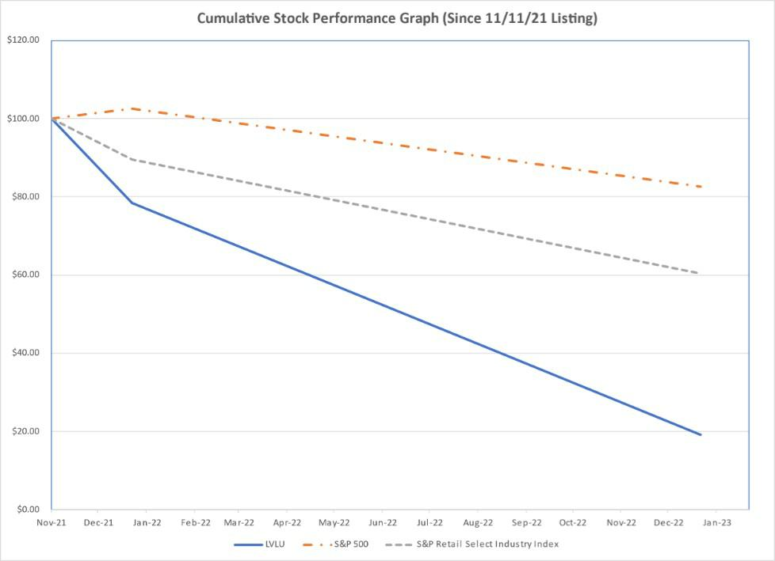

Company/Index |  | November 11, |  |  |  | January 2, |  |  | January 1,
 |  |  | 2021 |  |  | 2022 |  |  | 2023
Lulu's Fashion Lounge Holdings, Inc. |  | $ | 100.00 |  | $ | 78.33 |  | $ | 19.22
S&P 500 Index |  | $ | 100.00 |  | $ | 102.51 |  | $ | 82.58
S&P Retail Select Industry Index |  | $ | 100.00 |  | $ | 89.54 |  | $ | 60.37

Recent Sales of Unregistered Securities; Use of Proceeds from Registered Securities

Recent Sales of Unregistered Securities

None.

53

Table of Contents

Purchases of Equity Securities by the Issuer and Affiliated Purchasers

None.

54

Table of Contents

Item 6. [Reserved]

Item 7. Management’s Discussion and Analysis of Financial Condition and Results of Operations

You should read the following discussion and analysis of our financial condition and results of operations together with our consolidated financial statements and related notes included elsewhere in this Annual Report on Form 10-K. This discussion contains forward-looking statements based upon current plans, expectations and beliefs involving risks and uncertainties. Our actual results may differ materially from those anticipated in these forward-looking statements as a result of various factors, including those set forth in Part I, “Item 1A. Risk Factors” and other factors set forth in other parts of this Annual Report on Form 10-K. Discussion of the year-to-year comparisons between 2021 and 2020 can be found in “Management’s Discussion and Analysis of Financial Condition and Results of Operations” in Part II, Item 7 of the Company’s Annual Report on Form 10-K for the fiscal year ended January 2, 2022.

Overview

Lulus is a customer-driven, digitally-native fashion brand primarily serving a large, diverse community of Millennial and Gen Z women, who typically meet us in their 20s and stay with us through their 30s and beyond. We focus relentlessly on giving our customers what they want. We do this by using data coupled with human insight to deliver a curated and continuously evolving broad assortment of on-trend, affordable luxury fashion for many of life’s moments. Our customer obsession sets the tone for everything we do, from our personalized online shopping experience to our exceptional customer service.

Initial Public Offering

On November 10, 2021, our registration statement on Form S-1 relating to its IPO was declared effective by the SEC and the shares of its common stock began trading on the Nasdaq Global Market on November 11, 2021. The IPO closed on November 15, 2021, pursuant to which we issued and sold 5,750,000 shares of our common stock at a public offering price of $16.00 per share. On November 15, 2021, we received net proceeds of approximately $82.0 million from the IPO, after deducting underwriting discounts and commissions of approximately $6.1 million and other issuance costs of approximately $3.9 million. Immediately prior to the completion of the IPO, we filed an amended and restated certificate of incorporation, which authorized a total of 250,000,000 shares of common stock at $0.001 par value per share, and 10,000,000 shares of preferred stock, $0.001 par value per share. Immediately prior to the completion of the IPO, all shares of the Series A Preferred Stock then outstanding were converted into 15,000,000 shares of common stock. Additionally, 215,702 shares of common stock were issued to the LP immediately prior to the completion of the IPO. All shares of the Series B Preferred Stock and the Series B-1 Preferred Stock were redeemed and extinguished for a total payment of approximately $17.9 million on November 15, 2021.

Impact of the COVID-19 Pandemic

While there continues to be uncertainty related to the COVID-19 pandemic, we believe the significant impact of the pandemic on the demand for our product related to social distancing mandates, lockdowns, cancelled social events and travel has largely subsided. However, we are still susceptible to broader COVID-19 risks globally, especially in relation to our supply chain. We continue to take actions to anticipate changes in the business environment and supply chain pressures, including placing orders earlier than pre-pandemic times, leveraging our “test, learn and reorder” approach to test small order quantities and then graduate successful styles to our re-order algorithms and diversifying our supply chain network to mitigate rising costs and service delays. We have modified our business practices in response to the COVID-19 pandemic and plan to continue to take proactive measures.

We expect ongoing volatility in these trends as the continued impact from COVID-19 remains uncertain. We may take further actions that impact our business operations as may be required by federal, state, or local authorities or that we determine to be in the best interests of our employees and our customers. For additional discussion of risks related to the COVID-19 pandemic and the impact of the COVID-19 pandemic on our Company, see “Risk Factors—Risks Related to our Business—The COVID-19 pandemic has had and may in the future have an adverse effect on our labor workforce availability, supply chain, business, financial condition, cash flows, and results of operations in ways that remain unpredictable.”

55

Table of Contents

Impact of Macroeconomic Trends on Business

Changing macroeconomic factors, including inflation, interest rates, fuel prices, and overall consumer confidence with respect to current and future economic conditions have directly impacted our sales in fiscal 2022 as discretionary consumer spending levels and shopping behavior fluctuate with these factors. During fiscal 2022, we have responded to these factors by taking appropriate pricing, promotional and other actions to stimulate customer demand. These factors are expected to continue to have an impact on our business, results of operations, our growth and financial condition.

Historically, our business model has resulted in strong growth. Between fiscal years 2016 and 2019, we grew our net revenue by 179% to $370 million, or an annual compounded growth rate of 41%. In fiscal year 2020, our net revenue declined by 33% to $249 million as a result of the COVID-19 pandemic. In fiscal year 2021, our business rebounded from the initial impact of the pandemic on consumer behavior, and we grew our net revenue by 51% compared to 2020. Our sales growth slowed in fiscal year 2022 due to heightened macro-economic pressures, resulting in a 17% growth in net revenue compared to 2021.

Key Operating and Financial Metrics

We collect and analyze operating and financial data to assess the performance of our business and optimize resource allocation. The following table sets forth our key performance indicators for the periods presented (in thousands, except for percentages and Average Order Value).

 |  | 2022 |  | 2021 |  | 2020
Gross Margin |  | 43.5 % |  | 47.1 % |  | 44.4 %
Net income (loss) | $ | 3,725 | $ | 2,045 | $ | (19,304)
Adjusted EBITDA (1) | $ | 29,096 | $ | 41,406 | $ | 18,911
Adjusted EBITDA Margin (1) |  | 6.6 % |  | 11.0 % |  | 7.6 %
Active Customers (2) |  | 3,223 |  | 2,760 |  | 2,000
Average Order Value | $ | 131 | $ | 120 | $ | 106

- For a reconciliation of non-GAAP financial measures to the most directly comparable GAAP financial measure and why we consider them useful, see “Management’s Discussion and Analysis of Financial Condition and Results of Operations—Non-GAAP Financial Measures.”

- Active Customers count is based on de-duplication logic using customer account and guest checkout name, address, and email information. Active Customer count is as of the last day of the relevant period.

Active Customers

We define Active Customers as the number of customers who have made at least one purchase across our platform in the prior 12-month period. We consider the number of Active Customers to be a key performance metric on the basis that it is directly related to consumer awareness of our brand, our ability to attract visitors to our digital platform, and our ability to convert visitors to paying customers. Active Customers counts are based on de-duplication logic using customer account and guest checkout name, address, and email information.

Average Order Value

We define Average Order Value (“AOV”) as the sum of the total gross sales before returns across our platform in a given period, plus shipping revenue, less discounts and markdowns, divided by the Total Orders Placed in that period. AOV reflects average basket size of our customers. AOV may fluctuate as we continue investing in the development and introduction of new Lulus merchandise and as a result of our promotional discount activity.

Total Orders Placed

We define Total Orders Placed as the number of customer orders placed across our platform during a particular period. An order is counted on the day the customer places the order. We do not adjust the number of Total Orders Placed for any cancellation or return that may have occurred subsequent to a customer placing an order. We consider Total Orders Placed as a key performance metric on the

56

Table of Contents

basis that it is directly related to our ability to attract and retain customers as well as drive purchase frequency. Total Orders Placed, together with Average Order Value, is an indicator of the net revenue we expect to generate in a particular period.

Gross Margin

We define Gross Margin as gross profit as a percentage of our net revenue. Gross profit is equal to our net revenue less cost of revenue. Certain of our competitors and other retailers report cost of revenue differently than we do. As a result, the reporting of our gross profit and Gross Margin may not be comparable to other companies.

Non-GAAP Financial Measures

We report our financial results in accordance with accounting principles generally accepted in the United States of America (“GAAP”). However, management believes that certain non-GAAP financial measures provide investors of our financial information with additional useful information in evaluating our performance and that excluding certain items that may vary substantially in frequency and magnitude period-to-period from net income (loss) provides useful supplemental measures that assist in evaluating our ability to generate earnings and to more readily compare these metrics between past and future periods. These non-GAAP financial measures may be different than similarly titled measures used by other companies.

To supplement our audited consolidated financial statements which are prepared in accordance with GAAP, we use “Adjusted EBITDA”, “Adjusted EBITDA Margin” and “Net Debt” which are non-GAAP financial measures (collectively referred to as “Adjusted EBITDA”). Our non-GAAP financial measures should not be considered in isolation from, or as substitutes for, financial information prepared in accordance with GAAP. There are several limitations related to the use of our non-GAAP financial measures as compared to the closest comparable GAAP measures. Some of these limitations include:

- Adjusted EBITDA does not reflect our cash expenditures, or future requirements for capital expenditures or contractual commitments;

- Adjusted EBITDA does not reflect changes in, or cash requirements for, our working capital needs;

- Adjusted EBITDA does not reflect the interest expense, or the cash requirements necessary to service interest or principal payments on our debt;

- Adjusted EBITDA does not reflect our tax expense or the cash requirements to pay our taxes;

- although depreciation and amortization are non-cash charges, the assets being depreciated and amortized will often have to be replaced in the future and such measures do not reflect any cash requirements for such replacements;

- Net Debt subtracts cash and cash equivalents and therefore may imply that there is less Company debt than the most comparable GAAP measure indicates; and

- other companies in our industry may calculate such measures differently than we do, limiting their usefulness as comparative measures.

Due to these limitations, Adjusted EBITDA, Adjusted EBITDA margin, and Net Debt should not be considered as measures of discretionary cash available to us to invest in the growth of our business. We compensate for these limitations by relying primarily on our GAAP results and using these non-GAAP measures only supplementally. As noted in the table below, Adjusted EBITDA includes adjustments to exclude the impact of depreciation and amortization, interest expense, income taxes, management fees, transaction fees, which represent the write-off of offering costs deferred during 2019 upon abandonment of a prior offering in 2020, and equity-based compensation. It is reasonable to expect that some of these items will occur in future periods. However, we believe these adjustments are appropriate because the amounts recognized can vary significantly from period to period, do not directly relate to the ongoing operations of our business and may complicate comparisons of our internal results of operations and results of operations of other companies over time. In addition, Adjusted EBITDA includes adjustments for other items that we do not expect to regularly record. Each of the normal recurring adjustments and other adjustments described in this paragraph and in the following reconciliation table

57

Table of Contents

help management with a measure of our core operating performance over time by removing items that are not related to day-to-day operations. Adjusted EBITDA Margin is a non-GAAP financial measure that we calculate as Adjusted EBITDA (as defined above) as a percentage of our net revenue.

The following table provides a reconciliation for Adjusted EBITDA and Adjusted EBITDA margin:

 |  | 2022 |  |  |  | 2021 |  |  |  | 2020
 |  |  |  |  |  | (in thousands)
Net income (loss) | $ | 3,725 |  |  | $ | 2,045 |  |  | $ | (19,304)
Depreciation and amortization |  | 4,134 |  |  |  | 2,828 |  |  |  | 3,216
Interest expense |  | 1,103 |  |  |  | 12,774 |  |  |  | 16,037
Loss on extinguishment of debt |  | — |  |  |  | 1,392 |  |  |  | —
Income tax provision (benefit) |  | 4,047 |  |  |  | 6,212 |  |  |  | (1,271)
Management fees (1) |  | — |  |  |  | 534 |  |  |  | 626
Write-off of previously capitalized transaction fees (2) |  | — |  |  |  | — |  |  |  | 1,950
Transaction fees (3) |  | — |  |  |  | 476 |  |  |  | —
Equity-based compensation expense (4) |  | 16,087 |  |  |  | 13,664 |  |  |  | 9,086
Equity-based compensation expense related to redeemable preferred stock
issuance (5) |  | — |  |  |  | 1,481 |  |  |  | 8,571
Adjusted EBITDA | $ | 29,096 |  |  | $ | 41,406 |  |  | $ | 18,911
Adjusted EBITDA Margin |  |  | % |  |  |  | %
Adjusted EBITDA Margin |  | 6.6 | % |  |  | 11.0 | % |  |  | 7.6 | %

- Represents management fees and expenses paid pursuant to the professional services agreement with H.I.G. and IVP for consulting and other services. All outstanding management fees were settled and the management agreement was terminated at the time of the Company’s IPO in 2021.

- Represents the write-off of offering costs deferred during 2019 upon abandonment of a prior offering in 2020.

- Represents costs related primarily to marketing and presentations for the investment community, as well as travel and other miscellaneous costs incurred as a result of the Company’s IPO.

- 2022 includes equity-based compensation expense for restricted stock units (“RSUs”) granted during the period, as well as equity-based awards granted in prior periods. 2021 includes equity-based compensation expense related to modifications and vesting of Class P unit awards, as well as stock options and special compensation awards granted during the period. 2020 includes equity-based compensation expense related to modifications and vesting of Class P unit awards.

- Represents the excess of fair value over the consideration paid for Series B Preferred Stock that was issued to an employee, H.I.G., and IVP in June 2020. In addition, represents the excess of fair value over the consideration paid for Series B-1 Preferred Stock that was issued to certain employees in March 2021.

58

Table of Contents

Net Debt

We define Net Debt as total debt, which includes short-term borrowings and long-term obligations, less cash and cash equivalents. We consider net debt to be an important supplemental measure of our financial position, which allows us to analyze our leverage.

A reconciliation of non-GAAP Net Debt as of January 1, 2023 and January 2, 2022 is as follows:

 |  | As of
 |  | January 1, 2023 |  |  | January 2, 2022
 |  | (in thousands)
Revolving line of credit, long term | $ | (25,000) |  | $ | (25,000)
Cash and cash equivalents |  | 10,219 |  |  | 11,402
Net Debt | $ | (14,781) |  | $ | (13,598)

Factors Affecting Our Performance

Our financial condition and results of operations have been, and will continue to be, affected by a number of factors that present significant opportunities for us but also pose risks and challenges, including what is discussed below. See “Risk Factors.”

Customer Acquisition

Our business performance depends in part on our continued ability to cost-effectively acquire new customers. We define customer acquisition cost (“CAC”) as our brand and performance marketing expenses attributable to acquiring new customers, including, but not limited to, agency costs and marketing team costs but excluding any applicable equity-based compensation, divided by the number of customers who placed their first order with us in a given period. As a digital brand, our marketing strategy is primarily focused on brand awareness marketing and digital advertising in channels like search, social, and programmatic – platforms that enable us to engage our customer where she spends her time, and in many cases also quickly track the success of our marketing, which allows us to adjust and optimize our marketing spend.

Customer Retention

Our continued success depends in part on our ability to retain and drive repeat purchases from our existing customers. We monitor retention across our entire customer base. Our goal is to attract and convert visitors into active customers and foster relationships that drive repeat purchases. During the trailing twelve months ended January 1, 2023, we served 3.2 million Active Customers compared to 2.8 million for the trailing 12 months ended January 2, 2022.

Inventory Management

We utilize a data-driven strategy that leverages our proprietary reorder algorithm to manage inventory as efficiently as possible. Our “test, learn, and reorder” approach consists of limited inventory purchases followed by the analysis of proprietary data including real-time transaction data and customer feedback, which then informs our selection and customization of popular merchandise prior to reordering in larger quantities. While our initial orders are limited in size and financial risk and our supplier partners are highly responsive, we nonetheless purchase inventory in anticipation of future demand and therefore are exposed to potential shifts in customer preferences and price sensitivity over time. As we continue to grow, we will adjust our inventory purchases to align with the current needs of the business.

Investment in Our Operations and Infrastructure

We will continue to invest in our operations and infrastructure to facilitate further growth of our business. While we expect our expenses to increase accordingly, we will harness the strength of our existing platform and our on-trend fashion expertise to make informed investment decisions. We intend to invest in headcount, inventory, fulfillment, logistics, and our software and data capabilities in order to improve our platform, expand into international markets, and drive operational efficiencies. We cannot guarantee that increased spending on these investments will be cost effective or result in future growth in our customer base. However, we set a high

59

Table of Contents

bar for approval of any capital spending initiative. We believe that our disciplined approach to capital spending will enable us to generate positive returns on our investments over the long term.

Components of Our Results of Operations

Net Revenue

Net revenue consists primarily of gross sales, net of merchandise returns and promotional discounts and markdowns, generated from the sale of apparel, footwear, and accessories. Net revenue excludes sales taxes assessed by governmental authorities. We recognize net revenue at the point in time when control of the ordered product is transferred to the customer, which we determine to have occurred upon shipment.

Net revenue is impacted by our number of customers and their spending habits, AOV, product assortment and availability, and marketing and promotional activities. During any given period, we may seek to increase sales by increasing promotional discounts, and in other periods we may instead seek to increase sales by increasing our selling and marketing expenses. We consider both actions together, so increased promotional discounts in a period, which would reduce net revenue accordingly in such period, might also result in lower selling and marketing expenses in such period. Similarly, if we increase selling and marketing expenses in a given period, promotional discounts may be correspondingly reduced, thereby improving net revenue.

Cost of Revenue and Gross Margin

Cost of revenue consists of the product costs of merchandise sold to customers; shipping and handling costs, including all inbound, outbound, and return shipping expenses; rent, insurance, business property tax, utilities, depreciation and amortization, and repairs and maintenance related to our distribution facilities; and charges related to inventory shrinkage, damages, and our allowance for excess or obsolete inventory. Cost of revenue is primarily driven by growth in orders placed by customers, the mix of the product available for sale on our site, and transportation costs related to inventory receipts from our suppliers. We expect our cost of revenue to fluctuate as a percentage of net revenue primarily due to how we manage our inventory and merchandise mix.

Gross profit is equal to our net revenue less cost of revenue. We calculate Gross Margin as gross profit as a percentage of our net revenue. Our Gross Margin varies across Lulus, exclusive to Lulus, and third-party branded products. Exclusive to Lulus consists of products that we develop with design partners and have exclusive rights to sell across our platform, but that do not bear the Lulus brand. Gross Margin on sales of Lulus and exclusive to Lulus merchandise is generally higher than Gross Margin on sales of third-party branded products, which we offer for customers to “round out” the shopping basket. As we continue to optimize our distribution capabilities and gain more negotiation leverage with suppliers as we scale, our Gross Margin may fluctuate from period to period depending on the interplay of these factors.

Selling and Marketing Expenses

Our selling and marketing expenses consist primarily of payment processing fees, advertising, targeted online performance marketing and customer order courtesy adjustments. Selling and marketing expenses also include our spend on brand marketing channels, including compensation and free clothing to social media influencers, events, and other forms of online and offline marketing related to growing and retaining the customer base. As discussed in “Net Revenue” above, in any given period, the amount of our selling and marketing expense can be affected by the use of promotional discounts in such period.

General and Administrative Expenses

General and administrative expenses consist primarily of payroll and benefits costs, including equity-based compensation for our employees involved in general corporate functions including finance, merchandising, marketing, and technology, as well as costs associated with the use by these functions of facilities and equipment, including depreciation, rent, and other occupancy expenses. General and administrative expenses are primarily driven by increases in headcount required to support business growth and meeting our obligations as a public company.

Since our IPO, we have incurred significant legal, accounting, and other expenses that we did not incur as a private company. We expect that compliance with the Sarbanes-Oxley Act and the Dodd-Frank Wall Street Reform and Consumer Protection Act, as well as

60

Table of Contents

rules and regulations subsequently implemented by the SEC, will increase our legal and financial compliance costs and will make some activities more time consuming and costly.

Other Income (Expense), Net

Other income (expense), net consists primarily of interest expense and other miscellaneous income.

(Provision) Benefit for Income Taxes

The (provision) benefit for income taxes represents federal, state, and local income taxes. The effective rate differs from the statutory rate primarily due to non-deductible equity-based compensation expenses and state taxes. Our effective tax rate will change from quarter to quarter based on recurring and nonrecurring factors including, but not limited to, the geographical mix of earnings, enacted tax legislation, state and local income taxes, the impact of permanent tax adjustments, and the interaction of various tax strategies.

Our Results of Operations

The following tables set forth our consolidated results of operations for the years presented and as a percentage of net revenue:

 |  |  |  | 2022 |  |  | 2021 |  | Percentage Change |  |  |  | 2020
 |  |  |  | 2022 |  |  | 2021 |  | 2022 VS 2021 |  |  |  | 2020
 |  |  |  |  |  |  | (in |  | thousands)
 | Net revenue | $ |  | 439,652 | $ |  | 375,625 |  | 17 % |  | $ |  | 248,656
 | Cost of revenue |  |  | 248,206 |  |  | 198,893 |  | 25 |  |  |  | 138,364
 | Gross profit |  |  | 191,446 |  |  | 176,732 |  | 8 |  |  |  | 110,292
 | Selling and marketing expenses |  |  | 83,559 |  |  | 66,684 |  | 25 |  |  |  | 47,812
 | General and administrative expenses |  |  | 99,148 |  |  | 87,710 |  | 13 |  |  |  | 67,155
 | Income (loss) from operations |  |  | 8,739 |  |  | 22,338 |  | (61) |  |  |  | (4,675)
 | Other income (expense), net:
 | Interest expense |  |  | (1,103) |  |  | (12,774) |  | (91) |  |  |  | (16,037)
 | Loss on extinguishment of debt |  |  | — |  |  | (1,392) |  | (100) |  |  |  | —
 | Other income, net |  |  | 136 |  |  | 85 |  | 60 |  |  |  | 137
 | Total other expense, net |  |  | (967) |  |  | (14,081) |  | (93) |  |  |  | (15,900)
 | Income (loss) before income taxes |  |  | 7,772 |  |  | 8,257 |  | (6) |  |  |  | (20,575)
 | Income tax (provision) benefit |  |  | (4,047) |  |  | (6,212) |  | (35) |  |  |  | 1,271
Net income (loss) |  |  | $ | 3,725 |  | $ | 2,045 |  | 82 % |  |  | $ | (19,304)

61

Table of Contents

2022 |  |  |  | 2021 |  | 2020
Net revenue |  | 100 | % | 100 | % | 100 | %
Cost of revenue |  | 56 |  | 53 |  | 56
Gross profit |  | 44 |  | 47 |  | 44
Selling and marketing expenses |  | 19 |  | 18 |  | 19
General and administrative expenses |  | 23 |  | 23 |  | 27
Income (loss) from operations |  | 2 |  | 6 |  | (2)
Other income (expense), net:
Interest expense |  | — |  | (3) |  | (6)
Loss on extinguishment of debt |  | — |  | — |  | —
Other income, net |  | — |  | — |  | —
Total other expense, net |  | — |  | (3) |  | (6)
Income (loss) before income taxes |  | 2 |  | 3 |  | (8)
Income tax (provision) benefit |  | (1) |  | (2) |  | —
Net income (loss) |  | 1 % |  | 1 % |  | (8)%

Comparisons for the Fiscal Years Ended January 1, 2023 and January 2, 2022

Net Revenue

Net revenue increased in 2022 by $64.0 million, or 17%, compared to 2021. The increase in revenue was primarily due to 17% increase in Active Customers, 16% increase in Total Orders Placed and 9% increase in Average Order Value. The higher revenue was partially offset by higher sales returns, markdowns and promotional discounts compared to 2021.

Cost of Revenue

Cost of revenue increased in 2022 by $49.3 million, or 25%, compared to 2021, primarily due to the increase in our net revenue. Additionally, there were sales mix shifts into higher product cost categories, higher outbound and returned product shipping costs, as well as the impact of higher depreciation and allocated facility costs related to our Southern California distribution facility that was not in place until late 2021.

Selling and Marketing Expenses

Selling and marketing expenses increased in 2022 by $16.9 million, or 25% compared to 2021. There was a $14.2 million increase in online marketing expenses to acquire new customers and retain existing customers compared to 2021. In addition, merchant processing fees increased by $2.7 million in 2022 compared to the same period of the prior year largely due to the increase in net revenue coupled with higher merchant fee rates.

General and Administrative Expenses

General and administrative expenses increased by $11.4 million in 2022, or 13%, compared to 2021. The increase was primarily due to a $3.3 million increase in variable labor costs, which increased by 15% from 2021 to 2022 and was in line with our increase in net revenue. Additionally, fixed labor costs increased by $2.0 million primarily due to higher base wages and health insurance which were partially offset by lower bonus expenses. There was higher equity-based compensation expense of $0.9 million related to equity-based awards during 2022 due to an increase of $2.9 million in equity-based compensation expense and an additional $0.5 million of expense related to Executive Chairman liability-classified awards, offset by a decrease of $1.5 million in equity-based compensation expense related to redeemable preferred stock issuance and a decrease of $1.0 million in CEO special compensation awards expense. In

62

Table of Contents

addition, there was a $4.5 million increase in insurance costs and professional services, which was primarily driven by a $3.2 million increase in director and officer insurance costs associated with being a public company. There was also an increase of $1.1 million in hardware, software and supplies. These increases were partially offset by a $0.4 million reduction in other expenses, primarily comprised of management fees that were eliminated at the time of our IPO in November 2021.

Interest Expense

Interest expense decreased significantly in 2022 by $11.7 million, or 91%, compared to 2021. The decrease is attributable to the repayment of our Term Loan with the proceeds from our IPO in November 2021, which was partially offset by interest expense and unused fees related to the New Revolving Facility, under which $25.0 million of borrowings remained outstanding as of January 1, 2023.

Income Tax Provision

Our income tax provision in 2022 decreased by $2.2 million, or 35%, to $4.0 million, from $6.2 million in 2021. The decrease in the income tax provision was primarily due to an increase in non-deductible equity-based compensation expenses and non-deductible officer compensation.

Quarterly Trends and Seasonality

We experience moderate seasonal fluctuations in aggregate sales volume during the year. Seasonality in our business does not follow that of traditional retailers, such as a typical concentration of revenue in the holiday quarter. Our quarterly net revenue in 2021 was most highly concentrated outside of the fourth fiscal quarter. In 2021, we saw our highest net revenue in the second and third fiscal quarters compared to the rest of the year as customers purchased dresses and event wear for special occasions that had been postponed during the height of the COVID-19 pandemic. Our quarterly net revenue in 2022 reflected the highest concentrations in the first and second fiscal quarters compared to the rest of the year, as customer demand remained strong for dresses and event wear, carrying forward the trend seen in 2021 with the resurgence of events and special occasions. The third and fourth fiscal quarters of 2022 were impacted by a worse macroeconomic environment where consumers generally lowered their spending levels and sought higher levels of promotions and discounts.

Our quarterly gross profit fluctuates primarily based on how we manage our inventory and merchandise mix and has typically been in line with fluctuations in net revenue. When quarterly gross profit fluctuations have been unfavorable relative to the fluctuations in sales, these situations have been driven by non-recurring, external factors, such as the COVID-19 pandemic and the ensuing macroeconomic slowdown that began in mid-2022. We saw strong demand and favorable gross profits, with very limited promotions and discounts, during 2021 and the first half of 2022, largely due to the increase in demand for event and occasion wear. During the second half of 2022, we successfully utilized increased promotional discounts and markdowns to optimize our inventory mix and quantities and stimulate customer demand, which was negatively impacted by macroeconomic conditions, such as inflation and higher fuel prices.

Selling and marketing expenses generally fluctuate with net revenue. Further, in any given period, the amount of our selling and marketing expense can be affected by the use of promotional discounts in such period. In addition, we may increase or decrease marketing spend to assist with optimizing inventory mix and quantities.

General and administrative expenses consist primarily of payroll and benefit costs and vary quarter to quarter due to changes in the number of seasonal workers to meet demand based on our seasonality.

Liquidity and Capital Resources

Our primary sources of liquidity and capital resources are cash generated from operating activities and borrowings under our New Revolving Facility. Our primary requirements for liquidity and capital are inventory purchases, payroll and general operating expenses, capital expenditures associated with distribution, network expansion and capitalized software and debt service requirements. Our corporate banking relationship is with Bank of America.

63

Table of Contents

Credit Facilities

During November 2021, we entered into a Credit Agreement with Bank of America to provide a revolving facility that provides for borrowings up to $50.0 million. During the term of the Credit Agreement, we may increase the aggregate amount of the New Revolving Facility up to an additional $25.0 million (for maximum aggregate lender commitments of up to $75.0 million), subject to the satisfaction of certain conditions under the Credit Agreement, including obtaining the consent of the administrative agent and an increased commitment from existing or new lenders. In addition, the Credit Agreement may be used to issue letters of credit up to $7.5 million (the “Letter of Credit”). During 2022, we borrowed $30.0 million under the New Revolving Facility and repaid $30.0 million of the outstanding balance. As of January 1, 2023, we had $25.0 million outstanding under the New Revolving Facility and had utilized $0.3 million under the Letter of Credit. As of January 1, 2023, we had $24.7 million available for borrowing under the New Revolving Facility and $7.2 million available to issue letters of credit.

The New Revolving Facility matures three years after November 15, 2021, and borrowings thereunder will accrue interest at a rate equal to, at our option, either (x) the term SOFR rate, plus the applicable SOFR adjustment plus a margin of 1.75% per annum or (y) the base rate plus a margin of 0.75% (with the base rate being the highest of the federal funds rate plus 0.50%, the prime rate and term SOFR for a period of one month plus 1.00%). The New Revolving Facility contains a financial maintenance covenant requiring a maximum total leverage ratio of no more than 2.50:1.00, stepping down to 2.00:1.00 after 18 months. A commitment fee of 37.5 basis points will be assessed on unused commitments under the New Revolving Facility.

Availability and Use of Cash

As of January 1, 2023, we had cash and cash equivalents of $10.2 million and no restricted cash. We believe that our cash and cash equivalents, cash flows from operating activities and the available borrowings under our New Revolving Facility, will be sufficient to meet our capital expenditures, working capital needs and debt repayments for at least the next 12 months from the date of this Annual Report on Form 10-K. However, we cannot ensure that our business will generate sufficient cash flow from operating activities or that future borrowings will be available under our borrowing agreements in amounts sufficient to pay indebtedness or fund other working capital needs. Actual results of operations will depend on numerous factors, many of which are beyond our control as further discussed in Part I, “Item 1A. Risk Factors” included elsewhere in this Annual Report on Form 10-K.

Cash Flow Analysis

The following table summarizes our cash flows for the periods indicated:

 |  |  | 2022 |  |  | 2021 |  |  | 2020
 |  |  |  |  |  | (in thousands)
Net cash provided by (used in):
Operating activities | $ |  | 6,199 | $ |  | 26,896 | $ |  | 4,856
Investing activities |  |  | (5,123) |  |  | (3,394) |  |  | (1,913)
Financing activities |  |  | (2,765) |  |  | (27,653) |  |  | 6,755
Net (decrease) increase in cash, cash equivalents and restricted cash |  | $ | (1,689) |  | $ | (4,151) |  | $ | 9,698

Operating Activities

During 2022, net cash provided by operating activities was $6.2 million after net income of $3.7 million was adjusted for certain non-cash items, including depreciation and amortization, non-cash lease expense, amortization of debt discount and debt issuance costs, equity-based compensation, deferred taxes and the effect of changes in working capital and other activities.

In 2022, net cash provided by operating activities decreased $20.7 million from $26.9 million in 2021 to $6.2 million in 2022. The changes in cash provided was primarily driven by an increase of $1.7 million due to an increase in net income from $2.0 million in 2021 to net income of $3.7 million in 2022, a decrease of $29.5 million related to changes in our operating assets and liabilities and an increase of $7.1 million of non-cash items. The decrease of $29.5 million was due to changes in our operating assets and liabilities from a net increase of $6.6 million in 2021 to net decrease of $22.9 million in 2022. This was primarily driven by a $19.6 million decrease in accrued expenses and other current liabilities, $15.7 million increase in inventory balances, $6.5 million increase in income tax receivable and a $2.6 million decrease in operating lease liabilities; these were partially offset by $4.0 million increase in accounts

64

Table of Contents

payable, $3.4 million increase in prepaid and other current assets, $3.5 million decrease in accounts receivable, $2.6 million decrease in assets for recovery, and a $1.4 million decrease in other non-current liabilities. In addition, the increase of $7.1 million of non-cash items was from a net increase of $18.3 million in 2021 to a net increase of $25.4 million in 2022. This was primarily driven by $3.8 million less payments in interest capitalized to principal of long term debt and revolving line of credit, $3.4 million increase in deferred income taxes, $3.3 million increase in non-cash lease expense as a result of the adoption of Financial Accounting Standards Board Accounting Standards Codification 842, Leases (“ASC 842”) in 2022, $1.3 million increase in depreciation and amortization and an increase of $0.9 million in non-cash equity-based compensation expenses due to increase in non-cash equity-based compensation expense including employee and Executive Chairman equity-based compensation grants, which were partially offset by reductions in equity-based compensation expense related to CEO special compensation awards and redeemable preferred stock issuance. These increases in non-cash expenses were offset by reductions associated with the payoff of our long-term debt in 2021, including decreases of $2.1 million of amortization of debt discount and debt issuance costs, $2.1 million of interest capitalized to principal of long-term debt and revolving line of credit, and $1.4 million of loss on debt extinguishment.

Investing Activities

Our primary investing activities have consisted of purchases of equipment to support our overall business growth and internally developed software for the continued development of our proprietary technology infrastructure. Purchases of property and equipment may vary from period-to-period due to timing of the expansion of our operations. We have no material commitments for capital expenditures.

In 2022, net cash used in investing activities was $5.1 million, which was a $1.7 million increase from $3.4 million in 2021. This was attributable to capital expenditures related to the opening of our new distribution facility in Ontario, California, the relocation and opening of our new studio facility in Los Angeles, California, as well as equipment for our general operations, software and hardware purchases, and internally developed software.

Financing Activities

Financing activities consist primarily of borrowings and repayments related to our New Revolving Facility and Credit Facility, and issuance of common and preferred stock.

In 2022, net cash used in financing activities was $2.8 million, which was a decrease of $24.9 million from $27.7 million of net cash used in financing activities in 2021. This decrease was attributable primarily to a reduction of $110.1 million in repayments of long-term debt and debt issuance cost and a reduction of $16.5 million related to the net of redemption and issuance of redeemable preferred stock. This was offset by a reduction of $83.4 million of net proceeds from the IPO in 2021 and related offering costs, a $16.5 million decreases in proceeds (net of repayments) from our revolving line of credit facilities, $1.1 million of withholding tax payments related to vesting of RSUs, and a $0.8 million increase of finance lease payments primarily attributed to the robotics system at the Pennsylvania distribution center.

Contractual Obligations and Other Commitments

Our most significant contractual obligations relate to our New Revolving Facility and operating lease obligations on our distribution facilities and corporate offices. For information on our New Revolving Facility, see Note 5, Debt, and for information on our contractual obligations for operating leases, see Note 6, Leases, of the accompanying notes to our consolidated financial statements included elsewhere in this Annual Report on Form 10-K.

Critical Accounting Policies and Estimates

Our consolidated financial statements and the related notes thereto included elsewhere in this Annual Report on Form 10-K are prepared in accordance with GAAP. The preparation of consolidated financial statements requires us to make estimates and assumptions that affect the reported amounts of assets, liabilities, revenue, costs and expenses and related disclosures. We base our estimates on historical experience and on various other assumptions that we believe to be reasonable under the circumstances. Actual results could differ significantly from our estimates. To the extent that there are differences between our estimates and actual results, our future financial statement presentation, financial condition, results of operations and cash flows will be affected.

65

Table of Contents

We believe that the assumptions and estimates associated with revenue recognition, equity-based compensation, and income taxes have the greatest potential impact on our consolidated financial statements. Therefore, we consider these to be our critical accounting policies and estimates. For further information on all of our significant accounting policies, please see Note 2, Significant Accounting Policies, of the accompanying notes to our consolidated financial statements included elsewhere in this Annual Report on Form 10-K.

Revenue Recognition

While our revenue recognition does not involve significant judgment, it represents an important accounting policy. We generate revenue from the sale of merchandise products sold directly to end customers. We recognize revenue when the product is transferred to the customer, which is generally upon shipment. We estimate a reserve of future returns based on historical return rates. There is judgment in utilizing historical trends for estimating future returns. Our refund liability for sales returns is included in returns reserve on the consolidated balance sheets and represents the expected value of the refund that will be due to our customers.

Leases

On January 3, 2022, we adopted ASC 842. We elected the practical expedient package, which among other practical expedients, includes the option to retain the historical classification of leases entered into prior to January 3, 2022, and allows entities to recognize lease payments on a straight-line basis over the lease term for leases with a term of 12 months or less. We also elected the practical expedient to combine lease and non-lease components. We determine if an arrangement contains a lease at inception based on whether the Company has the right to control the asset during the contract period and other facts and circumstances.

We are the lessee in a lease contract when we obtain the right to control the asset. Operating leases are included in lease right-of-use ("ROU") assets, lease liabilities, current and lease liabilities, noncurrent in our consolidated balance sheets. ROU assets represent our right to use an underlying asset for the lease term, and lease liabilities represent our obligation to make lease payments arising from the lease. Lease liabilities are recognized based on the present value of the future minimum lease payments over the lease term at lease inception or modification, with ROU assets recorded based on the corresponding lease liability at lease inception or modification adjusted for payments made to the lessor at or before the lease commencement date, initial direct costs incurred and any tenant incentives allowed for under the lease. We determine the lease term by assuming the exercise of renewal options that are reasonably certain. As most of our leases do not provide an implicit interest rate, we use our incremental borrowing rate (“IBR”) to determine the present value of lease payments. The determination of the IBR requires judgment and is primarily based on publicly-available information for companies within similar industries and with similar credit profiles. We adjust the rate for the impact of collateralization, the lease term and other specific terms included in each lease arrangement. The IBR is determined at the lease commencement and is subsequently reassessed upon a modification to the lease arrangement. Refer to Note 6, Leases, of the accompanying notes to our consolidated financial statements included elsewhere in this Annual Report on Form 10-K.

Equity-Based Compensation

Equity-based compensation is measured at the grant date or modification date (“measurement date”) for all equity-based awards made to employees and nonemployees based on the estimated fair value of the awards. Equity-based compensation expense is recognized on a straight-line basis over the period the employee or non-employee is required to provide service in exchange for the award, which is generally the vesting period. We recognize forfeitures as they occur.

Under an employment agreement entered into with Mr. McCreight in 2021 and subject to ongoing employment, and in light of the closing of the IPO, Mr. McCreight will receive two bonuses to settled in fully-vested shares of our common stock equal to $3.0 million each ($6.0 million in aggregate) on March 31, 2022 and March 31, 2023. We initially concluded that the two bonuses were liability-classified upon issuance. Upon the completion of the IPO, the two bonuses became equity-classified as they no longer met the criteria for liability classification and $2.9 million was reclassified from accrued expenses and other current liabilities and other noncurrent liabilities to additional paid-in capital in 2021. Under a new employment agreement with Mr. McCreight signed in November 2022, reflecting his new role as Executive Chairman, which became effective on the Effective Date, Mr. McCreight will receive two bonuses equal to $2.0 million and $1.0 million in March 2023 and March 2024, respectively, which will be settled in RSUs that vest in 4 and 2 quarterly installments from March 2023 and March 2024, respectively, through December 2023 and June 2024, respectively. We concluded that the two bonuses were liability-classified upon issuance in November 2022.

66

Table of Contents

The fair value of grants of restricted stock or restricted stock units is based on the fair value of our common stock underlying the award on the measurement date. For stock option awards, we apply the Black-Scholes option pricing model to determine the fair value. The model utilizes the estimated per share fair value of our underlying common stock at the measurement date, the expected or contractual term of the option, the expected stock price volatility, risk-free interest rates, and the expected dividend yield of the common stock.

We base estimates of expected volatility on the historical volatility of comparable companies from a representative peer group selected based on industry, financial, and market capitalization data.

Determining the grant date fair value of options using the Black-Scholes option pricing model requires us to make assumptions and judgments. These estimates involve inherent uncertainties and, if different assumptions had been used, stock-based compensation expense could have been materially different from the amounts recorded.

Income Taxes

We compute our provision for income taxes using the asset and liability method, under which deferred tax assets and liabilities are recognized for the expected future tax consequences of temporary differences between the financial reporting and tax bases of assets and liabilities and for operating losses and tax credit carryforwards. Deferred tax assets and liabilities are measured using the currently enacted tax rates that apply to taxable income in effect for the years in which they are expected to be realized or settled.

Deferred tax assets are evaluated for future realization and reduced by a valuation allowance to the amount that is more likely than not to be realized. We consider many factors when assessing the likelihood of future realization, including our recent cumulative loss, earnings expectations in earlier future years, and other relevant factors. We believe that it is more likely than not that forecasted income, together with future reversals of existing taxable temporary differences and results of recent operations, will be sufficient to fully recover the deferred tax assets. In the event that the Company determines all or part of the net deferred tax assets are not realizable in the future, the Company would record a valuation allowance.

Recent Accounting Pronouncements

See Note 2, Significant Accounting Policies—Recently Issued Accounting Pronouncements, of the accompanying notes to our consolidated financial statements included elsewhere in this Annual Report on Form 10-K for more information about recent accounting pronouncements, the timing of their adoption, and our assessment, to the extent we have made one, of their potential impact on our financial position and our results of operations.

JOBS Act Accounting Election

We are an “emerging growth company,” as defined in the JOBS Act. Under the JOBS Act, emerging growth companies can delay adopting new or revised accounting standards until such time as those standards apply to private companies. We have elected to use this extended transition period until we are no longer an emerging growth company or until we affirmatively and irrevocably opt out of the extended transition period. Accordingly, our consolidated financial statements and our unaudited interim consolidated financial statements may not be comparable to companies that comply with new or revised accounting pronouncements as of public company effective dates.

Item 7A. Quantitative and Qualitative Disclosures About Market Risk.

Our operations are solely based within the United States and the majority of our sales are within the United States. We are exposed to market risks in the ordinary course of our business, including the effects of foreign currency fluctuations, interest rate changes and inflation. Information relating to quantitative and qualitative disclosures about these market risks is set forth below.

Interest Rate Sensitivity

Cash and cash equivalents are held primarily in money market funds and cash deposits. The fair value of our cash and cash equivalents would not be significantly affected by either an increase or decrease in interest rates due mainly to the short-term nature of these instruments. Interest on any borrowings incurred pursuant to our New Revolving Facility accrue at a floating rate based on a

67

Table of Contents

formula tied to certain market rates at the time of incurrence; however, we do not expect that any change in prevailing interest rates will have a material impact on our results of operations.

Foreign Currency Risk

All of our sales and operating expenses are denominated in U.S. dollars, and therefore, our net revenue is not currently subject to foreign currency risk.

Inflation

We have experienced inflationary pressures in our supply chain and in our operating costs, as well as impacts related to our customers’ spending levels, which fluctuate with inflation. We continue to monitor the impact of inflation in order to minimize its effects through pricing strategies, productivity improvements and cost reductions. If our costs were to become subject to significant inflationary pressures, we may not be able to fully offset such higher costs through price increases. Our inability or failure to do so could harm our business, financial condition and results of operations.

68

Table of Contents
Item 8. Financial Statements and Supplementary Data.
 |  |  |  | LULU’S FASHION LOUNGE HOLDINGS, INC.
 |  |  | INDEX TO CONSOLIDATED FINANCIAL STATEMENTS
 |  |  |  |  |  |  |  |  |  |  | Page
Report of Independent Registered Public Accounting Firm (PCAOB ID No. 34) |  |  |  |  |  |  |  |  |  |  | 70
Financial Statements:
Consolidated Balance Sheets as of January 1, 2023 and January 2, 2022 |  |  |  |  |  |  |  |  |  |  | 71
Consolidated Statements of Operations and Comprehensive Income (Loss) for the fiscal years ended January 1, 2023, January 2, 2022,
 | and January 3, 2021 |  |  |  |  |  |  |  |  |  | 72
Consolidated Statements of Redeemable Preferred Stock, Convertible Preferred Stock and Stockholders’ Equity (Deficit) for the fiscal
 | years ended January 1, 2023, January 2, 2022, and January 3, 2021 |  |  |  |  |  |  |  |  |  | 73
Consolidated Statements of Cash Flows for the fiscal years ended January 1, 2023, January 2, 2022, and January 3, 2021 |  |  |  |  |  |  |  |  |  |  | 74
Notes to Consolidated Financial Statements |  |  |  |  |  |  |  |  |  |  | 76

69

Table of Contents

REPORT OF INDEPENDENT REGISTERED PUBLIC ACCOUNTING FIRM

To the stockholders and the Board of Directors of Lulu’s Fashion Lounge Holdings, Inc.

Opinion on the Financial Statements

We have audited the accompanying consolidated balance sheets of Lulu’s Fashion Lounge Holdings, Inc. and subsidiaries (the "Company") as of January 1, 2023 and January 2, 2022, the related consolidated statements of operations and comprehensive income (loss), redeemable preferred stock, convertible preferred stock and stockholders’ equity (deficit), and cash flows, for each of the three years in the period ended January 1, 2023, and the related notes (collectively referred to as the "financial statements"). In our opinion, the financial statements present fairly, in all material respects, the financial position of the Company as of January 1, 2023 and January 2, 2022, and the results of its operations and its cash flows for each of the three years in the period ended January 1, 2023, in conformity with accounting principles generally accepted in the United States of America.

Basis for Opinion

These financial statements are the responsibility of the Company's management. Our responsibility is to express an opinion on the Company's financial statements based on our audits. We are a public accounting firm registered with the Public Company Accounting Oversight Board (United States) (PCAOB) and are required to be independent with respect to the Company in accordance with the U.S. federal securities laws and the applicable rules and regulations of the Securities and Exchange Commission and the PCAOB.

We conducted our audits in accordance with the standards of the PCAOB. Those standards require that we plan and perform the audit to obtain reasonable assurance about whether the financial statements are free of material misstatement, whether due to error or fraud. The Company is not required to have, nor were we engaged to perform, an audit of its internal control over financial reporting. As part of our audits, we are required to obtain an understanding of internal control over financial reporting but not for the purpose of expressing an opinion on the effectiveness of the Company’s internal control over financial reporting. Accordingly, we express no such opinion.

Our audits included performing procedures to assess the risks of material misstatement of the financial statements, whether due to error or fraud, and performing procedures that respond to those risks. Such procedures included examining, on a test basis, evidence regarding the amounts and disclosures in the financial statements. Our audits also included evaluating the accounting principles used and significant estimates made by management, as well as evaluating the overall presentation of the financial statements. We believe that our audits provide a reasonable basis for our opinion.

/s/ Deloitte & Touche LLP

San Francisco, California

March 14, 2023

We have served as the Company's auditor since 2017.

70

Table of Contents

LULU’S FASHION LOUNGE HOLDINGS, INC.

Consolidated Balance Sheets

(in thousands, except share and per share amounts)

 |  |  |  | January 1, |  |  | January 2,
 |  |  |  | 2023 |  |  | 2022
 | Assets
 | Current assets:
 | Cash and cash equivalents | $ |  | 10,219 | $ |  | 11,402
 | Accounts receivable |  |  | 3,908 |  |  | 5,649
 | Inventory, net |  |  | 43,186 |  |  | 22,176
 | Assets for recovery |  |  | 3,890 |  |  | 3,754
 | Income tax refund receivable |  |  | 4,078 |  |  | 748
 | Prepaids and other current assets |  |  | 3,738 |  |  | 5,364
 | Total current assets |  |  | 69,019 |  |  | 49,093
 | Restricted cash |  |  | — |  |  | 506
 | Property and equipment, net |  |  | 4,391 |  |  | 3,231
 | Goodwill |  |  | 35,430 |  |  | 35,430
 | Tradename |  |  | 18,509 |  |  | 18,509
 | Intangible assets, net |  |  | 3,090 |  |  | 2,244
 | Lease right-of-use assets |  |  | 32,514 |  |  | —
 | Other noncurrent assets |  |  | 4,251 |  |  | 4,763
 | Total assets |  | $ | 167,204 |  | $ | 113,776
 | Liabilities and Stockholders' Equity
 | Current liabilities:
 | Accounts payable | $ |  | 5,320 | $ |  | 4,227
 | Accrued expenses and other current liabilities |  |  | 17,976 |  |  | 21,948
 | Returns reserve |  |  | 9,066 |  |  | 9,731
 | Stored-value card liability |  |  | 10,828 |  |  | 7,240
 | Lease liabilities, current |  |  | 4,456 |  |  | —
 | Total current liabilities |  |  | 47,646 |  |  | 43,146
 | Revolving line of credit |  |  | 25,000 |  |  | 25,000
 | Lease liabilities, noncurrent |  |  | 29,042 |  |  | —
 | Other noncurrent liabilities |  |  | 623 |  |  | 1,108
 | Total liabilities |  |  | 102,311 |  |  | 69,254
 | Commitments and Contingencies (Note 7)
 | Stockholders' equity:
 | Preferred stock: $0.001 par value, 10,000,000 shares authorized, and no shares issued or outstanding |  |  | — |  |  | —
 | Common stock: $0.001 par value, 250,000,000 shares authorized; and 39,259,328 and 38,421,124 shares issued and
 | outstanding as of January 1, 2023 and January 2, 2022, respectively |  |  | 39 |  |  | 38
 | Additional paid-in capital |  |  | 238,725 |  |  | 222,080
 | Accumulated deficit |  |  | (173,871) |  |  | (177,596)
 | Total stockholders' equity |  |  | 64,893 |  |  | 44,522
 | Total liabilities and stockholders' equity |  | $ | 167,204 |  | $ | 113,776

The accompanying notes are an integral part of the consolidated financial statements.

71

Table of Contents

LULU’S FASHION LOUNGE HOLDINGS, INC.

Consolidated Statements of Operations and Comprehensive Income (Loss)

(in thousands, except share and per share amounts)

 |  |  |  |  | Fiscal Years Ended
 |  |  | January 1, |  |  | January 2, |  |  | January 3,
 |  |  | 2023 |  |  | 2022 |  |  | 2021
 |  |  | (52 weeks) |  |  | (52 weeks) |  |  | (53 weeks)
Net revenue |  | $ | 439,652 |  | $ | 375,625 |  | $ | 248,656
Cost of revenue |  |  | 248,206 |  |  | 198,893 |  |  | 138,364
Gross profit |  |  | 191,446 |  |  | 176,732 |  |  | 110,292
Selling and marketing expenses |  |  | 83,559 |  |  | 66,684 |  |  | 47,812
General and administrative expenses |  |  | 99,148 |  |  | 87,710 |  |  | 67,155
Income (loss) from operations |  |  | 8,739 |  |  | 22,338 |  |  | (4,675)
Other income (expense), net:
Interest expense |  |  | (1,103) |  |  | (12,774) |  |  | (16,037)
Loss on extinguishment of debt |  |  | — |  |  | (1,392) |  |  | —
Other income, net |  |  | 136 |  |  | 85 |  |  | 137
Total other expense, net |  |  | (967) |  |  | (14,081) |  |  | (15,900)
Income (loss) before (provision) benefit for income taxes |  |  | 7,772 |  |  | 8,257 |  |  | (20,575)
Income tax (provision) benefit |  |  | (4,047) |  |  | (6,212) |  |  | 1,271
Net income (loss) and comprehensive income (loss) |  |  | 3,725 |  |  | 2,045 |  |  | (19,304)
Deemed dividend to preferred stockholders |  |  | — |  |  | (122,962) |  |  | (504)
Stock dividend issued to LP |  |  | — |  |  | (3,451) |  |  | —
Deemed contribution from redemption of redeemable preferred stock |  |  | — |  |  | 1,420 |  |  | —
Net income (loss) attributable to common stockholders |  | $ | 3,725 |  | $ | (122,948) |  | $ | (19,808)
Net income (loss) per share attributable to common stockholders:
Basic | $ |  | 0.10 | $ |  | (6.08) | $ |  | (1.13)
Diluted |  | $ | 0.10 |  | $ | (6.08) |  | $ | (1.13)
Weighted average shares used to compute net income (loss) per share attributable
to common stockholders:
Basic |  |  | 38,583,854 |  |  | 20,229,675 |  |  | 17,462,283
Diluted
Diluted |  |  | 38,853,393 |  |  | 20,229,675 |  |  | 17,462,283

The accompanying notes are an integral part of the consolidated financial statements.

72

Table of Contents

LULU’S FASHION LOUNGE HOLDINGS, INC.

Consolidated Statements of Redeemable Preferred Stock, Convertible Preferred Stock and Stockholders’

Equity (Deficit)

(in thousands, except share amounts)

 |  |  |  |  |  |  |  |  |  |  |  |  |  |  |  |  |  |  |  | Additional |  |  |  |  |  |  | Total
 | Redeemable Preferred Stock |  |  |  |  |  | Convertible Preferred Stock |  |  |  |  |  |  | Common Stock |  |  |  |  |  | Paid-In |  | Accumulated |  |  |  | Stockholders'
 | Shares |  |  |  | Amount |  |  | Shares |  |  | Amount |  |  | Shares |  |  | Amount |  |  | Capital |  |  | Deficit |  |  | Equity (Deficit)
Balance as of December 29, 2019 | — |  |  | $ | — |  |  | 3,129,634 |  | $ | 117,038 |  |  | 17,462,283 |  | $ | 18 |  | $ | 2,040 |  | $ | (160,337) |  |  | $ | (158,279)
Series B redeemable preferred stock
issuance, net of issuance costs of $163 | 7,500,001 |  |  |  | 16,412 |  |  | — |  |  | — |  |  | — |  |  | — |  |  | (504) |  |  | — |  |  |  | (504)
Equity-based compensation expense | — |  |  |  | — |  |  | — |  |  | — |  |  | — |  |  | — |  |  | 9,086 |  |  | — |  |  |  | 9,086
Net loss and comprehensive loss | — |  |  |  | — |  |  | — |  |  | — |  |  | — |  |  | — |  |  | — |  |  | (19,304) |  |  |  | (19,304)
Balance as of January 3, 2021 | 7,500,001 |  |  |  | 16,412 |  |  | 3,129,634 |  |  | 117,038 |  |  | 17,462,283 |  |  | 18 |  |  | 10,622 |  |  | (179,641) |  |  |  | (169,001)
Series B-1 redeemable preferred stock
issuance, net of issuance costs of $23 | 1,450,000 |  |  |  | 2,908 |  |  | — |  |  | — |  |  | — |  |  | — |  |  | — |  |  | — |  |  |  | —
Issuance of common stock upon initial
public offering (IPO), net of underwriting
discounts and commissions and issuance
costs of $10,016 | — |  |  |  | — |  |  | — |  |  | — |  |  | 5,750,000 |  |  | 5 |  |  | 81,983 |  |  | — |  |  |  | 81,988
Deemed dividend to convertible preferred
stockholders upon the IPO | — |  |  |  | — |  |  | — |  |  | 122,962 |  |  | — |  |  | — |  |  | (122,962) |  |  | — |  |  |  | (122,962)
Conversion of convertible preferred stock to
common stock upon the IPO | — |  |  |  | — |  | (3,129,634) |  |  |  | (240,000) |  |  | 15,000,000 |  |  | 15 |  |  | 239,985 |  |  | — |  |  |  | 240,000
Redemption of redeemable preferred stock
upon the IPO | (8,950,001) |  |  |  | (19,320) |  |  | — |  |  | — |  |  | — |  |  | — |  |  | 1,420 |  |  | — |  |  |  | 1,420
Stock dividend for issuance of common
stock to LP upon the IPO | — |  |  |  | — |  |  | — |  |  | — |  |  | 215,702 |  |  | — |  |  | — |  |  | — |  |  |  | —
Reclassification of liability-classified CEO
award to equity-classified award | — |  |  |  | — |  |  | — |  |  | — |  |  | — |  |  | — |  |  | 2,887 |  |  | — |  |  |  | 2,887
Forfeiture of unvested restricted stock | — |  |  |  | — |  |  | — |  |  | — |  |  | (6,861) |  |  | — |  |  | — |  |  | — |  |  |  | —
Equity-based compensation | — |  |  |  | — |  |  | — |  |  | — |  |  | — |  |  | — |  |  | 8,145 |  |  | — |  |  |  | 8,145
Net income and comprehensive income | — |  |  |  | — |  |  | — |  |  | — |  |  | — |  |  | — |  |  | — |  |  | 2,045 |  |  |  | 2,045
Balance as of January 2, 2022 | — |  |  |  | — |  |  | — |  |  | — |  |  | 38,421,124 |  |  | 38 |  |  | 222,080 |  |  | (177,596) |  |  |  | 44,522
Issuance of common stock for vesting of
RSUs | — |  |  |  | — |  |  | — |  |  | — |  |  | 791,064 |  |  | 1 |  |  | (1) |  |  | — |  |  |  | —
Issuance of common stock for special
compensation award | — |  |  |  | — |  |  | — |  |  | — |  |  | 208,914 |  |  | — |  |  | — |  |  | — |  |  |  | —
Shares withheld for withholding tax on
RSUs | — |  |  |  | — |  |  | — |  |  | — |  |  | (139,081) |  |  | — |  |  | (1,200) |  |  | — |  |  |  | (1,200)
Offering costs related to IPO | — |  |  |  | — |  |  | — |  |  | — |  |  | — |  |  | — |  |  | (290) |  |  | — |  |  |  | (290)
Settlement of distributions payable to former
Class P unit holders | — |  |  |  | — |  |  | — |  |  | — |  |  | — |  |  | — |  |  | 2,648 |  |  | — |  |  |  | 2,648
Forfeited shares of restricted stock | — |  |  |  | — |  |  | — |  |  | — |  |  | (22,693) |  |  | — |  |  | — |  |  | — |  |  |  | —
Equity-based compensation expense | — |  |  |  | — |  |  | — |  |  | — |  |  | — |  |  | — |  |  | 15,488 |  |  | — |  |  |  | 15,488
Net income and comprehensive income | — |  |  |  | — |  |  | — |  |  | — |  |  | — |  |  | — |  |  | — |  |  | 3,725 |  |  |  | 3,725
Balance as of January 1, 2023 | — |  |  | $ | — |  |  | — |  | $ | — |  |  | 39,259,328 |  | $ | 39 |  | $ | 238,725 |  | $ | (173,871) |  |  | $ | 64,893

The accompanying notes are an integral part of the consolidated financial statements.

73

Table of Contents

LULU’S FASHION LOUNGE HOLDINGS, INC.

Consolidated Statements of Cash Flows

(in thousands)

 |  |  |  |  | Fiscal Years Ended
 |  |  |  | January 1, |  |  | January 2, |  |  |  | January 3,
 |  |  |  | 2023 |  |  | 2022 |  |  |  | 2021
 |  |  |  | (52 weeks) |  |  | (52 weeks) |  |  |  | (53 weeks)
 | Cash Flows from Operating Activities
 | Net income (loss) | $ |  | 3,725 | $ |  | 2,045 |  | $ |  | (19,304)
 | Adjustments to reconcile net income (loss) to net cash provided by operating activities:
 | Depreciation and amortization |  |  | 4,134 |  |  | 2,828 |  |  |  | 3,216
 | Noncash lease expense |  |  | 3,257 |  |  | — |  |  |  | —
 | Loss on debt extinguishment |  |  | — |  |  | 1,392 |  |  |  | —
 | Amortization of debt discount and debt issuance costs |  |  | 157 |  |  | 2,283 |  |  |  | 2,485
 | Interest expense capitalized to principal of long-term debt and revolving line of credit |  |  | — |  |  | 2,074 |  |  |  | 1,747
 | Payment of interest capitalized to principal of long-term debt and revolving line of credit |  |  | — |  |  | (3,821) |  |  |  | —
 | Equity-based compensation expense |  |  | 16,087 |  |  | 13,664 |  |  |  | 9,086
 | Equity-based compensation expense related to redeemable preferred stock issuance |  |  | — |  |  | 1,481 |  |  |  | 8,571
 | Write-off of deferred offering costs |  |  | — |  |  | — |  |  |  | 1,950
 | Deferred income taxes |  |  | 1,658 |  |  | (1,663) |  |  |  | (14)
 | Loss (gain) on disposal of property and equipment |  |  | 18 |  |  | 9 |  |  |  | (25)
 | Changes in operating assets and liabilities:
 | Accounts receivable |  |  | 1,740 |  |  | (1,816) |  |  |  | 123
 | Inventories |  |  | (21,010) |  |  | (5,281) |  |  |  | 9,242
 | Assets for recovery |  |  | (136) |  |  | (2,650) |  |  |  | 2,147
 | Income taxes (receivable) payable |  |  | (4,364) |  |  | 2,094 |  |  |  | (302)
 | Prepaid and other current assets |  |  | 694 |  |  | (2,721) |  |  |  | 339
 | Accounts payable |  |  | 1,148 |  |  | (2,895) |  |  |  | (3,702)
 | Accrued expenses and other current liabilities |  |  | 1,691 |  |  | 21,263 |  |  |  | (9,346)
 | Operating lease liabilities |  |  | (2,608) |  |  | — |  |  |  | —
 | Other noncurrent liabilities |  |  | 8 |  |  | (1,390) |  |  |  | (1,357)
 | Net cash provided by operating activities |  |  | 6,199 |  |  | 26,896 |  |  |  | 4,856
 | Cash Flows from Investing Activities
 | Capitalized software development costs |  |  | (2,500) |  |  | (1,522) |  |  |  | (1,273)
 | Purchases of property and equipment |  |  | (2,511) |  |  | (1,447) |  |  |  | (700)
 | Other |  |  | (112) |  |  | (425) |  |  |  | 60
 | Net cash used in investing activities |  |  | (5,123) |  |  | (3,394) |  |  |  | (1,913)
 | Cash Flows from Financing Activities
 | Proceeds from borrowings on revolving line of credit |  |  | 30,000 |  |  | 25,000 |  |  |  | 5,300
 | Repayments on revolving line of credit |  |  | (30,000) |  |  | (8,580) |  |  |  | (800)
 | Repayment of long-term debt |  |  | — |  |  | (109,608) |  |  |  | (2,531)
 | Payment of debt issuance costs |  |  | — |  |  | (514) |  |  |  | (437)
 | Issuance of common stock upon IPO, net of underwriting discounts and commissions and issuance costs |  |  | — |  |  | 82,546 |  |  |  | —
 | Proceeds from the issuance of redeemable preferred stock, net of issuance costs |  |  | — |  |  | 1,427 |  |  |  | 7,337
 | Redemption of redeemable preferred stock |  |  | — |  |  | (17,900) |  |  |  | —
 | Principal payments on finance lease obligations |  |  | (786) |  |  | — |  |  |  | —
 | Payment of offering costs related to the IPO |  |  | (832) |  |  | — |  |  |  | —
 | Advance from LP |  |  | — |  |  | — |  |  |  | 37
 | Repayment of advance from LP |  |  | — |  |  | — |  |  |  | (2,040)
 | Withholding tax payments related to vesting of RSUs |  |  | (1,115) |  |  | — |  |  |  | —
 | Other |  |  | (32) |  |  | (24) |  |  |  | (111)
 | Net cash (used in) provided by financing activities |  |  | (2,765) |  |  | (27,653) |  |  |  | 6,755
 | Net (decrease) increase in cash, cash equivalents and restricted cash |  |  | (1,689) |  |  | (4,151) |  |  |  | 9,698
 | Cash, cash equivalents and restricted cash at beginning of period |  |  | 11,908 |  |  | 16,059 |  |  |  | 6,361
Cash, cash equivalents and restricted cash at end of period |  |  | $ | 10,219 |  | $ | 11,908 |  |  | $ | 16,059
 | Reconciliation of cash, cash equivalents and restricted cash
 | Cash and cash equivalents | $ |  | 10,219 | $ |  | 11,402 |  | $ |  | 15,554
 | Restricted cash |  |  | — |  |  | 506 |  |  |  | 505
 | Total cash, cash equivalents and restricted cash at end of period |  | $ | 10,219 |  | $ | 11,908 |  |  | $ | 16,059

(Continued)

74

Table of Contents

LULU’S FASHION LOUNGE HOLDINGS, INC.

Consolidated Statements of Cash Flows

(in thousands)

 |  |  |  |  | Fiscal Years Ended
 |  |  |  | January 1, |  |  | January 2, |  |  |  | January 3,
 |  |  |  | 2023 |  |  | 2022 |  |  |  | 2021
 |  |  |  | (52 weeks) |  |  | (52 weeks) |  |  |  | (53 weeks)
 | Supplemental Disclosure
 | Cash paid for income taxes, net | $ |  | 6,436 | $ |  | 6,112 |  | $ |  | 171
 | Cash paid for interest | $ |  | 893 | $ |  | 8,555 |  | $ |  | 12,732
 | Supplemental Disclosure of Non-Cash Investing and Financing Activities
 | Addition of right-of-use assets, including prepaid rent, net of deferred rent recorded upon adoption of ASC 842 | $ |  | 28,018 | $ |  | — |  | $ |  | —
 | Addition of lease liabilities recorded upon adoption of ASC 842 | $ |  | 28,599 | $ |  | — |  | $ |  | —
 | Right-of-use assets acquired under operating lease obligations | $ |  | 2,299 | $ |  | — |  | $ |  | —
 | Remeasurement of operating lease right-of-use assets for lease modification | $ |  | 1,616 | $ |  | — |  | $ |  | —
 | Assets acquired under finance lease obligations | $ |  | 4,750 | $ |  | — |  | $ |  | —
 | Prepaid rent reclassified to lease right-of-use assets | $ |  | 381 | $ |  | — |  | $ |  | —
 | Purchases of property and equipment included in accounts payable and accrued expenses | $ |  | 259 | $ |  | 55 |  | $ |  | 94
 | Debt issuance costs included in accrued expenses | $ |  | — | $ |  | — |  | $ |  | 917
 | Deemed dividend to preferred stockholders | $ |  | — | $ |  | (122,962) |  | $ |  | 504
 | Paid-in-kind interest added to principal balance of long-term debt and revolving line of credit | $ |  | — | $ |  | 2,074 |  | $ |  | 1,747
 | Offering costs included in accrued expenses | $ |  | — | $ |  | 542 |  | $ |  | —
 | Deemed contribution from redemption of redeemable preferred stock | $ |  | — | $ |  | 1,420 |  | $ |  | —
 | Conversion of convertible preferred stock to common stock upon the IPO | $ |  | — | $ |  | 240,000 |  | $ |  | —
 | Reclassification of CEO special compensation award from a liability award to an equity award | $ |  | — | $ |  | 2,887 |  | $ |  | —
 |  |  |  |  |  |  |  |  |  |  | (Concluded)

The accompanying notes are an integral part of the consolidated financial statements.

75

Table of Contents

LULU’S FASHION LOUNGE HOLDINGS, INC.

Notes to Consolidated Financial Statements

- Description of Business, Organization and Liquidity

Organization and Business

Pursuant to a reorganization, Lulu’s Fashion Lounge Holdings, Inc., a Delaware Corporation (“Lulus”, “we”, “our”, or the “Company”), was formed on August 25, 2017 as a holding company and its primary asset is an indirect membership interest in Lulu’s Fashion Lounge, LLC (“Lulus LLC”). Prior to the Company’s initial public offering, the Company was majority-owned by Lulu’s Holdings, L.P. (the “LP”). In connection with the Company’s initial public offering, the LP was liquidated.

Lulus LLC was founded in 1996, starting as a vintage boutique in Chico, CA that began selling online in 2005 and transitioned to a purely online business in 2008. The LP was formed in 2014 as a holding company and purchased 100% of Lulus LLC’s outstanding common stock in 2014. The Company, through Lulus LLC, is an online retailer of women’s clothing, shoes and accessories based in Chico, CA.

Initial Public Offering

On November 10, 2021, the Company’s registration statement on Form S-1 relating to its initial public offering (“IPO”) was declared effective by the Securities and Exchange Commission (“SEC”) and the shares of its common stock began trading on the Nasdaq Global Market on November 11, 2021. The IPO closed on November 15, 2021, pursuant to which the Company issued and sold 5,750,000 shares of its common stock at a public offering price of $16.00 per share. On November 15, 2021, the Company received net proceeds of approximately $82.0 million from the IPO, after deducting underwriting discounts and commissions of approximately $6.1 million and other issuance costs of approximately $3.9 million. Immediately prior to the completion of the IPO, the Company filed an amended and restated certificate of incorporation, which authorized a total of 250,000,000 shares of common stock at $0.001 par value per share, and 10,000,000 shares of preferred stock, $0.001 par value per share. Immediately prior to the completion of the IPO, all shares of the Series A Preferred Stock then outstanding were converted into 15,000,000 shares of common stock. Additionally, 215,702 shares of common stock were issued to the LP immediately prior to the completion of the IPO. All shares of the Series B Preferred Stock and the Series B-1 Preferred Stock were redeemed and extinguished for a total payment of approximately $17.9 million on November 15, 2021.

Impact of COVID-19

While there continues to be uncertainty related to the COVID-19 pandemic, we believe the significant impact of the pandemic on the demand for our product, related to social distancing mandates, lockdowns, cancelled social events and travel, has largely subsided. However, we are still susceptible to broader COVID-19 risks globally, especially in relation to our supply chain. We continue to take actions to anticipate changes in the business environment and supply chain pressures, including placing orders earlier than pre-pandemic times, leveraging our “test, learn and reorder” approach to test small order quantities and then graduate successful styles to our re-order algorithms and diversifying our supply chain network to mitigate rising costs and service delays. We have modified our business practices in response to the COVID-19 pandemic and plan to continue to take proactive measures.

Impact of Macroeconomic Trends on Business

Changing macroeconomic factors, including inflation, interest rates, fuel prices, and overall consumer confidence with respect to current and future economic conditions, have directly impacted our sales in 2022 as discretionary consumer spending levels and shopping behavior fluctuate with these factors. During 2022, we have responded to these factors by taking appropriate pricing, promotional and other actions to stimulate customer demand. These factors are expected to continue to have an impact on our business, results of operations, our growth and financial condition.

76

Table of Contents

LULU’S FASHION LOUNGE HOLDINGS, INC.

Notes to Consolidated Financial Statements

- Significant Accounting Policies

Basis of Presentation and Fiscal Year

The Company’s fiscal year consists of a 52-week or 53-week period ending on the Sunday nearest December 31. The fiscal year ended January 1, 2023 (“2022”) consisted of 52 weeks, the fiscal year ended January 2, 2022 (“2021”) consisted of 52 weeks, and the fiscal year ended January 3, 2021 (“2020”) consisted of 53 weeks.

The consolidated financial statements and accompanying notes include the accounts of the Company and its wholly owned subsidiaries, after elimination of all intercompany balances and transactions. The accompanying consolidated financial statements have been prepared in accordance with accounting principles generally accepted in the Unites States of America (“GAAP”) and the requirements of the Securities and Exchange Commission.

Use of Estimates

The preparation of consolidated financial statements in conformity with GAAP requires management to make estimates and assumptions that affect the reported amount of assets and liabilities and disclosure of contingent assets and liabilities at the date of the consolidated financial statements and the reported amounts of revenue and expenses during the reporting period. The significant estimates and assumptions made by management relate to sales return reserves and related assets for recovery, lease right-of-use assets and related lease liabilities, income tax valuation allowance and fair value of equity awards. Management evaluates its estimates and assumptions on an ongoing basis using historical experience and other factors, including the current economic environment, which management believes to be reasonable under the circumstances. The Company adjusts such estimates and assumptions when facts and circumstances dictate. Changes in those estimates resulting from continuing changes in the economic environment will be reflected in the consolidated financial statements in future periods. As future events and their effects cannot be determined with precision, actual results could materially differ from those estimates and assumptions.

Segment Reporting

The Company manages its business on the basis of one operating and reportable segment, retail. The Company’s chief operating decision maker is its chief executive officer (“CEO”). All long-lived assets are located in the United States and substantially all revenue is attributable to customers based in the United States. International sales are not significant.

Concentration of Credit Risks

Financial instruments that potentially subject the Company to concentrations of credit risk consist of cash, cash equivalents and restricted cash. Such amounts may exceed federally insured limits. The Company reduces credit risk by depositing its cash with major credit-worthy financial institutions within the United States. To date, the Company has not experienced any losses on its cash deposits. As of January 1, 2023, and January 2, 2022, a single wholesale customer represented 15% and 24% respectively, of the Company’s accounts receivable balance. No customer accounted for greater than 10% of the Company’s net revenue during 2022, 2021 and 2020.

Accounts Receivable

Accounts receivable consist primarily of receivables from credit card processing agencies and wholesale customers. Based on historical collections from these agencies and wholesale customers, no allowance for doubtful accounts was deemed necessary as of January 1, 2023 and January 2, 2022.

77

Table of Contents

LULU’S FASHION LOUNGE HOLDINGS, INC.

Notes to Consolidated Financial Statements

Inventory

Inventory consists of finished goods, which are recorded at the lower of cost or net realizable value, with cost determined using the first-in-first-out method. The cost of inventory consists of merchandise costs and inbound freight costs. Inventory levels are reviewed to identify slow-moving merchandise, and promotions and markdowns are used to clear merchandise. In the period in which the Company determines estimated selling price, less costs to sell, is below cost, or identifies excess, obsolete, or unsalable items, the Company writes its inventory down to its net realizable value.

Property and Equipment, net

Property and equipment are recorded at cost and depreciated on a straight-line basis over their estimated useful lives, which range from 3 to 9 years. Improvements that extend the life of a specific asset are capitalized, while normal maintenance and repairs are expensed as incurred. When assets are sold or otherwise retired, their cost and related accumulated depreciation are removed from the balance sheet with any resulting gain or loss reflected in general and administrative expenses in the consolidated statements of operations and comprehensive income (loss).

Goodwill and Tradename

Goodwill is stated at the excess of the acquisition price over the fair value of net assets acquired in a purchase acquisition and is not amortized. Goodwill arose from the LP’s purchase of 100% of the outstanding common stock of Lulus LLC on July 25, 2014 and the Company has one reporting unit. The Company’s tradename is an indefinite-lived intangible asset and is not amortized. The Company reviews its goodwill and tradename for impairment at least annually (on the first day of the fourth quarter) or more frequently whenever events or changes in circumstances indicate that the carrying amount may be impaired.

When testing goodwill for impairment, the Company first performs an assessment of qualitative factors (“Step 0 Test”). The qualitative assessment includes assessing the totality of relevant events and circumstances that affect the fair value or carrying value of the reporting unit. These events and circumstances include macroeconomic conditions, industry and competitive environment conditions, overall financial performance, reporting unit specific events and market considerations. The Company also considers recent valuations of the reporting unit, including the magnitude of the difference between the most recent fair value estimate and the carrying value, as well as both positive and adverse events and circumstances, and the extent to which each of the events and circumstances identified may affect the comparison of a reporting unit’s fair value with its carrying value. If the qualitative assessment results in a conclusion that it is more likely than not that the fair value of a reporting unit exceeds the carrying value, then no further testing is performed for that reporting unit. The Company performed the qualitative assessment of its goodwill and determined that it is more likely than not that the fair value of its reporting unit exceeds the carrying value of the reporting unit. As a result, there was no goodwill impairment during 2022, 2021 and 2020. There was no accumulated impairment of goodwill as of January 1, 2023, and January 2, 2022.

When testing the tradename for impairment, the Company first performs an assessment of qualitative factors. If qualitative factors indicate that it is more likely than not that the fair value of the tradename is less than its carrying amount, the Company tests the tradename for impairment at the asset level. The Company determines the fair value of the tradename and compares it to the carrying value. If the carrying value of the tradename exceeds the fair value, the Company recognizes an impairment loss in an amount equal to the excess. The Company performed the qualitative assessment of its tradename and determined that it is more likely than not that the fair value of the tradename exceeds the carrying value of the reporting unit. There were no additions to, disposals of, or impairments of the tradename during 2022, 2021 and 2020, There was no accumulated impairment of the tradename as of January 1, 2023, and January 2, 2022.

78

Table of Contents

LULU’S FASHION LOUNGE HOLDINGS, INC.

Notes to Consolidated Financial Statements

Intangible Assets, net

Intangible assets, net consists of capitalized internal-use software development, which is amortized over a 3-year period. The Company capitalizes certain costs in connection with obtaining or developing software for internal use. Additionally, the Company capitalizes qualifying costs incurred for upgrades and enhancements that result in additional functionality to existing software. Amortization of such costs begins when the project is substantially complete and ready for its intended use. Costs related to design or maintenance are expensed as incurred. Intangible asset amortization expense was $1.7 million, $1.6 million and $1.7 million during 2022, 2021 and 2020, respectively.

Intangible assets are amortized on a straight-line basis over the estimated useful life of the assets. The Company reviews intangible assets for impairment under the long-lived asset model described below. No impairment of intangible assets was recorded during the years presented.

Long-Lived Asset Impairment

The Company evaluates long-lived assets, including lease right-of-use assets, for impairment periodically whenever events or changes in circumstances indicate that their related carrying amounts may not be recoverable. In evaluating long-lived assets for recoverability, the Company uses its best estimate of future cash flows expected to result from the use of the asset and eventual disposition. To the extent that projected undiscounted future net cash flows attributable to the asset are less than the carrying amount, an impairment loss is recognized in an amount equal to the difference between the carrying value of such asset and its estimated fair value. There was no impairment recorded during the years presented.

Deferred Offering Costs

Deferred offering costs consist of expenses incurred in connection with an equity offering, including legal, accounting, printing, and other IPO-related costs. Deferred offering costs are written off to operating expenses in the consolidated statements of operations and comprehensive income (loss) upon the termination or significant delay of a planned equity offering. During 2020, approximately $2.0 million of deferred offering costs from an offering that was postponed were written off to general and administrative expenses in the Company’s consolidated statements of operations and comprehensive income (loss). There were no deferred offering costs related to the IPO capitalized in the consolidated balance sheets as of January 1, 2023, January 2, 2022 and January 3, 2021.

Leases

Prior to the adoption of Financial Accounting Standards Board (“FASB”) Accounting Standards Codification (“ASC”) 842 on January 3, 2022

Leases were reviewed for classification as operating or capital leases. For operating leases, the Company recognized rent on a straight-line basis over the term of the lease. The Company recorded the difference between cash payments and rent expense recognized as a deferred rent liability included in accrued expenses and other current liabilities and other noncurrent liabilities on the condensed consolidated balance sheets. Incentives granted under the Company’s facility leases, including allowances to fund leasehold improvements, were deferred and are recognized as adjustments to rental expense on a straight-line basis over the term of the lease. The Company changed its method of accounting for leases as of January 3, 2022 due to the adoption of FASB ASC 842, Leases (“ASC 842”).

Subsequent to the adoption of ASC 842 on January 3, 2022

Contracts that have been determined to convey the right to use an identified asset are evaluated for classification as an operating or finance lease. For the Company’s operating and finance leases, the Company records a lease liability based

79

Table of Contents

LULU’S FASHION LOUNGE HOLDINGS, INC.

Notes to Consolidated Financial Statements

on the present value of the lease payments at lease inception. The present value of lease payments is determined by using the interest rate implicit in the lease, if that rate is readily determinable; otherwise, the Company uses its incremental borrowing rate (“IBR”). The determination of the IBR requires judgment and is primarily based on publicly-available information for companies within similar industries and with similar credit profiles. We adjust the rate for the impact of collateralization, the lease term and other specific terms included in each lease arrangement. The IBR is determined at the lease commencement and is subsequently reassessed upon a modification to the lease arrangement. The right-of-use asset is recorded based on the corresponding lease liability at lease inception, adjusted for payments made to the lessor at or before the commencement date, initial direct costs incurred and any tenant incentives allowed for under the lease. The Company does not include optional renewal terms or early termination provisions unless the Company is reasonably certain such options would be exercised at the inception of the lease. Lease right-of-use assets, current portion of lease liabilities, and lease liabilities, net of current portion are included on the condensed consolidated balance sheets.

Fixed lease expense for operating leases is recognized on a straight-line basis, unless the right-of-use assets have been impaired, over the reasonably assured lease term based on the total lease payments and is included in operating expenses in the condensed consolidated statements of operations and comprehensive income (loss). Fixed and variable lease expense on operating leases is recognized within operating expenses in the condensed consolidated statements of operations and comprehensive income (loss). Finance lease expenses are recognized on a straight-line basis. Fixed and variable expenses are captured within interest expense and depreciation expense, which has components within general and administrative expenses and cost of revenue. The Company’s non-lease components are primarily related to maintenance, insurance and taxes, which varies based on future outcomes and is thus recognized in lease expense when incurred.

Revenue Recognition

The Company generates revenue primarily from the sale of merchandise products directly to end customers. The sale of products is a distinct performance obligation, and revenue is recognized at a point in time when control of the promised product is transferred to customers, which the Company determined occurs upon shipment based on its evaluation of the related shipping terms. Revenue is recognized in an amount that reflects the transaction price consideration that the Company expects to receive in exchange for those products. The Company’s payment terms are typically at the time of order processing and shipment.

The Company elected to exclude from revenue taxes assessed by governmental authorities, including value-added and other sales-related taxes, that are imposed on and concurrent with revenue-producing activities. The Company has elected to apply the practical expedient, relative to e-commerce sales, which allows an entity to account for shipping and handling as fulfillment activities, and not a separate performance obligation. Accordingly, the Company recognizes revenue for only one performance obligation, the sale of the product, at shipping point (when the customer gains control). Shipping and handling costs associated with outbound freight are accounted for as fulfillment costs and are included in cost of goods sold. The Company has elected to apply the practical expedient to expense costs as incurred for incremental costs to obtain a contract when the amortization period would have been one year or less.

Revenue from merchandise product sales is reported net of sales returns, which includes an estimate of future returns based on historical return rates, with a corresponding reduction to cost of sales. There is judgment in utilizing historical trends for estimating future returns. The Company’s refund liability for sales returns is included in the returns reserve on its consolidated balance sheets and represents the expected value of the refund that will be due to the Company’s customers. The Company also has a corresponding asset for recovery that represents the expected net realizable value of the merchandise inventory to be returned.

The Company sells stored-value gift cards to customers and offers merchandise credit stored-value cards for certain returns. Such stored-value cards do not have an expiration date. The Company recognizes revenue from stored-value cards when the card is redeemed by the customer. The Company has determined that sufficient evidence exists to support an

80

Table of Contents

LULU’S FASHION LOUNGE HOLDINGS, INC.

Notes to Consolidated Financial Statements

estimate for stored-value card breakage. Subject to requirements to remit balances to governmental agencies, breakage is recognized as revenue in proportion to the pattern of rights exercised by the customer, which is substantially within thirty-six months from the date of issuance. The amount of breakage recognized in revenue during 2022, 2021 and 2020 was not material.

The Company has two types of contractual liabilities: (i) cash collections from its customers prior to delivery of products purchased (“deferred revenue”), which are initially recorded within accrued expenses and recognized as revenue when the products are shipped, (ii) unredeemed gift cards and online store credits, which are initially recorded as a stored-value card liability and are recognized as revenue in the period they are redeemed.

The following table summarizes the significant changes in the contract liabilities balances during 2022, 2021 and 2020 (in thousands):

 |  |  |  | Deferred |  |  |  | Stored-Value
 |  |  |  | Revenue |  |  |  | Cards
 | Balance as of December 29, 2019 |  | $ | 547 |  |  | $ | 4,605
 | Revenue recognized that was included in contract liability balance at the beginning of the
period |  |  |  | (547) |  |  |  | (2,094)
 | Increase due to cash received, excluding amounts recognized as revenue during the period |  |  | 792 |  |  |  | 2,462
Balance as of January 3, 2021 |  |  |  | 792 |  |  |  | 4,973
 | Revenue recognized that was included in contract liability balance at the beginning of the
 | period |  |  | (792) |  |  |  | (1,471)
 | Increase due to cash received, excluding amounts recognized as revenue during the period |  |  | 145 |  |  |  | 3,738
 | Balance as of January 2, 2022 |  |  | 145 |  |  |  | 7,240
 | Revenue recognized that was included in contract liability balance at the beginning of the
period |  |  |  | (145) |  |  |  | (3,282)
 | Increase due to cash received, excluding amounts recognized as revenue during the period |  |  | 69 |  |  |  | 6,870
Balance as of January 1, 2023 |  |  | $ | 69 |  |  | $ | 10,828

Cost of Revenue

Cost of revenue consists of the product costs of merchandise sold to customers; shipping and handling costs including all inbound, outbound, and return shipping expenses; rent, insurance, business property tax, utilities, depreciation and amortization, and repairs and maintenance related to the Company’s distribution facilities; and charges related to inventory shrinkage, damages and the allowance for excess or obsolete inventory.

General and Administrative Expenses

General and administrative expenses consist primarily of payroll and benefits costs, including equity-based compensation for the Company’s employees involved in general corporate functions including finance, merchandising, marketing, and technology, as well as costs associated with the use by these functions of facilities and equipment, including depreciation and amortization, rent and other occupancy expenses.

81

Table of Contents

LULU’S FASHION LOUNGE HOLDINGS, INC.

Notes to Consolidated Financial Statements

Selling and Marketing Expenses

Selling and marketing expenses consist primarily of customer service, payment processing fees, advertising, targeted online performance marketing and search engine optimization costs. Selling and marketing expenses also include spend on brand marketing channels, including cash and free clothing compensation to influencers, events and other forms of online and offline marketing related to growing and retaining the customer base. Advertising costs included in selling and marketing expenses were $64.4 million, $53.6 million, and $38.1 million in 2022, 2021 and 2020, respectively.

Equity-Based Compensation

The Company grants stock-based awards to certain employees, officers, directors, and other nonemployee service providers. Equity-based compensation is measured at the grant date or modification date for all equity-based awards made to employees and nonemployees based on the estimated fair value of the awards. Equity-based compensation expense is recognized on a straight-line basis over the period the employee or non-employee is required to provide service in exchange for the award, which is generally the vesting period. The Company classifies equity-based compensation expense as general and administrative expense in the Company’s consolidated statements of operations and comprehensive income (loss).

The Company has elected to recognize forfeitures by reducing the equity-based compensation expense in the same period as the forfeitures occur.

The fair value of grants of restricted stock or restricted stock units (“RSUs”) is based on the fair value of the Company’s common stock underlying the award on the grant date or modification date. For stock option awards, the Company applies the Black-Scholes option pricing model to determine the fair value. The model utilizes the estimated per share fair value of the Company’s underlying common stock at the grant date, the expected or contractual term of the option, the expected stock price volatility, risk-free interest rates, and the expected dividend yield of the common stock.

The Company bases its estimate of expected volatility on the historical volatility of comparable companies from a representative peer group selected based on industry, financial, and market capitalization data. The risk-free interest rate for the expected term of the option is based on the U.S. Treasury implied yield at the date of grant. The Company has elected to use the “simplified method” to determine the expected term which is the midpoint between the vesting date and the end of the contractual term because it has insufficient history upon which to base an assumption about the term; the Company believes the simplified method approximates a term if it were to be based on expected life. The expected dividend yield is 0.0% as the Company has not paid and does not anticipate paying dividends on its common stock.

Determining the grant date fair value of options using the Black-Scholes option pricing model requires management to make assumptions and judgments. These estimates involve inherent uncertainties and, if different assumptions had been used, stock-based compensation expense could have been materially different from the amounts recorded.

Certain prior year amounts have been reclassified for consistency with the current year presentation. The Company combined equity-based compensation expense and equity-based compensation expense related to CEO special compensation awards into one line item, equity-based compensation expense, in the consolidated statements of cash flows.

Income Taxes

The Company accounts for income taxes using the asset and liability method, under which deferred tax assets and liabilities are recognized for the expected future tax consequences of temporary differences between the financial reporting and tax basis of assets and liabilities and for operating losses and tax credit carryforwards. Deferred tax assets and liabilities

82

Table of Contents

LULU’S FASHION LOUNGE HOLDINGS, INC.

Notes to Consolidated Financial Statements

are measured using the currently enacted tax rates that apply to taxable income in effect for the years in which they are expected to be realized or settled.

The Company believes that it is more likely than not that forecasted income, together with future reversals of existing taxable temporary differences and results of recent operations, will be sufficient to fully recover the deferred tax assets. In the event that the Company determines all or part of the net deferred tax assets are not realizable in the future, the Company would record a valuation allowance.

The Company recognizes tax benefits from uncertain tax positions only if it is more likely than not that the tax position will be sustained on examination by the taxing authorities, based on the technical merits of the position. The tax benefits recognized in the consolidated financial statements from such positions are then measured based on the largest benefit that has a greater than 50% likelihood of being realized upon ultimate settlement. The Company recognizes interest and penalties related to unrecognized tax benefits, if any, as income tax expense.

Net Income (Loss) Per Share Attributable to Common Stockholders

The Company calculates basic and diluted net income (loss) per share attributable to common stockholders in conformity with the two-class method required for participating securities as the application of the if converted method is not more dilutive. The two-class method requires income (loss) available to common stockholders for the period to be allocated between common stock and participating securities based upon their respective rights to receive dividends as if all income for the period had been distributed.

The Company considers its redeemable preferred stock and convertible preferred stock to be participating securities. In accordance with the two-class method, net income (loss) is adjusted for earnings allocated to these participating securities and the related number of outstanding shares of the participating securities, which include contractual participation rights in undistributed earnings, have been excluded from the computation of basic and diluted net income (loss) per share attributable to common stockholders. The redeemable preferred stock and convertible preferred stock contractually entitle the holders of such shares to participate in dividends but do not contractually require the holders of such shares to participate in the Company’s losses. As such, where applicable, net losses were not allocated to these securities.

Basic net income (loss) per share attributable to common stockholders is computed using net income (loss) attributable to common stockholders divided by the weighted average number of common shares outstanding during the period. Diluted net income (loss) per share attributable to common stockholders represents net income (loss) attributable to common stockholders divided by the weighted average number of common shares outstanding during the period, including the effects of any dilutive securities outstanding.

83

Table of Contents

LULU’S FASHION LOUNGE HOLDINGS, INC.

Notes to Consolidated Financial Statements

The following table presents the calculation of basic and diluted weighted average shares used to compute net income (loss) per share attributable to common stockholders:

 | 2022 |  | 2021 |  | 2020
Weighted average shares used to compute net
income (loss) per share attributable to common
stockholders – Basic | 38,583,854 |  | 20,229,675 |  | 17,462,283
Dilutive securities:
Unvested restricted stock | 55,127 |  | - |  | -
Unvested RSUs | 139,064 |  | - |  | -
Special compensation awards | 67,547 |  | - |  | -
Employee Stock Purchase Plan | 7,801 |  | - |  | -
Weighted average shares used to compute net
income (loss) per share attributable to common | 38,853,393 |  | 20,229,675 |  | 17,462,283
stockholders – Diluted | 38,853,393 |  | 20,229,675 |  | 17,462,283

The following securities were excluded from the computation of diluted net income (loss) per share attributable to common stockholders for the fiscal years presented because including them would have been anti-dilutive (on an as-converted basis):

 | 2022 |  | 2021 |  | 2020
Series A convertible preferred stock | — |  | — |  | 3,129,634
Stock options | 322,793 |  | 322,793 |  | —
Unvested restricted stock | 78,303 |  | 381,612 |  | —
Unvested RSUs | 904,076 |  | — |  | —
CEO award share settlement | — |  | 417,828 |  | —
Total | 1,305,172 |  | 1,122,233 |  | 3,129,634

Redeemable Preferred Stock

The Company has elected to record its redeemable preferred stock at the greater of its redemption value or the issuance date fair value, net of issuance costs, as it is probable of becoming redeemable due to the passage of time. Any change to the carrying value of redeemable preferred stock recognized in each period is recorded to additional paid-in capital, or in the absence of additional paid-in capital, recorded to accumulated deficit.

The issuance date fair value of the redeemable preferred stock shares purchased by entities related to current employees, board members, and service providers was higher than the consideration paid and such excess was recorded as equity-based compensation. The excess of the fair value over consideration paid for redeemable preferred stock shares purchased by an existing convertible preferred stockholder was accounted for as a deemed dividend and recorded in additional paid-in capital.

Comprehensive Income (Loss)

Comprehensive income (loss) is defined as a change in equity of a business enterprise during a period, resulting from transactions from non-owner sources. To date, the Company has not had any transactions that are required to be reported in comprehensive income (loss) other than the net income (loss) incurred from operations. Thus, comprehensive income (loss) is the same as net income (loss) for the periods presented.

84

Table of Contents

LULU’S FASHION LOUNGE HOLDINGS, INC.

Notes to Consolidated Financial Statements

Recently Adopted Accounting Pronouncements

The Company is an emerging growth company, as defined in the Jumpstart Our Business Startups Act of 2012 (the “JOBS Act”). Under the JOBS Act, emerging growth companies can delay adopting new or revised accounting standards issued subsequent to the enactment of the JOBS Act until such time as those standards apply to private companies. The Company has elected to use this extended transition period for complying with new or revised accounting standards that have different effective dates for public and private companies until the earlier of the date that it (i) is no longer an emerging growth company or (ii) affirmatively and irrevocably opts out of the extended transition period provided in the JOBS Act. As a result, these consolidated financial statements may not be comparable to companies that comply with the new or revised accounting pronouncements as of public company effective dates.

In February 2016, the FASB issued ASU 2016-02, Leases (Topic 842), as amended, which requires lessees to recognize a right-of-use asset and lease liability on their condensed consolidated balance sheets for all leases with a term longer than 12 months. Under the new lease standard, the Company determines if an arrangement is a lease at inception. Lease liabilities and their corresponding right-of-use assets are recorded based on the present value of lease payments over the expected lease term. In determining the present value of lease payments, the Company uses its incremental borrowing rate based on the information available at the lease commencement date if the rate implicit in the lease is not readily determinable. The new standard requires lessees to apply a dual approach, classifying leases as either finance or operating leases based on the principle of whether or not the lease is effectively a financed purchase by the lessee. This classification will determine whether lease expense is recognized based on an effective interest method or on a straight-line basis over the term of the lease. A lessee is also required to record right-of-use assets and lease liabilities for all leases with a term of greater than 12 months regardless of their classification. Leases with a term of 12 months or less may be accounted for similar to existing guidance for operating leases today and are not recorded on the Company’s balance sheet. The Company adopted the new standard as of January 3, 2022 on a modified retrospective basis under the alternative transition method. The Company elected to take the practical expedient to not separate lease and non-lease components as part of the adoption. Lease agreements entered into after the adoption of Topic 842 that include lease and non-lease components are accounted for as a single lease component. Beginning on January 3, 2022, the Company’s operating leases, excluding those with terms less than 12 months, were discounted and recorded as assets and liabilities on the Company’s balance sheet. As of the effective date of adoption, the Company recognized lease right-of-use assets of $28.0 million, which included $0.4 million previously recorded as prepaid rent net of $1.0 million previously recorded as deferred rent, $2.2 million of current lease liabilities and $26.4 million in lease liabilities, net of current portion, related to its operating leases.

In December 2019, the FASB issued ASU 2019-12, Income Taxes (Topic 740): Simplifying the Accounting for Income Taxes, which is intended to simplify various aspects related to accounting for income taxes. ASU 2019-12 removes certain exceptions to the general principles in Topic 740 and also clarifies and amends existing guidance to improve consistent application. This standard is effective for fiscal periods beginning after December 15, 2021, including interim periods within fiscal years beginning after December 15, 2022, with early adoption permitted. The Company adopted this guidance on January 3, 2022, and it did not have a material impact on its condensed consolidated financial statements.

Recently Issued Accounting Pronouncements

In June 2016, the FASB issued ASU 2016-13, Financial Instruments – Credit Losses (Topic 326): Measurement of Credit Losses on Financial Instruments, as amended, which amends guidance on reporting credit losses for assets held at amortized cost basis and available-for-sale debt securities from an incurred loss methodology to an expected loss methodology. For assets held at amortized cost basis, the guidance eliminates the probable initial recognition threshold and instead requires an entity to reflect its current estimate of all expected credit losses. The allowance for credit losses is a valuation account that is deducted from the amortized cost basis of the assets to present the net amount expected to be collected. For available-for-sale debt securities, credit losses are recorded through an allowance for credit losses, rather than a write-down, limited to the amount by which fair value is below amortized cost. Additional disclosures about

85

Table of Contents

LULU’S FASHION LOUNGE HOLDINGS, INC.

Notes to Consolidated Financial Statements

significant estimates and credit quality are also required. The guidance is effective for the Company for fiscal years beginning after December 15, 2022. The Company will adopt this guidance on January 2, 2023, and does not expect such adoption to have a material impact on its consolidated financial statements or disclosure requirements.

- Fair Value Measurements

The Company discloses and recognizes the fair value of its assets and liabilities using a hierarchy that prioritizes the inputs to valuation techniques used to measure fair value. Fair value is defined as the price that would be received to sell an asset or paid to transfer a liability (an exit price) in an orderly transaction between market participants at the measurement date. The guidance establishes three levels of the fair value hierarchy as follows:

Level 1—Inputs are unadjusted, quoted prices in active markets for identical assets or liabilities at the measurement

date.

Level 2—Inputs are observable, unadjusted quoted prices in active markets for similar assets or liabilities, unadjusted quoted prices for identical or similar assets or liabilities in markets that are not active, or other inputs that are observable or can be corroborated by observable market data for substantially the full term of the related assets or liabilities.

Level 3—Unobservable inputs that are significant to the measurement of the fair value of the assets or liabilities that are supported by little or no market data.

The Company’s financial instruments consist of cash and cash equivalents, restricted cash, accounts payable, accrued expenses, revolving line of credit and long-term debt. As of January 1, 2023 and January 2, 2022, the carrying values of cash and cash equivalents, restricted cash, accounts payable and accrued expenses and other current liabilities approximate fair value due to their short-term maturities. The fair value of the Company’s new revolving facility that provides for borrowings up to $50.0 million (the “New Revolving Facility” — see Note 5, Debt) approximates its carrying value as the stated interest rates reset daily at the daily secured overnight financing rate (“SOFR”) plus an applicable margin and, as such, approximate market rates currently available to the Company. The Company does not have any financial instruments that were determined to be Level 3.

- Balance Sheet Components

Property and Equipment, net

Property and equipment, net consisted of the following (in thousands) as of:

 |  |  | Estimated Useful Lives |  | January 1, |  |  | January 2,
 |  |  | in Years |  |  | 2023 |  |  | 2022
 | Leasehold improvements |  | 3-9 |  | $ | 3,802 |  | $ | 3,502
 | Equipment | 3-7 |  |  |  | 2,659 |  |  | 3,278
 | Furniture and fixtures | 3-7 |  |  |  | 1,880 |  |  | 2,123
 | Construction in progress |  |  |  |  | 36 |  |  | 107
 | Total property and equipment |  |  |  |  | 8,377 |  |  | 9,010
 | Less: accumulated depreciation and amortization |  |  |  |  | (3,986) |  |  | (5,779)
 | Property and equipment, net |  |  |  | $ | 4,391 |  | $ | 3,231
 |  | 86

Table of Contents

LULU’S FASHION LOUNGE HOLDINGS, INC.

Notes to Consolidated Financial Statements

Depreciation of property and equipment was $2.4 million, $1.3 million and $1.5 million for 2022, 2021 and 2020, respectively.

Accrued Expenses and Other Current Liabilities

Accrued expenses and other current liabilities consisted of the following (in thousands) as of:

 |  | January 1, |  |  |  | January 2,
 |  | 2023 |  |  |  | 2022
Accrued compensation and benefits | $ | 6,751 |  |  | $ | 8,136
Accrued distributions payable to former Class P unit holders |  | — |  |  |  | 2,648
Accrued marketing |  | 3,206 |  |  |  | 3,621
Accrued inventory |  | 3,411 |  |  |  | 2,928
Other |  | 4,608 |  |  |  | 4,615
Accrued expenses and other current liabilities | $ | 17,976 |  |  | $ | 21,948

- Debt

New Revolving Facility

During November 2021, the Company entered into a Credit Agreement with Bank of America (the “Credit Agreement”) to provide the New Revolving Facility that provides for borrowings up to $50.0 million. During the term of the Credit Agreement, the Company can increase the aggregate amount of the New Revolving Facility up to an additional $25.0 million (for maximum aggregate lender commitments of up to $75.0 million), subject to the satisfaction of certain conditions under the Credit Agreement, including obtaining the consent of the administrative agent and an increased commitment from existing or new lenders. In addition, the Credit Agreement may be used to issue letters of credit up to $7.5 million (the “Letter of Credit”). During 2022, the Company borrowed $30.0 million under the New Revolving Facility and repaid $30.0 million of the outstanding balance. The New Revolving Facility matures on November 15, 2024, while the Letter of Credit matures on November 8, 2024. As of January 1, 2023, the Company had $0.3 million outstanding under the Letter of Credit. As of January 1, 2023, the Company had $24.7 million available for borrowing under the New Revolving Facility and $7.2 million available to issue letters of credit.

All borrowings under the Credit Agreement accrue interest at a rate equal to, at the Company’s option, either (x) the term daily SOFR, plus the applicable SOFR adjustment plus a margin of 1.75% per annum or (y) the base rate plus a margin of 0.75% (with the base rate being the highest of the federal funds rate plus 0.50%, the prime rate and term SOFR for a period of one month plus 1.00%). Additionally, a commitment fee of 37.5 basis points will be assessed on unused commitments under the New Revolving Facility, taking into account the sum of outstanding borrowings and letter of credit obligations. As of January 1, 2023, the interest rate for the New Revolving Facility was 6.2%, and during 2022 and 2021, the effective interest rate for the New Revolving Facility was 4.2% and 2.5%, respectively.

Amounts borrowed under the Credit Agreement are collateralized by all assets of the Company and contains various financial and non-financial covenants for reporting, protecting and obtaining adequate insurance coverage for assets collateralized and for coverage of business operations, and complying with requirements, including the payment of all necessary taxes and fees for all federal, state and local government entities. Immediately upon the occurrence and during the continuance of an event of default, including the noncompliance with the above covenants, the lender may increase the

87

Table of Contents

LULU’S FASHION LOUNGE HOLDINGS, INC.

Notes to Consolidated Financial Statements

interest rate per annum by 2.0% above the rate that would be otherwise applicable. As of January 1, 2023, management has determined that the Company was in compliance with all financial covenants.

Term Loan

In August 2017, the Company entered into a term loan with a principal amount of $135.0 million (the “Term Loan”) and a revolving credit facility of $10.0 million (the “Revolving Facility”) with certain financial institutions for which Credit Suisse acted as an administrative agent (the “Credit Facility”).

During November 2021, the Company utilized the proceeds from the IPO and the New Revolving Facility to repay the $105.8 million of outstanding principal and $1.4 million of accrued interest related to the Term Loan. The Credit Facility was terminated on November 15, 2021 and no prepayment penalties were incurred. With the repayment of the Credit Facility, the Company recognized a loss on debt extinguishment of $1.4 million, comprised of the write-off of $2.3 million in unamortized debt issuance costs and debt discounts, net of forgiveness of accrued debt amendment fees of $0.9 million in accordance with the Fifth Amendment.

The effective interest rate on the Term Loan was 15.3% and 13.3% for 2021 and 2020, respectively.

Revolving Facility

Outstanding amounts under the Revolving Facility bore interest at variable rates with a minimum of 7.00%. The Company repaid $8.6 million outstanding under the Revolving Facility in March 2021, and the Revolving Facility was terminated on November 15, 2021. The effective interest rate for the Revolving Facility was 11.6% and 10.4% for 2021 and 2020, respectively.

Debt Discounts and Issuance Costs

Debt discounts and issuance costs are deferred and amortized over the life of the related loan using the effective interest method. The associated expense is included in interest expense in the consolidated statements of operations and comprehensive income (loss). Debt discounts and issuance costs are presented as a reduction of long-term debt with the exception of debt issuance costs related to the New Revolving Facility, which are included in other non-current assets in the consolidated balance sheets. As of January 1, 2023, and January 2, 2022, unamortized debt issuance costs recorded within other non-current assets were $0.3 million and $0.4 million, respectively.

Future minimum payments of principal on the Company’s outstanding debt were as follows (in thousands):

Fiscal Year Ending |  | Amounts
2023 | $ | —
2024 |  | 25,000
Total principal amount | $ | 25,000

- Leases

Subsequent to the adoption of ASC 842

On January 3, 2022, the Company adopted ASC 842 using the alternative transition method and applied the standard only to leases that existed at that date. Under the alternative transition method, the Company did need to restate the

88

Table of Contents

LULU’S FASHION LOUNGE HOLDINGS, INC.

Notes to Consolidated Financial Statements

comparative periods in transition and will continue to present financial information and disclosures for periods before January 3, 2022, in accordance with FASB ASC 840, Leases. The Company elected the practical expedient package, which among other practical expedients, includes the option to retain the historical classification of leases entered into prior to January 3, 2022, and allows entities to recognize lease payments on a straight-line basis over the lease term for leases with a term of 12 months or less. The Company also elected the practical expedient to combine lease and non-lease components.

The Company is a lessee under various lease agreements. The determination of whether an arrangement contains a lease, and the lease classification is made at lease commencement (date upon which the Company takes possession of the asset). At lease commencement, the Company also measures and recognizes a right-of-use asset, representing the Company’s right to use the underlying asset, and a lease liability, representing the Company’s obligation to make lease payments under the terms of the arrangement. The lease term is defined as the noncancelable portion of the lease term plus any periods covered by an option to extend the lease if it is reasonably certain that the option will be exercised. For the purposes of recognizing right-of-use assets and lease liabilities associated with the Company’s leases, the Company has elected the practical expedient of not recognizing a right-of-use asset or lease liability for short-term leases, which are leases with a term of 12 months or less. The Company has one finance lease and multiple operating leases that are combined and included in the lease right-of-use assets, lease liabilities, current, and lease liabilities, noncurrent on the Company’s condensed consolidated balance sheets.

The Company primarily leases its distribution facilities and corporate offices under operating lease agreements expiring on various dates through December 2031, most of which contain options to extend. As of January 3, 2022, the Company had various operating leases with a lease term of less than 12 months for its office spaces. In addition to payment of base rent, the Company is also required to pay property taxes, insurance, and common area maintenance expenses. The Company records lease expense on a straight-line basis over the term of the lease. As of January 1, 2023, the Company had immaterial remaining obligations for the base rent related to the short-term leases.

The Company also leases equipment under one master finance lease agreement, with two equipment leases that commenced in March 2022 and August 2022, and both expire in March 2026 with lease payments due quarterly through December 2025.

As of January 1, 2023, the future minimum lease payments for the Company’s operating and finance leases for each of the next five fiscal years, and thereafter, were as follows (in thousands):

Fiscal Year: |  | Operating Leases |  |  | Finance Leases |  |  | Total
2023 | $ | 5,173 |  | $ | 1,252 |  | $ | 6,425
2024 |  | 5,229 |  |  | 1,252 |  |  | 6,481
2025 |  | 5,883 |  |  | 1,252 |  |  | 7,135
2026 |  | 4,610 |  |  | — |  |  | 4,610
2027 |  | 5,138 |  |  | — |  |  | 5,138
Thereafter |  | 11,631 |  |  | — |  |  | 11,631
Total undiscounted lease payment |  | 37,664 |  |  | 3,756 |  |  | 41,420
Present value adjustment |  | (7,759) |  |  | (163) |  |  | (7,922)
Total lease liabilities |  | 29,905 |  |  | 3,593 |  |  | 33,498
Less: lease liabilities, current |  | (3,294) |  |  | (1,162) |  |  | (4,456)
Lease liabilities, noncurrent | $ | 26,611 |  | $ | 2,431 |  | $ | 29,042

Under the terms of the remaining lease agreements, the Company is also responsible for certain variable lease payments that are not included in the measurement of the lease liability, including non-lease components such as common area maintenance fees, taxes, and insurance.

89

Table of Contents

LULU’S FASHION LOUNGE HOLDINGS, INC.

Notes to Consolidated Financial Statements

The following information represents supplemental disclosure of lease costs, components of the statement of cash flows related to operating and finance leases and components of right-of-use assets (in thousands):

Finance lease cost
Amortization of ROU assets

Interest on lease liabilities
Operating lease cost

Short-term lease cost
Variable lease cost
Total lease cost

Lease cost included in cost of revenue
Lease cost included in general and administrative expenses

Cash paid for amounts included in the measurement of lease liabilities
Operating cash flows from operating leases
Operating cash flows from finance leases

Financing cash flows from finance leases

Right-of-use assets obtained in exchange for new finance

lease liabilities

Right-of-use assets obtained in exchange for new

operating lease liabilities

Remeasurement of operating lease right-of-use
assets for lease modification

Weighted-average remaining lease term - finance leases

Weighted-average remaining lease term - operating leases

Weighted-average discount rate - finance leases
Weighted-average discount rate - operating leases

Prior to the adoption of ASC 842

 | 2022
$ | 920
 | 90
 | 4,631
 | 771
 | 743
$ | 7,155
$ | 6,038
$ | 1,117
$ | 4,706
$ | —
$ | 786
$ | 4,750
$ | 2,299
$ | 1,616
 | 39 months
87 months

3.00%

6.50%

Rent expense for non-cancelable operating leases was $3.3 million and $3.1 million in 2021 and 2020, respectively.

- Commitments and Contingencies

Litigation and Other

From time to time, the Company may be a party to litigation and subject to claims incurred in the ordinary course of business, including personal injury and indemnification claims, labor and employment claims, threatened claims, breach of contract claims, and other matters. The Company accrues a liability when management believes information available prior to the issuance of the consolidated financial statements indicates it is probable a loss has been incurred as of the date of the consolidated financial statements and the amount of loss can be reasonably estimated. The Company adjusts its accruals to reflect the impact of negotiations, settlements, rulings, advice of legal counsel, and other information and events

90

Table of Contents

LULU’S FASHION LOUNGE HOLDINGS, INC.

Notes to Consolidated Financial Statements

pertaining to a particular case. Legal costs are expensed as incurred. Although the results of litigation and claims are inherently unpredictable, management concluded that it was not probable that it had incurred a material loss during the periods presented related to such loss contingencies. Therefore, the Company has not recorded a reserve for any contingencies.

During the normal course of business, the Company may be a party to claims that are not covered by insurance. While the ultimate liability, if any, arising from these claims cannot be predicted with certainty, management does not believe that the resolution of any such claims would have a material adverse effect on the Company’s consolidated financial statements. As of January 1, 2023 and January 2, 2022, the Company was not aware of any currently pending legal matters or claims, individually or in the aggregate, that are expected to have a material adverse impact on its consolidated financial statements.

Indemnification

The Company also maintains director and officer insurance, which may cover certain liabilities arising from its obligation to indemnify the Company’s directors. To date, the Company has not incurred any material costs and has not accrued any liabilities in the consolidated financial statements as a result of these provisions.

- Preferred Stock

Pursuant to the Company’s amended and restated certificate of incorporation, the Company is authorized to issue 10,000,000 shares of preferred stock having a par value of $0.001 per share. The Company’s Board of Directors has the authority to issue preferred stock and to determine the rights, preferences, privileges, and restrictions, including voting rights, of those shares. As of January 1, 2023, no shares of preferred stock were issued and outstanding.

In connection with the Company’s IPO in 2021, all of the Company’s outstanding 3,129,634 shares of convertible preferred stock were converted to 15,000,000 shares of the Company’s common stock. The Company’s convertible preferred stock contained a down round provision that if preferred stock or common stock without consideration or for a consideration per share less than the conversion price for the convertible preferred stock of $38.34 per share was issued, then the preferred stock conversion price would be automatically adjusted. As a result of issuing common stock at $16.00 per share in connection with the IPO, the down round feature within the convertible preferred stock was triggered and resulted in the Company issuing 11,870,366 additional shares of common stock. The Company recorded a deemed dividend of $123.0 million in additional paid-in capital related to the conversion of the convertible preferred stock that represented the difference between the liquidation amount of $240.0 million and the carrying value of $117.0 million

Series B and Series B-1 Redeemable Preferred Stock Issuance.

During February 2021, the Company amended its Second Amended and Restated Certificate of Incorporation to amend the liquidation preference of the Series B preferred stock to an amount per share equal to a) two times the original issue price of $1.00 per share until August 28, 2022, or b) two times the original issue price of $1.00 per share plus an amount equal to 15% per annum accruing on two times the original issue price from August 28, 2022 through and including the date of payment, plus any dividends declared but unpaid.

During March 2021, the Company issued and sold 1,450,000 shares of Series B-1 Preferred Stock at $1.00 per share to current executives of the Company. The Company received gross cash proceeds of $1.5 million and incurred nominal issuance costs associated with the Series B-1 Preferred Stock issuance. For accounting purposes, the Company determined the fair value of the Series B-1 Preferred Stock to be $2.02 per share at issuance. The Series B-1 Preferred Stock shares were recorded at fair value and the excess of the fair value over the consideration paid was recorded as equity-based compensation of $1.5 million.

91

Table of Contents

LULU’S FASHION LOUNGE HOLDINGS, INC.

Notes to Consolidated Financial Statements

In connection with the sale of the Series B-1 Preferred Stock, the Company filed an amended and restated certificate of incorporation which authorized the issuance of up to 2,500,000 shares of Series B-1 Preferred Stock with the same rights, preferences and privileges of the Series B Preferred Stock and increased the authorized shares of common stock to 24,000,000.

The fair value of the Series B Preferred Stock and Series B-1 Preferred Stock was estimated using a two-step process. First, the Company’s enterprise value was established using generally accepted valuation methodologies, including discounted cash flow analysis and comparable public company analysis. Second, the Company’s enterprise value was allocated among the various classes of outstanding securities using the Black-Scholes option-pricing method. The option-pricing method treats all levels of the capital structure as call options on the enterprise’s value, with the exercise price based on the “breakpoints” between each of the different claims on the securities. The inputs necessary for the Series B Preferred Stock option-pricing model include the Company’s then-current enterprise value, breakpoints (the various characteristics for each class of equity, including liquidation preferences and priority distributions), time to liquidity of 3 years, risk-free rate of 0.21%, and volatility of 72.0%.The inputs necessary for the Series B-1 Preferred Stock option-pricing model include the Company’s then-current enterprise value, breakpoints (the various characteristics for each class of equity, including liquidation preferences and priority distributions), time to liquidity ranging from 0.5 to 1.5 years depending on the scenario, risk-free rate of 0.11%, and volatility of 78.0%.

In connection with the Company’s IPO in 2021, all redeemable preferred stock was redeemed for $17.9 million and extinguished. The difference between the liquidation amount of $17.9 million and the carrying value of $19.3 million was recorded as a deemed contribution of $1.4 million in additional paid-in capital.

- Common Stock

Pursuant to the Company’s amended and restated certificate of incorporation the Company is authorized to issue 250,000,000 shares of common stock with a $0.001 par value. Holders of common stock are entitled to one vote per share on all matters to be voted upon by the stockholders of the Company. Subject to the preferences that may be applicable to any outstanding share of preferred stock, the holders of common stock are entitled to receive dividends, if any, as may be declared by the Board of Directors. No dividends have been declared to date.

The IPO closed on November 15, 2021, pursuant to which the Company issued and sold 5,750,000 shares of its common stock at a public offering price of $16.00 per share. The Company received net proceeds of $82.0 million, after deducting underwriting discounts and commissions of approximately $6.1 million and other issuance costs of approximately $3.9 million. In connection with the IPO, all outstanding shares of convertible preferred stock were converted into 15,000,000 shares of common stock. Immediately prior to the completion of the Company’s IPO, 215,702 shares of common stock were issued to the LP. The Company concluded that these additional 215,702 shares are considered stock dividends of $3.5 million based on the Company’s IPO price of $16.00 per share during 2021. The 215,702 shares were subsequently distributed to the LP’s unit holders, which included current and prior employees (Class P unit holders), board members, and service providers upon the liquidation of the LP on November 15, 2021.

As of January 1, 2023, the Company has reserved 322,793 shares of common stock for issuance upon the exercise of stock options, 208,914 shares of common stock to settle the CEO Special Compensation Awards in March 2023, and 4,237,022 shares of common stock for future issuance under the equity plans described in Note 10, Equity-Based Compensation.

92

Table of Contents

LULU’S FASHION LOUNGE HOLDINGS, INC.

Notes to Consolidated Financial Statements

- Equity-Based Compensation

Omnibus Equity Plan and Employee Stock Purchase Plan

In connection with the closing of the IPO, the Company adopted the Omnibus Equity Plan (the “Omnibus Equity Plan”) and the 2021 Employee Stock Purchase Plan (the “ESPP”).

Under the Omnibus Equity Plan, incentive awards may be granted to employees, directors, and consultants of the Company. The Company initially reserved 3,719,000 shares of common stock for future issuance under the Omnibus Equity Plan, including any shares subject to awards under the 2021 Equity Incentive Plan (the “2021 Equity Plan”) that are forfeited or lapse unexercised. The number of shares reserved for issuance under the Omnibus Equity Plan will automatically increase on the first day of each fiscal year, starting in 2022 and continuing through 2031, by a number of shares equal to (a) 4% of the total number of shares of the Company’s common stock outstanding on the last day of the immediately preceding year or (b) such smaller number of shares as determined by the Company’s Board of directors.

Under the ESPP, the Company initially reserved 743,803 shares of common stock for future issuance. The number of shares of common stock reserved for issuance will automatically increase on the first day of each fiscal year beginning in 2022 and ending in 2031, by a number of shares equal to (a) 1% of the total number of shares of the Company’s common stock outstanding on the last day of the immediately preceding fiscal year or (b) such smaller number of shares as determined by the Company’s Board of Directors.

On April 1, 2022, the Company filed a Registration Statement on Form S-8 (the “Form S-8”) with the SEC for the purpose of registering an additional 5,921,056 shares of the Company’s common stock, inclusive of 1,536,845 and 384,211 shares associated with automatic increases that occurred on January 3, 2022 under the Omnibus Equity Plan and ESPP, respectively. An additional 3,200,000 and 800,000 shares were registered in the Form S-8 for the Omnibus Equity Plan and the ESPP, respectively, which represents two years’ worth of estimated future automatic increases in availability for these plans. As of January 1, 2023, the Company had 3,109,008 and 1,128,014 shares available for issuance under the Omnibus Equity Plan and ESPP, respectively. The compensation committee of the Company’s Board of Directors (the “compensation committee”) administers the Omnibus Equity Plan and determines to whom awards will be granted, the exercise price of any options, the rates at which awards vest and the other terms and conditions of the awards granted under the Omnibus Equity Plan. The compensation committee may or may not issue the full number of shares that are reserved for issuance.

The Company’s initial ESPP offering period commenced on August 26, 2022. The ESPP consists of consecutive, overlapping 12-month offering periods that begin on each August 26 and February 26 during the term of the ESPP, and end on each August 25 and February 25 occurring 12 months later, as applicable. Each offering period is comprised of two consecutive six-month purchase periods that begin on each August 26 and February 26 within each offering period and end on each February 25 and August 25, respectively, thereafter. The duration and timing of offering periods and purchase periods may be changed by the Company’s Board of Directors or compensation committee at any time. The ESPP allows participants to purchase shares of the Company’s common stock at a 15 percent discount from the lower of the Company’s stock price on (i) the first day of the offering period or on (ii) the last day of the purchase period and includes a rollover mechanism for the purchase price if the stock price on the purchase date is less than the stock price on the offering date. The ESPP also allows participants to reduce their percentage election once during the offering period, but they cannot increase their election until the next offering period. The Company recognizes equity-based compensation expense related to shares issued pursuant to the ESPP on a graded vesting approach over each offering period. During 2022, equity-based compensation expense related to the ESPP was $54 thousand.

93

Table of Contents

LULU’S FASHION LOUNGE HOLDINGS, INC.

Notes to Consolidated Financial Statements

The Company used the Black-Scholes model to estimate the fair value of the purchase rights under the ESPP. During 2022, the

Company utilized the following assumptions:

Expected term (in years) |  | 0.50 to 1.00
Expected volatility |  | 63.80 to 78.05 %
Risk-free interest rate |  | 3.26 to 3.36 | %
Dividend yield |  | -
Weighted average fair value per share of ESPP awards granted | $ | 2.33 to 2.56

2021 Equity Plan

During April 2021, the Company’s Board of Directors adopted the 2021 Equity Plan. The 2021 Equity Plan provides for the issuance of incentive stock options, restricted stock, restricted stock units and other stock-based and cash-based awards to the Company’s employees, directors, and consultants. The maximum aggregate number of shares reserved for issuance under the 2021 Equity Plan was 925,000 shares. The Company’s Board of Directors administers the 2021 Equity Plan. The options outstanding under the 2021 Equity Plan expire ten years from the date of grant. The Company issues new common shares to satisfy stock option exercises. In connection with the closing of the IPO, no further awards will be granted under the 2021 Equity Plan.

CEO Stock Options and Special Compensation Awards

In April 2021, the Company entered into an Employment Agreement (“Employment Agreement”) with the CEO and granted stock options under the 2021 Equity Plan to purchase 322,793 shares of common stock with an exercise price of $11.35 per share, which vest based on service and performance conditions. 275,133 of these stock options have only service vesting conditions, and 47,660 of these stock options have both service and performance vesting conditions. In addition, a portion of these stock options were subject to accelerated vesting conditions upon the occurrence of certain future events, which were satisfied upon the closing of the IPO. Upon completion of the IPO, 137,567 stock options with service conditions and 23,830 stock options with both service and performance vesting conditions were accelerated.

Under the Employment Agreement and subject to ongoing employment, and in light of the closing of the IPO, the CEO will receive two bonuses which will be settled in fully-vested shares of the Company’s common stock equal to $3.0 million each ($6.0 million in aggregate) on March 31, 2022 and March 31, 2023. The Company initially concluded that the two bonuses were liability-classified upon issuance. Upon the completion of the IPO, the two bonuses became equity-classified as they no longer met the criteria for liability classification and $2.9 million was reclassified from accrued expenses and other current liabilities and other noncurrent liabilities to additional paid-in capital in 2021. During 2022 and 2021, the Company recognized equity-based compensation related to the two bonuses of $2.3 million and $3.3 million, respectively, and issued 208,914 of fully-vested shares in 2022 upon satisfaction of the service performed through March 31, 2022. On March 31, 2023, the Company will issue 208,914 fully-vested shares to the CEO upon satisfaction of the requisite service period. As of January 1, 2023, the unrecognized equity-based compensation expense is $0.4 million and will be recognized over a weighted-average period of 0.3 years.

Under a new employment agreement with Mr. McCreight signed in November 2022, reflecting his new role as Executive Chairman, which became effective on March 6, 2023, Mr. McCreight will receive two equity-based awards equal to $2.0 million and $1.0 million in March 2023 and March 2024, respectively, which will be settled in RSUs that vest in four and two quarterly installments from March 2023 and March 2024, respectively, through December 2023 and June 2024, respectively. We concluded that the two awards are liability-classified upon issuance in November 2022 and are recorded within accrued expense and other current liabilities and other noncurrent liabilities. During 2022, the Company recognized expense of $0.5 million for the two awards. As of January 1, 2023, the unrecognized expense is $2.5 million and will be recognized over a weighted-average period of 1.2 years.

94

Table of Contents

LULU’S FASHION LOUNGE HOLDINGS, INC.

Notes to Consolidated Financial Statements

Stock Options

A summary of stock option activity in 2022 is as follows:

 |  |  |  |  | Weighted- |  | Weighted-
 |  |  |  |  | Average |  | Average |  |  | Aggregate
 |  | Options |  |  | Exercise |  | Remaining |  |  | Aggregate
 |  | Options |  |  | Price per |  | Contractual |  |  | Intrinsic
 |  | Outstanding |  |  | Option |  | Life (years) |  |  | Value
 | Balance as of January 2, 2022 | 322,793 |  | $ | 11.35 |  | 9.29
 | Granted | — |  |  | — |  | —
 | Outstanding as of January 1, 2023 | 322,793 |  | $ | 11.35 |  | 8.29
Exercisable as of January 1, 2023 |  | 161,397 |  | $ | 11.35 |  | 8.29 | $ |  | —
 | Vested and expected to vest as of January 1, 2023 | 322,793 |  | $ | 11.35 |  | 8.29 |  | $ | —

There were no options granted during 2022. There were 322,793 options granted during 2021 with a weighted-average grant-date fair value of $16.44 per share.

The following table presents the range of assumptions used to estimate the fair value of options granted during 2021:

Fair value of common stock | $ | 25.86
Expected term (in years) |  | 6.48
Expected volatility |  | 50.62 | %
Risk-free rate |  | 1.17 | %
Dividend yield |  | 0 | %

Fair Value of Common Stock – Given the absence of a public market prior to the IPO, the Board of Directors, with the assistance of a third-party valuation specialist, determined the fair value of the Company’s common stock at the time of the grant of stock options by considering a number of objective and subjective factors, including the Company’s actual operating and financial performance, market conditions and performance of comparable publicly-traded companies, developments and milestones in the Company, the likelihood of achieving a liquidity event and transactions involving the Company’s common stock, among other factors. The fair value of the underlying common stock was determined by the Board of directors. The Company has not granted any stock options subsequent to the IPO.

Risk-Free Interest Rate - The risk-free interest rate is based on the U.S. Treasury yield in effect at the time the options are granted for zero coupon U.S. Treasury notes with maturities approximately equal to the expected term of the option.

Expected Term - The expected term is based upon the Company’s consideration of the historical life of options, the vesting period of the option granted, and the contractual period of the option granted. The Company has a limited history of granting options, accordingly, the expected life was calculated using the simplified method.

Volatility - As the Company was not publicly traded prior to the IPO, the expected volatility for the Company’s stock options was determined by using an average of historical volatilities of selected industry peers deemed to be comparable to the Company’s business corresponding to the expected term of the awards.

Dividend Yield - The expected dividend rate is zero as the Company currently has no history or expectation of declaring dividends on its common stock.

During 2022 and 2021, equity-based compensation expense of $1.4 million and $3.2 million, respectively, was recorded to general and administrative expense related to the stock options. As of January 1, 2023, total unrecognized

95

Table of Contents

LULU’S FASHION LOUNGE HOLDINGS, INC.

Notes to Consolidated Financial Statements

compensation cost related to unvested stock options was $1.2 million, which is expected to be recognized over a weighted average remaining service period of 1.25 years.

Restricted Stock and RSUs

Immediately before the completion of the IPO, the LP was liquidated and the unit holders of the LP received shares of the Company’s common stock in exchange for their units of the LP. The Class P unit holders (see below) received 1,964,103 shares of common stock, comprised of 1,536,304 shares of vested common stock and 427,799 shares of unvested restricted stock. Any such shares of restricted stock received in respect of unvested Class P units of the LP are subject to vesting and a risk of forfeiture to the same extent as the corresponding Class P units. The Company recorded equity-based compensation expense of $2.6 million during 2022, related to the exchanged restricted stock. As of January 1, 2023, the unrecognized equity-based compensation expense for all restricted stock is $1.1 million and will be recognized over a weighted-average period of 1.67 years.

The following table summarizes the rollforward of unvested restricted stock in 2022:

 | Unvested |  |  | Weighted-
 | Restricted |  |  | Average Fair
 | Stock |  |  | Value per Share
Balance at January 2, 2022 | 381,612 |  | $ | 5.39
Restricted stock granted | — |  |  | —
Restricted stock vested | (280,616) |  |  | 5.39
Restricted stock forfeited | (22,693) |  |  | 5.39
Balance at January 1, 2023 | 78,303 |  | $ | 5.38
The fair value of restricted stock vested during 2022 was $2.2 million.

During 2022, the Company granted 2,088,544 RSUs to certain executives and employees which vest over a two- or three-year service period, and 197,374 RSUs to certain directors which vest over a six-month to three-year service period pursuant to the Company’s Non-Employee Director Compensation Program. The Company recognized equity-based compensation expense of $8.8 million related to the RSUs during 2022. As of January 1, 2023, the unrecognized equity-based compensation expense related to the RSUs is $10.8 million and will be recognized over a weighted-average period of 1.42 years.

The following table summarizes the rollforward of unvested RSUs in 2022:

 |  |  |  | Weighted-
 | Unvested |  |  | Average Fair
 | RSUs |  |  | Value per Share
Balance at January 2, 2022 | — |  |  | —
RSUs granted | 2,285,918 |  | $ | 9.41
RSUs vested | (791,064) |  |  | 10.08
RSUs forfeited | (158,180) |  |  | 10.02
Balance at January 1, 2023 | 1,336,674 |  | $ | 8.94

The fair value of RSUs vested during 2022 was $5.3 million.

96

Table of Contents

LULU’S FASHION LOUNGE HOLDINGS, INC.

Notes to Consolidated Financial Statements

The Company recognized a tax benefit of $0.8 million related to equity-based compensation expense in 2022. There was no income tax benefit recognized related to equity-based compensation expense in 2021 or 2020.

Class P Units

Certain of the Company’s employees participated in an equity incentive program (consisting of Class P units) offered by the LP. The LP’s Class P units were available to be issued as incentive compensation to employees, officers, directors, and other nonemployee service providers or consultants of the Company. During 2020, all outstanding Class P units totaling 1,858,210 were modified ($7.22 weighted average modification date fair value per unit) to include a provision that if the employment with or service to the Company is terminated, then all outstanding Class P units that have satisfied the service-based vesting requirements will remain outstanding. 384,522 of the outstanding Class P units were also modified to include both a service condition and a performance condition. The performance-based vesting condition was satisfied upon completion of the IPO. As of the modification dates, the Company measured the fair value of all modified Class P units. During 2020, the LP granted an additional 1,094,861 Class P units which vest monthly over four years from the grant date and only include a service condition ($4.54 weighted average grant date fair value per unit).

During 2021, the LP modified the vesting schedule related to 763,178 outstanding Class P units for two senior executives to accelerate vesting if the two senior executives perform service after the completion of the IPO over the subsequent 12-month period. The Company concluded that the amendment to the Class P units was a modification under ASC 718 and there was no incremental equity-based compensation expense to recognize. With the completion of the Company’s IPO, the remaining unrecognized expense associated with the restricted stock, received in exchange at the IPO for the modified Class P units, was recognized over the subsequent 12-month period through November 2022.

The Company recorded equity-based compensation expense of $1.9 million and $8.8 million ($8.4 million upon modification) during 2021 and 2020, respectively, related to the outstanding and vested service-based Class P units and after the conversion to restricted stock discussed above. The total fair value of Class P units vested during 2021 was $3.4 million.

Class P - Distributions

With the completion of the IPO, the performance condition for the distributions related to the Class P units was met and the Company recognized a cumulative catch-up to equity-based compensation expense of $2.6 million during 2021. Such amounts payable to the former Class P unit holders (“FCPUs”) of $2.6 million were included in accrued expenses and other current liabilities as of January 2, 2022. The distributions payable to the FCPUs were determined to be settled in 2022 as a result of agreements reached with the FCPUs, and were recorded as an increase to additional paid-in capital as such amounts were related to the shares of common stock received by the FCPUs as part of the liquidation of the LP in November 2021. The agreements provided for payments to the FCPUs of up to $0.6 million (if future sales of shares of common stock held by the FCPUs during 2022 occur at a price less than the threshold stated in the agreements). No material amounts were recorded as equity-based compensation expense in 2022 as the period in which the FCPUs were eligible for this payment expired on June 20, 2022 with one immaterial payment being triggered under this agreement.

97

Table of Contents

LULU’S FASHION LOUNGE HOLDINGS, INC.

Notes to Consolidated Financial Statements

- Income Taxes

All of the Company’s income (loss) before income taxes is from the United States. The following table presents the components of the income tax (provision) benefit (in thousands):

 |  |  | 2022 |  |  |  |  |  | 2021 |  |  |  |  |  | 2020
Current:
Federal |  | $ | (2,325) |  |  |  |  | $ | (5,919) |  |  |  |  | $ | 900
State |  |  | (64) |  |  |  |  |  | (1,956) |  |  |  |  |  | 357
Total current (provision) benefit |  |  | (2,389) |  |  |  |  |  | (7,875) |  |  |  |  |  | 1,257
Deferred:
Federal |  |  | (1,263) |  |  |  |  |  | 1,341 |  |  |  |  |  | (220)
State |  |  | (395) |  |  |  |  |  | 322 |  |  |  |  |  | 234
Total deferred (provision) benefit |  |  | (1,658) |  |  |  |  |  | 1,663 |  |  |  |  |  | 14
Income tax (provision) benefit |  | $ | (4,047) |  |  |  |  | $ | (6,212) |  |  |  |  | $ | 1,271
The following table presents a reconciliation of the statutory federal rate to the Company’s effective tax rate:
 |  |  | 2022 |  |  |  |  |  | 2021 |  |  |  |  |  | 2020
Federal statutory rate |  |  | 21.0 % |  |  |  |  |  | 21.0 % |  |  |  |  |  | 21.0 %
State income taxes, net of federal tax benefit |  |  | 0.9 |  |  |  |  |  | 16.3 |  |  |  |  |  | 0.9
Non-deductible equity-based compensation expense |  |  | 17.3 |  |  |  |  |  | 22.0 |  |  |  |  |  | (18.0)
Non-deductible officer compensation |  |  | 20.4 |  |  |  |  |  | 14.0 |  |  |  |  |  | —
Tax credits |  |  | — |  |  |  |  |  | — |  |  |  |  |  | 0.4
Change in uncertain tax position |  |  | 3.9 |  |  |  |  |  | (0.9) |  |  |  |  |  | 1.5
Prior year adjustments |  |  | (1.0) |  |  |  |  |  | 2.3 |  |  |  |  |  | 0.2
Federal 2018 amended return |  |  | (10.2) |  |  |  |  |  | — |  |  |  |  |  | —
Other |  |  | (0.4) |  |  |  |  |  | 0.5 |  |  |  |  |  | 0.2
Effective tax rate |  |  | 51.9 | % |  |  |  |  | 75.2 | % |  |  |  |  | 6.2 | %

The 2021 non-deductible officer compensation rate impact has been reclassified from non-deductible equity-based compensation expense rate impact in the table above to conform to the current year presentation.

Deferred income taxes reflect the net effects of (a) temporary differences between the carrying amounts of assets and liabilities for financial reporting purposes and the amount used for income tax purposes, and (b) operating losses and tax credit carryforwards.

98

Table of Contents

LULU’S FASHION LOUNGE HOLDINGS, INC.

Notes to Consolidated Financial Statements

The following table presents the significant components of the Company’s deferred tax assets and liabilities (in thousands) as of:

 |  | January 1, |  |  | January 2,
 |  | 2023 |  |  | 2022
Deferred tax assets:
Accruals and allowances | $ | 1,928 |  | $ | 2,888
Interest disallowance |  | 1,910 |  |  | 3,456
Inventory capitalization and other adjustments |  | 1,405 |  |  | 849
Deferred revenue |  | 1,475 |  |  | 1,142
Equity-based compensation |  | 698 |  |  | 531
Net operating losses and tax credit carryforwards |  | 148 |  |  | 488
R&D capitalization |  | 1,113 |  |  | —
Lease liabilities |  | 8,319 |  |  | —
Other |  | 166 |  |  | 423
Gross deferred tax assets |  | 17,162 |  |  | 9,777
Deferred tax liabilities:
Depreciation and amortization |  | (7,825) |  |  | (6,856)
Lease right-of-use asset |  | (8,074) |  |  | —
Other |  | — |  |  | —
Gross deferred tax liabilities |  | (15,899) |  |  | (6,856)
Net deferred tax assets | $ | 1,263 |  | $ | 2,921

Net deferred tax assets are included in other noncurrent assets on the consolidated balance sheets as of January 1, 2023 and January 2, 2022.

The tax benefit of net operating losses, temporary differences and credit carryforwards is required to be recorded as an asset to the extent that management assesses the realization is “more likely than not.” Realization of the future tax benefit is dependent on the Company’s ability to generate sufficient taxable income within the carryforward period. A valuation allowance is recognized if, based on the weight of available evidence, it is more-likely-than-not that some portion, or all, of the deferred tax asset will not be realized. Management must analyze all available positive and negative evidence regarding realization of the deferred tax assets and make an assessment of the likelihood of sufficient future taxable income. We have not provided a valuation allowance on our federal and state deferred tax assets as we have determined that it its more-likely-than-not that they are realizable based upon the available positive evidence such as cumulative taxable income and estimated future taxable income.

As of January 1, 2023, the Company had state net operating loss carryforwards of $1.67 million. The state net operating loss carryforwards will begin to expire in 2039. The Company also has state tax credit carryforwards of $0.04 million. The state tax credits will begin to expire in 2026. Lastly, the Company currently has $8.27 million of a federal disallowed interest expense carryforward under Section 163(j) of the Internal Revenue Code, which can be carried forward indefinitely.

Utilization of our net operating loss carryforwards, interest expense carryforwards, and tax credits may be subject to an annual limitation due to ownership changes that may have occurred or that could occur in the future, as required by Section 382 of the Internal Revenue Code and similar state provisions. These ownership change limitations may limit the amount of net operating loss carryforwards or interest expense carryforwards and tax credits that can be utilized annually to offset future taxable income and tax, respectively.

99

Table of Contents

LULU’S FASHION LOUNGE HOLDINGS, INC.

Notes to Consolidated Financial Statements

The Coronavirus Aid, Relief, and Economic Security Act (“CARES Act”) was enacted on March 27, 2020 in the United States, which includes several significant provisions for corporations, including a payment deferral of employer payroll taxes. The Company elected to defer the payment of employer payroll taxes in 2020. The Company repaid $0.5 million during 2021 and repaid the remaining $0.5 million during 2022.

As of January 1, 2023 and January 2, 2022, the Company’s uncertain tax positions and related accrued interest and penalties were not material. The Company’s policy is to recognize interest and penalties related to unrecognized tax benefits in the financial statements as a component of income tax expense. The Company does not anticipate that the uncertain tax positions balance as of January 1, 2023 will change significantly over the next 12 months.

The Company’s federal and state income tax returns are generally not subject to examination by taxing authorities for fiscal years before 2018.

- Related Party Transactions

Transactions with the LP

Certain of the Company’s transactions with the LP are classified as a component within additional paid-in capital in the consolidated statements of stockholders’ deficit as there are no defined payments or other terms associated with these transactions. Such transactions included equity-based compensation related to outstanding Class P units of $4.5 million during 2021 and $9.1 million during 2020. With the completion of the IPO, the performance condition for pre-vesting distributions related to the Class P units was met and the Company recognized a cumulative catch-up to general and administrative expenses of $2.6 million during 2021 and $2.6 million payable to the Class P unit holders is included in accrued expense and other current liabilities as of January 2, 2022.

Immediately prior to the completion of the IPO, 215,702 shares of common stock were issued to the LP as a stock dividend for $3.5 million based on the Company’s IPO price of $16.00 per share during 2021.

Series B Redeemable Preferred Stock Issuance

The Series B Preferred Stock shares purchased by entities related to current employees, board members, and service providers were recorded at fair value and the excess of the fair value of $2.21 per share over the consideration paid of $1.00 per share was recorded as equity-based compensation of $8.6 million in 2020. The Series B Preferred Stock shares purchased by an existing Series A stockholder was recorded at fair value and excess of the fair value of $2.21 per share over the consideration paid of $1.00 per share was recorded as a deemed dividend of $0.5 million in additional paid-in capital in 2020.

Series B-1 Redeemable Preferred Stock Issuance

The Series B-1 Preferred Stock shares purchased by current executives were recorded at fair value and the excess of the fair value of $2.02 per share over the consideration paid of $1.00 per share was recorded as equity-based compensation of $1.5 million in 2021.

Advance to/from the LP

An additional $37,000 was advanced to the Company from the LP during 2020. During 2020, the Company repaid the $2.0 million of advances from the LP plus accrued interest of $0.1 million, and such repayment was used by the LP to pay accrued Class P unit distributions to certain current employees of the Company.

100

Table of Contents

LULU’S FASHION LOUNGE HOLDINGS, INC.

Notes to Consolidated Financial Statements

Management & Consulting Fees

The Company has accrued for management and consulting fees to H.I.G. Capital, LLC (“H.I.G.”, the LP’s ultimate parent), Institutional Venture Partners (Series A Preferred Stockholder), and certain board members. Expenses for such services were $0.4 million to H.I.G and $0.3 million to other related parties during 2021 and $0.5 million to H.I.G and $0.2 million to other related parties during 2020. All outstanding management fees were settled at the time of our IPO and the management and consulting agreements were terminated upon the IPO.

Significant Shareholder Relationships

The Company identified three shareholders with aggregate ownership interest in the Company greater than 10%. The Company reviewed the respective investment portfolio holdings of these shareholders and identified investments in other entities that the Company engages in business with. All of these business relationships were obtained without the support of these shareholders, and as such, are believed to be at terms comparable to those that would be obtained through arm’s length dealings with unrelated third parties.

Operating Leases

Until June 2021, the Company leased operations and warehouse spaces from a limited partner of the LP and a Series B Preferred Stockholder of the Company. After June 2021, the Company continued to lease a retail space from this limited partner and Series B Preferred Stockholder. Following the liquidation of the LP and the redemption of the Series B Preferred Stock in November 2021, the Company leased this retail space from the same party, who remains related as a common stockholder of the Company. Total rent expense to the related party was $0.1 million, $0.1 million and $0.1 million during 2022, 2021 and 2020, respectively.

- Defined Contribution Plans

The Company sponsors a participant-directed 401(k) profit sharing plan for employees who have been working at the Company for at least three months and are at least 18 years of age. Participants may make wage-deferred contributions up to the maximum allowed by law. The Company matches 100% of each participating employee’s deferral up to a maximum of 4% of eligible compensation. The Company may make additional discretionary matching contributions up to 6% of eligible compensation. The Company made matching contributions of $1.0 million, $0.9 million, and $0.7 million during 2022, 2021, and 2020, respectively.

- Subsequent Events

On February 13, 2023, Mr. McCreight voluntarily forfeited 161,396 unvested stock options of the Company, which the Company expects will result in an immediate acceleration of the remaining $1.2 million of compensation expense related to the unvested stock options in the first quarter of 2023.

Additionally, on February 13, 2023, the Company and Mr. McCreight entered into the First Amendment to Lulu’s Fashion Lounge Holdings, Inc. 2021 Equity Incentive Plan Stock Option Agreement (the “Amendment”) in order to extend the post-termination exercise period of 161,397 vested stock options from 90 days to three (3) years from a termination of service other than for cause, death or disability. No other changes to the option agreement were made. The Company expects the Amendment will result in an immediate compensation expense to the Company of between $50,000 to $80,000.

On March 5, 2023, the Company entered into an employment agreement with Ms. Landsem for her service as Chief Executive Officer (the “CEO Employment Agreement”), which became effective on March 6, 2023. Under the terms of the CEO Employment Agreement, Ms. Landsem will receive an annual base salary of $500,000 and will be eligible to

101

Table of Contents

LULU’S FASHION LOUNGE HOLDINGS, INC.

Notes to Consolidated Financial Statements

earn an annual bonus target equal to 80% of base salary for the 2023 fiscal year (with target amounts for fiscal years after 2023 determined by the Compensation Committee, which shall in no event be less than a target of 80% of base salary) based on performance against bonus key performance indicators. Pursuant to the terms of the CEO Employment Agreement, Ms. Landsem received a grant of 1,811,572 RSUs, which will vest in quarterly installments beginning on June 30, 2023 through December 31, 2026, and a grant of 1,811,571 Performance Stock Units (“PSUs”), which will vest in three equal annual installments if the volume-weighted average price of the Company's common stock over trailing ten (10) trading days equals or exceeds certain thresholds and Ms. Landsem remains employed under the terms of the CEO Employment Agreement on each of March 5, 2024, March 5, 2025 and March 5, 2026.

On March 6, 2023, the Board appointed Tiffany R. Smith as the Chief Financial Officer of the Company effective as of March 6, 2023. On March 8, 2023, the Company entered into an employment agreement with Ms. Smith for her service as Chief Financial Officer (the “CFO Employment Agreement”), which governs her employment terms effective as of March 6, 2023. Under the terms of the CFO Employment Agreement, Ms. Smith will receive an annual base salary of $385,000 and will be eligible to earn an annual bonus target equal to 50% of base salary based on the achievement of the applicable performance goals and pursuant to the Company’s bonus policies and plans at that time. Ms. Smith is entitled to receive an initial grant of RSUs for fiscal year 2023 with a target value of $385,000 based on the initial share price, as defined in the CFO Employment Agreement which shall vest in three (3) substantially equal installments annually on each of March 8, 2024, March 7, 2025 and March 6, 2026.

On March 8, 2023, the Board approved, upon the Compensation Committee’s recommendation, a bonus program for 2023 applicable to certain executive officers and employees that allows, based on established performance criteria (which can be Company financial performance criteria or a combination of Company financial and individual performance criteria), participants to earn a bonus to be paid in RSUs up to an aggregate program maximum of approximately 1.5 million RSUs. If the applicable performance criteria are achieved, the RSUs would be granted and fully vested upon completion of the Company's fiscal year 2023 financial statement audit and confirmation of bonus eligibility. The RSU awarded under the bonus program will be issued pursuant to the Omnibus Equity Plan.

102

Table of Contents

Item 9. Changes in and Disagreements with Accountants on Accounting and Financial Disclosure

None.

Item 9A. Controls and Procedures

Limitations on effectiveness of controls and procedures

In designing and evaluating our disclosure controls and procedures, management recognizes that any controls and procedures, no matter how well designed and operated, can provide only reasonable assurance of achieving the desired control objectives. In addition, the design of disclosure controls and procedures must reflect the fact that there are resource constraints and that management is required to apply judgment in evaluating the benefits of possible controls and procedures relative to their costs.

Evaluation of disclosure controls and procedures

Under the supervision and with the participation of our management, including our Chief Executive Officer and Chief Financial Officer, we conducted an evaluation of the effectiveness of the design and operation of our disclosure controls and procedures pursuant to Rule 13a-15(e) and Rule 15d-15(e) under the Securities Exchange Act of 1934, as amended, as of January 1, 2023. Based on that evaluation, our Chief Executive Officer and Chief Financial Officer concluded that our disclosure controls and procedures were effective as of January 1, 2023, such that the information required to be included in our SEC reports is: (i) recorded, processed, summarized and reported within the time periods specified in SEC rules and forms relating to the Company, including our consolidated subsidiaries; and (ii) accumulated and communicated to our management, including our Chief Executive Officer and Chief Financial Officer, as appropriate to allow timely decisions regarding required disclosure.

Management’s Annual Report on Internal Control Over Financial Reporting

Management, including our Chief Executive Officer and Chief Financial Officer, is responsible for establishing and maintaining adequate internal control over financial reporting as defined in Rules 13a-15(f) and 15d-15(f) under the Exchange Act. Our internal control over financial reporting is a process designed to provide reasonable assurance regarding the preparation of reliable financial statements in accordance with U.S. GAAP.

Because of its inherent limitations, internal control over financial reporting may not prevent or detect misstatements. Also, projections of any evaluation of effectiveness to future periods are subject to the risk that controls may become inadequate because of changes in conditions, or that the degree of compliance with the policies or procedures may deteriorate. We continue to review our internal control over financial reporting and may from time to time make changes aimed at enhancing their effectiveness and to ensure that our systems evolve with our business.

Under the supervision and with the participation of our management, including our Chief Executive Officer and Chief Financial Officer, we have conducted an evaluation of the effectiveness of our internal control over financial reporting based on criteria established in Internal Control - Integrated Framework (2013) issued by the Committee of Sponsoring Organizations of the Treadway Commission (COSO). Based on that evaluation under the COSO criteria, management determined that our internal control over financial reporting was effective as of January 1, 2023.

This Form 10-K does not include an attestation report on internal controls over financial reporting by our independent registered accounting firm. Our independent registered accounting firm will not be required to opine on the effectiveness of our internal control over financial reporting pursuant to Section 404 until we are no longer an “emerging growth company” as defined in the JOBS Act.

103

Table of Contents

Changes in Internal Control over Financial Reporting

There were no changes in our internal control over financial reporting (as defined in Rules 13a-15(f) and 15d-15(f) under the Exchange Act) during the quarter ended January 1, 2023 that have materially affected, or are reasonably likely to materially affect, our internal control over financial reporting.

Item 9B. Other Information

None.

Item 9C. Disclosure Regarding Foreign Jurisdictions that Prevent Inspections

Not applicable.

104

Table of Contents

PART III

Item 10. Directors, Executive Officers, and Corporate Governance

We have adopted a written code of ethics, entitled “Code of Business Conduct and Ethics,” that applies to all of our directors, executive officers and employees, including our principal executive officer, principal financial officer, principal accounting officer and controller, or persons performing similar functions. We make available our Code of Business Conduct and Ethics free of charge through our investor relations website, which is located at https://investors.lulus.com. We intend to post on our website all disclosures that are required by law or Nasdaq listing standards concerning any amendments to, or waivers from, any provision of our code of ethics.

Certain information relating to our executive officers and directors is included in Part I, Item 1 of this Form 10-K. The remaining information required by this item is incorporated by reference to the Company’s Proxy Statement for its 2022 Annual Meeting of Stockholders.

Item 11. Executive Compensation

The information required by this item is incorporated by reference to the Company’s Proxy Statement for its 2023 Annual Meeting of Stockholders.

Item 12. Security Ownership of Certain Beneficial Owners and Management and Related Stockholder Matters

The information required by this item is incorporated by reference to the Company’s Proxy Statement for its 2023 Annual Meeting of Stockholders.

Item 13. Certain Relationships and Related Transactions, and Director Independence

The information required by this item is incorporated by reference to the Company’s Proxy Statement for its 2023 Annual Meeting of Stockholders.

Item 14. Principal Accountant Fees and Services

Information about aggregate fees billed to us by our principal accountant, Deloitte & Touche LLP (PCAOB ID No. 34) is incorporated herein by reference to the Company’s Proxy Statement for its 2023 Annual Meeting of Stockholders.

105

Table of Contents

PART IV

Item 15. Exhibit and Financial Statement Schedules

- The following documents are filed as part of this Annual Report on Form 10-K:

  - The consolidated financial statements are filed as part of this Annual Report on Form 10-K under, Part II, “Item 8. Financial Statements and Supplementary Data.”

  - The financial statement schedules are omitted because they are either not applicable, or the required information is included in the consolidated financial statements or notes thereto under Part II, “Item 8. Financial Statements and Supplementary Data” in this Annual Report on Form 10-K

  - The exhibits listed in the following Exhibit Index are filed, furnished or incorporated by reference as part of this Annual Report on Form 10-K.

INDEX TO EXHIBITS

 |  |  |  |  |  |  |  |  |  |  |  |  |  |  |  |  |  |  |  |  |  |  |  |  |  |  |  |  |  | Incorporated by Reference |  |  |  |  |  | Filed/
Exhibit |  |  |  |  |  |  |  |  |  |  |  |  |  |  |  |  |  |  |  |  |  |  |  |  |  |  |  |  |  |  |  |  |  | Filing |  |  | Furnished
Number |  |  |  |  | Exhibit Description |  |  |  |  |  |  |  |  |  |  |  |  |  |  |  |  |  |  |  |  |  |  | Form |  | File No. |  | Exhibit |  | Filing |  |  | Furnished
Number |  |  |  |  |  |  |  |  |  |  |  |  |  |  |  |  |  |  |  |  |  |  |  |  |  |  |  |  |  |  |  |  |  | Date |  |  | Herewith
3.1 |  | Amended and Restated Certificate of |  |  |  |  |  |  |  |  |  |  |  |  |  |  |  |  |  |  |  |  |  |  |  |  |  | 10-Q |  | 001-41059 |  | 3.1 |  | 12/16/2021
 |  | Incorporation of Lulu’s Fashion Lounge Holdings,
 |  | Inc.
3.2 |  | Amended and Restated Bylaws of Lulu’s Fashion |  |  |  |  |  |  |  |  |  |  |  |  |  |  |  |  |  |  |  |  |  |  |  |  |  | 10-Q |  | 001-41059 |  | 3.2 |  | 12/16/2021
 |  | Lounge Holdings, Inc.
4.1 |  | Form of Common Stock Certificate |  |  |  |  |  |  |  |  |  |  |  |  |  |  |  |  |  |  |  |  |  |  |  |  |  | S-1/A |  | 333-260194 |  | 4.1 |  | 11/01/2021
4.2 |  | Investors’ Rights Agreement, dated as of April 12, |  |  |  |  |  |  |  |  |  |  |  |  |  |  |  |  |  |  |  |  |  |  |  |  |  | S-1 |  | 333-260194 |  | 4.2 |  | 10/12/2021
 |  | 2018, among the Lulu’s Fashion Lounge
 |  | Holdings, Inc., the Investors listed on Schedule A
 |  | thereto, Lulu’s Holdings, L.P. and LFL
 |  | Acquisition Corp.
4.3 |  | Description of the Registrant’s Securities |  |  |  |  |  |  |  |  |  |  |  |  |  |  |  |  |  |  |  |  |  |  |  |  |  | 10-K |  | 001-41059 |  | 4.3 |  | 03/31/2022
10.1+ |  | Omnibus Equity Plan and Form of Stock Option |  |  |  |  |  |  |  |  |  |  |  |  |  |  |  |  |  |  |  |  |  |  |  |  |  | 10-K |  | 001-41059 |  | 10.1 |  | 03/31/2022
 |  | Agreement and Restricted Stock Unit Agreement
10.2+ |  | 2021 Employee Stock Purchase Plan. |  |  |  |  |  |  |  |  |  |  |  |  |  |  |  |  |  |  |  |  |  |  |  |  |  | S-1/A |  | 333-260194 |  | 10.2 |  | 11/01/2021
10.3+ |  | Form of Stock Award Agreement (Evidencing |  |  |  |  |  |  |  |  |  |  |  |  |  |  |  |  |  |  |  |  |  |  |  |  |  | S-1/A |  | 333-260194 |  | 10.3 |  | 11/01/2021
 |  | Common Stock Received in Respect of Class P
 |  | Units).
10.4+ |  | 2021 Equity Incentive Plan |  |  |  |  |  |  |  |  |  |  |  |  |  |  |  |  |  |  |  |  |  |  |  |  |  | S-1 |  | 333-260194 |  | 10.4 |  | 10/12/2021
10.5+ |  | Stock Option Agreement and Grant Notice |  |  |  |  |  |  |  |  |  |  |  |  |  |  |  |  |  |  |  |  |  |  |  |  |  | S-1 |  | 333-260194 |  | 10.5 |  | 10/12/2021
 |  | between the Registrant and David W. McCreight
 |  | under the 2021 Equity Incentive Plan
10.6+ |  | Special Compensation Award Agreement and |  |  |  |  |  |  |  |  |  |  |  |  |  |  |  |  |  |  |  |  |  |  |  |  |  | S-1 |  | 333-260194 |  | 10.6 |  | 10/12/2021
 |  | Grant Notice between the Registrant and David
 |  | W. McCreight under the 2021 Equity Incentive
 |  | Plan
10.7+ |  | Employment Agreement, dated as of April 15, |  |  |  |  |  |  |  |  |  |  |  |  |  |  |  |  |  |  |  |  |  |  |  |  |  | S-1 |  | 333-260194 |  | 10.7 |  | 10/12/2021
 |  | 2021, among, Lulu’s Fashion Lounge, LLC, the
 |  | Registrant and David W. McCreight
 |  | 106

Table of Contents

 |  |  |  |  |  |  |  |  |  |  |  |  |  |  |  |  |  |  |  |  |  |  |  |  |  |  |  |  |  |  |  |  |  | Incorporated by Reference |  |  |  |  |  | Filed/
Exhibit |  |  |  |  |  |  |  |  |  |  |  |  |  |  |  |  |  |  |  |  |  |  |  |  |  |  |  |  |  |  |  |  |  |  |  |  |  | Filing |  |  | Furnished
Number |  |  |  |  | Exhibit Description |  |  |  |  |  |  |  |  |  |  |  |  |  |  |  |  |  |  |  |  |  |  |  |  |  |  | Form |  | File No. |  | Exhibit |  | Filing |  |  | Furnished
Number |  |  |  |  |  |  |  |  |  |  |  |  |  |  |  |  |  |  |  |  |  |  |  |  |  |  |  |  |  |  |  |  |  |  |  |  |  | Date |  |  | Herewith
10.8+ |  | Form of Indemnification Agreement |  |  |  |  |  |  |  |  |  |  |  |  |  |  |  |  |  |  |  |  |  |  |  |  |  |  |  |  |  | S-1/A |  | 333-260194 |  | 10.8 |  | 11/01/2021
10.9 |  | Commercial Lease Agreement (Unit C and Unit |  |  |  |  |  |  |  |  |  |  |  |  |  |  |  |  |  |  |  |  |  |  |  |  |  |  |  |  |  | S-1/A |  | 333-260194 |  | 10.14 |  | 11/01/2021
 |  | F), dated as of October 26, 2016, between Hegan
 |  | Lane Partnership and Lulu’s Fashion Lounge, Inc.
10.10 |  | Addenda to the Commercial Lease Agreements |  |  |  |  |  |  |  |  |  |  |  |  |  |  |  |  |  |  |  |  |  |  |  |  |  |  |  |  |  | S-1/A |  | 333-260194 |  | 10.15 |  | 11/01/2021
 |  | (Unit B, Unit C and Unit F), dated as of
 |  | September 6, 2019, between Hegan Lane
 |  | Partnership and Lulu’s Fashion Lounge, LLC
10.11 |  | Lease Agreement, dated as of January 7, 2019, |  |  |  |  |  |  |  |  |  |  |  |  |  |  |  |  |  |  |  |  |  |  |  |  |  |  |  |  |  | S-1/A |  | 333-260194 |  | 10.17 |  | 11/01/2021
 |  | between Chrin-Carson Development, LLC and the
 |  | Registrant
10.12 |  | First Amendment to Lease, dated as of February |  |  |  |  |  |  |  |  |  |  |  |  |  |  |  |  |  |  |  |  |  |  |  |  |  |  |  |  |  | S-1/A |  | 333-260194 |  | 10.18 |  | 11/01/2021
 |  | 24, 2019, between Chrin-Carson Development,
 |  | LLC and the Registrant
10.13+ |  | Registration Rights Agreement among the |  |  |  |  |  |  |  |  |  |  |  |  |  |  |  |  |  |  |  |  |  |  |  |  |  |  |  |  |  | 10-Q |  | 001-41059 |  | 10.9 |  | 12/16/2021
 |  | Registrant and certain of its stockholders, dated
 |  | November 10, 2021.
10.14+ |  | Stockholders Agreement among the Registrant, |  |  |  |  |  |  |  |  |  |  |  |  |  |  |  |  |  |  |  |  |  |  |  |  |  |  |  |  |  | 10-Q |  | 001-41059 |  | 10.10 |  | 12/16/2021
 |  | H.I.G. Growth Partners—Lulu’s, L.P., entities
 |  | affiliated with IVP and Canada Pension Plan
 |  | Investment Board, dated November 10, 2021.
10.15+ |  | Lulu’s Fashion Lounge Holdings, Inc. Non- |  |  |  |  |  |  |  |  |  |  |  |  |  |  |  |  |  |  |  |  |  |  |  |  |  |  |  |  |  | 8-K |  | 001-41059 |  | 10.1 |  | 01/31/2022
 |  | Employee Director Compensation Program
10.16 |  | Employment Agreement by and among Lulu’s |  |  |  |  |  |  |  |  |  |  |  |  |  |  |  |  |  |  |  |  |  |  |  |  |  |  |  |  |  | 10-Q |  | 001-41059 |  | 10.1 |  | 5/17/2022
 |  | Fashion Lounge, LLC, Lulu’s Fashion Lounge
 |  | Holdings, Inc., and Crystal Landsem, dated May
 |  | 12, 2022
10.17 |  | Employment Agreement by and among Lulu’s |  |  |  |  |  |  |  |  |  |  |  |  |  |  |  |  |  |  |  |  |  |  |  |  |  |  |  |  |  | 10-Q |  | 001-41059 |  | 10.2 |  | 5/17/2022
 |  | Fashion Lounge, LLC, Lulu’s Fashion Lounge
 |  | Holdings, Inc., and Mark Vos, dated May 12,
 |  | 2022
10.18 |  | Credit Agreement, dated as of November 15, |  |  |  |  |  |  |  |  |  |  |  |  |  |  |  |  |  |  |  |  |  |  |  |  |  |  |  |  |  | 10-Q |  | 001-41059 |  | 10.3 |  | 5/17/2022
 |  | 2021, among Lulu’s Fashion Lounge, LLC, Lulu’s
 |  | Fashion Lounge Parent, LLC, certain subsidiaries
 |  | and Bank of America, N.A., as Administrative
 |  | Agent, dated as of November 15, 2021
10.19 |  | Master Fulfillment System Acquisition & |  |  |  |  |  |  |  |  |  |  |  |  |  |  |  |  |  |  |  |  |  |  |  |  |  |  |  |  |  | 10-Q |  | 001-41059 |  | 10.8 |  | 5/17/2022
 |  | Software License Agreement, dated as of
 |  | September 24, 2021, between 6 River Systems,
 |  | LLC and Lulu’s Fashion Lounge, LLC
 |  | 107

Table of Contents

 |  |  |  |  |  |  |  |  |  |  |  |  |  |  |  |  |  |  |  |  |  |  |  |  |  |  |  |  |  | Incorporated by Reference |  |  |  |  |  | Filed/
Exhibit |  |  |  |  |  |  |  |  |  |  |  |  |  |  |  |  |  |  |  |  |  |  |  |  |  |  |  |  |  |  |  |  |  | Filing |  |  | Furnished
Number |  |  |  |  | Exhibit Description |  |  |  |  |  |  |  |  |  |  |  |  |  |  |  |  |  |  |  |  |  |  | Form |  | File No. |  | Exhibit |  | Filing |  |  | Furnished
Number |  |  |  |  |  |  |  |  |  |  |  |  |  |  |  |  |  |  |  |  |  |  |  |  |  |  |  |  |  |  |  |  |  | Date |  |  | Herewith
10.20 |  | Commercial Lease Agreement, dated as of |  |  |  |  |  |  |  |  |  |  |  |  |  |  |  |  |  |  |  |  |  |  |  |  |  | 10-Q |  | 001-41059 |  | 10.9 |  | 5/17/2022
 |  | September 3, 2021 , between Adaya Slover
 |  | Holdings, LLC, and Lulu’s Fashion Lounge, LLC
10.21+ |  | Employment Agreement, dated as of November |  |  |  |  |  |  |  |  |  |  |  |  |  |  |  |  |  |  |  |  |  |  |  |  |  | 8-K |  | 001-41059 |  | 10.1 |  | 11/15/2022
 |  | 11, 2022, among Lulu's Fashion Lounge
 |  | Holdings, Inc., Lulu's Fashion Lounge, LLC and
 |  | David W. McCreight
10.22+ |  | First Amendment to Lulu's Fashion Lounge |  |  |  |  |  |  |  |  |  |  |  |  |  |  |  |  |  |  |  |  |  |  |  |  |  | 8-K |  | 001-41059 |  | 10.1 |  | 2/14/2023
 |  | Holdings, Inc. 2021 Equity Incentive Plan Stock
 |  | Option Agreement, dated as of February 13, 2023,
 |  | between Lulu's Fashion Lounge Holdings, Inc.
 |  | and David W. McCreight
10.23+ |  | Employment Agreement, dated as of March 5, |  |  |  |  |  |  |  |  |  |  |  |  |  |  |  |  |  |  |  |  |  |  |  |  |  | 8-K |  | 001-41059 |  | 10.1 |  | 03/06/2023
 |  | 2023, among Lulu's Fashion Lounge Holdings,
 |  | Inc., Lulu's Fashion Lounge, LLC and Crystal
 |  | Landsem
10.24+ |  | Amendment to Employment Agreement, dated as |  |  |  |  |  |  |  |  |  |  |  |  |  |  |  |  |  |  |  |  |  |  |  |  |  | 8-K |  | 001-41059 |  | 10.2 |  | 03/06/2023
 |  | of March 5, 2023, among Lulu's Fashion Lounge
 |  | Holdings, Inc, Lulu's Fashion Lounge, LLC and
 |  | Mark Vos
10.25+ |  | Employment Agreement, dated as of March 8, |  |  |  |  |  |  |  |  |  |  |  |  |  |  |  |  |  |  |  |  |  |  |  |  |  | 8-K |  | 001-41059 |  | 10.2 |  | 03/09/2023
 |  | 2023, among Lulu's Fashion Lounge Holdings,
 |  | Inc., Lulu's Fashion Lounge, LLC and Tiffany R.
 |  | Smith
10.26+ |  | Amended 2021 Employee Stock Purchase Plan |  |  |  |  |  |  |  |  |  |  |  |  |  |  |  |  |  |  |  |  |  |  |  |  |  |  |  |  |  |  |  |  | *
10.27 |  | Commercial Lease Agreement (Unit B), dated as |  |  |  |  |  |  |  |  |  |  |  |  |  |  |  |  |  |  |  |  |  |  |  |  |  |  |  |  |  |  |  |  | *
 |  | of May 6, 2017, between Hegan Lane Partnership
 |  | and Lulu’s Fashion Lounge, Inc.
10.28 |  | Commercial Lease Agreement (Unit E), dated as |  |  |  |  |  |  |  |  |  |  |  |  |  |  |  |  |  |  |  |  |  |  |  |  |  |  |  |  |  |  |  |  |  |  | *
 |  | of November 5, 2019, between Hegan Lane
 |  | Partnership and Lulu’s Fashion Lounge, LLC
10.29 |  | Commercial Lease Agreement (Unit G), dated as |  |  |  |  |  |  |  |  |  |  |  |  |  |  |  |  |  |  |  |  |  |  |  |  |  |  |  |  |  |  |  |  |  |  | *
 |  | of September 24, 2020, between Hegan Lane
 |  | Partnership and Lulu’s Fashion Lounge, LLC
10.30 |  | Addendum to the Commercial Lease Agreement |  |  |  |  |  |  |  |  |  |  |  |  |  |  |  |  |  |  |  |  |  |  |  |  |  |  |  |  |  |  |  |  |  |  | *
 |  | (Unit B), dated as of January 6, 2020, between

Hegan Lane Partnership and Lulu’s Fashion

Lounge, LLC

108

Table of Contents

 |  |  |  |  |  |  |  |  |  |  |  |  |  |  |  | Incorporated by Reference |  |  |  |  |  | Filed/
Exhibit |  |  |  |  |  |  |  |  |  |  |  |  |  |  |  |  |  |  |  | Filing |  |  | Furnished
Number |  | Exhibit Description |  |  |  |  |  |  |  |  |  |  |  | Form |  | File No. |  | Exhibit |  | Filing |  |  | Furnished
 |  |  |  |  |  |  |  |  |  |  |  |  |  |  |  |  |  |  |  | Date |  |  | Herewith
10.31 |  | Extension to the Commercial Lease Agreement |  |  |  |  |  |  |  |  |  |  |  |  |  |  |  |  |  |  | *
 |  | (Unit B, Unit C, Unit E, Unit F and Unit G), dated
 |  | as of December 27, 2022, between Hegan Lane
 |  | Partnership and Lulu’s Fashion Lounge, LLC
21.1 |  | Subsidiaries of the Registrant |  |  |  |  |  |  |  |  |  |  |  |  |  |  |  |  |  |  | *
23.1 |  | Consent of Independent Registered Public |  |  |  |  |  |  |  |  |  |  |  |  |  |  |  |  |  |  | *
 |  | Accounting Firm
31.1 |  | Certification of Chief Executive Officer pursuant |  |  |  |  |  |  |  |  |  |  |  |  |  |  |  |  |  |  | *
 |  | to Rule 13a-14(a)/15d-14(a).
31.2 |  | Certification of Chief Financial Officer pursuant |  |  |  |  |  |  |  |  |  |  |  |  |  |  |  |  |  |  | *
 |  | to Rule 13a-14(a)/15d-14(a).
32.1 |  | Certification of Chief Executive Officer pursuant |  |  |  |  |  |  |  |  |  |  |  |  |  |  |  |  |  |  | **
 |  | to 18 U.S.C. Section 1350.
32.2 |  | Certification of Chief Financial Officer pursuant |  |  |  |  |  |  |  |  |  |  |  |  |  |  |  |  |  |  | **
 |  | to 18 U.S.C. Section 1350.
101.INS |  | Inline XBRL Instance Document - the instance |  |  |  |  |  |  |  |  |  |  |  |  |  |  |  |  |  |  | *
 |  | document does not appear in the Interactive Data
 |  | file because its XBRL tags are embedded within
 |  | the Inline XBRL document
101.SCH |  | Inline XBRL Taxonomy Extension Schema |  |  |  |  |  |  |  |  |  |  |  |  |  |  |  |  |  |  | *
 |  | Document
101.CAL |  | Inline XBRL Taxonomy Extension Calculation |  |  |  |  |  |  |  |  |  |  |  |  |  |  |  |  |  |  | *
 |  | Linkbase Document
101.DEF |  | Inline XBRL Taxonomy Extension Definition |  |  |  |  |  |  |  |  |  |  |  |  |  |  |  |  |  |  | *
 |  | Linkbase Document
101.LAB |  | Inline XBRL Taxonomy Extension Label |  |  |  |  |  |  |  |  |  |  |  |  |  |  |  |  |  |  | *
 |  | Linkbase Document
101.PRE |  | Inline XBRL Taxonomy Extension Presentation |  |  |  |  |  |  |  |  |  |  |  |  |  |  |  |  |  |  | *
 |  | Linkbase Document
104 |  | Cover Page Interactive Data File (as formatted as |  |  |  |  |  |  |  |  |  |  |  |  |  |  |  |  |  |  | *
 |  | Inline XBRL and contained in Exhibit 101)

- Filed herewith.

- Furnished herewith.

- Indicates a management contract or compensatory plan or arrangement

109

Table of Contents

Item 16. Form 10-K Summary

None.

110

Table of Contents

SIGNATURES

Pursuant to the requirements of Section 13 or 15(d) of the Securities Exchange Act of 1934, the registrant has duly caused this report to be signed on its behalf by the undersigned thereunto duly authorized.

LULU’S FASHION LOUNGE HOLDINGS, INC.

Date: March 14, 2023 By: /s/ Crystal Landsem

Crystal Landsem

Chief Executive Officer

(Principal Executive Officer)

Date: March 14, 2023 By: /s/ Tiffany R. Smith

Tiffany R. Smith

Chief Financial Officer

(Principal Financial and Accounting Officer)

Pursuant to the requirements of the Securities Exchange Act of 1934, this report has been signed below by the following persons on behalf of the registrant and in the capacities and on the dates indicated.

Signature |  | Title | Date
/s/ Crystal Landsem | Chief Executive Officer (Principal Executive Officer) |  | March 14, 2023
Crystal Landsem | and Director
/s/ Tiffany R. Smith | Chief Financial Officer (Principal Financial and |  | March 14, 2023
Tiffany R. Smith | Accounting Officer)
/s/ David McCreight | Executive Chairman |  | March 14, 2023
David McCreight
/s/ Dara Bazzano | Director |  | March 14, 2023
Dara Bazzano
/s/ John Black | Director |  | March 14, 2032
John Black
/s/ Evan Karp |  | Director | March 14, 2023
Evan Karp
/s/ Anisa Kumar | Director |  | March 14, 2023
Anisa Kumar
/s/ Eric Liaw | Director |  | March 14, 2023
Eric Liaw
/s/ Michael Mardy | Director |  | March 14, 2023
Michael Mardy
 | 111

Table of Contents

/s/ Danielle Qi | Director |  | March 14, 2023
Danielle Qi
/s/ Caroline Sheu | Director |  | March 14, 2023
Caroline Sheu
/s/ Kira Yugay | Director |  | March 14, 2023
Kira Yugay

112

Exhibit 10.26
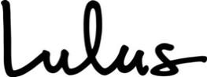

2021 Employee Stock Purchase Plan

_________________________________________________________

- Purpose

The Plan’s purpose is to assist employees of the Company and its Designated Subsidiaries in acquiring a stock ownership interest in the Company, and to help such employees provide for their future security and to encourage them to remain in the employment of the Company and its Subsidiaries.

The Plan consists of two components: the Section 423 Component and the Non-Section 423 Component. The Section 423 Component is intended to qualify as an “employee stock purchase plan” under Section 423 of the Code and shall be administered, interpreted and construed in a manner consistent with the requirements of Section 423 of the Code. In addition, this Plan authorizes the grant of Options under the Non-Section 423 Component, which need not qualify as Options granted pursuant to an “employee stock purchase plan” under Section 423 of the Code; such Options granted under the Non-Section 423 Component shall be granted pursuant to separate Offerings containing such sub-plans, appendices, rules or procedures as may be adopted by the Administrator and designed to achieve tax, securities laws or other objectives for Eligible Employees and the Designated Subsidiaries in locations outside of the United States. Except as otherwise provided herein, the Non-Section 423 Component will operate and be administered in the same manner as the Section 423 Component. Offerings intended to be made under the Non-Section 423 Component will be designated as such by the Administrator at or prior to the time of such Offering.

For purposes of this Plan, the Administrator may designate separate Offerings under the Plan, the terms of which need not be identical, in which Eligible Employees will participate, even if the dates of the applicable Offering Period(s) in each such Offering is identical, provided that the terms of participation are the same within each separate Offering under the Section 423 Component as determined under Section 423 of the Code. Solely by way of example and without limiting the foregoing, the Company could, but shall not be required to, provide for simultaneous Offerings under the Section 423 Component and the Non-Section 423 Component of the Plan.

- Definitions

As used in the Plan, the following words and phrases have the meanings specified below, unless the context clearly indicates otherwise:

2.1 “Administrator” means the Committee, or such individuals to which authority to administer the Plan has been delegated under Section 7.1 hereof.

2.2 “Agent” means the brokerage firm, bank or other financial institution, entity or person(s), if any, engaged, retained, appointed or authorized to act as the agent of the Company or an Employee with regard to the Plan.

2.3 “Board” means the Board of Directors of the Company.

Page 1 of 14

2.4 “Code” means the U.S. Internal Revenue Code of 1986, as amended, and all regulations, guidance, compliance programs and other interpretative authority issued thereunder.

2.5 “Committee” means the Compensation Committee of the Board.

2.6 “Common Stock” means the common stock of the Company.

2.7 “Company” means Lulu’s Fashion Lounge Holdings, Inc., a Delaware corporation, or any successor.

2.8 “Compensation” of an Employee means the regular earnings or base salary, bonuses and commissions paid to the Employee from the Company on each Payday as compensation for services to the Company or any Designated Subsidiary, before deduction for any salary deferral contributions made by the Employee to any tax-qualified or nonqualified deferred compensation plan, including overtime, shift differentials, vacation pay, salaried production schedule premiums, holiday pay, jury duty pay, funeral leave pay, paid time off, military pay, prior week adjustments and weekly bonus, but excluding education or tuition reimbursements, imputed income arising under any group insurance or benefit program, travel expenses, business and moving reimbursements, including tax gross ups and taxable mileage allowance, income received in connection with any stock options, restricted stock, restricted stock units or other compensatory equity awards and all contributions made by the Company or any Designated Subsidiary for the Employee’s benefit under any employee benefit plan now or hereafter established. Such Compensation shall be calculated before deduction of any income or employment tax withholdings, but shall be withheld from the Employee’s net income.

2.9 “Designated Subsidiary” means each Subsidiary, including any Subsidiary in existence on the Effective Date and any Subsidiary formed or acquired following the Effective Date, that has been designated by the Board or Committee from time to time in its sole discretion as eligible to participate in the Plan, in accordance with Section 7.2 hereof, such designation to specify whether such participation is in the Section 423 Component or Non-Section 423 Component. A Designated Subsidiary may participate in either the Section 423 Component or Non-Section 423 Component, but not both; provided that a Subsidiary that, for U.S. tax purposes, is disregarded from the Company or any Subsidiary that participates in the Section 423 Component shall automatically constitute a Designated Subsidiary that participates in the Section 423 Component.

2.10 “Effective Date” means the date immediately prior to the date the Company’s registration statement relating to its initial public offering becomes effective, provided that the Board has adopted the Plan prior to or on such date, subject to approval of the Plan by the Company’s stockholders.

2.11 “Eligible Employee” means, except as otherwise provided by the Administrator, an Employee:

- who has been employed by the Company or a Designated Subsidiary since at least the last day of the month before the month in which the enrollment period for the applicable Enrollment Date begins; and

- who, after the granting of the Option, would not be deemed for purposes of Section 423(b)(3) of the Code to possess 5% or more of the total combined voting power or value of all classes of stock of the Company or any Subsidiary.

For purposes of clause (b), the rules of Section 424(d) of the Code with regard to the attribution of stock ownership shall apply in determining the stock ownership of an individual, and stock which an Employee may purchase under outstanding options shall be treated as stock owned by the Employee.

Page 2 of 14

Notwithstanding the foregoing, the Administrator may exclude from participation in any Offering under the Section 423

Component as an Eligible Employee:

  - any Employee who is customarily scheduled to work 20 hours or less per week;

  - any Employee whose customary employment is five months or less in a calendar year;

  - any Employee who has not met a minimum service requirement designated by the Administrator pursuant to Section 423(b)(4)(A) of the Code (which service requirement must be less than two years);

  - any Employee that is a “highly compensated employee” of the Company or any Designated Subsidiary (within the meaning of Section 414(q) of the Code), or that is such a “highly compensated employee” (A) with compensation above a specified level, (B) who is an officer or (C) who is subject to the disclosure requirements of Section 16(a) of the Exchange Act; or

  - any Employee who is a citizen or resident of a foreign jurisdiction (without regard to whether they are also a citizen of the United States or a resident alien (within the meaning of Section 7701(b)(1)(A) of the Code)) if either
- the grant of the Option is prohibited under the laws of the jurisdiction governing such Employee, or (B) compliance with the laws of the foreign jurisdiction would cause the Section 423 Component, any Offering thereunder or an Option granted thereunder to violate the requirements of Section 423 of the Code;

provided that any exclusion in clauses (i) through (v) shall be applied in an identical manner under each Offering to all Employees of the Company and all Designated Subsidiaries, in accordance with Treas. Reg. § 1.423-2(e). Further, notwithstanding the foregoing, with respect to the Non-Section 423 Component, the first sentence in this definition shall apply in determining who is an “Eligible Employee,” except (a) the Administrator may limit eligibility further within the Company or a Designated Subsidiary so as to only designate some Employees of the Company or a Designated Subsidiary as Eligible Employees, and (b) to the extent the restrictions in the first sentence in this definition are not consistent with applicable local laws, the applicable local laws shall control.

2.12 “Employee” means any person who renders services to the Company or a Designated Subsidiary in the status of an employee within the meaning of Section 3401(c) of the Code. “Employee” shall not include any director of the Company or a Designated Subsidiary who does not render services to the Company or a Designated Subsidiary in the status of an employee within the meaning of Section 3401(c) of the Code. For purposes of the Plan, the employment relationship shall be treated as continuing intact while the individual is on military leave, sick leave or other leave of absence approved by the Company or a Designated Subsidiary and meeting the requirements of Treas. Reg. § 1.421-1(h)(2). Where the period of leave exceeds three months, or such other period specified in Treas. Reg. § 1.421-1(h)(2), and the individual’s right to reemployment is not guaranteed either by statute or by contract, the employment relationship shall be deemed to have terminated on the first day immediately following such three-month period, or such other period specified in Treas. Reg. § 1.421-1(h)(2).

2.13 “Enrollment Date” means the first date of each Offering Period.

2.14 “Exercise Date” means the last day of each Purchase Period, except as provided in Section 5.2 hereof.

2.15 “Exchange Act” means the Securities Exchange Act of 1934, as amended.

Page 3 of 14

2.16 “Fair Market Value” means, as of any date, the value of Common Stock determined as follows:

- If the Common Stock is (i) listed on any established securities exchange (such as the New York Stock Exchange or Nasdaq Stock Market), (ii) listed on any national market system or (iii) listed, quoted or traded on any automated quotation system, its Fair Market Value shall be the closing sales price for a share of Common Stock as quoted on such exchange or system for such date or, if there is no closing sales price for a share of Common Stock on the date in question, the closing sales price for a share of Common Stock on the last preceding date for which such quotation exists, as reported in The Wall Street Journal or such other source as the Administrator deems reliable;

- If the Common Stock is not listed on an established securities exchange, national market system or automated quotation system, but the Common Stock is regularly quoted by a recognized securities dealer, its Fair Market Value shall be the mean of the high bid and low asked prices for such date or, if there are no high bid and low asked prices for a share of Common Stock on such date, the high bid and low asked prices for a share of Common Stock on the last preceding date for which such information exists, as reported in The Wall Street Journal or such other source as the Administrator deems reliable; or

- If the Common Stock is neither listed on an established securities exchange, national market system or automated quotation system nor regularly quoted by a recognized securities dealer, its Fair Market Value shall be established by the Administrator in good faith.

2.17 “Grant Date” means the first day of an Offering Period.

2.18 “New Exercise Date” has the meaning set forth in Section 5.2(b) hereof.

2.19 “Non-Section 423 Component” means those Offerings under the Plan, together with the sub-plans, appendices, rules or procedures, if any, adopted by the Administrator as a part of this Plan, in each case, pursuant to which Options may be granted to non-U.S. Eligible Employees that need not satisfy the requirements for Options granted pursuant to an “employee stock purchase plan” that are set forth under Section 423 of the Code.

2.20 “Offering” means an offer under the Plan of an Option that may be exercised during an Offering Period as further described in Section 4 hereof. Unless otherwise specified by the Administrator, each Offering to the Eligible Employees of the Company or a Designated Subsidiary shall be deemed a separate Offering, even if the dates and other terms of the applicable Purchase Periods of each such Offering are identical and the provisions of the Plan will separately apply to each Offering. To the extent permitted by Treas. Reg. § 1.423-2(a)(1), the terms of each separate Offering under the Section 423 Component need not be identical, provided that the terms of the Section 423 Component and an Offering thereunder together satisfy Treas. Reg. § 1.423-2(a)(2) and (a)(3).

2.21 “Offering Period” means each consecutive, overlapping 12-month period commencing on such dates as determined by the Administrator, in its discretion, and with respect to which Options shall be granted to Participants. The duration and timing of Offering Periods may be established or changed by the Board or Committee at any time, in its sole discretion. Notwithstanding the foregoing, in no event may an Offering Period exceed 27 months.

2.22 “Option” means the right to purchase shares of Common Stock pursuant to the Plan during each Offering Period.

2.23 “Option Price” means the purchase price of a share of Common Stock hereunder as provided in Section 4.2

hereof.

Page 4 of 14

2.24 “Parent” means any entity that is a parent corporation of the Company within the meaning of Section 424 of the

Code.

2.25 “Participant” means any Eligible Employee who elects to participate in the Plan.

2.26 “Payday” means the regular and recurring established day for payment of Compensation to an Employee of the Company or any Designated Subsidiary.

2.27 “Plan” means this 2021 Employee Stock Purchase Plan, including both the Section 423 Component and Non-Section 423 Component and any other sub-plans or appendices hereto, as amended from time to time.

2.28 “Plan Account” means a bookkeeping account established and maintained by the Company in the name of each Participant.

2.29 “Purchase Period” means each consecutive six-month period commencing on such dates as determined by the Administrator, in its discretion. The first Purchase Period of each Offering Period shall commence on the Grant Date and end with the next Exercise Date. The duration and timing of Purchase Periods may be established or changed by the Board or Committee at any time, in its sole discretion. Notwithstanding the foregoing, in no event may a Purchase Period exceed the duration of the Offering Period under which it is established.

2.30 “Section 409A” means Section 409A of the Code.

2.31 “Section 423 Component” means those Offerings under the Plan that are intended to meet the requirements under Section 423(b) of the Code.

2.32 “Subsidiary” means any entity that is a subsidiary corporation of the Company within the meaning of Section 424 of the Code. In addition, with respect to the Non-Section 423 Component, Subsidiary shall include any corporate or noncorporate entity in which the Company has a direct or indirect equity interest or significant business relationship.

2.33 “Treas. Reg.” means U.S. Department of the Treasury regulations.

2.34 “Withdrawal Election” has the meaning set forth in Section 6.1(a) hereof.

- Participation

3.1Eligibility.

  - Any Eligible Employee who is employed by the Company or a Designated Subsidiary on a given Enrollment Date for an Offering Period shall be eligible to participate in the Plan during such Offering Period, subject to the requirements of Articles 4 and 5 hereof, and, for the Section 423 Component, the limitations imposed by Section 423(b) of the Code.

  - No Eligible Employee shall be granted an Option under the Section 423 Component which permits the Participant’s rights to purchase shares of Common Stock under the Plan, and to purchase stock under all other employee stock purchase plans of the Company, any Parent or any Subsidiary subject to Section 423 of the Code, to accrue at a rate which exceeds $25,000 of fair market value of such stock (determined at the time such Option is granted) for each calendar year in which such Option is outstanding at any time. The limitation under this Section 3.1(b) shall be applied in accordance with Section 423(b)(8) of the Code.

Page 5 of 14

3.2 Election to Participate; Payroll Deductions

- Except as provided in Section 3.2(e), an Eligible Employee may become a Participant in the Plan only by means of payroll deduction. Each individual who is an Eligible Employee as of an Offering Period’s Enrollment Date may elect to participate in such Offering Period and the Plan by delivering to the Company a payroll deduction authorization no later than the period of time prior to the applicable Enrollment Date that is determined by the Administrator, in its sole discretion.

- Subject to Section 3.1(b) hereof and except as may otherwise be determined by the Administrator, payroll deductions (i) shall equal at least 1% of the Participant’s Compensation as of each Payday of the Offering Period following the Enrollment Date, but not more than 15% of the Participant’s Compensation as of each Payday of the Offering Period following the Enrollment Date; and (ii) may be expressed either as (A) a whole number percentage, or (B) a fixed dollar amount. Amounts deducted from a Participant’s Compensation with respect to an Offering Period pursuant to this Section 3.2 shall be deducted each Payday through payroll deduction and credited to the Participant’s Plan Account; provided that for the first Offering Period, payroll deductions shall not begin until such date determined by the Board or Committee, in its sole discretion. For clarity, if a Participant receives no Compensation on a particular Payday during an Offering Period (whether due to an unpaid leave of absence or otherwise), the Participant shall not have a payroll deduction on such Payday, and the Participant’s payroll deductions shall resume (if at all) on the next Payday on which the Participant receives Compensation and for which a payroll deduction authorization is in effect.

- Following at least one payroll deduction, a Participant may decrease (to as low as zero) the amount deducted from such Participant’s Compensation only once during an Offering Period upon ten calendar days’ prior written notice to the Company. A Participant may not increase the amount deducted from such Participant’s Compensation during an Offering Period.

- Upon the completion of an Offering Period, each Participant in such Offering Period shall automatically participate in the immediately following Offering Period at the same payroll deduction percentage or fixed amount as in effect at the termination of such Offering Period, unless such Participant delivers to the Company a different election with respect to the successive Offering Period in accordance with Section 3.2(a) hereof, or unless such Participant becomes ineligible for participation in the Plan.

- Notwithstanding any other provisions of the Plan to the contrary, in non-U.S. jurisdictions where participation in the Plan through payroll deductions is prohibited, the Administrator may provide that an Eligible Employee may elect to participate through contributions to the Participant’s account under the Plan in a form acceptable to the Administrator in lieu of or in addition to payroll deductions; provided, however, that, for any Offering under the Section 423 Component, the Administrator must determine that any alternative method of contribution is applied on an equal and uniform basis to all Eligible Employees in the Offering.

3.3 Leave of Absence. For clarity, and subject to Section 3.2 hereof, during a leave of absence approved by the Company meeting the requirements of Treas. Reg. § 1.421-1(h)(2), a Participant will automatically continue participation in the Plan and in the then-current Offering Period that includes the beginning of the leave of absence, and the Participant’s then-current payroll deduction authorization will remain in effect, in each case, unless and until the Participant ceases to be an Eligible Employee (in which case Section 6.2 hereof shall apply) or the Participant submits a Withdrawal Election in accordance with Section 6.1(a) hereof.

IV. Purchase of Shares

Page 6 of 14

4.1 Grant of Option. The Company may make one or more Offerings under the Plan, which may be successive or overlapping with one another, until the earlier of: (i) the date on which the shares of Common Stock available under the Plan have been sold or (ii) the date on which the Plan is suspended or terminates. The Administrator shall designate the terms and conditions of each Offering in writing, including without limitation, the Offering Period and the Purchase Periods. Each Participant shall be granted an Option with respect to an Offering Period on the applicable Grant Date. Subject to the limitations of Section 3.1(b) hereof, the number of shares of Common Stock subject to a Participant’s Option shall be determined by dividing (a) such Participant’s payroll deductions accumulated prior to an Exercise Date and retained in the Participant’s Plan Account on such Exercise Date by (b) the applicable Option Price; provided that in no event shall a Participant be permitted to purchase during each Offering Period more than 100,000 shares of Common Stock (subject to any adjustment pursuant to Section 5.2 hereof). The Administrator may, for future Offering Periods, increase or decrease, in its absolute discretion, the maximum number of shares of Common Stock that a Participant may purchase during such future Offering Periods. Each Option shall expire on the last Exercise Date for the applicable Offering Period immediately after the automatic exercise of the Option in accordance with Section 4.3 hereof, unless such Option terminates earlier in accordance with Article 6 hereof.

4.2 Option Price. The “Option Price” per share of Common Stock to be paid by a Participant upon exercise of the Participant’s Option on an Exercise Date for an Offering Period shall equal 85% of the lesser of the Fair Market Value of a share of Common Stock on (a) the applicable Grant Date and (b) the applicable Exercise Date, or such other price designated by the Administrator; provided that in no event shall the Option Price per share of Common Stock be less than the par value per share of the Common Stock; provided, further, that no Option Price shall be designated by the Administrator that would cause the Section 423 Component to fail to meet the requirements under Section 423(b) of the Code.

4.3 Purchase of Shares.

- On each Exercise Date for an Offering Period, each Participant shall automatically and without any action on such Participant’s part be deemed to have exercised the Participant’s Option to purchase at the applicable per share Option Price the largest number of whole shares of Common Stock which can be purchased with the amount in the Participant’s Plan Account. Any balance less than the per share Option Price that is remaining in the Participant’s Plan Account (after exercise of such Participant’s Option) as of the Exercise Date shall be carried forward to the next Purchase Period or Offering Period, unless the Participant has elected to withdraw from the Plan pursuant to Section 6.1 hereof or, pursuant to Section 6.2 hereof, such Participant has ceased to be an Eligible Employee. Any balance not carried forward to the next Purchase Period or Offering Period in accordance with the prior sentence shall be promptly refunded to the applicable Participant. In no event shall an amount greater than or equal to the per share Option Price as of an Exercise Date be carried forward to the next Purchase Period or Offering Period.

- As soon as practicable following each Exercise Date, the number of shares of Common Stock purchased by such Participant pursuant to Section 4.3(a) hereof shall be delivered (either in share certificate or book entry form), in the Company’s sole discretion, to either (i) the Participant or (ii) an account established in the Participant’s name at a stock brokerage or other financial services firm designated by the Company. If the Company is required to obtain from any commission or agency authority to issue any such shares of Common Stock, the Company shall seek to obtain such authority. Inability of the Company to obtain from any such commission or agency authority which counsel for the Company deems necessary for the lawful issuance of any such shares shall relieve the Company from liability to any Participant except to refund to the Participant such Participant’s Plan Account balance, without interest thereon.

Page 7 of 14

4.4 Automatic Termination of Offering Period. If the Fair Market Value of a share of Common Stock on any Exercise Date (except the final scheduled Exercise Date of any Offering Period) is lower than the Fair Market Value of a share of Common Stock on the Grant Date for an Offering Period, then such Offering Period shall terminate on such Exercise Date after the automatic exercise of the Option in accordance with Section 4.3 hereof, and each Participant shall automatically be enrolled in the Offering Period that commences immediately following such Exercise Date and such Participant’s payroll deduction authorization shall remain in effect for such Offering Period.

4.5 Transferability of Rights. An Option granted under the Plan shall not be transferable, other than by will or the applicable laws of descent and distribution, and is exercisable during the Participant’s lifetime only by the Participant. No option or interest or right to the Option shall be available to pay off any debts, contracts or engagements of the Participant or the Participant’s successors in interest or shall be subject to disposition by pledge, encumbrance, assignment or any other means whether such disposition be voluntary or involuntary or by operation of law by judgment, levy, attachment, garnishment or any other legal or equitable proceedings (including bankruptcy), and any attempt at disposition of the Option shall have no effect.

- Provisions Relating to Common Stock

5.1 Common Stock Reserved. Subject to adjustment as provided in Section 5.2 hereof, the maximum number of shares of Common Stock that shall be made available for sale under the Plan shall be the sum of (a) 743,803 shares and (b) an annual increase on the first day of each year beginning in 2022 and ending in 2031 equal to the lesser of (i) 1% of the shares outstanding (on an as converted basis) on the last day of the immediately preceding fiscal year and (ii) such number of shares as may be determined by the Board; provided, however, no more than 5,578,527 shares may be issued under the Plan. Shares made available for sale under the Plan may be authorized but unissued shares, treasury shares of Common Stock, or reacquired shares reserved for issuance under the Plan.

5.2 Adjustments Upon Changes in Capitalization, Dissolution, Liquidation, Merger or Asset Sale.

- Changes in Capitalization. Subject to any required action by the stockholders of the Company, the number of shares of Common Stock which have been authorized for issuance under the Plan but not yet placed under Option, as well as the price per share and the number of shares of Common Stock covered by each Option under the Plan which has not yet been exercised shall be proportionately adjusted for any increase or decrease in the number of issued shares of Common Stock resulting from a stock split, reverse stock split, stock dividend, combination or reclassification of the Common Stock, or any other increase or decrease in the number of shares of Common Stock effected without receipt of consideration by the Company; provided, however, that conversion of any convertible securities of the Company shall not be deemed to have been “effected without receipt of consideration.” Such adjustment shall be made by the Administrator, whose determination in that respect shall be final, binding and conclusive. Except as expressly provided herein, no issuance by the Company of shares of stock of any class, or securities convertible into shares of stock of any class, shall affect, and no adjustment by reason thereof shall be made with respect to, the number or price of shares of Common Stock subject to an Option.

- Dissolution or Liquidation. In the event of the proposed dissolution or liquidation of the Company, the Offering Periods then in progress shall be shortened by setting a new Exercise Date (the “New Exercise Date”), and shall terminate immediately prior to the consummation of such proposed dissolution or liquidation, unless provided otherwise by the Administrator. The New Exercise Date shall be before the date of the Company’s proposed dissolution or liquidation. The Administrator shall notify each Participant in writing prior to the New Exercise Date, that the Exercise Date for the Participant’s Option has been changed to the New Exercise Date and that the Participant’s Option shall be

Page 8 of 14

exercised automatically on the New Exercise Date, unless prior to such date the Participant has withdrawn from the Offering Period as provided in Section 6.1 hereof or the Participant has ceased to be an Eligible Employee as provided in Section 6.2 hereof.

- Merger or Asset Sale. In the event of a proposed sale of all or substantially all of the assets of the Company, or the merger of the Company with or into another corporation, each outstanding Option shall be assumed or an equivalent Option substituted by the successor corporation or a Parent or Subsidiary of the successor corporation. If the successor corporation refuses to assume or substitute for the Option, any Offering Periods then in progress shall be shortened by setting a New Exercise Date and any Offering Periods then in progress shall end on the New Exercise Date. The New Exercise Date shall be before the date of the Company’s proposed sale or merger. The Administrator shall notify each Participant in writing prior to the New Exercise Date, that the Exercise Date for the Participant’s Option has been changed to the New Exercise Date and that the Participant’s Option shall be exercised automatically on the New Exercise Date, unless prior to such date the Participant has withdrawn from the Offering Period as provided in Section 6.1 hereof or the Participant has ceased to be an Eligible Employee as provided in Section 6.2 hereof.

5.3 Insufficient Shares. If the Administrator determines that, on a given Exercise Date, the number of shares of Common Stock with respect to which Options are to be exercised may exceed the number of shares of Common Stock remaining available for sale under the Plan on such Exercise Date, the Administrator shall make a pro rata allocation of the shares of Common Stock available for issuance on such Exercise Date in as uniform a manner as shall be practicable and as it shall determine in its sole discretion to be equitable among all Participants exercising Options to purchase Common Stock on such Exercise Date, and unless additional shares are authorized for issuance under the Plan, no further Offering Periods shall take place and the Plan shall terminate pursuant to Section 7.5 hereof. If an Offering Period is so terminated, then the balance of the amount credited to the Participant’s Plan Account which has not been applied to the purchase of shares of Common Stock shall be paid to such Participant in one lump sum in cash within 30 days after such Exercise Date, without any interest thereon.

5.4 Rights as Stockholders. With respect to shares of Common Stock subject to an Option, a Participant shall not be deemed to be a stockholder of the Company and shall not have any of the rights or privileges of a stockholder. A Participant shall have the rights and privileges of a stockholder of the Company when, but not until, shares of Common Stock have been deposited in the designated brokerage account following exercise of the Participant’s Option.

VI. Termination of Participation

6.1 Cessation of Contributions; Voluntary Withdrawal.

- A Participant may cease payroll deductions during an Offering Period and elect to withdraw from the Plan by delivering written notice of such election to the Company in such form and at such time prior to the Exercise Date for such Offering Period as may be established by the Administrator (a “Withdrawal Election”). A Participant electing to withdraw from the Plan may elect to either (i) withdraw all of the funds then credited to the Participant’s Plan Account as of the date on which the Withdrawal Election is received by the Company, in which case amounts credited to such Plan Account shall be returned to the Participant in one lump-sum payment in cash within 30 days after such election is received by the Company, without any interest thereon, and the Participant shall cease to participate in the Plan and the Participant’s Option for such Offering Period shall terminate; or (ii) exercise the Option for the maximum number of whole shares of Common Stock on the applicable Exercise Date with any remaining Plan Account balance returned to the Participant in one lump-sum payment in cash within 30 days after such Exercise Date, without any interest thereon, and after such exercise cease to participate

Page 9 of 14

in the Plan. Upon receipt of a Withdrawal Election, the Participant’s payroll deduction authorization shall terminate.

- A Participant’s withdrawal from the Plan shall not have any effect upon the Participant’s eligibility to participate in any similar plan which may hereafter be adopted by the Company or in succeeding Offering Periods which commence after the termination of the Offering Period from which the Participant withdraws.

- A Participant who ceases contributions to the Plan pursuant to a Withdrawal Election during any Offering Period shall not be permitted to resume contributions to the Plan during that Offering Period.

6.2 Termination of Eligibility. Upon a Participant’s ceasing to be an Eligible Employee, for any reason, such Participant’s Option for the applicable Offering Period shall automatically terminate, the Participant shall be deemed to have elected to withdraw from the Plan, and such Participant’s Plan Account shall be paid to such Participant or, in the case of the Participant’s death, to the person or persons entitled thereto pursuant to applicable law, within 30 days after such cessation of being an Eligible Employee, without any interest thereon. If a Participant transfers employment from the Company or any Designated Subsidiary participating in the Section 423 Component to any Designated Subsidiary participating in the Non-Section 423 Component, such transfer shall not be treated as a termination of employment, but the Participant shall immediately cease to participate in the Section 423 Component; however, any contributions made for the Offering Period in which such transfer occurs shall be transferred to the Non-Section 423 Component, and such Participant shall immediately join the then-current Offering under the Non-Section 423 Component upon the same terms and conditions in effect for the Participant’s participation in the Section 423 Component, except for such modifications otherwise applicable for Participants in such Offering. A Participant who transfers employment from any Designated Subsidiary participating in the Non-Section 423 Component to the Company or any Designated Subsidiary participating in the Section 423 Component shall not be treated as terminating the Participant’s employment and shall remain a Participant in the Non-Section 423 Component until the earlier of (i) the end of the current Offering Period under the Non-Section 423 Component, or

- the Enrollment Date of the first Offering Period in which the Participant is eligible to participate following such transfer. Notwithstanding the foregoing, the Administrator may establish different rules to govern transfers of employment between companies participating in the Section 423 Component and the Non-Section 423 Component, consistent with the applicable requirements of Section 423 of the Code.

VII. General Provisions

7.1 Administration.

- The Plan shall be administered by the Committee, which shall be composed of members of the Board. The Committee may delegate administrative tasks under the Plan to the services of an Agent or Employees to assist in the administration of the Plan, including establishing and maintaining an individual securities account under the Plan for each Participant.

- It shall be the duty of the Administrator to conduct the general administration of the Plan in accordance with the provisions of the Plan. The Administrator shall have the power, subject to, and within the limitations of, the express provisions of the Plan:

  - To establish and terminate Offerings;

  - To determine when and how Options shall be granted and the provisions and terms of each Offering (which need not be identical);

Page 10 of 14

  - To select Designated Subsidiaries in accordance with Section 7.2 hereof;

  - To impose a mandatory holding period pursuant to which Participants may not dispose of or transfer shares of Common Stock purchased under the Plan for a period of time determined by the Administrator in its discretion; and

  - To construe and interpret the Plan, the terms of any Offering and the terms of the Options and to adopt such rules for the administration, interpretation, and application of the Plan as are consistent therewith and to interpret, amend or revoke any such rules. The Administrator, in the exercise of this power, may correct any defect, omission or inconsistency in the Plan, any Offering or any Option, in a manner and to the extent it shall deem necessary or expedient to administer the Plan, subject to Section 423 of the Code for the Section 423 Component.

- The Administrator may adopt rules or procedures relating to the operation and administration of the Plan to accommodate the specific requirements of local laws and procedures. Without limiting the generality of the foregoing, the Administrator is specifically authorized to adopt rules and procedures regarding handling of participation elections, payroll deductions, payment of interest, conversion of local currency, payroll tax, withholding procedures and handling of stock certificates which vary with local requirements. In its absolute discretion, the Board may at any time and from time to time exercise any and all rights and duties of the Administrator under the Plan.

- The Administrator may adopt sub-plans applicable to particular Designated Subsidiaries or locations, which sub-plans may be designed to be outside the scope of Section 423 of the Code. The rules of such sub-plans may take precedence over other provisions of this Plan, with the exception of Section 5.1 hereof, but unless otherwise superseded by the terms of such sub-plan, the provisions of this Plan shall govern the operation of such sub-plan.

- All expenses and liabilities incurred by the Administrator in connection with the administration of the Plan shall be borne by the Company. The Administrator may, with the approval of the Committee, employ attorneys, consultants, accountants, appraisers, brokers or other persons. The Administrator, the Company and its officers and directors shall be entitled to rely upon the advice, opinions or valuations of any such persons. All actions taken and all interpretations and determinations made by the Administrator in good faith shall be final and binding upon all Participants, the Company and all other interested persons. No member of the Board or Administrator shall be personally liable for any action, determination or interpretation made in good faith with respect to the Plan or the options, and all members of the Board or Administrator shall be fully protected by the Company in respect to any such action, determination, or interpretation.

7.2 Designation of Subsidiary Corporations. The Board or Administrator shall designate from time to time the Subsidiaries that shall constitute Designated Subsidiaries, and determine whether such Designated Subsidiaries shall participate in the Section 423 Component or Non-Section 423 Component. The Board or Administrator may designate a Subsidiary, or terminate the designation of a Subsidiary, without the approval of the stockholders of the Company.

7.3 Reports. Individual accounts shall be maintained for each Participant in the Plan. Statements of Plan Accounts shall be given to Participants at least annually, which statements shall set forth the amounts of payroll deductions, the Option Price, the number of shares purchased and the remaining cash balance, if any.

7.4 No Right to Employment. Nothing in the Plan shall be construed to give any person (including any Participant) the right to remain in the employ of the Company, a Parent or a Subsidiary or to affect the right of the Company, any Parent or any Subsidiary to terminate the employment of any person (including any Participant) at any time, with or without cause, which right is expressly reserved.

Page 11 of 14

7.5 Amendment and Termination of the Plan.

- The Board may, in its sole discretion, amend, suspend or terminate the Plan at any time and from time to time. To the extent necessary to comply with Section 423 of the Code (or any successor rule or provision), with respect to the Section 423 Component, or any other applicable law, regulation or stock exchange rule, the Company shall obtain stockholder approval of any such amendment to the Plan in such a manner and to such a degree as required by Section 423 of the Code or such other law, regulation or rule.

- If the Administrator determines that the ongoing operation of the Plan may result in unfavorable financial accounting consequences, the Administrator may in its discretion modify or amend the Plan to reduce or eliminate such accounting consequence including, but not limited to:

  - altering the Option Price for any Offering Period including an Offering Period underway at the

time of the change in Option Price;

  - shortening any Offering Period so that the Offering Period ends on a new Exercise Date, including an Offering Period underway at the time of the Administrator action; and

  - allocating shares of Common Stock.

Such modifications or amendments shall not require stockholder approval or the consent of any Participant.

- Upon termination of the Plan, the balance in each Participant’s Plan Account shall be refunded as soon as practicable after such termination, without any interest thereon.

7.6 Use of Funds; No Interest Paid. All funds received by the Company by reason of purchase of shares of Common Stock under the Plan shall be included in the general funds of the Company free of any trust or other restriction and may be used for any corporate purpose. No interest shall be paid to any Participant or credited under the Plan.

7.7 Term; Approval by Stockholders. No Option may be granted during any period of suspension of the Plan or after termination of the Plan. The Plan shall be submitted for the approval of the Company’s stockholders within 12 months after the date of the Board’s initial adoption of the Plan. Options may be granted prior to such stockholder approval; provided, however, that such Options shall not be exercisable prior to the time when the Plan is approved by the stockholders; provided, further that if such approval has not been obtained by the end of the 12-month period, all Options previously granted under the Plan shall thereupon terminate and be canceled and become null and void without being exercised.

7.8 Effect Upon Other Plans. The adoption of the Plan shall not affect any other compensation or incentive plans in effect for the Company, any Parent or any Subsidiary. Nothing in the Plan shall be construed to limit the right of the Company, any Parent or any Subsidiary (a) to establish any other forms of incentives or compensation for Employees of the Company or any Parent or any Subsidiary, or (b) to grant or assume Options otherwise than under the Plan in connection with any proper corporate purpose, including, but not by way of limitation, the grant or assumption of options in connection with the acquisition, by purchase, lease, merger, consolidation or otherwise, of the business, stock or assets of any corporation, firm or association.

7.9 Conformity to Securities Laws. Notwithstanding any other provision of the Plan, the Plan and the participation in the Plan by any individual who is then subject to Section 16 of the Exchange Act

Page 12 of 14

shall be subject to any additional limitations set forth in any applicable exemption rule under Section 16 of the Exchange Act (including any amendment to Rule 16b-3 of the Exchange Act) that are requirements for the application of such exemptive rule. To the extent permitted by applicable law, the Plan shall be deemed amended to the extent necessary to conform to such applicable exemptive rule.

7.10 Notice of Disposition of Shares. Each Participant shall give the Company prompt notice of any disposition or other transfer of any shares of Common Stock, acquired pursuant to the exercise of an Option granted under the Section 423 Component, if such disposition or transfer is made (a) within two years after the applicable Grant Date or (b) within one year after the transfer of such shares of Common Stock to such Participant upon exercise of such Option. The Company may direct that any certificates evidencing shares acquired pursuant to the Plan refer to such requirement.

7.11 Tax Withholding. The Company or any Parent or any Subsidiary shall be entitled to require payment in cash or deduction from other compensation payable to each Participant of any sums required by federal, state or local tax law to be withheld with respect to any purchase of shares of Common Stock under the Plan or any sale of such shares.

7.12 Governing Law. The Plan and all rights and obligations thereunder shall be construed and enforced in accordance with the laws of the State of Delaware, without regard to the conflict of law rules thereof or of any other jurisdiction.

7.13 Notices. All notices or other communications by a Participant to the Company under or in connection with the Plan shall be deemed to have been duly given when received in the form specified by the Company at the location, or by the person, designated by the Company for the receipt thereof.

7.14 Conditions To Issuance of Shares.

- Notwithstanding anything herein to the contrary, the Company shall not be required to issue or deliver any certificates or make any book entries evidencing shares of Common Stock pursuant to the exercise of an Option by a Participant, unless and until the Board or the Committee has determined, with advice of counsel, that the issuance of such shares of Common Stock is in compliance with all applicable laws, regulations of governmental authorities and, if applicable, the requirements of any securities exchange or automated quotation system on which the shares of Common Stock are listed or traded, and the shares of Common Stock are covered by an effective registration statement or applicable exemption from registration. In addition to the terms and conditions provided herein, the Board or the Committee may require that a Participant make such reasonable covenants, agreements, and representations as the Board or the Committee, in its discretion, deems advisable in order to comply with any such laws, regulations, or requirements.

- All certificates for shares of Common Stock delivered pursuant to the Plan and all shares of Common Stock issued pursuant to book entry procedures are subject to any stop-transfer orders and other restrictions as the Committee deems necessary or advisable to comply with federal, state, or foreign securities or other laws, rules and regulations and the rules of any securities exchange or automated quotation system on which the shares of Common Stock are listed, quoted, or traded. The Committee may place legends on any certificate or book entry evidencing shares of Common Stock to reference restrictions applicable to the shares of Common Stock.

- The Committee shall have the right to require any Participant to comply with any timing or other restrictions with respect to the settlement, distribution or exercise of any Option, including a window-period limitation, as may be imposed in the sole discretion of the Committee.

- Notwithstanding any other provision of the Plan, unless otherwise determined by the Committee or required by any applicable law, rule or regulation, the Company may, in lieu of

Page 13 of 14

delivering to any Participant certificates evidencing shares of Common Stock issued in connection with any Option, record the issuance of shares of Common Stock in the books of the Company (or, as applicable, its transfer agent or stock plan administrator).

7.15 Equal Rights and Privileges. All Eligible Employees of the Company (or of any Designated Subsidiary) granted Options pursuant to an Offering under the Section 423 Component shall have equal rights and privileges under this Plan to the extent required under Section 423 of the Code so that the Section 423 Component qualifies as an “employee stock purchase plan” within the meaning of Section 423 of the Code. Any provision of the Section 423 Component that is inconsistent with Section 423 of the Code shall, without further act or amendment by the Company or the Board, be reformed to comply with the equal rights and privileges requirement of Section 423 of the Code. Eligible Employees participating in the Non-Section 423 Component need not have the same rights and privileges as Eligible Employees participating in the Section 423 Component.

7.16 Rules Particular to Specific Countries. Notwithstanding anything herein to the contrary, the terms and conditions of the Plan with respect to Participants who are tax residents of a particular non-U.S. country or who are foreign nationals or employed in non-U.S. jurisdictions may be subject to an addendum to the Plan in the form of an appendix or sub-plan (which appendix or sub-plan may be designed to govern Offerings under the Section 423 Component or the Non-Section 423 Component, as determined by the Administrator). To the extent that the terms and conditions set forth in an appendix or sub-plan conflict with any provisions of the Plan, the provisions of the appendix or sub-plan shall govern. The adoption of any such appendix or sub-plan shall be pursuant to Section 7.1 above. Without limiting the foregoing, the Administrator is specifically authorized to adopt rules and procedures, with respect to Participants who are foreign nationals or employed in non-U.S. jurisdictions, regarding the exclusion of particular Subsidiaries from participation in the Plan, eligibility to participate, the definition of Compensation, handling of payroll deductions or other contributions by Participants, payment of interest, conversion of local currency, data privacy security, payroll tax, withholding procedures, establishment of bank or trust accounts to hold payroll deductions or contributions.

7.17 Section 409A. The Section 423 Component of the Plan and the Options granted pursuant to Offerings thereunder are intended to be exempt from the application of Section 409A. Neither the Non-Section 423 Component nor any Option granted pursuant to an Offering thereunder is intended to constitute or provide for “nonqualified deferred compensation” within the meaning of Section 409A. Notwithstanding any provision of the Plan to the contrary, if the Administrator determines that any Option granted under the Plan may be or become subject to Section 409A or that any provision of the Plan may cause an Option granted under the Plan to be or become subject to Section 409A, the Administrator may adopt such amendments to the Plan and/or adopt other policies and procedures (including amendments, policies and procedures with retroactive effect), or take any other actions as the Administrator determines are necessary or appropriate to avoid the imposition of taxes under Section 409A, either through compliance with the requirements of Section 409A or with an available exemption therefrom.

Last Updated: November 11, 2022

* * * * *

Page 14 of 14

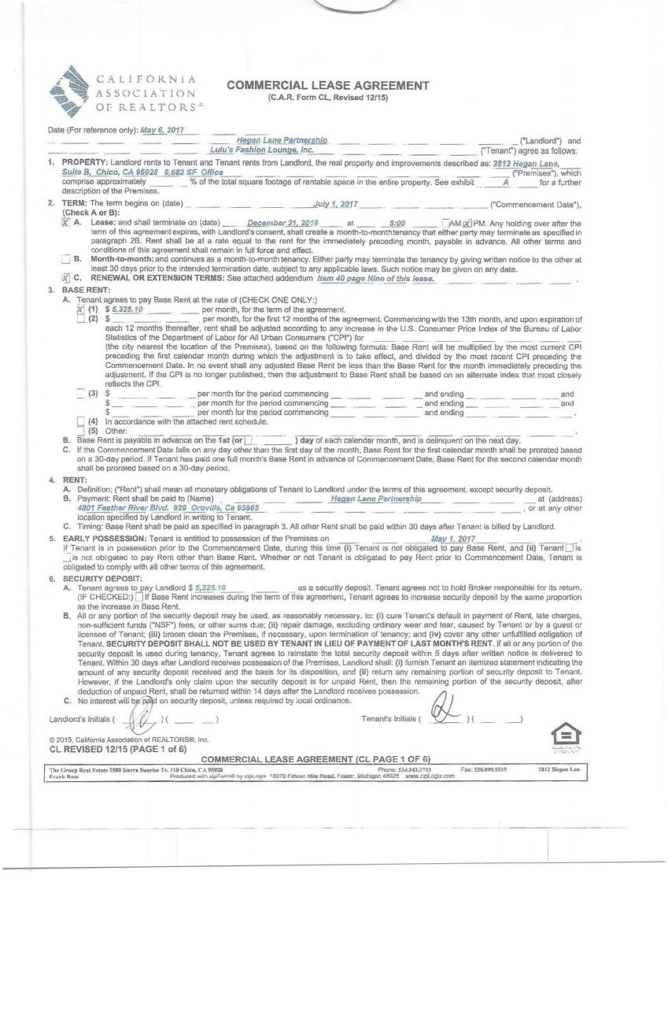



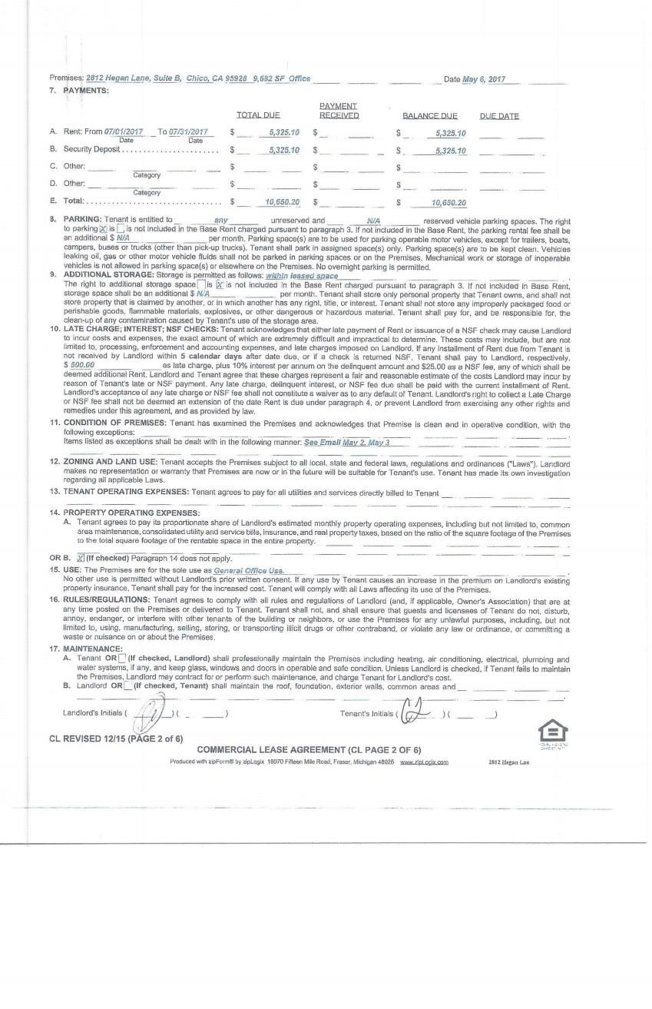



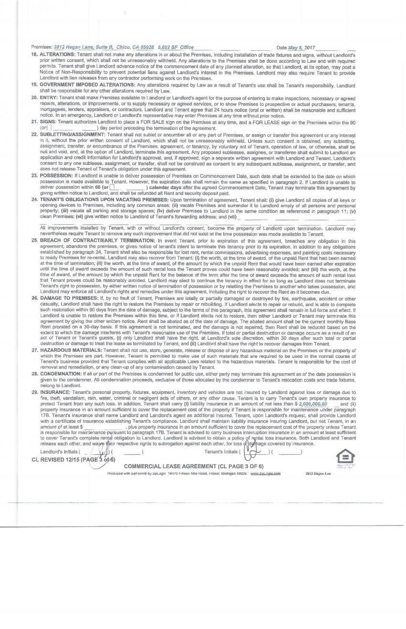

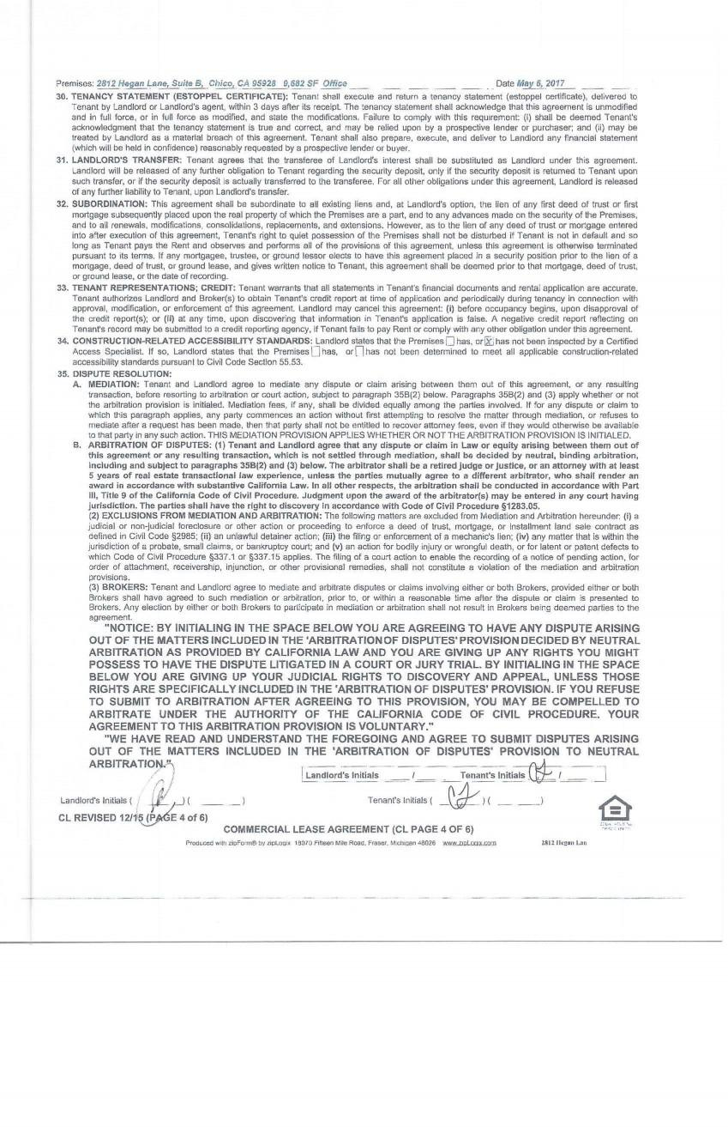

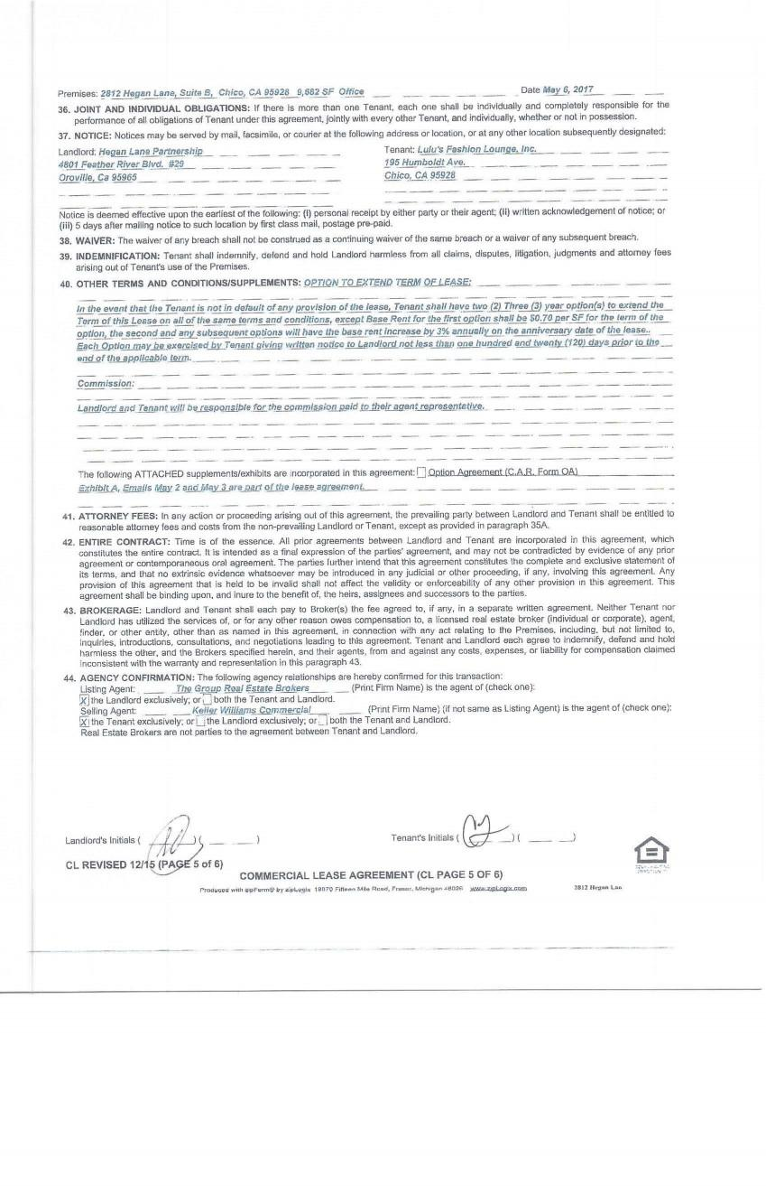

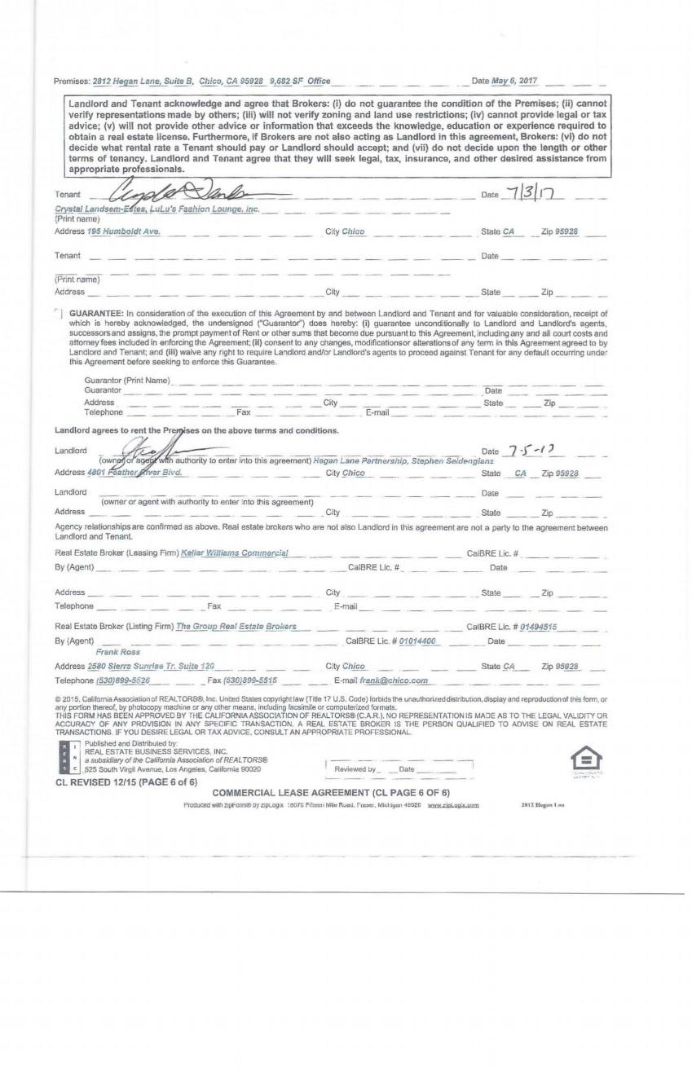



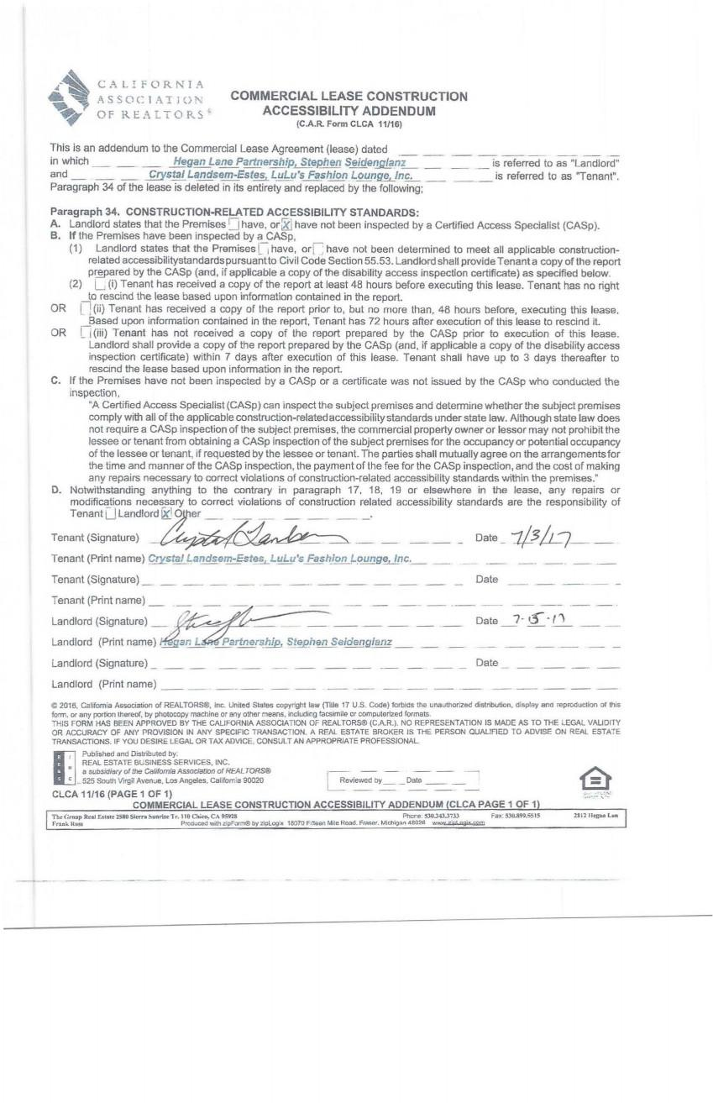



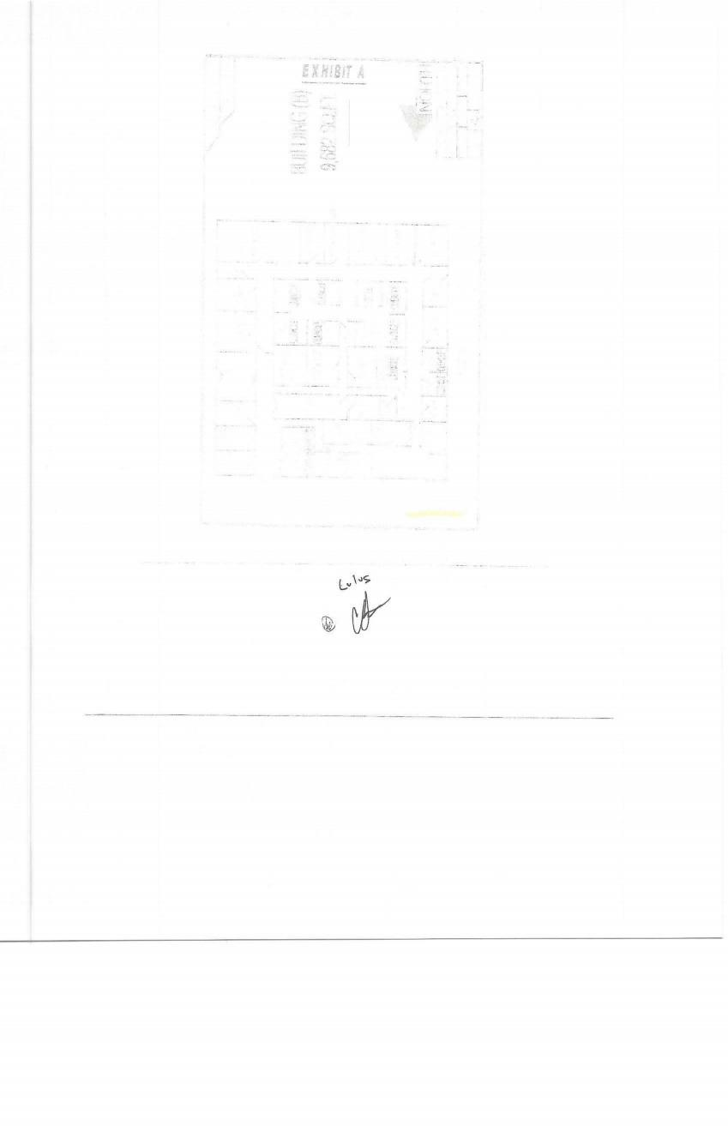

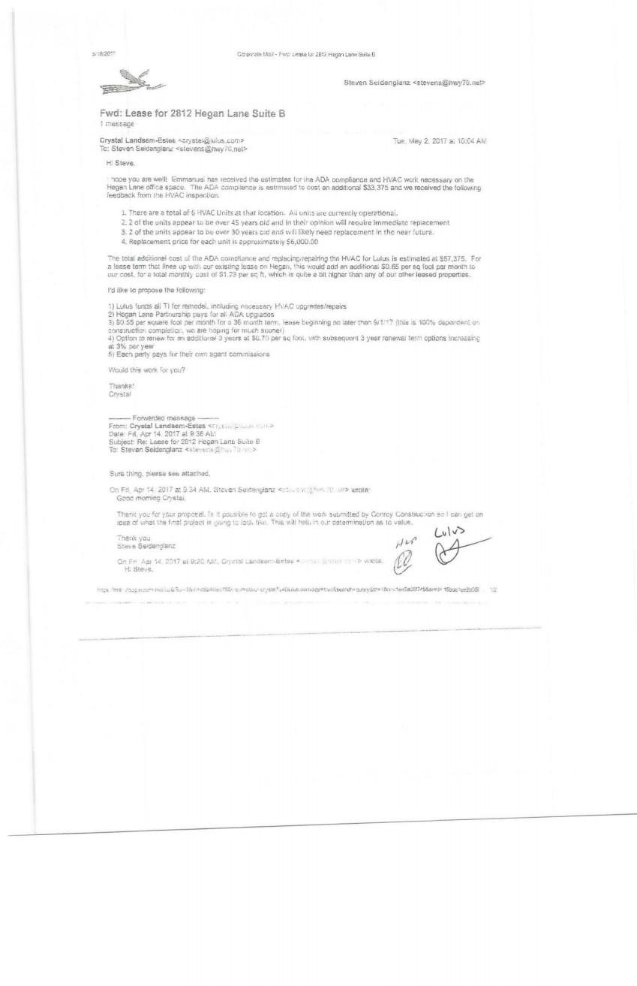



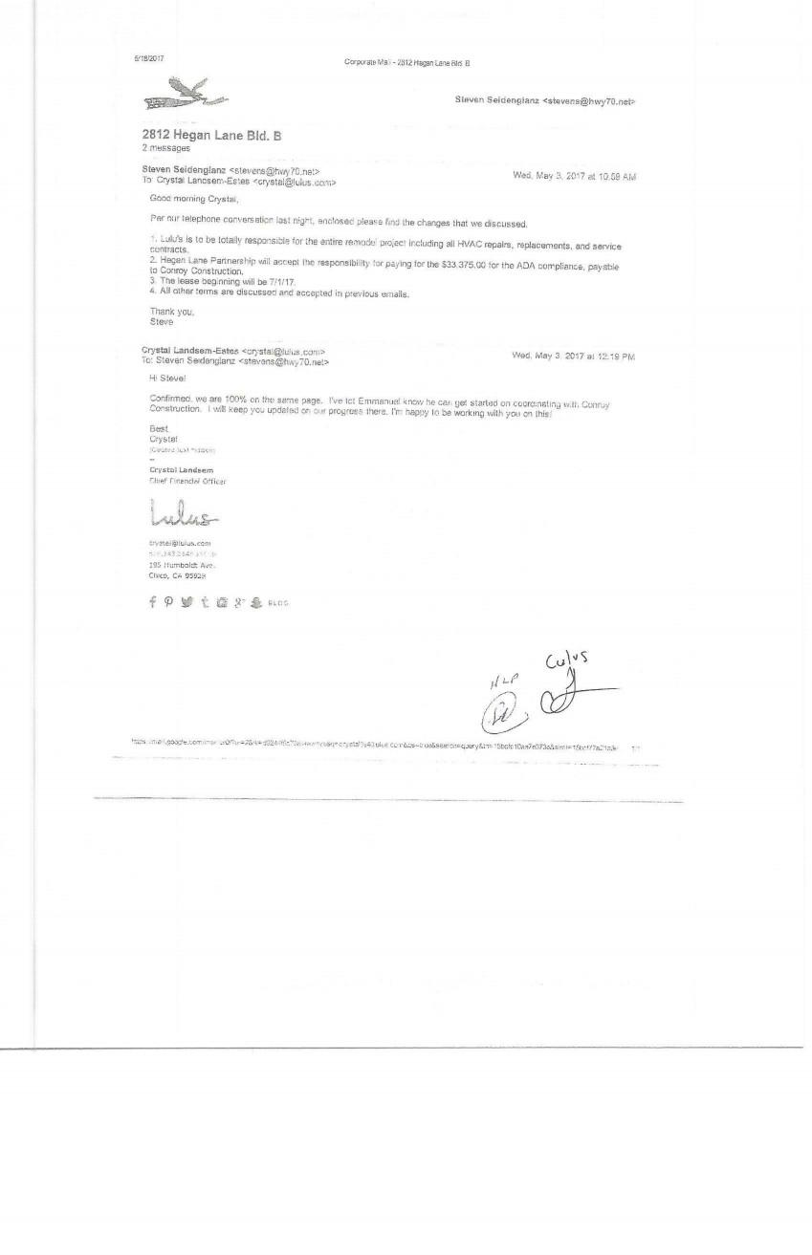

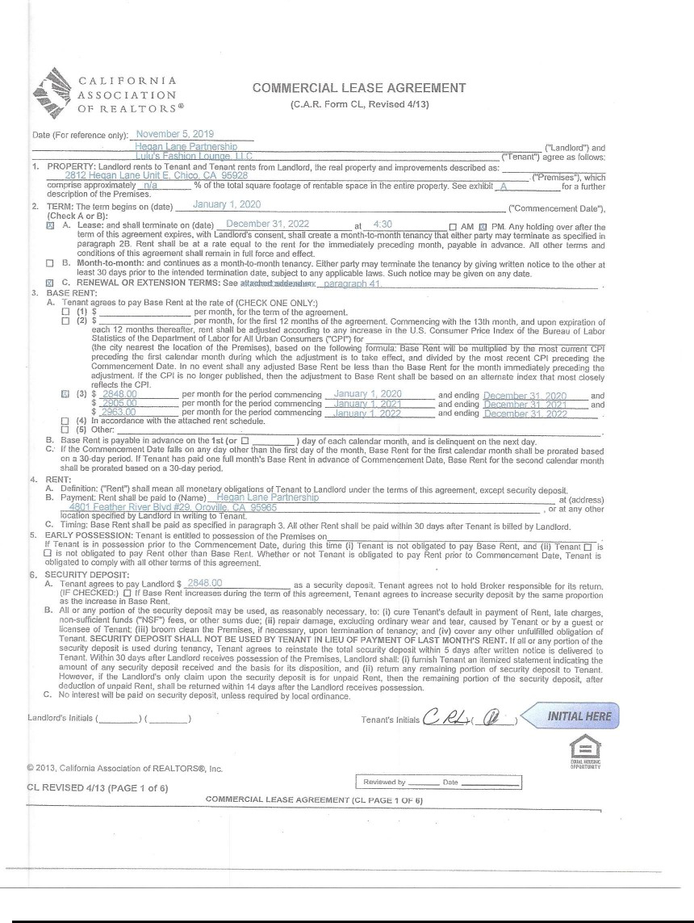

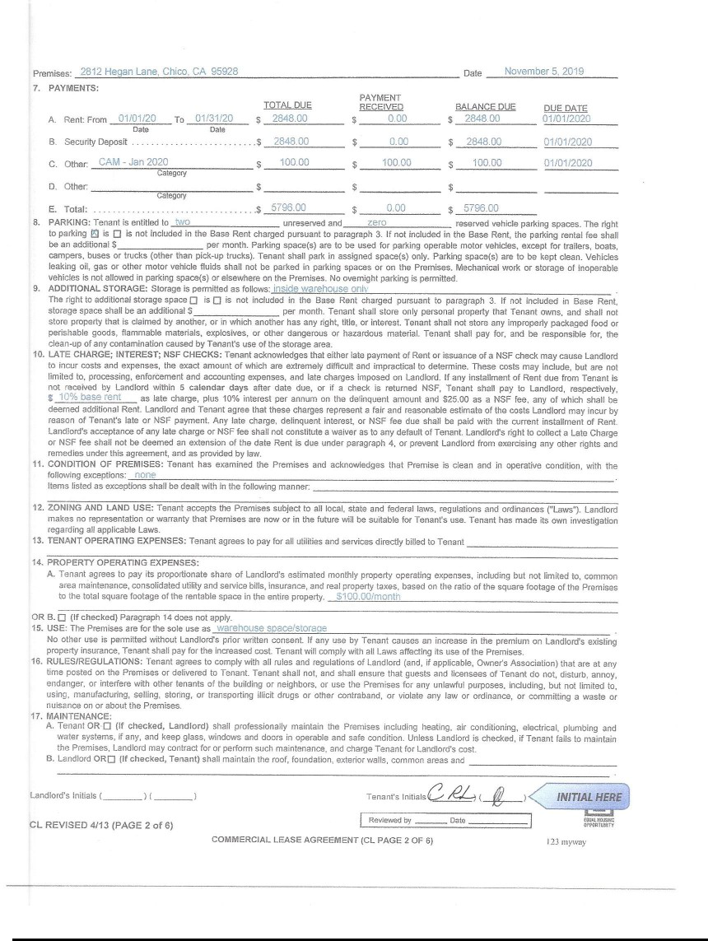

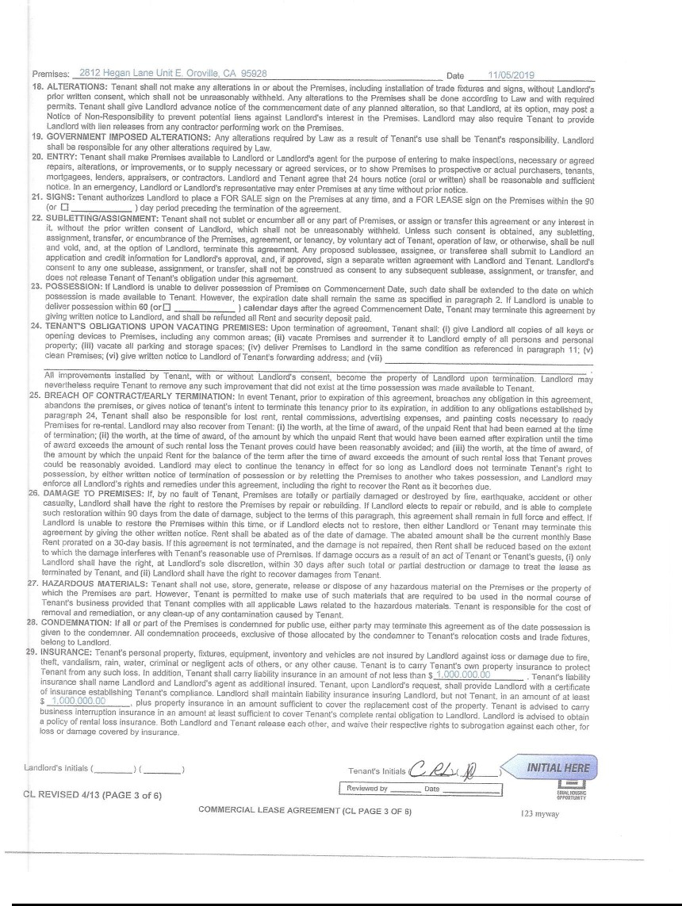

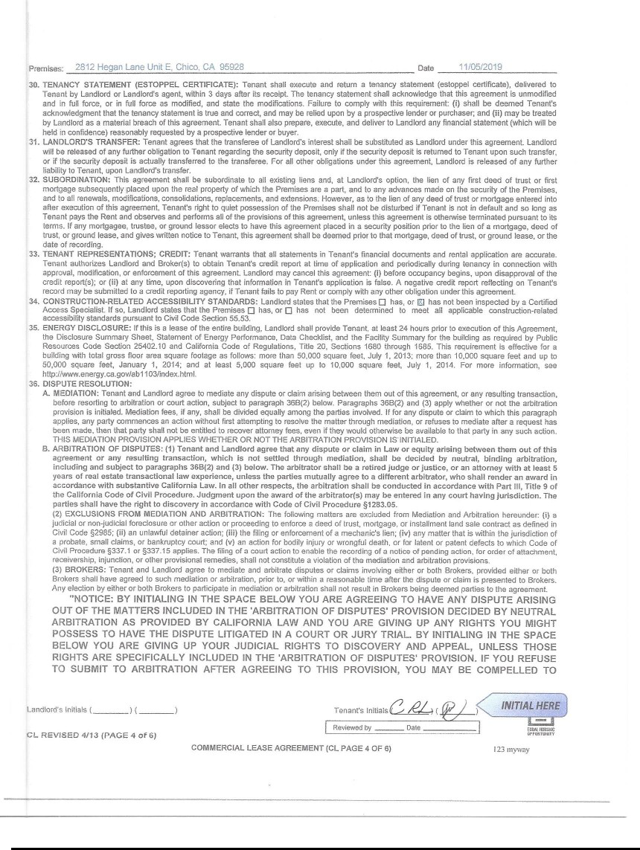

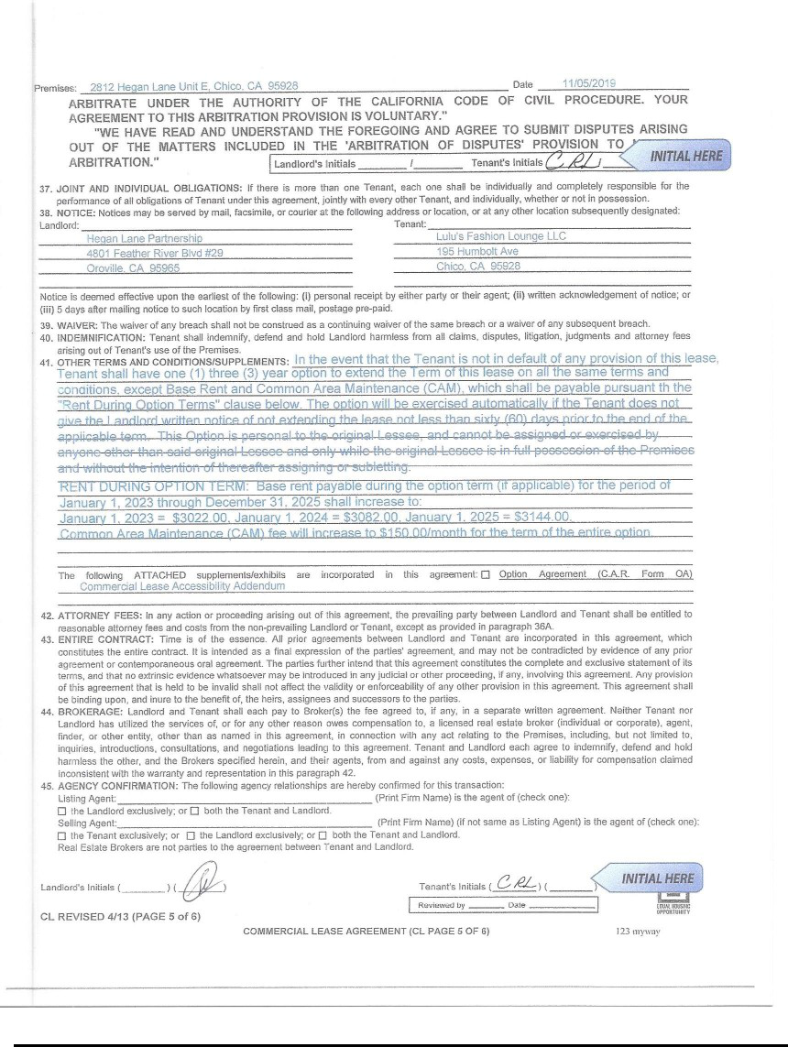

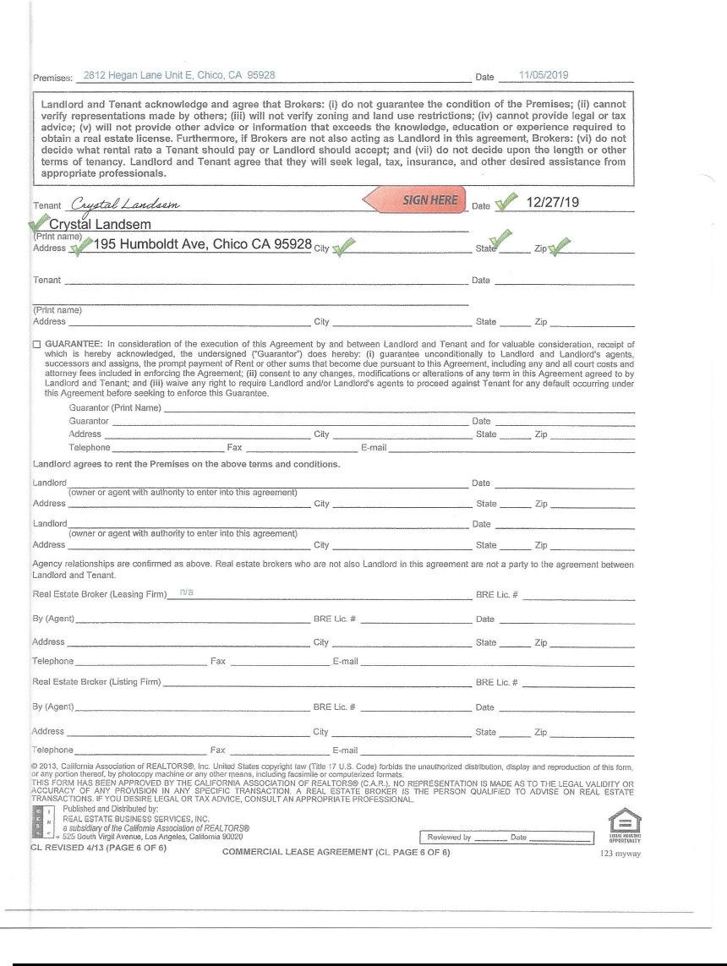

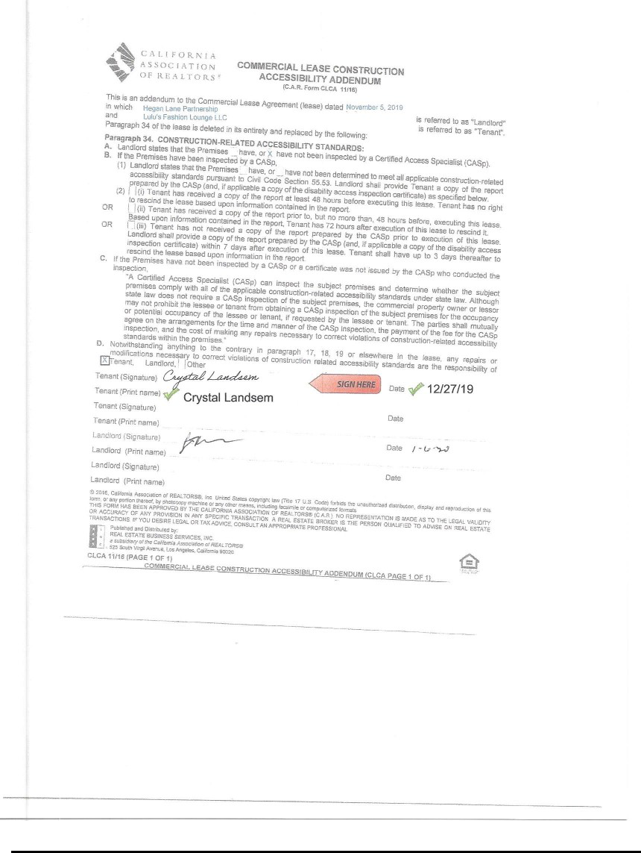

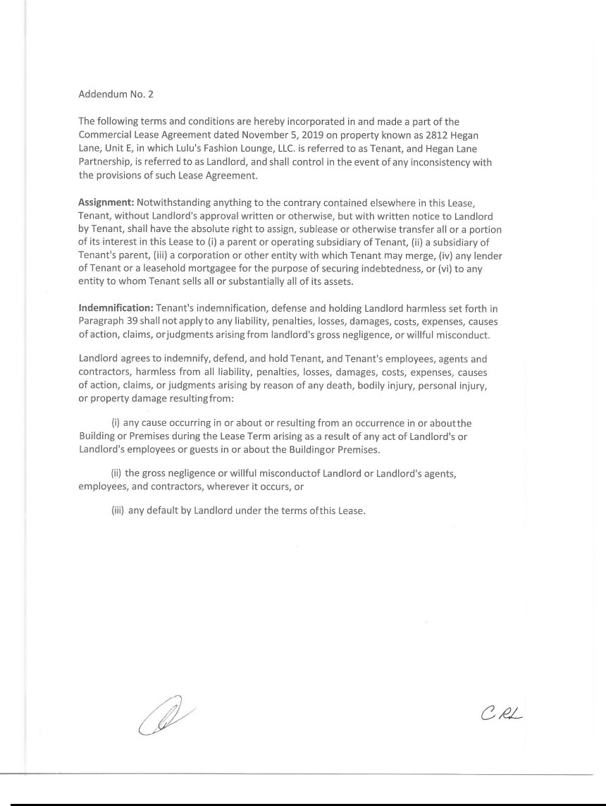

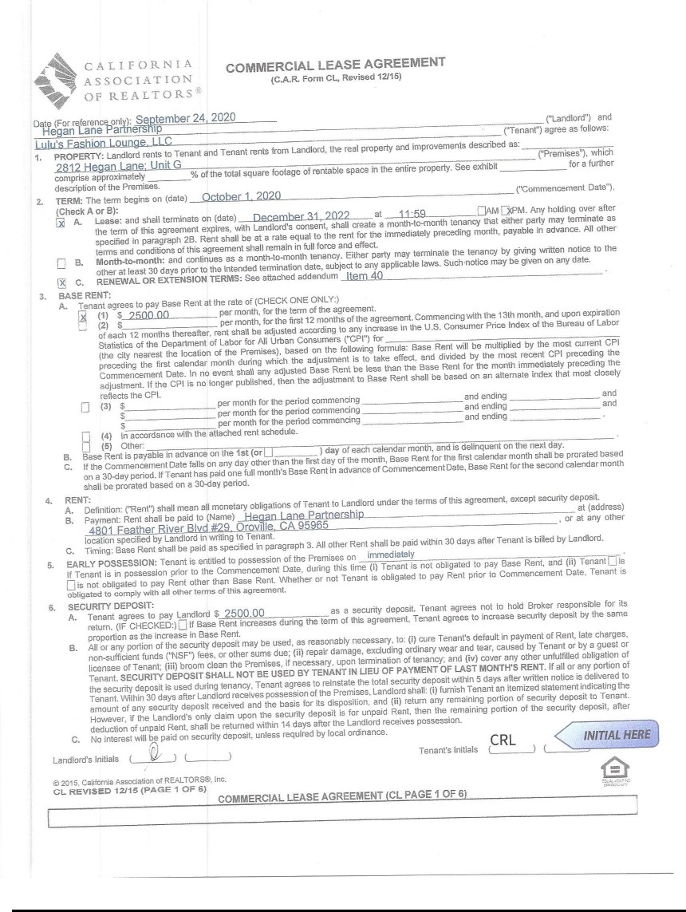

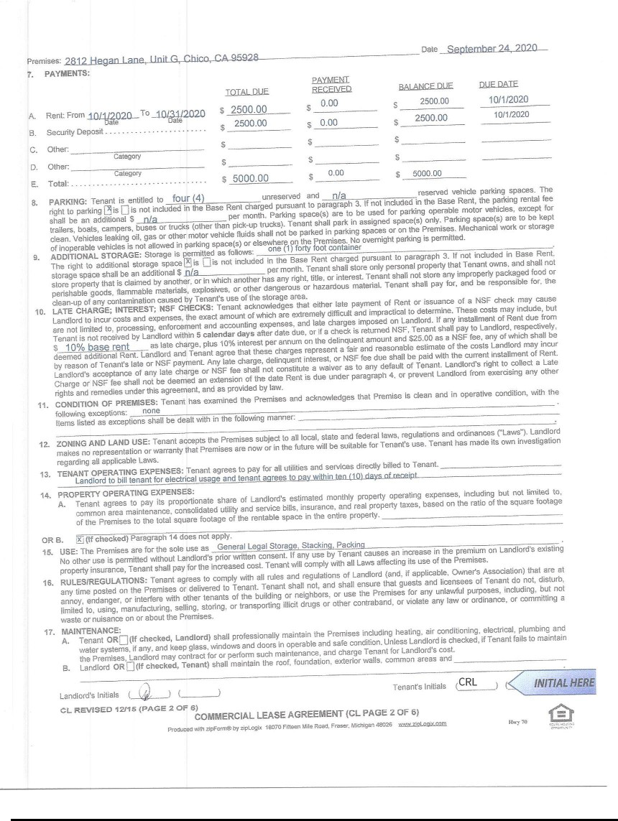

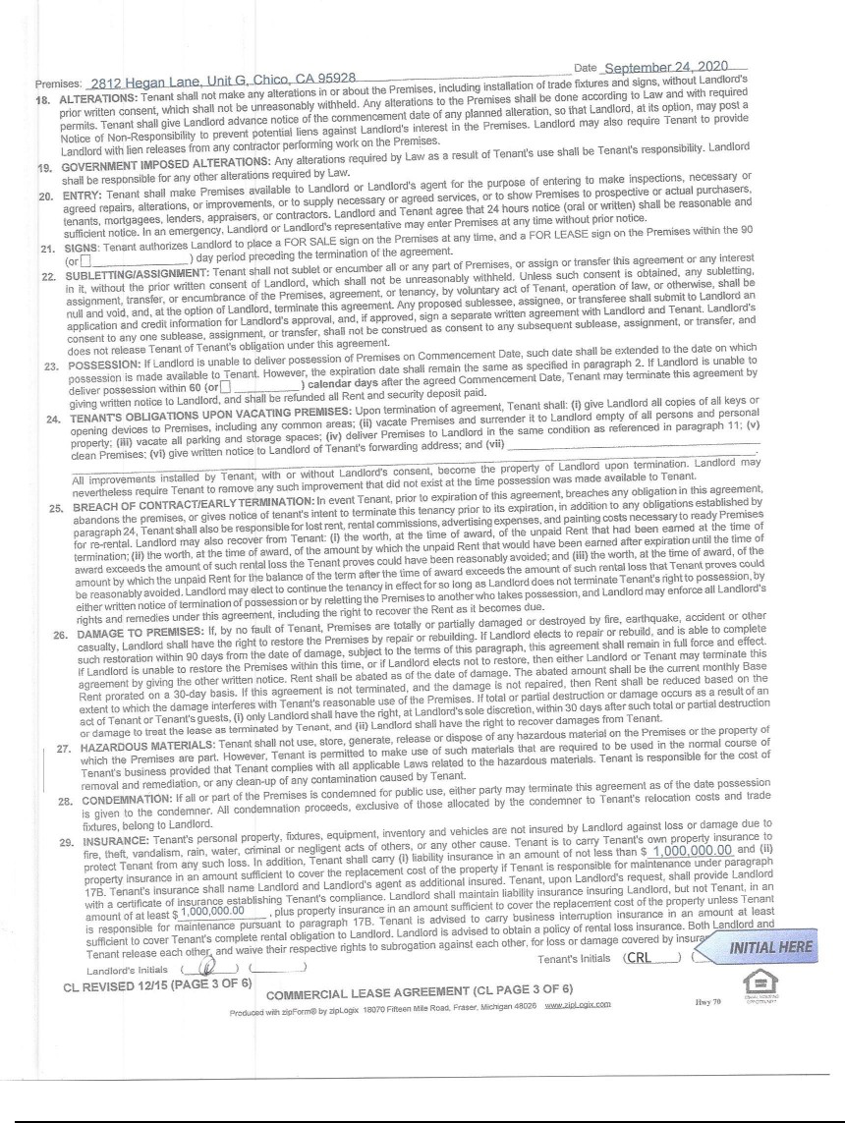

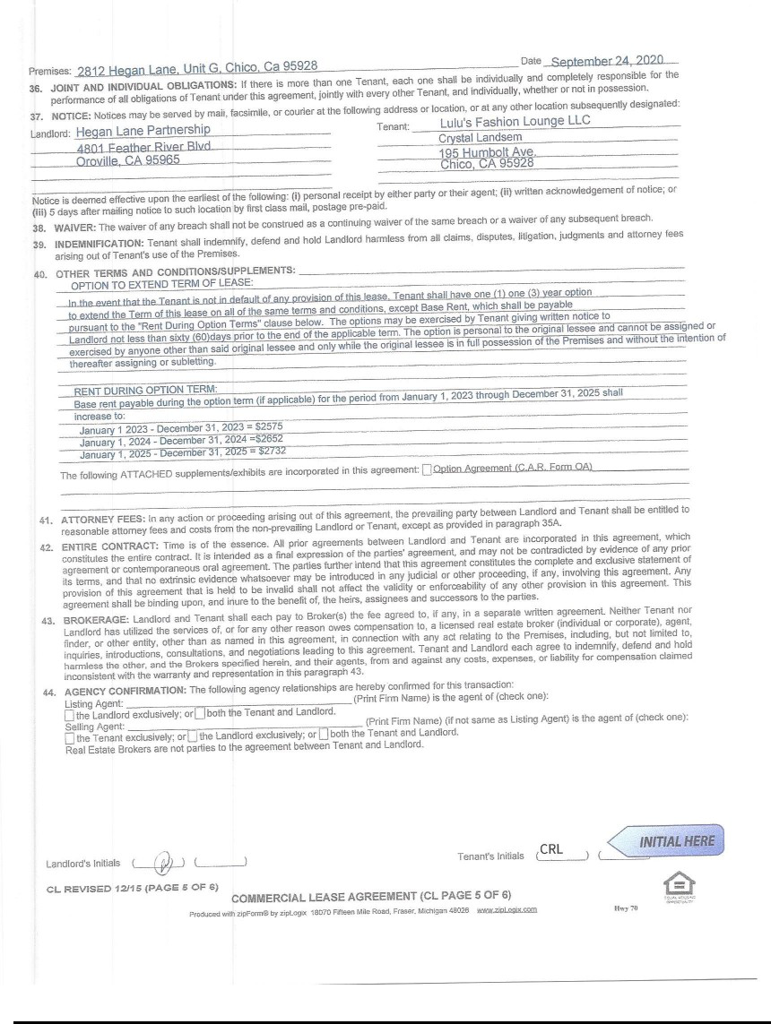

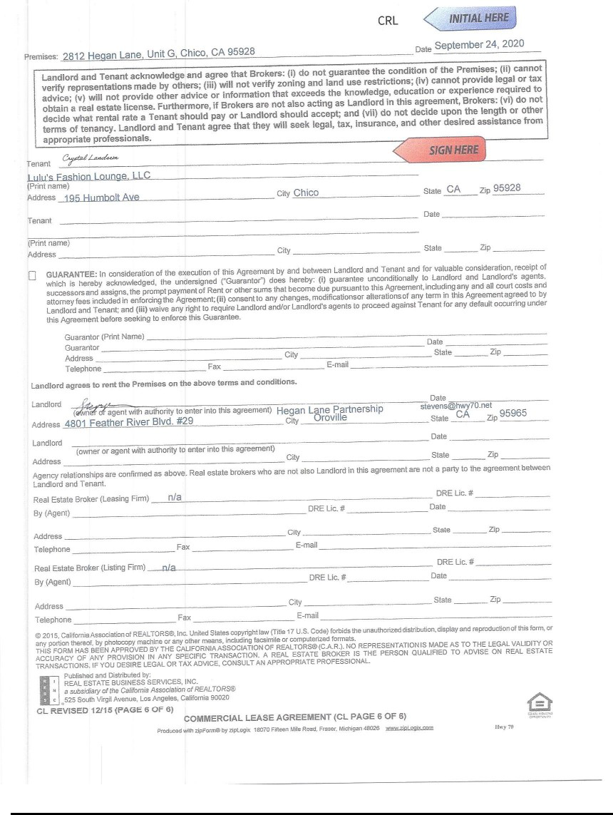

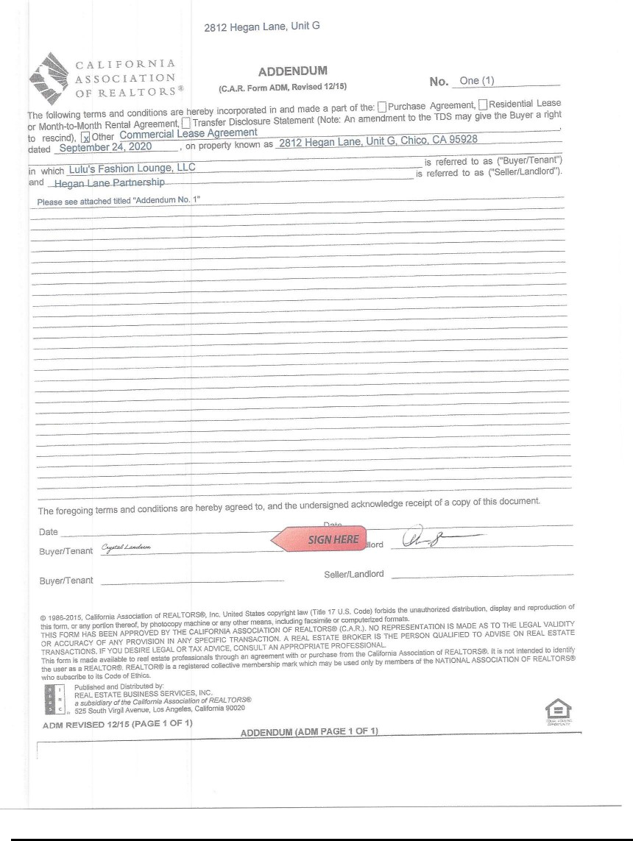

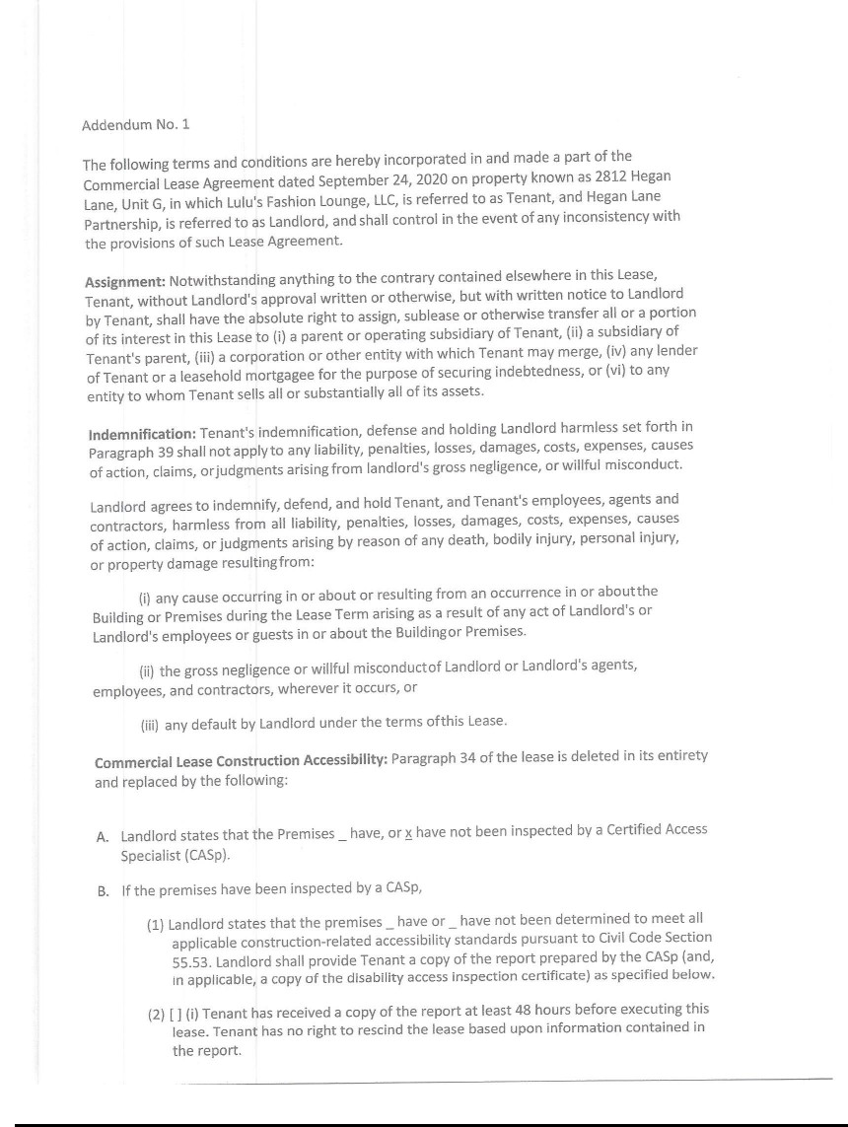

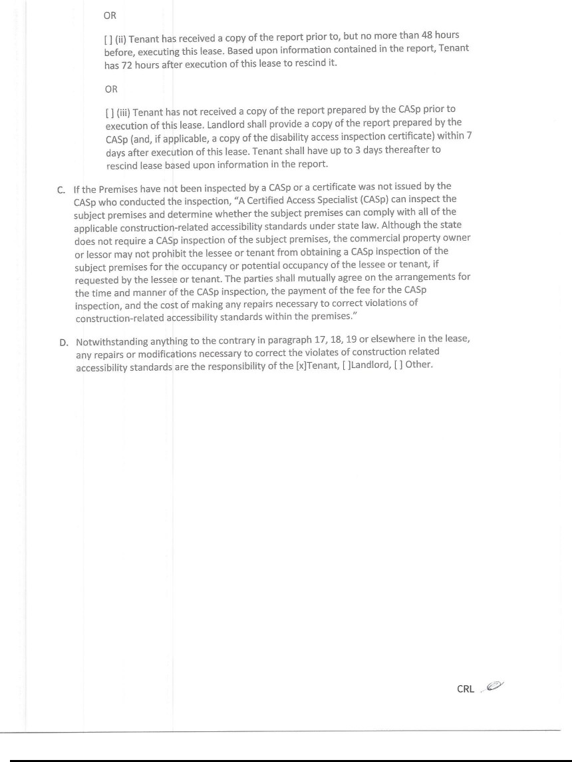

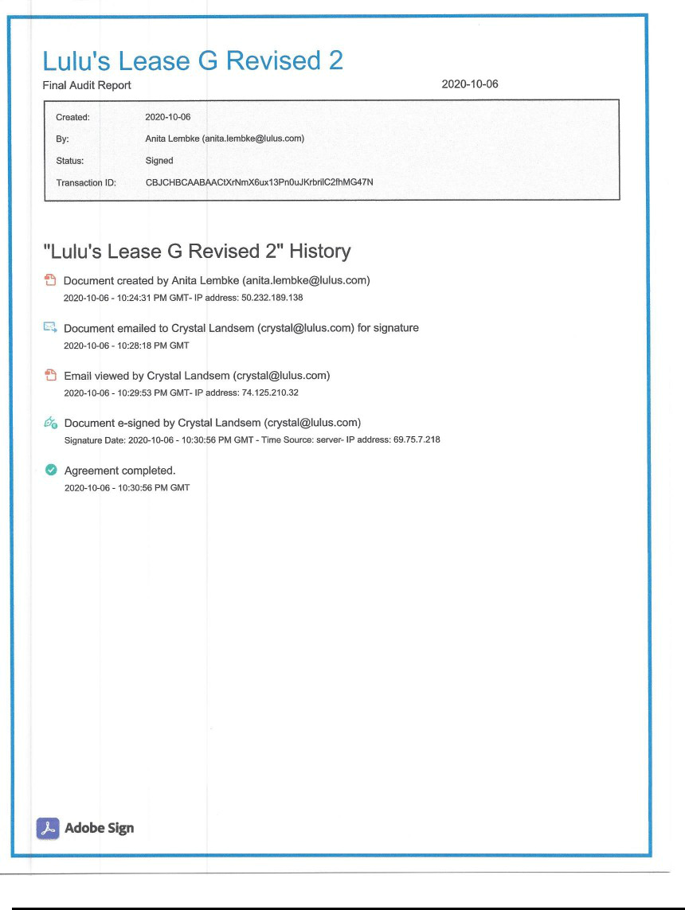

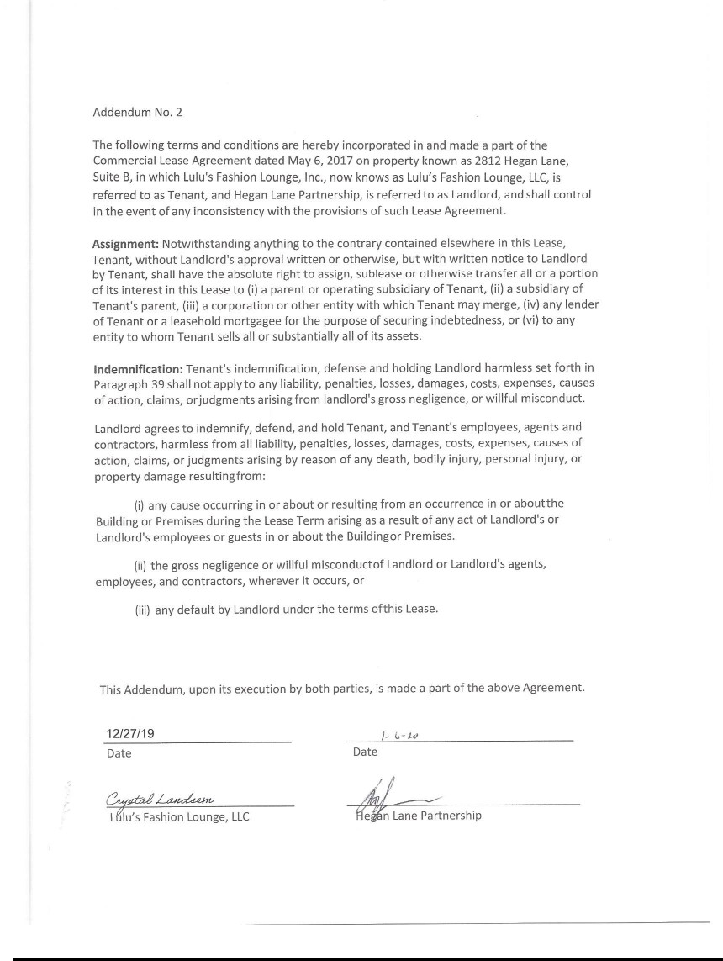

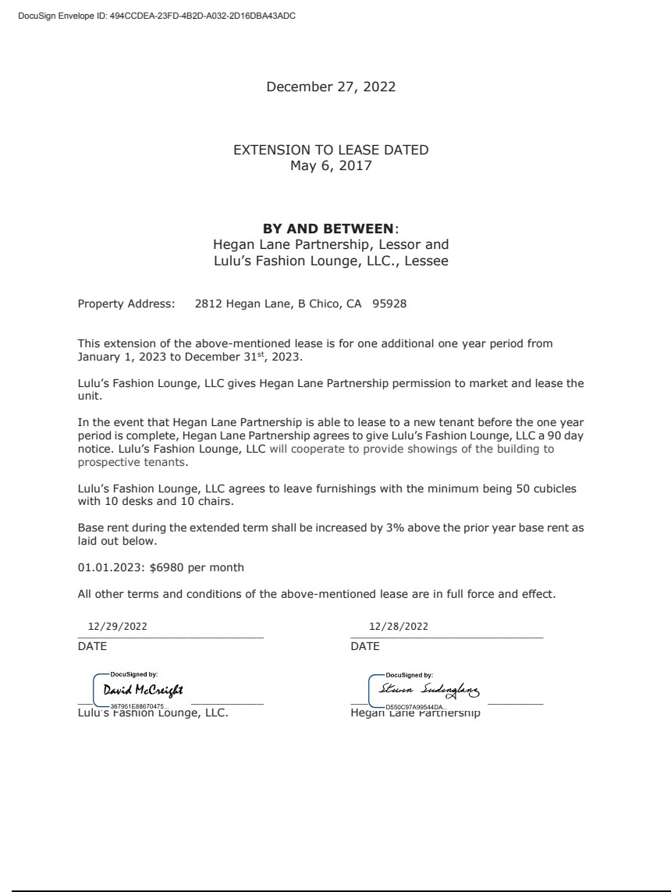

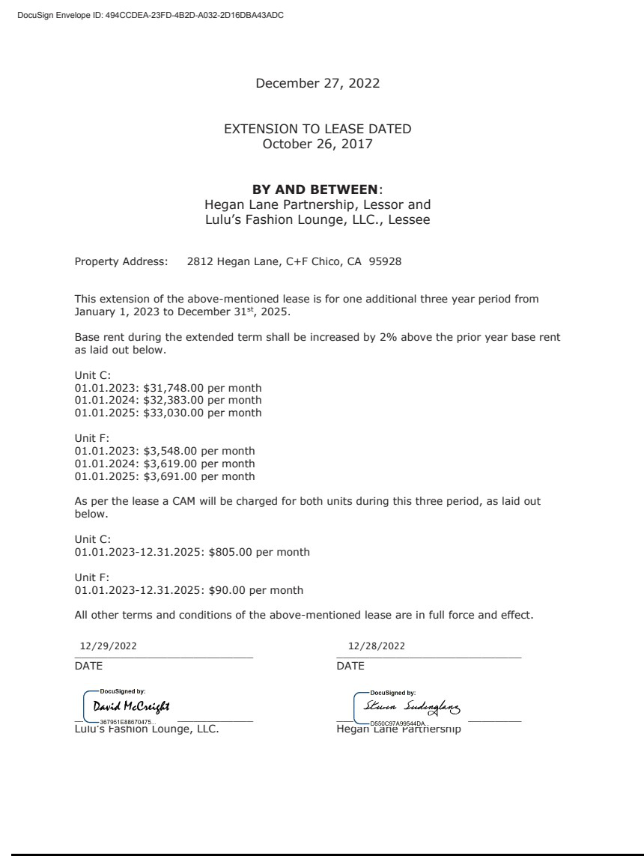

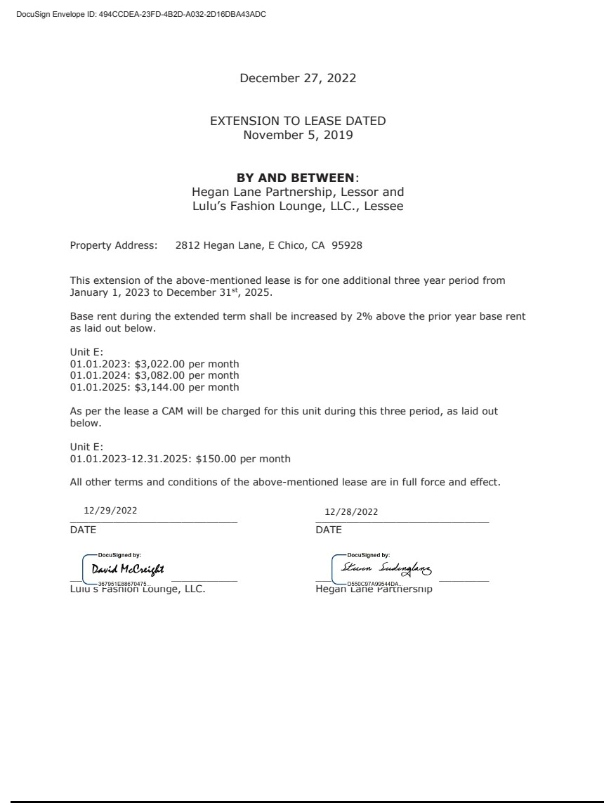

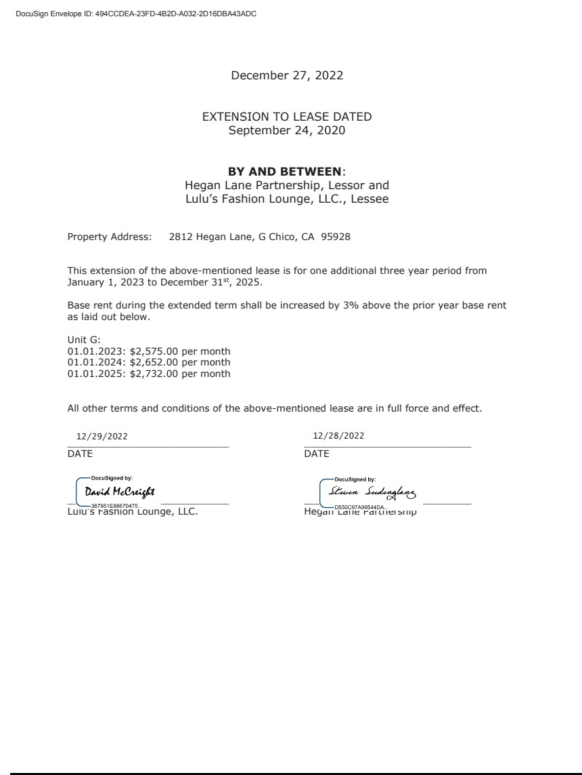

Exhibit 21.1

Subsidiaries of Lulu’s Fashion Lounge Holdings, Inc.

Pursuant to Item 601(b)(21) of Regulation S-K under the Securities Act of 1933, as amended (the “Securities Act”), we have omitted certain subsidiaries which, considered in the aggregate as a single subsidiary, would not constitute a “significant subsidiary” (as defined in Rule 1-02(w) of Regulation S-X under the Securities Act).

 | Legal Name |  | State or Other Jurisdiction of
 | Legal Name |  | Incorporation or Organization
 | Lulu’s Fashion Lounge Parent, LLC |  | Delaware
Lulu’s Fashion Lounge, LLC |  | Delaware

EXHIBIT 23.1

CONSENT OF INDEPENDENT REGISTERED PUBLIC ACCOUNTING FIRM

We consent to the incorporation by reference in Registration Statement Nos. 333-260985 and 333-264070 on Form S-8 of our report dated March 14, 2023, relating to the financial statements of Lulu’s Fashion Lounge Holdings, Inc. appearing in this Annual Report on Form 10-K for the fiscal year ended January 1, 2023.

/s/ Deloitte & Touche LLP

San Francisco, California

March 14, 2023

Exhibit 31.1

CERTIFICATION

I, David McCreight, certify that:

- I have reviewed this Annual Report on Form 10-K of Lulu’s Fashion Lounge Holdings, Inc.;

- Based on my knowledge, this report does not contain any untrue statement of a material fact or omit to state a material fact necessary to make the statements made, in light of the circumstances under which such statements were made, not misleading with respect to the period covered by this report;

- Based on my knowledge, the financial statements, and other financial information included in this report, fairly present in all material respects the financial condition, results of operations and cash flows of the registrant as of, and for, the periods presented in this report;

- The registrant’s other certifying officer(s) and I are responsible for establishing and maintaining disclosure controls and procedures (as defined in Exchange Act Rules 13a-15(e) and 15d-15(e)) for the registrant and have:

  - Designed such disclosure controls and procedures, or caused such disclosure controls and procedures to be designed under our supervision, to ensure that material information relating to the registrant, including its consolidated subsidiaries, is made known to us by others within those entities, particularly during the period in which this report is being prepared;

  - [Omitted];

  - Evaluated the effectiveness of the registrant’s disclosure controls and procedures and presented in this report our conclusions about the effectiveness of the disclosure controls and procedures, as of the end of the period covered by this report based on such evaluation; and

  - Disclosed in this report any change in the registrant’s internal control over financial reporting that occurred during the registrant’s most recent fiscal quarter (the registrant’s fourth fiscal quarter in the case of an annual report) that has materially affected, or is reasonably likely to materially affect, the registrant’s internal control over financial reporting; and

- The registrant’s other certifying officer(s) and I have disclosed, based on our most recent evaluation of internal control over financial reporting, to the registrant’s auditors and the audit committee of the registrant’s board of directors (or persons performing the equivalent functions):

  - All significant deficiencies and material weaknesses in the design or operation of internal control over financial reporting which are reasonably likely to adversely affect the registrant’s ability to record, process, summarize and report financial information; and

  - Any fraud, whether or not material, that involves management or other employees who have a significant role in the registrant’s internal control over financial reporting.

Date: March 14, 2023 By: /s/ Crystal Landsem

Crystal Landsem

Chief Executive Officer

(Principal Executive Officer)

Exhibit 31.2

CERTIFICATION

I, Tiffany Smith, certify that:

- I have reviewed this Annual Report on Form 10-K of Lulu’s Fashion Lounge Holdings, Inc.;

- Based on my knowledge, this report does not contain any untrue statement of a material fact or omit to state a material fact necessary to make the statements made, in light of the circumstances under which such statements were made, not misleading with respect to the period covered by this report;

- Based on my knowledge, the financial statements, and other financial information included in this report, fairly present in all material respects the financial condition, results of operations and cash flows of the registrant as of, and for, the periods presented in this report;

- The registrant’s other certifying officer(s) and I are responsible for establishing and maintaining disclosure controls and procedures (as defined in Exchange Act Rules 13a-15(e) and 15d-15(e)) for the registrant and have:

  - Designed such disclosure controls and procedures, or caused such disclosure controls and procedures to be designed under our supervision, to ensure that material information relating to the registrant, including its consolidated subsidiaries, is made known to us by others within those entities, particularly during the period in which this report is being prepared;

  - [Omitted];

  - Evaluated the effectiveness of the registrant’s disclosure controls and procedures and presented in this report our conclusions about the effectiveness of the disclosure controls and procedures, as of the end of the period covered by this report based on such evaluation; and

  - Disclosed in this report any change in the registrant’s internal control over financial reporting that occurred during the registrant’s most recent fiscal quarter (the registrant’s fourth fiscal quarter in the case of an annual report) that has materially affected, or is reasonably likely to materially affect, the registrant’s internal control over financial reporting; and

- The registrant’s other certifying officer(s) and I have disclosed, based on our most recent evaluation of internal control over financial reporting, to the registrant’s auditors and the audit committee of the registrant’s board of directors (or persons performing the equivalent functions):

  - All significant deficiencies and material weaknesses in the design or operation of internal control over financial reporting which are reasonably likely to adversely affect the registrant’s ability to record, process, summarize and report financial information; and

  - Any fraud, whether or not material, that involves management or other employees who have a significant role in the registrant’s internal control over financial reporting.

Date: March 14, 2023 By: /s/ Tiffany R. Smith

Tiffany R. Smith

Chief Financial Officer

(Principal Financial and Accounting Officer)

Exhibit 32.1

CERTIFICATION PURSUANT TO

18 U.S.C. SECTION 1350, AS ADOPTED PURSUANT TO

SECTION 906 OF THE SARBANES-OXLEY ACT OF 2002

In connection with the Annual Report on Form 10-K of Lulu’s Fashion Lounge Holdings, Inc. (the “Company”) for the period ended January 1, 2023 as filed with the Securities and Exchange Commission on the date hereof (the “Report”), I certify, pursuant to 18 U.S.C. § 1350, as adopted pursuant to § 906 of the Sarbanes-Oxley Act of 2002, that:

- The Report fully complies with the requirements of section 13(a) or 15(d) of the Securities Exchange Act of 1934, as amended; and

- The information contained in the Report fairly presents, in all material respects, the financial condition and results of operations of the Company.

Date: March 14, 2023 By: /s/ Crystal Landsem

Crystal Landsem

Chief Executive Officer

(Principal Executive Officer)

Exhibit 32.2

CERTIFICATION PURSUANT TO

18 U.S.C. SECTION 1350, AS ADOPTED PURSUANT TO

SECTION 906 OF THE SARBANES-OXLEY ACT OF 2002

In connection with the Annual Report on Form 10-K of Lulu’s Fashion Lounge Holdings, Inc. (the “Company”) for the period ended January 1, 2023 as filed with the Securities and Exchange Commission on the date hereof (the “Report”), I certify, pursuant to 18 U.S.C. § 1350, as adopted pursuant to § 906 of the Sarbanes-Oxley Act of 2002, that:

- The Report fully complies with the requirements of section 13(a) or 15(d) of the Securities Exchange Act of 1934, as amended; and

- The information contained in the Report fairly presents, in all material respects, the financial condition and results of operations of the Company.

Date: March 14, 2023 By: /s/ Tiffany R. Smith

Tiffany R. Smith

Chief Financial Officer

(Principal Financial and Accounting Officer)

